Name: Krishnmohan Mishra MSc CS Sem 1/Roll No:F016

# Cyber Security and Digital Forensics

## Practical 6: Creating Database, Dropping it and Restoring it

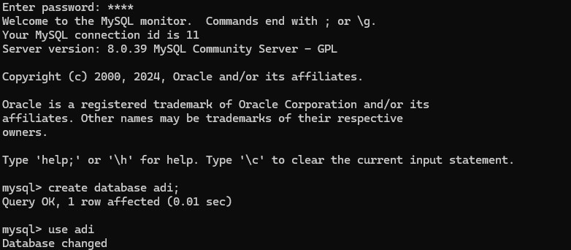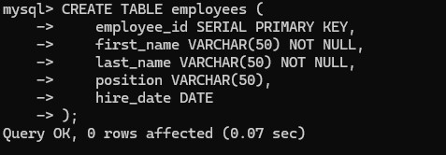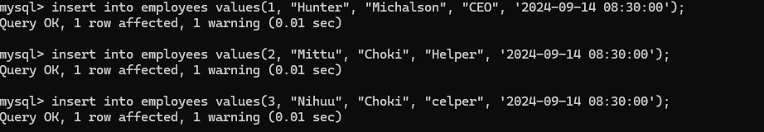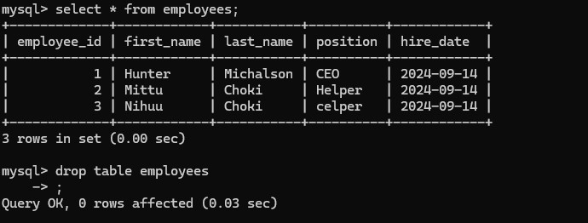

Name: Krishnmohan Mishra MSc CS Sem 1/Roll No:F016

