RETAIL SALES FORECASTING AND PROMOTION EFFECTIVENESS

ASSIGNMENT NO :3

KRISHNA P [RA2311042010017]

1. Introduction
Retail businesses need accurate sales forecasts to manage inventory, pricing, promotions, and store operations effectively. Sales can vary depending on previous demand, product prices, promotional activities, product characteristics, and store conditions.
This project focuses on forecasting weekly retail sales at the product-store level and studying how pricing and promotions influence demand. Historical transaction data was combined with product and store information to build a forecasting dataset. A time-based validation approach was used to compare a simple Naive Forecast with a Random Forest model.
The project also includes a price scenario analysis to understand how a potential price reduction could affect predicted demand.

2. Objectives
- To analyse the quality and characteristics of the retail sales data.
- To combine transaction, product, and store information.
- To create a product-store level sales forecasting dataset.
- To use historical sales, price, and promotion information for forecasting.
- To compare a Naive Forecast with a Random Forest model.
- To evaluate the models using a 13-week time-based holdout.
- To analyse the effect of price and promotional features on sales.
- To perform a price scenario analysis.
- To provide useful business recommendations based on the results.

3. Data Preparation and Analysis
The project uses the Dunnhumby Breakfast at the Frat retail dataset. The dataset contains transaction information along with product and store lookup information.
The transaction data contains 524,950 records covering 156 weeks. The data includes variables such as units sold, price, base price, feature promotion, display promotion, and TPR promotion.
The transaction data was combined with product and store lookup tables using the product and store identifiers. Data-quality checks were performed for missing values, duplicate records, invalid prices, and missing product or store mappings.
The final dataset was used to create weekly product-store observations for forecasting.

4. Forecasting Methodology
Historical sales information was used to create lag and rolling features such as previous-week sales and previous-period average sales. Price, discount, promotional, product, store, and calendar information were also included.
A chronological train-test split was used instead of a random split to maintain the time-series nature of the problem.
The training data covered the earlier 143 weeks, while the final 13 weeks were used as the holdout period.
Two forecasting approaches were compared:
- Naive Forecast – uses the previous week's sales as the forecast.
- Random Forest Regression – uses historical sales, price, promotion, product, and store features to predict demand.

5. Model Performance
The model performance was evaluated using MAE, RMSE, and MAPE.
Model | MAE | RMSE | MAPE
Naive Forecast | 9.84 | 25.39 | 63.96%
Random Forest | 6.53 | 13.44 | 52.51%
The Random Forest model performed better than the Naive Forecast across all three evaluation metrics.
The MAE improved from 9.84 to 6.53, while RMSE decreased from 25.39 to 13.44. This shows that using multiple demand-related factors provides more accurate forecasts than relying only on the previous week's sales.

6. Feature and Promotion Analysis
The analysis showed that historical sales were the most important factor for predicting future demand. The previous week's sales had the highest feature importance.
Promotional and pricing variables also contributed to the forecasting performance. The ablation study showed that adding price and promotion information improved the model compared with using historical sales alone.
This indicates that promotional activities and pricing decisions can provide useful information when estimating future retail demand.

7. Price Scenario Analysis
A price scenario was performed by reducing the product price by 10% and observing the change in predicted demand.
Measure | Result
Baseline predicted demand | 23.14 units
Scenario predicted demand | 26.45 units
Demand increase | 3.31 units
Estimated increase | 13.75%
The model predicted an increase in average demand from 23.14 units to 26.45 units after applying the 10% price reduction.
This result can help retailers evaluate possible pricing strategies. However, it is a model-based scenario estimate and should not be considered a direct causal measurement of price elasticity.

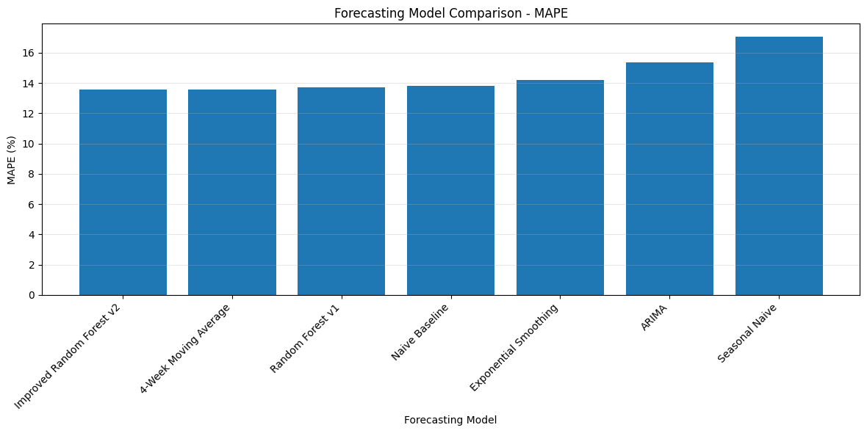

8. Key Findings
- The Random Forest model performed better than the Naive Forecast.
- Recent sales history was the strongest predictor of future demand.
- Price and promotion information improved forecasting accuracy.
- Promotional variables were important contributors to the model.
- The 10% price-reduction scenario resulted in a 13.75% increase in predicted demand.
- Product-store level forecasting provides more detailed demand information for retail decision-making.
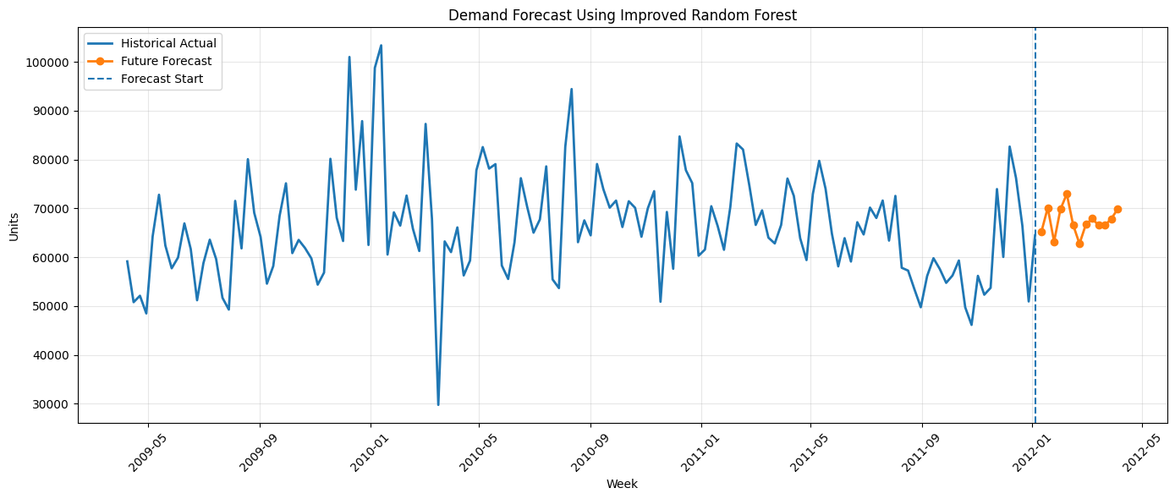

9. Limitations
- The analysis is based on historical retail data and may not completely represent future customer behaviour.
- MAPE can be less reliable when actual sales are very low.
- The price scenario is based on model predictions and does not establish a causal relationship.
- Some product-store combinations have limited historical data.
- The uncertainty estimates are approximate and may require further calibration for real-world deployment.

10. Business Recommendations
- Use recent sales trends to improve inventory and replenishment decisions.
- Include promotion information when preparing demand forecasts.
- Use price scenario analysis before implementing major pricing changes.
- Forecast at product-store level to identify differences in demand across stores.
- Consider forecast uncertainty when making inventory and planning decisions.

11. Conclusion
This project developed a retail sales forecasting system using historical sales, pricing, promotional, product, and store information. The Random Forest model provided better forecasting performance than the Naive Forecast when evaluated on a 13-week time-based holdout.
The analysis also showed that price and promotional information can improve demand forecasting. The price scenario demonstrated how the model can be used to support pricing decisions by estimating potential changes in demand.
Overall, the project provides a practical approach for supporting retail demand forecasting, inventory planning, pricing decisions, and promotional planning.

