REPORT
Title: TV management system
- Abstract:
We created a solution for easy TV management and this problem help us understand and organize TV channels based on their performances and making it easy to view all kind of details required.

Managing television channel data manually can lead to difficulty in tracking shows, scheduling, TRP ratings, costs, cast associations, marketing data, and upcoming replacements. This database automates analytics, maintains constraints, and improves decision-making for broadcasting companies.

- Objective:

1To build a dynamic TV management system
2.To implement CRUD functionality
3.To practice database connectivity using psycopg2
4.To learn Jinja templating in Flask
5.To use normalized relational tables (up to 3NF )

- Application Requirements

1.Python
2.Flask Framework
3.PostgreSQL
4.Psycopg2
5.HTML5, CSS, Jinja Templates

- System Architecture:

User → Browser → Flask App → PostgreSQL DB → Response to Browser

- ER diagram:
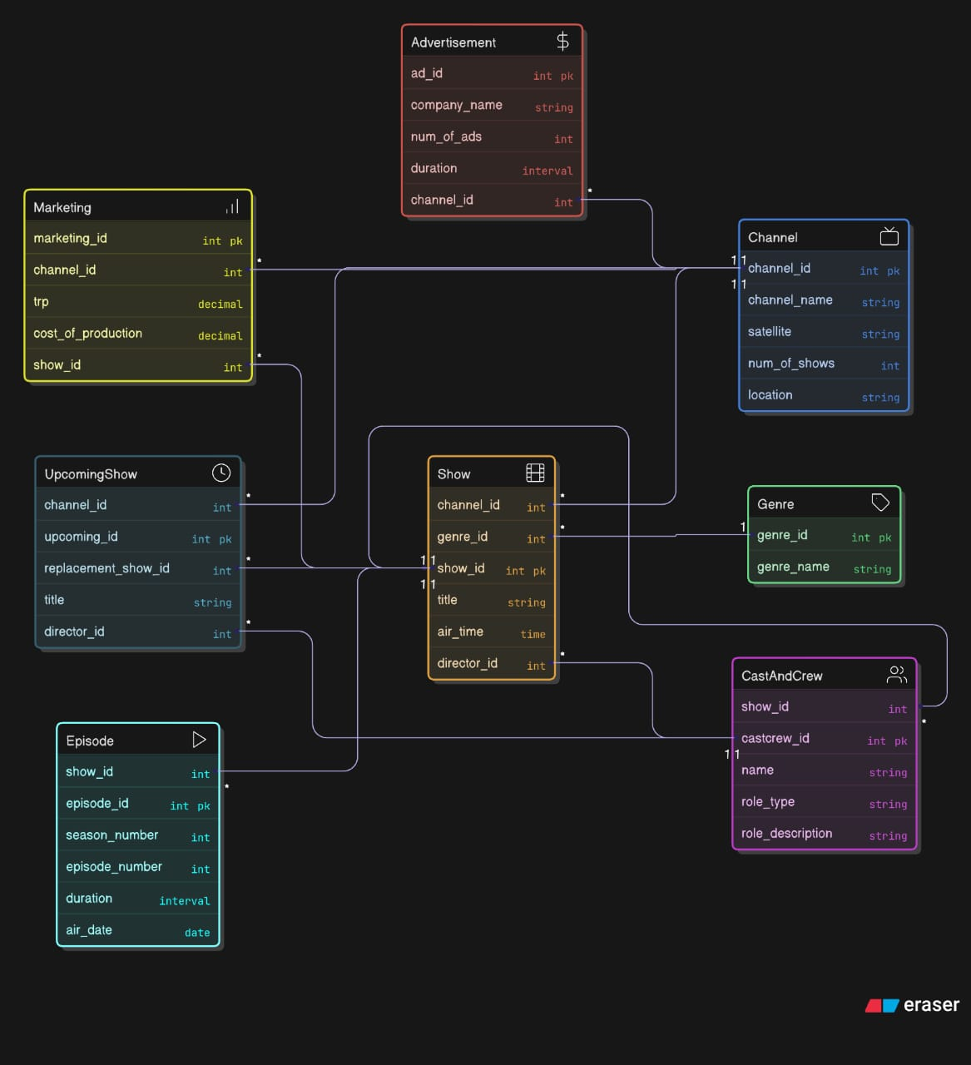
- Tables:
- Channels
- Shows
- Genre
- Cast and crew
- Advertisement
- Marketing
- Upcoming
- Episode

- Normalization:

1NF – Atomic values
2NF – No partial dependency (PK is atomic)
3NF – No transitive dependency

- Technology:

-> Flask

Routing (@app.route)
Templates (Jinja2)
Form handling (request.form)
Database connection

->Psycopg2

Connect Flask to PostgreSQL
Execute SQL queries
Cursor operations

->Jinja2

{% for r in rows %}
{{ query_name }}

Used to loop, display data dynamically in HTML.

- Output:
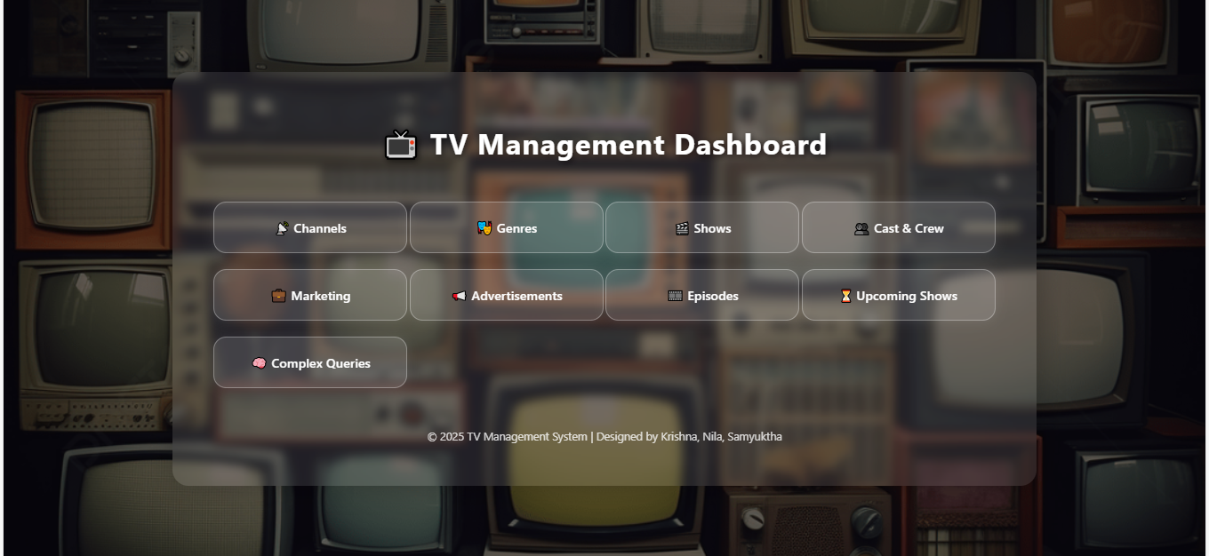

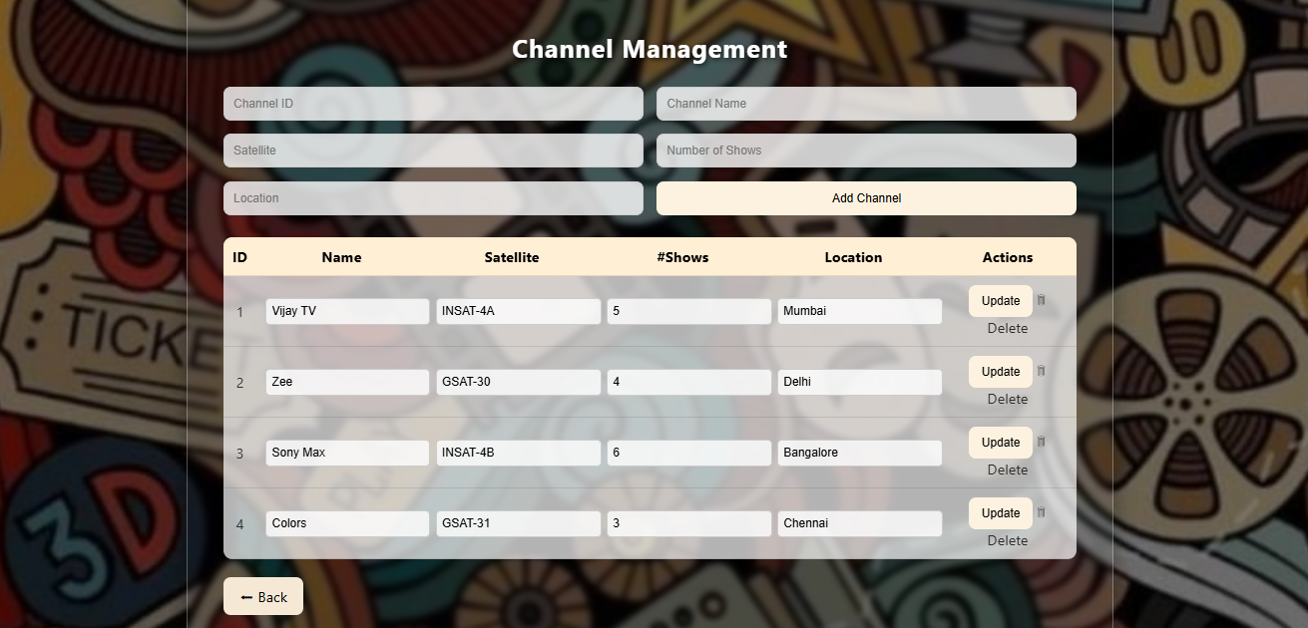

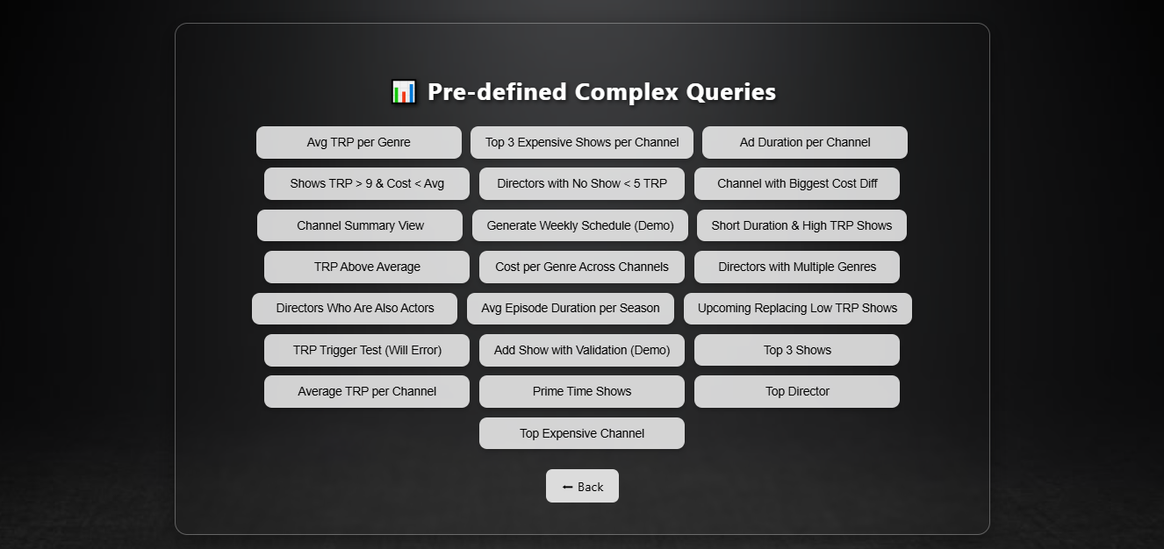

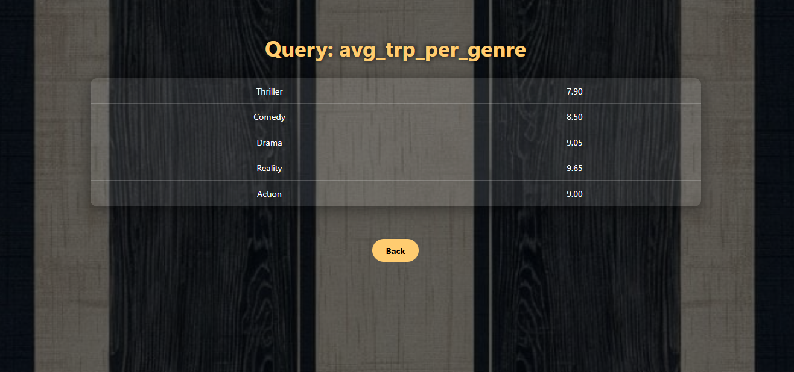

- Learning:

This project successfully demonstrates the development of a full-stack web application using Python Flask as the backend framework and PostgreSQL as the database. The TV Management System allows users to add, store, and retrieve TV details along with director and actor information. Through this project, relational database concepts such as Primary Keys, Foreign Keys, Many-to-Many relationships, and Normalization (up to 3NFFuture Enhancements

The project also integrates Psycopg2 for database connectivity and Jinja2 templating for dynamic webpage rendering, resulting in an interactive interface and efficient data handling. This practical implementation enhanced understanding of:

Web routing and HTTP request handling

Server-side rendering and form processing

SQL query execution from Python

Database schema design & normalization

- Future enhancement:

->User Login system

->Rating & Review

->IMDB API integration

->Upload Poster

