E-commerce Platform Search Function
- Understanding Notation

Big O Notation

Big O notation describes how the time or space complexity of an algorithm grows as the input size increases. It helps us compare algorithms based on performance and scalability — regardless of hardware or programming language.

Search Case Scenarios

Search Type | Best Case | Average Case | Worst Case
Linear Search | O(1) | O(n) | O(n)
Binary Search | O(1) | O(log n) | O(log n)
  - Best Case: When the item is found in the first attempt.
  - Average Case: When the item is found in the middle.
  - Worst Case: When the item is at the end or not found at all.

1.Main Class : Program.cs

using System;
using System.Linq;
using EcommerceSearchFunction.Models;

namespace EcommerceSearchFunction
{
class Program
{
// Linear Search
static Product? LinearSearch(Product[] products, string name)
{
foreach (var product in products)
{
if (product.ProductName.Equals(name, StringComparison.OrdinalIgnoreCase))
return product;
}
return null;
}

// Binary Search
static Product? BinarySearch(Product[] products, string name)
{
int left = 0, right = products.Length - 1;

while (left <= right)
{
int mid = (left + right) / 2;
int comparison = string.Compare(name, products[mid].ProductName, StringComparison.OrdinalIgnoreCase);

if (comparison == 0)
return products[mid];
else if (comparison < 0)
right = mid - 1;
else
left = mid + 1;
}
return null;
}

static void Main(string[] args)
{
// sample product data
Product[] products = new Product[]
{
new Product(1, "Laptop", "Electronics"),
new Product(2, "Shoes", "Footwear"),
new Product(3, "Watch", "Accessories"),
new Product(4, "Phone", "Electronics"),
new Product(5, "Bag", "Accessories"),
};

Console.WriteLine("Enter product name to search:");
string input = Console.ReadLine() ?? "";

// Linear Search
Console.WriteLine("\nLinear Search:");
var result1 = LinearSearch(products, input);
if (result1 != null)
Console.WriteLine($"Found: {result1.ProductName} (Category: {result1.Category})");
else
Console.WriteLine("Product not found.");

// Binary Search
Console.WriteLine("\nBinary Search:");
var sortedProducts = products.OrderBy(p => p.ProductName).ToArray();
var result2 = BinarySearch(sortedProducts, input);
if (result2 != null)
Console.WriteLine($"Found: {result2.ProductName} (Category: {result2.Category})");
else
Console.WriteLine("Product not found.");
}
}

2.Output

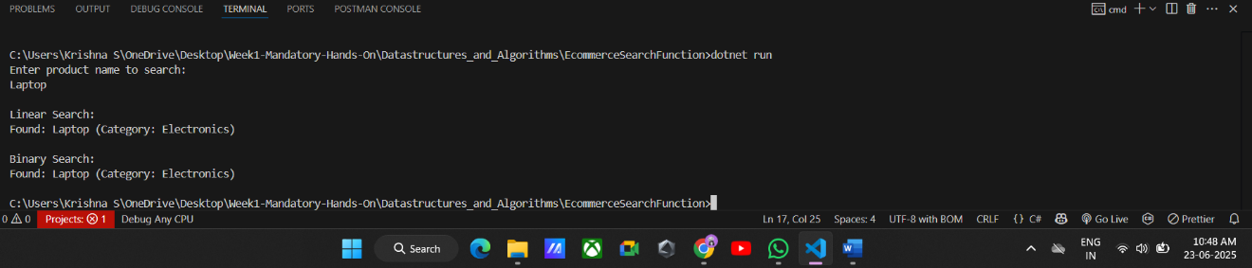

3.Time Complexity Analysis

Algorithm | Time Complexity | Space Complexity | Sorting Required
Linear Search | O(n) | O(1) | No
Binary Search | O(log n) | O(1) | Yes

4.Analysis

Time Complexity Comparison:
- Linear Search: O(n) – slower on large datasets; checks each item one by one.
- Binary Search: O(log n) – much faster, but requires data to be sorted.
Which is More Suitable?
- For an e-commerce platform, binary search is better for speed and efficiency if product data is sorted or indexed.

