Financial Forecasting

1. Understand Recursive Algorithms
- Recursion is a programming technique where a method calls itself to solve smaller instances of the same problem.
- It's useful when:
  - A problem can be divided into sub-problems of the same type.
  - Iterative solutions become complex or harder to read.
- In financial forecasting, recursion can help calculate future values based on a repeated pattern (e.g., annual growth).

2. Setup
V(n) = FV(n-1) * (1 + growthRate)
Where:
- FV(n) is the future value after n years
- growthRate is the annual percentage increase
3. Implementation
using System;

namespace FinancialForecasting
{
class Program
{
static double CalculateFutureValue(double currentValue, double growthRate, int years)
{
if (years == 0)
return currentValue;

return CalculateFutureValue(currentValue * (1 + growthRate), growthRate, years - 1);
}

static void Main(string[] args)
{
Console.WriteLine("Enter current value:");
double currentValue = Convert.ToDouble(Console.ReadLine());

Console.WriteLine("Enter annual growth rate (e.g., 0.05 for 5%):");
double growthRate = Convert.ToDouble(Console.ReadLine());

Console.WriteLine("Enter number of years:");
int years = Convert.ToInt32(Console.ReadLine());

double futureValue = CalculateFutureValue(currentValue, growthRate, years);

Console.WriteLine($"\nFuture value after {years} years: {futureValue:F2}");
}
}
}

4. Output

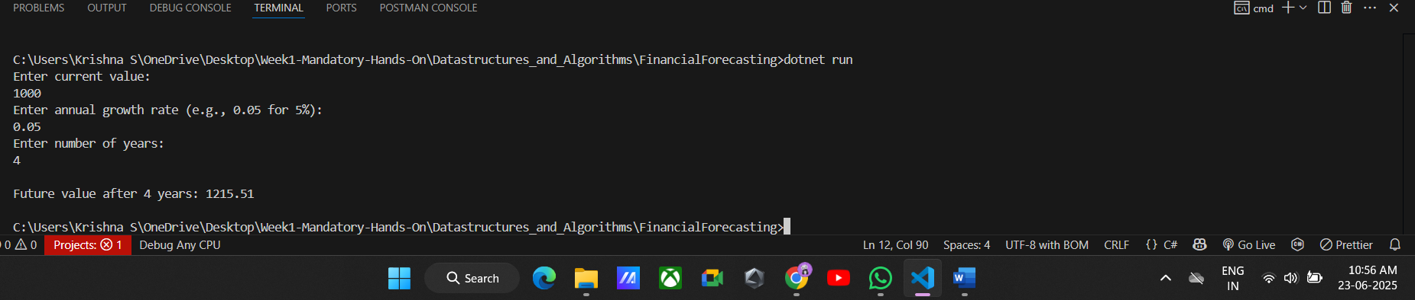

5. Analysis

Time Complexity:
- Each recursive call reduces years by 1.
- So for n years, we have O(n) time complexity.
- Space complexity is also O(n) due to function call stack.
Optimization:
Use Iteration instead of Recursion:
- Avoids overhead of multiple function calls.
- More efficient for large n.
double value = currentValue;
for (int i = 0; i < years; i++)
{
value *= (1 + growthRate);
}

The iterative method maintains O(n) time complexity but reduces space complexity to O(1), making it more efficient for large inputs.

