SQL Exercise: Advanced Ranking and Window Functions
- Objective:
Use ROW_NUMBER(), RANK(), and DENSE_RANK() with OVER(PARTITION BY ...) to retrieve the top 3 priced products per category and explore how ranking functions behave with ties.

Step 1: Create and Use Database
CREATE DATABASE RetailStore; GO

USE RetailStore;
GO

Step 2: Create Products Table

CREATE TABLE Products (
ProductID INT PRIMARY KEY,
ProductName VARCHAR(100),
Category VARCHAR(50),
Price DECIMAL(10,2)
);

Step 3: Insert Sample Data

INSERT INTO Products (ProductID, ProductName, Category, Price)
VALUES
(1, 'Laptop', 'Electronics', 80000),
(2, 'Smartphone', 'Electronics', 60000),
(3, 'TV', 'Electronics', 60000),
(4, 'Tablet', 'Electronics', 30000),
(5, 'Washing Machine', 'Appliances', 25000),
(6, 'Refrigerator', 'Appliances', 35000),
(7, 'Microwave', 'Appliances', 15000),
(8, 'Vacuum Cleaner', 'Appliances', 25000),
(9, 'Jeans', 'Clothing', 2000),
(10, 'Shirt', 'Clothing', 1500),
(11, 'Jacket', 'Clothing', 4000),
(12, 'Shoes', 'Clothing', 4000);

Step 4: Ranking with ROW_NUMBER()

SELECT
ProductID,
ProductName,
Category,
Price,
ROW_NUMBER() OVER (PARTITION BY Category ORDER BY Price DESC) AS RowNum
FROM Products;



Step 5: Ranking with RANK() and DENSE_RANK()

SELECT
ProductID,
ProductName,
Category,
Price,
RANK() OVER (PARTITION BY Category ORDER BY Price DESC) AS RankNum
FROM Products;


Step 6: Get Top 3 Products Using ROW_NUMBER()

SELECT
ProductID,
ProductName,
Category,
Price,
DENSE_RANK() OVER (PARTITION BY Category ORDER BY Price DESC) AS DenseRankNum
FROM Products;
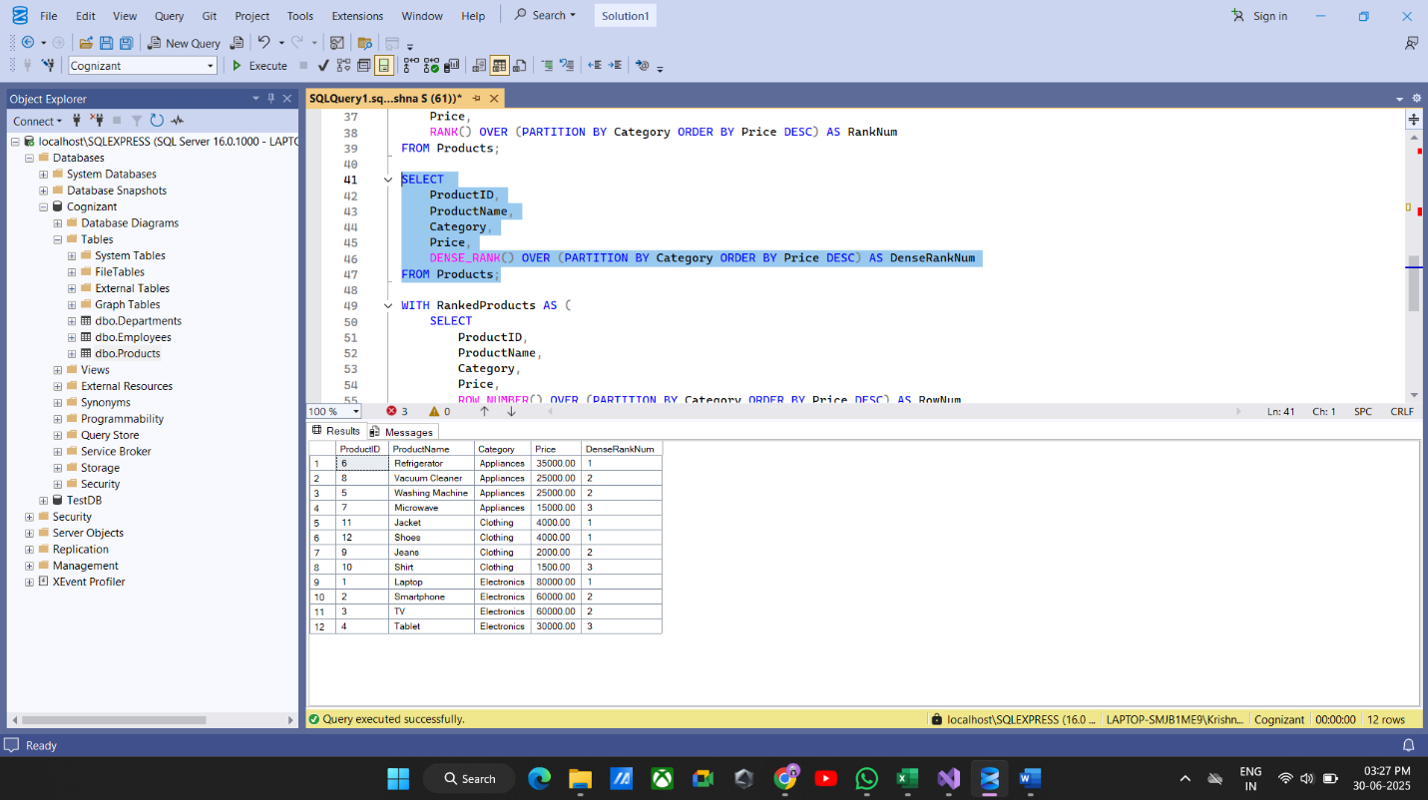

Step 7: Get Top 3 Products Using RANK() and DENSE_RANK()

WITH RankedProducts AS (
SELECT
ProductID,
ProductName,
Category,
Price,
ROW_NUMBER() OVER (PARTITION BY Category ORDER BY Price DESC) AS RowNum
FROM Products
)
SELECT *
FROM RankedProducts
WHERE RowNum <= 3;
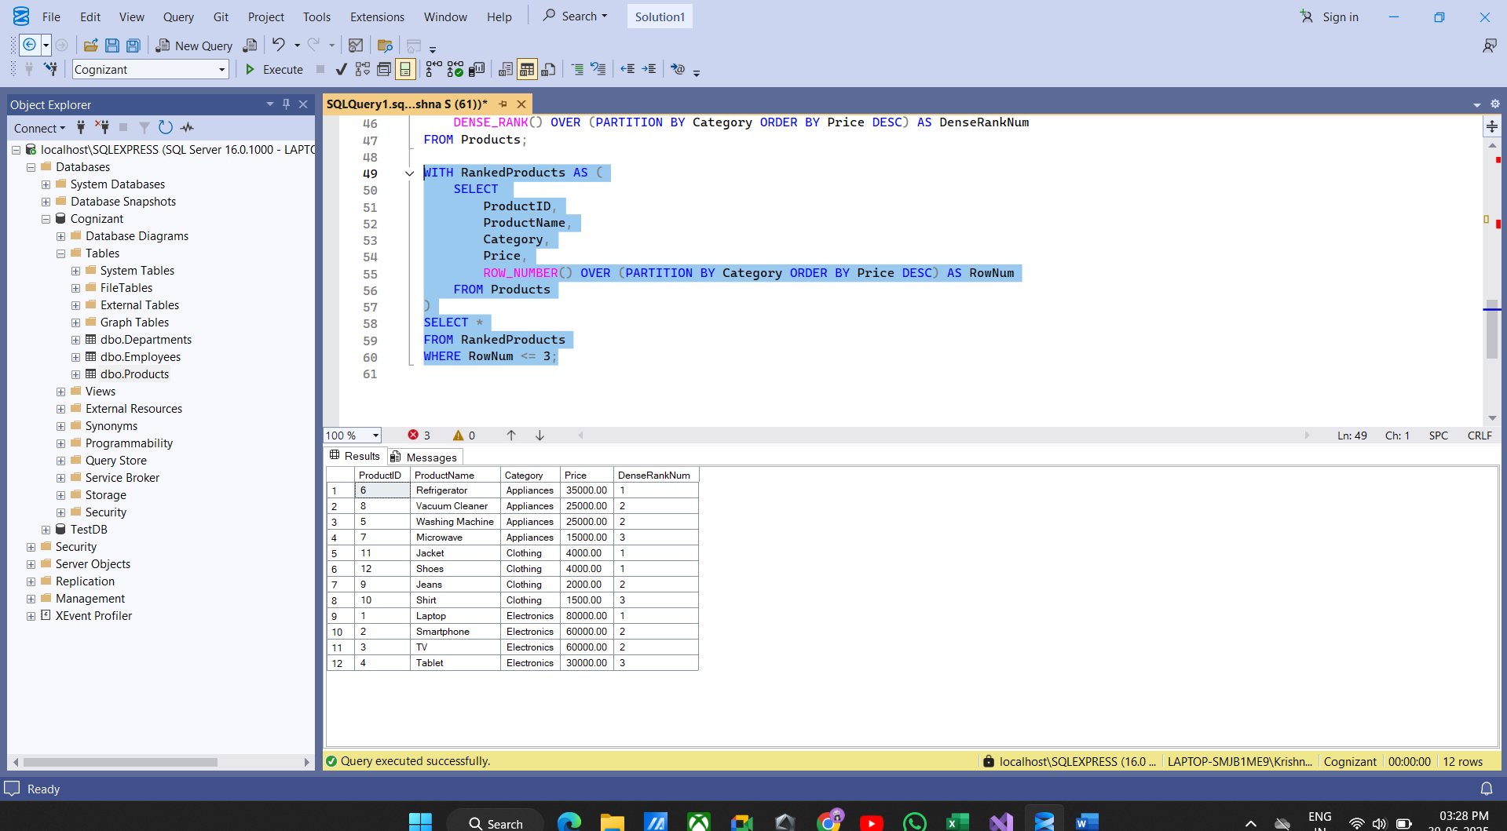

Summary

- ROW_NUMBER() always gives unique ranks, no matter if prices are tied.
- RANK() skips rank numbers when there are ties.
- DENSE_RANK() does not skip rank numbers when there are ties.
The queries return top 3 items per category based on these differences.

