🌦️ Weather Data Analysis & Power BI Dashboard
📌 Project Overview
This project focuses on analyzing historical weather data to identify weather trends, seasonal variations, and correlations between different weather attributes. Using Excel, SQL, and Power BI, the project transforms raw weather data into meaningful insights through data cleaning, analysis, and interactive visualizations.
The dashboard enables users to monitor weather conditions across multiple cities, compare historical patterns, and understand how weather parameters influence one another.

🎯 Project Objectives
- Analyze historical weather trends across multiple cities.
- Identify seasonal variations in temperature, humidity, pressure, and wind.
- Discover correlations between different weather attributes.
- Perform data cleaning and transformation using Excel and SQL.
- Develop an interactive Power BI dashboard for weather monitoring.
- Generate actionable insights from historical weather data.

🛠️ Tools & Technologies
Tool | Purpose
Excel | Data Cleaning, Formatting & Initial Analysis
SQL | Data Querying, Transformation & Analysis
Power BI | Dashboard Development & Data Visualization

📂 Dataset Description
The dataset contains hourly weather observations collected from multiple cities, including environmental parameters such as temperature, humidity, pressure, wind characteristics, and weather conditions.

📁 Dataset Files
1. City_attributes
Provides metadata for each city included in the dataset.
Column | Description
City | Name of the city
Country | Country where the city is located
Latitude | Geographical latitude
Longitude | Geographical longitude
Usage
- Map cities geographically
- Perform location-based analysis
- Create map visualizations in Power BI

2. Humidity
Contains hourly humidity readings for every city.
Column | Description
Datetime | Date & Time
City Columns | Hourly humidity values for each city
Usage
- Analyze humidity trends
- Compare seasonal humidity changes
- Study relationships with temperature and rainfall

3. Pressure
Contains hourly atmospheric pressure data.
Column | Description
Datetime | Date & Time
City Columns | Air pressure values
Usage
- Analyze pressure fluctuations
- Predict weather changes
- Compare pressure across cities

4. Temperature
Contains hourly temperature observations.
Column | Description
Datetime | Date & Time
City Columns | Temperature values for each city
Usage
- Identify heatwaves and cold spells
- Analyze seasonal temperature changes
- Compare city-wise temperature trends

5. Weather_description
Contains textual weather conditions recorded every hour.
Column | Description
Datetime | Date & Time
City Columns | Weather descriptions (e.g., Clear Sky, Rain, Clouds, Mist)
Usage
- Analyze weather condition frequency
- Categorize weather events
- Study weather distribution over time

6. Wind_direction
Contains hourly wind direction data.
Column | Description
Datetime | Date & Time
City Columns | Wind direction (Degrees)
Usage
- Study wind movement patterns
- Analyze seasonal wind direction
- Understand environmental impacts

7. Wind_speed
Contains hourly wind speed measurements.
Column | Description
Datetime | Date & Time
City Columns | Wind speed values
Usage
- Analyze wind intensity
- Detect high wind events
- Compare wind speed across cities

📊 Project Workflow
1️⃣ Data Collection
- Import weather datasets
- Verify data consistency
- Merge required files
2️⃣ Data Cleaning (Excel)
- Remove duplicates
- Handle missing values
- Correct data types
- Standardize date and time formats
3️⃣ Data Analysis (SQL)
- Perform filtering and aggregation
- Calculate monthly and yearly averages
- Identify weather trends
- Analyze correlations between weather parameters
4️⃣ Data Visualization (Power BI)
Create an interactive dashboard including:
- 🌡️ Temperature Trends
- 💧 Humidity Analysis
- 🌬️ Wind Speed & Direction
- 🌤️ Weather Condition Distribution
- 🌍 City-wise Weather Comparison
- 📅 Seasonal Analysis
- 📈 Historical Weather Trends

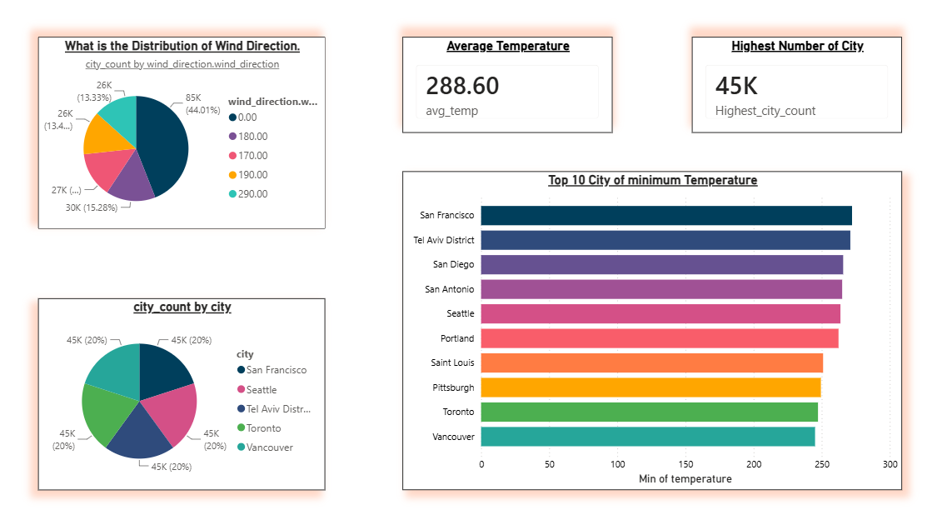
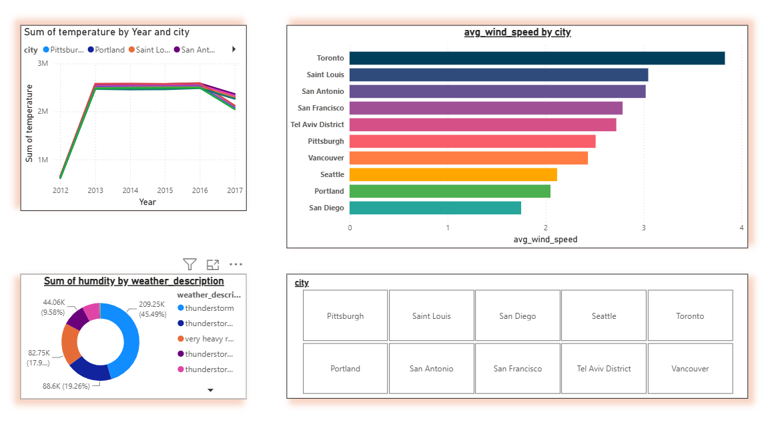
📷 Dashboard Preview

Conclusion
- This project successfully demonstrates how historical weather data can be transformed into meaningful insights using Excel, SQL, and Power BI.
- By analyzing key weather parameters such as temperature, humidity, pressure, wind speed, wind direction, and weather conditions, the project identifies seasonal patterns, weather trends, and relationships between different climate variables.
- The interactive Power BI dashboard enables users to monitor weather conditions across multiple cities, compare historical data, and explore trends through dynamic visualizations.
- SQL was used for efficient data extraction and analysis, while Excel supported data cleaning and preparation to ensure accurate results.
- Overall, this project highlights the importance of data analytics and business intelligence in weather monitoring.
- The insights generated can support informed decision-making in areas such as climate research, urban planning, agriculture, transportation, and environmental management. It also demonstrates practical skills in data cleaning, SQL querying, data modeling, visualization, and dashboard development, making it a valuable addition to any data analytics or business intelligence portfolio.

