**HASH**

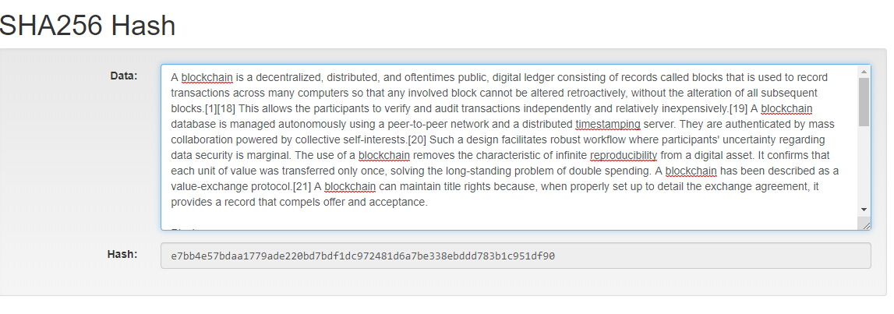

**BLOCK WITHOUT DATA**

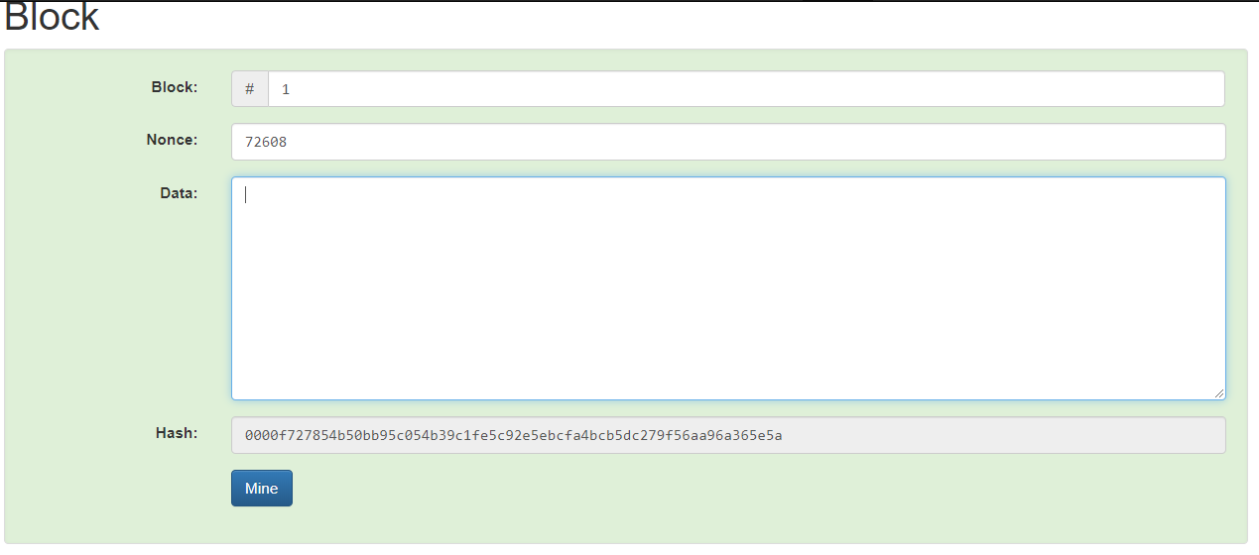

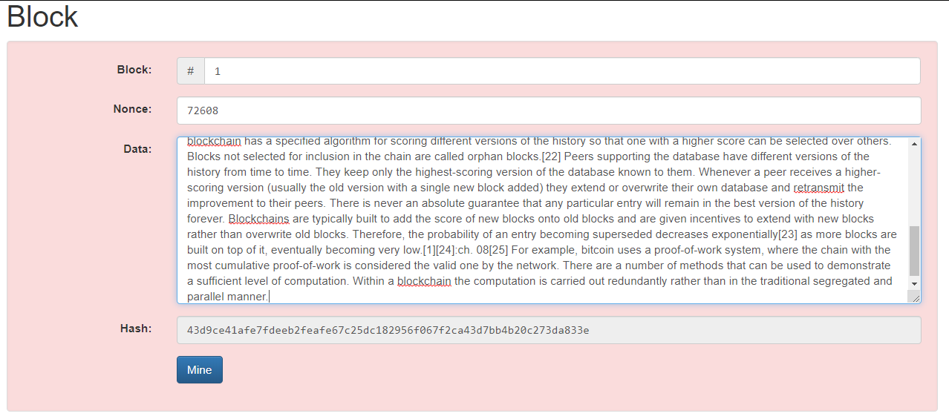**BLOCK WITH DATA**

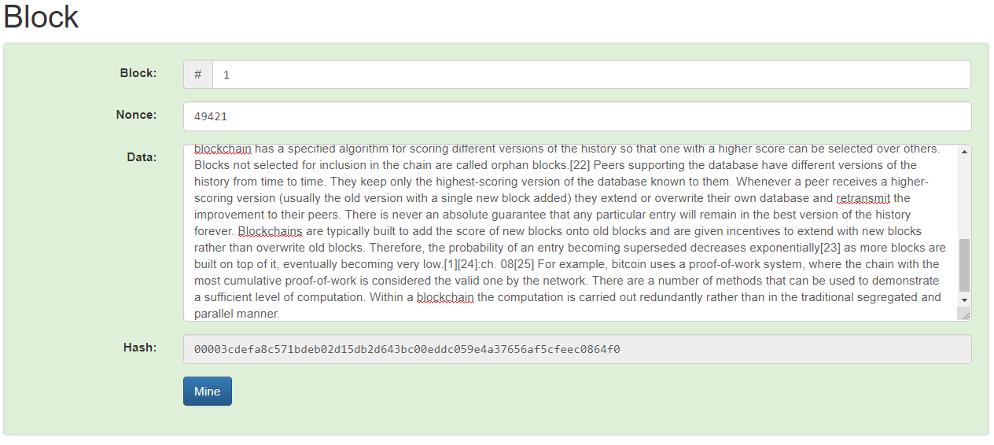**BLOCK AFTER MINNING**

**BLOCKCHAIN AFTER MINNING TWO BLOCKS**

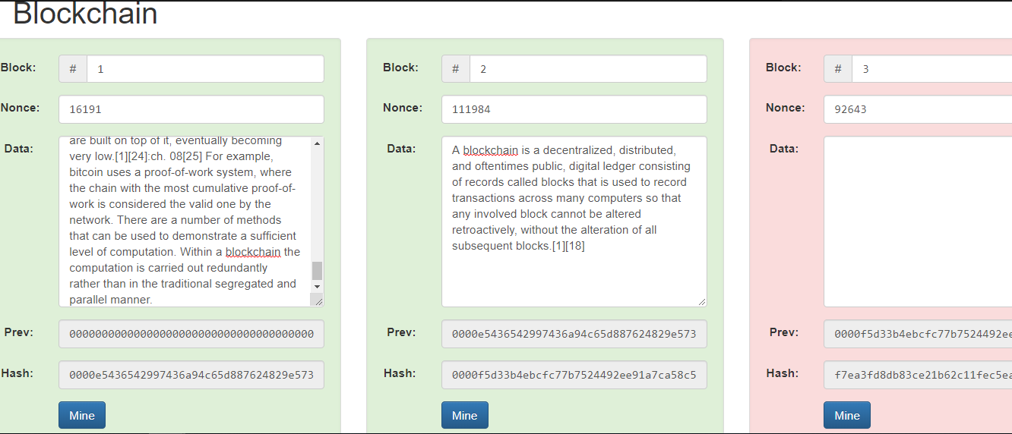

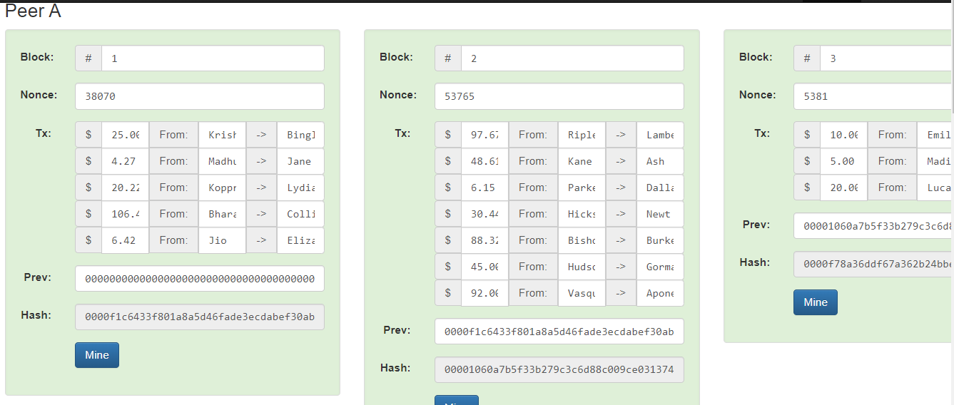**TOKENS**

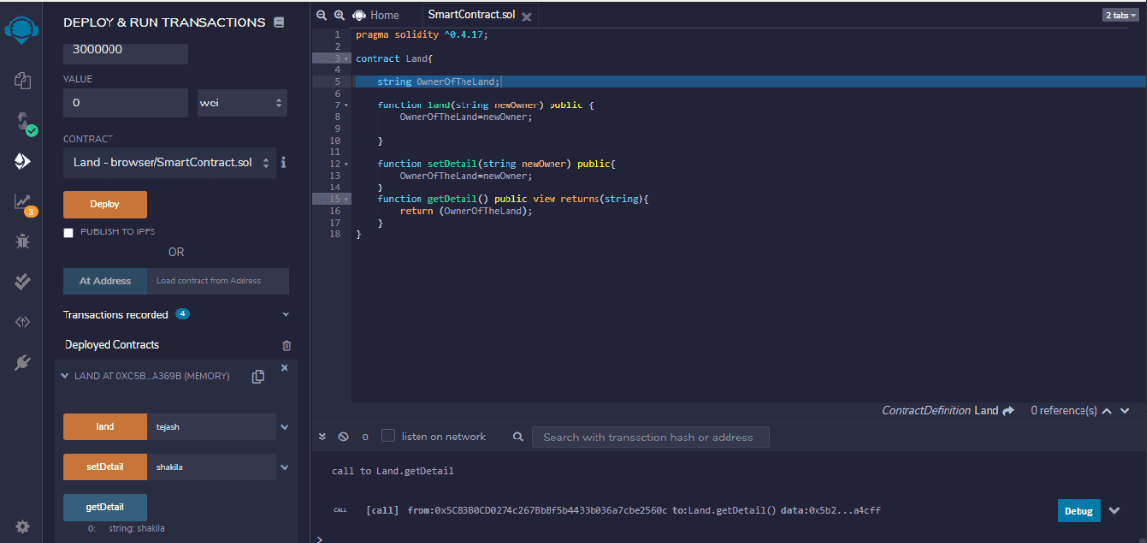**SAMPLE SMART CONTRACT**