Task 3: Docker Storage

docker run -d -p 5002:5000 --name lab2-nostorage lab2-python-app:1.0
curl.exe -s http://localhost:5002/
curl.exe -s http://localhost:5002/
curl.exe -s http://localhost:5002/
docker exec lab2-nostorage cat /data/counter.txt

docker stop lab2-nostorage
docker rm lab2-nostorage

docker run -d -p 5002:5000 --name lab2-nostorage-2 lab2-python-app:1.0
curl.exe -s http://localhost:5002/
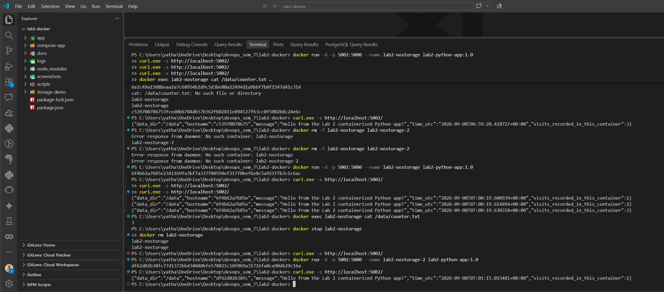

docker volume create lab2-data-volume
docker volume inspect lab2-data-volume

docker run -d -p 5004:5000 --name lab2-vol-1 -v lab2-data-volume:/data lab2-python-app:1.0
curl.exe -s http://localhost:5004/
curl.exe -s http://localhost:5004/
curl.exe -s http://localhost:5004/

docker stop lab2-vol-1
docker rm lab2-vol-1
docker volume ls --filter name=lab2-data-volume

docker run -d -p 5004:5000 --name lab2-vol-2 -v lab2-data-volume:/data lab2-python-app:1.0
curl.exe -s http://localhost:5004/
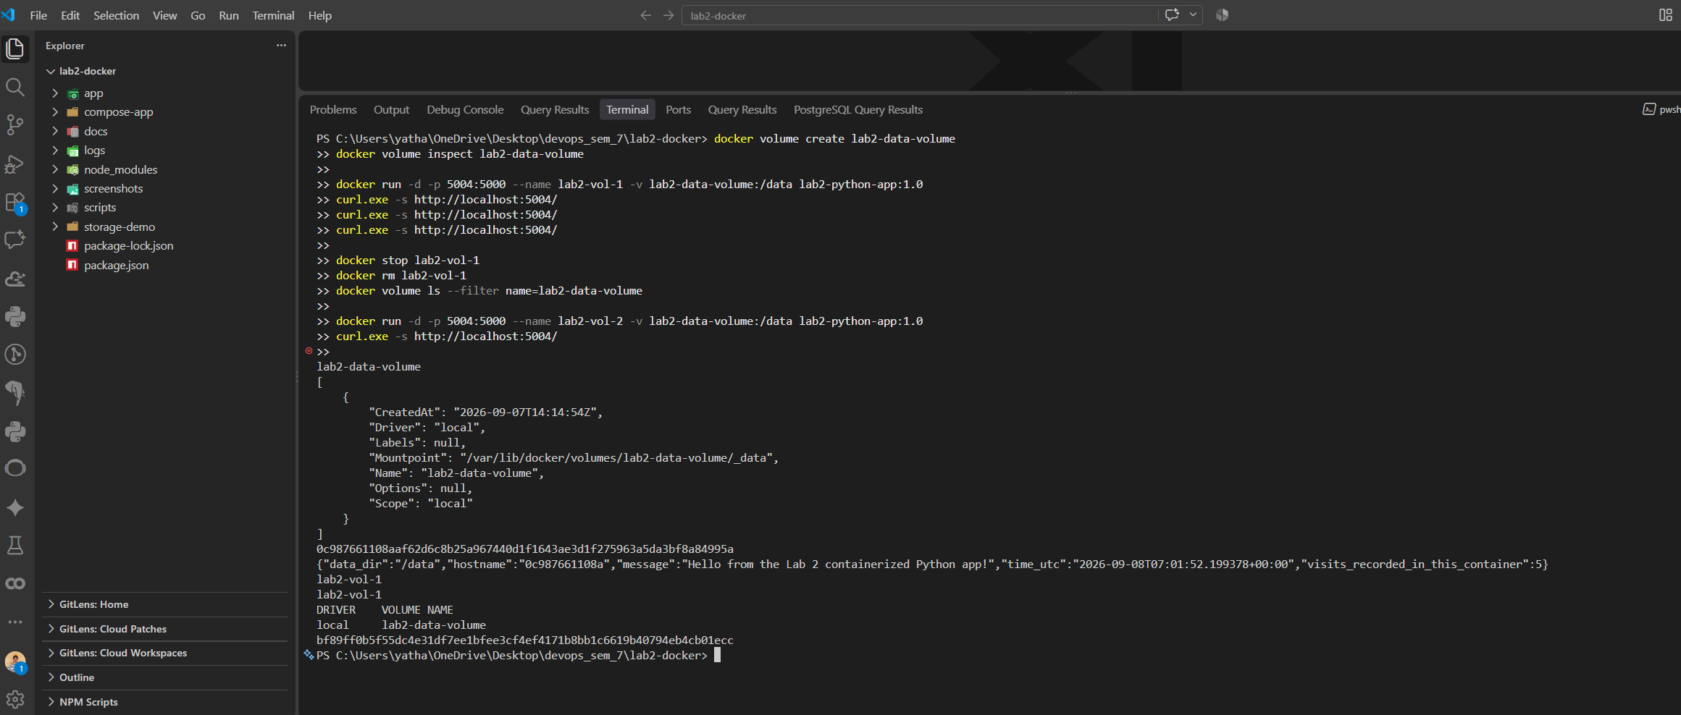
mkdir storage-demo\bind-data
docker run -d -p 5005:5000 --name lab2-bind-1 -v "${PWD}\storage-demo\bind-data:/data" lab2-python-app:1.0
curl.exe -s http://localhost:5005/
curl.exe -s http://localhost:5005/

type storage-demo\bind-data\counter.txt

docker stop lab2-bind-1
docker rm lab2-bind-1
dir storage-demo\bind-data\

docker run -d -p 5005:5000 --name lab2-bind-2 -v "${PWD}\storage-demo\bind-data:/data" lab2-python-app:1.0
curl.exe -s http://localhost:5005/
