Task 4: Docker Network

docker network create lab2-net
docker network inspect lab2-net --format "Name: {{.Name}} Driver: {{.Driver}}"

docker run -d --name lab2-net-app --network lab2-net lab2-python-app:1.0
docker run -d --name lab2-net-client --network lab2-net curlimages/curl:latest sleep 3600

docker ps --filter name=lab2-net
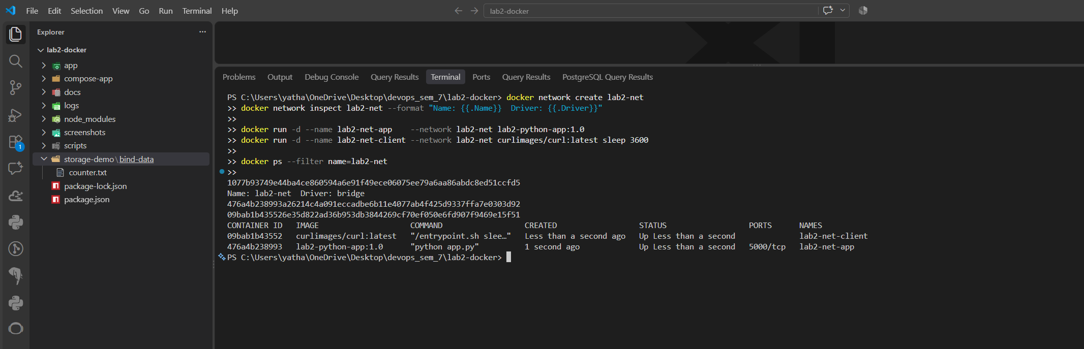
docker exec lab2-net-client curl -s http://lab2-net-app:5000/
docker exec lab2-net-client curl -s http://lab2-net-app:5000/health
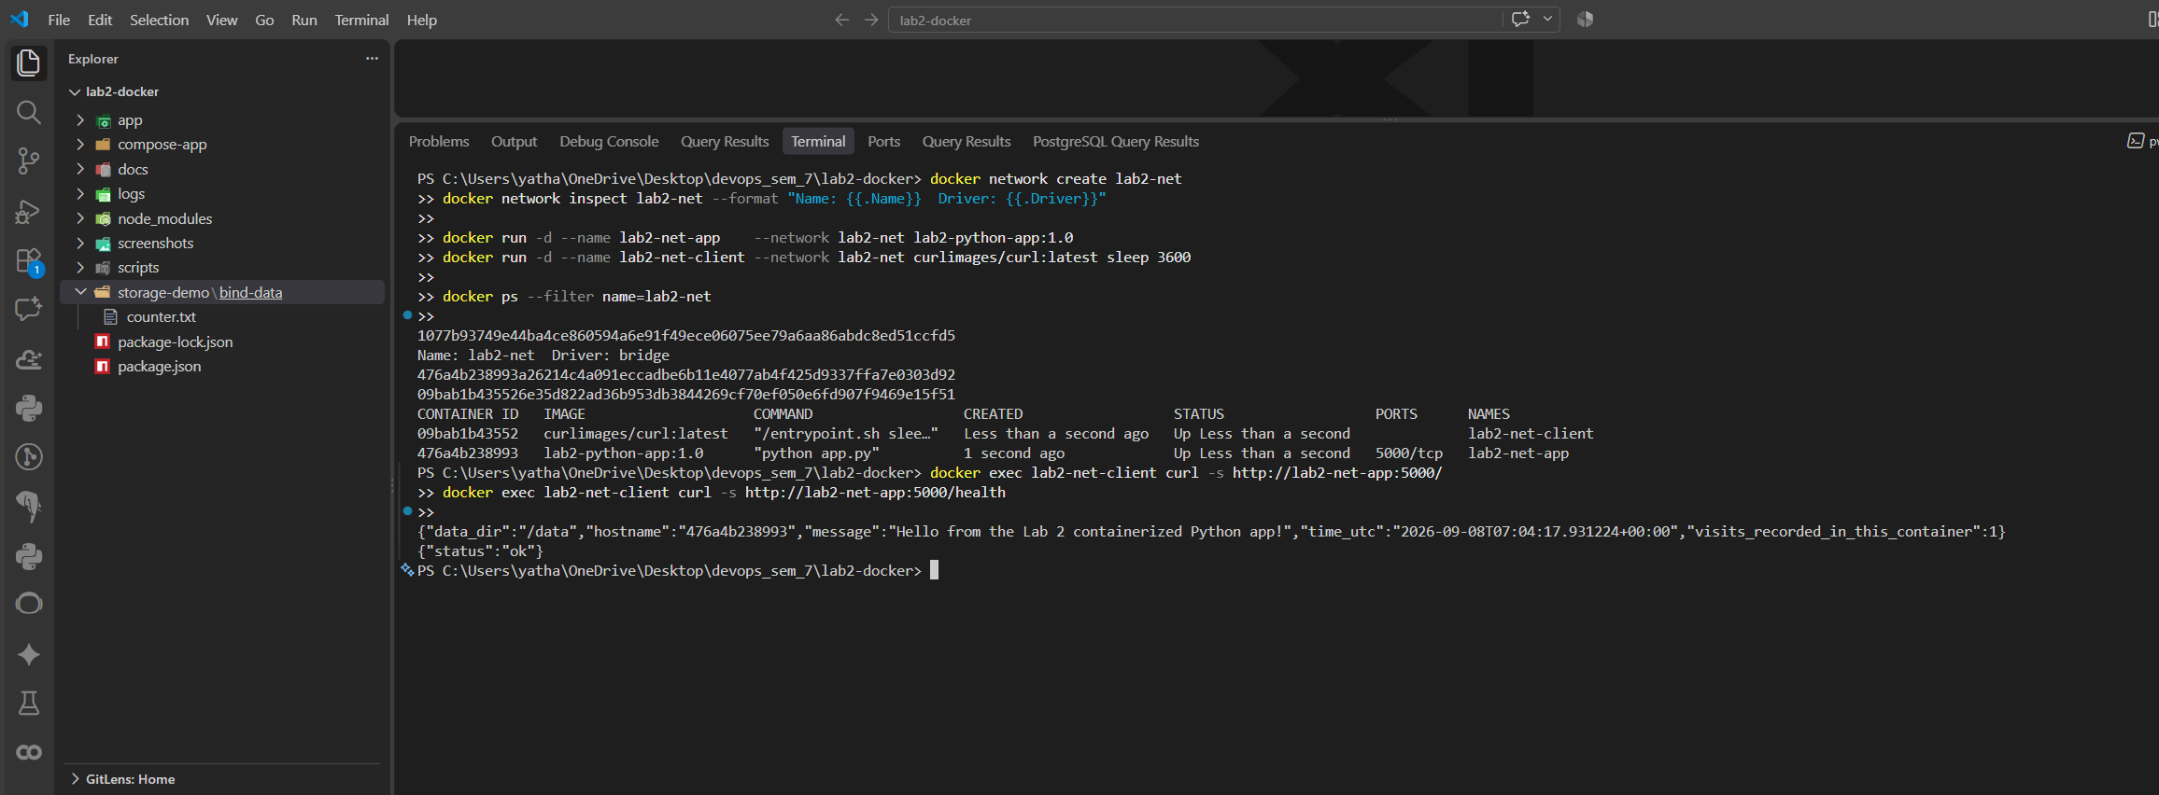
docker inspect -f '{{(index .NetworkSettings.Networks "lab2-net").IPAddress}}' lab2-net-app

docker exec lab2-net-client curl -s http://172.20.0.2:5000/
