

Analysis of the World Happiness Report:

Exploring South Asia and Middle East Perspectives

Name: Krishna Kumar Mandal
University ID: 2508742
College ID: np02cs4a240074
Group: L5CG2
Date Submitted: 2025/ 11 / 07

Introduction

The World Happiness Report (WHR) shows an important international statistical effort, moving the focus of policy evaluation beyond purely economic measures like GDP to include comprehensive assessments of well-being and life satisfaction. The report, drawing on extensive global survey data from the Gallup World Poll, provides governments, academics, and international organizations with a robust framework for identifying which factors—social, economic, and environmental are most critical in fostering human flourishing (WHR, 2024). The WHR explains happiness scores using six key variables: Log GDP per Capita, Social Support, Healthy Life Expectancy, Freedom to Make Life Choices, Generosity, and Perceptions of Corruption.
The main point of this report is to look closely at the data and compare different areas. The study is structured across three main problems: data preparation, focused analysis on South Asia, and a comparative analysis between the high-wealth Middle East and the economically diverse South Asia region.

The study has three main parts:
- Getting the data ready.
- Analyzing South Asia closely.
- Comparing the rich Middle East with South Asia (which has different economies).

The final goal is to create useful regional ideas. We will explain why the average happiness scores are different and give proof on which things give the best results when investing in well-being in each area.

2. Report Section: Problem 1 - Global Data Exploration and Preparation

2.1 Descriptive Statistics and Data Structure

The first look at the data showed 143 items. The first summary numbers showed the average world Happiness Score was 5.538 and the average Log GDP per Person was 1.399.

2.2 Data Pre-processing and Categorization
Missing Values

The analysis confirmed that 3 rows (Bahrain, Kuwait, and Sudan) had missing factor data.

Happiness Categorization
A new column, "Happiness Category," was created using numpy.select() to sort scores (Low: under 4, Medium: 4-6, High: over 6).
Observation:
Most of the world's distribution falls into the Medium (around 48.95) and High (around 39.16) categories.

3. Report Section: Problem 2 - Focused Analysis: South Asia
This part focused on how the South Asia region works inside.

3.1 Composite Score Analysis and Alignment with Original Score
A New Score was figured out (40 from GDP + 0.30 from Social Support + 0.30 from Health). This was done to check if the ranking was similar to the first score.

Discussion on Alignment:
The rankings from the New Score are not the same as the original Happiness Score.
Because Log GDP per Person was weighted at 40%:
- India's rank rose a lot (from 3rd to 2nd).
- Pakistan's rank fell (from 2nd to 3rd).
This shows that valuing money greatly changes the ranking. It stresses that India's economic base is better than its overall reported happiness position implies (Insert Figure 3.1: Scatter plot comparing Composite Score vs. Original Score for South Asia here)

3.2 Outlier Characteristics and Impact
Using the 1.5 x IQR rule, Afghanistan was officially named the only outlier in South Asia for both the Score (1.721) and Log GDP per Person (0.628).

Discussion on Characteristics and Impact:
Afghanistan's very low position is because of its unique crisis (humanitarian and conflict), which puts it far away from other countries in the region. This outlier strongly changes the regional numbers:
Regional Averages:
Afghanistan makes the South Asia average go way down (from about 4.44 to 3.895).

Variability:

It makes the region's spread (CV) look bigger (CV = 0.338). This makes South Asia look less alike and more divided than it really is without this one crisis point.

3.3 Correlation Analysis
The Pearson correlation (r) showed that Generosity (r = 0.877) is the strongest link to happiness in the region that is not related to money.

4. Report Section: Problem 3 - Comparative Analysis: South Asia vs. Middle East
This part looks at why the well-being is different between the two regions.

Interpretation:
The Middle East keeps a higher average score. Meanwhile, South Asia's higher CV confirms its scores are less alike (or less uniform), which is greatly affected by the Afghanistan outlier.
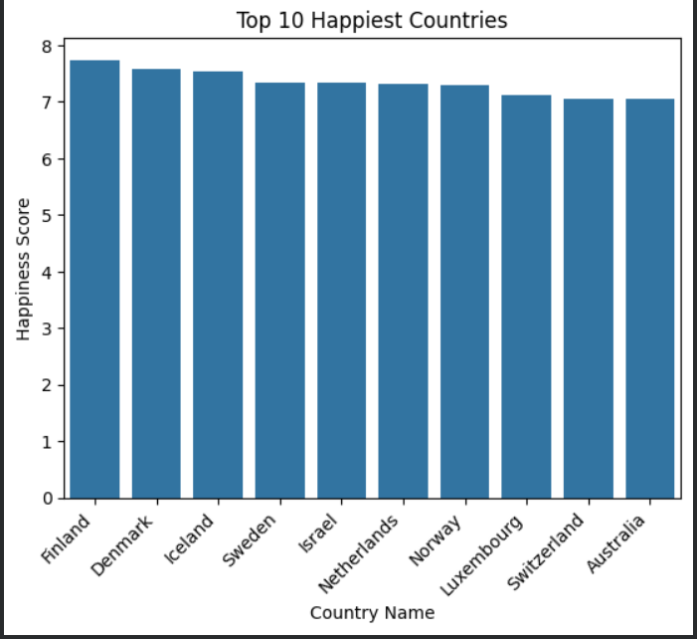
Fig: 4.1

4.2 Key Factor Disparities
The biggest differences in the average factor scores were found in money and social measures.

Interpretation: The Middle East's higher happiness mostly comes from its stronger Social Support (which is more than double South Asia's) and its greater wealth (GDP).

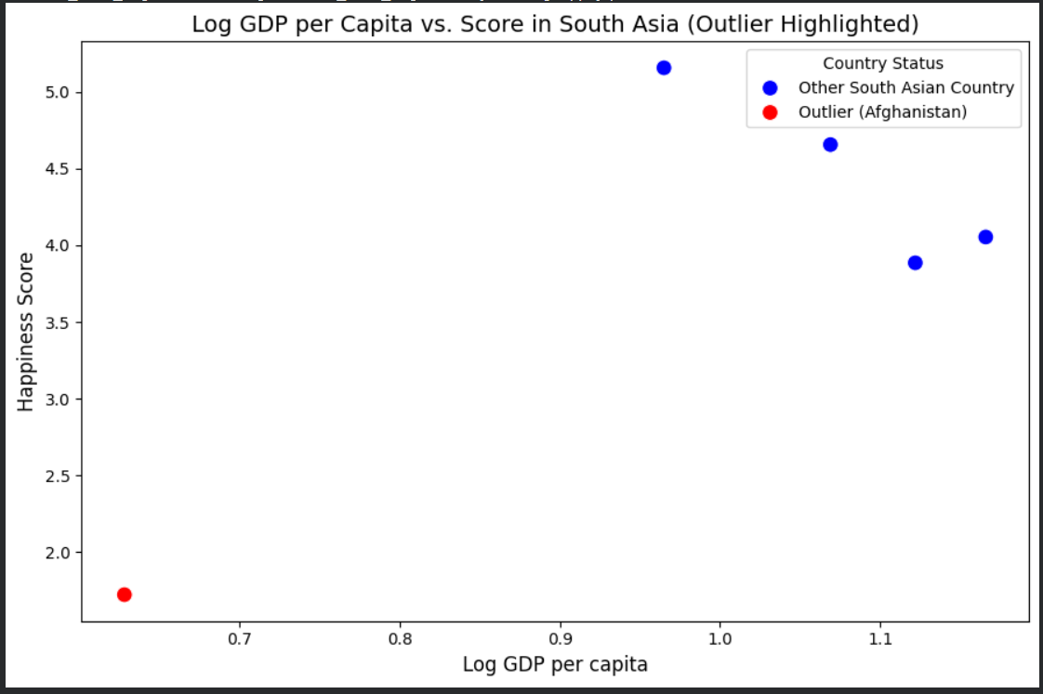
Fig: 4.2

4.3 Cross-Regional Correlation Analysis
The main things that make people happy (which are not about money) are different (Table 4.3).
Interpretation: In South Asia, Generosity shows that social closeness is important for well-being.
In the Middle East, Freedom to Make Life Choices is the most important non-economic factor. This suggests that personal control is key once people have their basic needs covered.
(Insert Figure 4.3: Comparative scatter plots of Score vs. Freedom and Score vs. Generosity by Region here)

4.4 Outlier Visualization
The visual analysis of Score versus GDP per Person proves that Afghanistan is an outlier, sitting alone in the bottom-left of the graph.
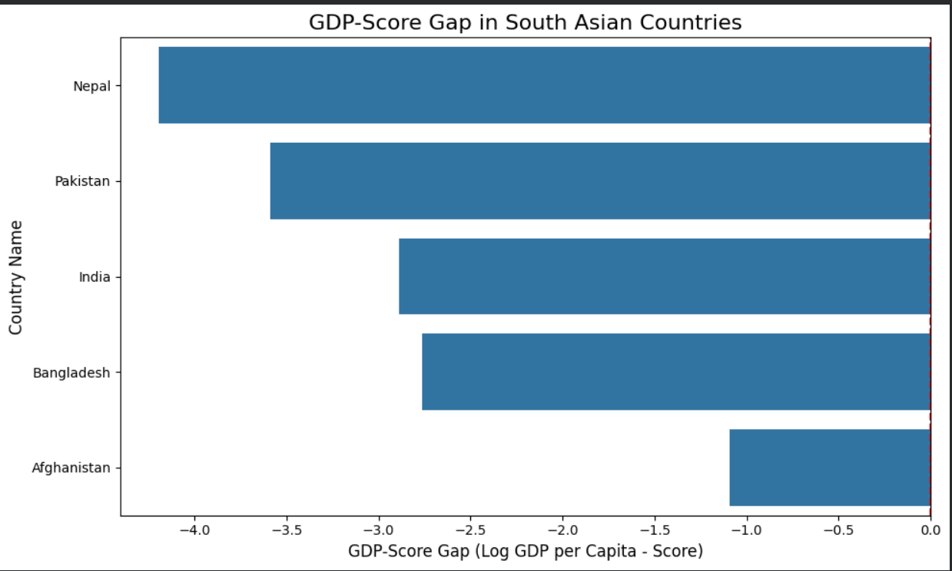
Fig: 4.3

5. Conclusion

5.1 Summary of Findings
The full study confirms that the Middle East has a higher average happiness score. This is driven by better scores in Log GDP per Person and Social Support. South Asia, while lower in rank, shows strength through Generosity (its strongest non-money-related factor).
The analysis showed Afghanistan is an extreme outlier that makes South Asia's numbers look more divided than they are.

5.2 Significance and Implications
The study shows that good happiness plans must fit the specific place.
- For South Asia, improving social support and community strength gives the best potential gain in happiness.
- For the Middle East, they need to keep focusing on personal freedoms along with high wealth.
Finally, the study proves that extreme outliers like Afghanistan must be noted or taken out of comparisons to keep the numbers honest and show a true picture of the region's well-being.

6. References
Helliwell, J. F., Layard, R., Sachs, J. D., De Neve, J. -E., Aknin, L. B., & Wang, S. (Eds.). (2024). World Happiness Report 2024. University of Oxford: Wellbeing Research Centre. Available at: https://www.worldhappiness.report/ed/2024/

