AI-BASED LOAD BALANCING IN COMPUTER NETWORKS
Implementation and Comparative Performance Evaluation
Institution: [Institution name]
Department: [Department name]
Student/team: [Student or team name]
Faculty guide: [Supervisor name]
Academic year: [Academic year]

Certificate
Insert the institution-approved certificate wording and signatures here. No approval or signature is asserted by this project file.

Declaration
Insert the institution-approved declaration here. Student names and signatures must be completed using the official template.

Acknowledgements
[Optional acknowledgement text.]

Abstract
This project implements and evaluates a Layer-7 HTTP load balancer comparing Round Robin, Least Connections, and a supervised Random Forest latency-routing policy. The FastAPI, PostgreSQL, Docker Compose, worker, React, and experiment components form a reproducible local testbed. A 36-run matrix evaluated three repetitions across uniform, heterogeneous, bursty, and mixed workloads. All valid runs completed with zero request errors, but AI routing was slower and lower-throughput than both baselines in all profiles. Dedicated failure tests verified exclusion, error mapping, model fallback, stale-telemetry handling, and recovery. The contribution is an auditable empirical evaluation, not a universal claim that AI improves load balancing.

Table of Contents
Update this field in Microsoft Word: References > Table of Contents. Heading styles are applied throughout this report.

1. Introduction
Modern services distribute HTTP requests across workers to improve availability, latency, and resource utilization. This project asks whether telemetry-driven prediction justifies its additional cost.

2. Problem Statement, Objectives, and Scope
The system must route only to registered workers, preserve request correlation, tolerate failures, persist evidence, and compare policies under identical workloads. Scope is a local Layer-7 testbed with simulated worker delays; Layer 3/4 routing, SDN, and production-scale claims are future work.

3. Literature Review and Research Gap
Conventional Round Robin and least-connected methods are strong baselines. The project uses the sources listed in the reference section and in docs/12-research-and-sources.md. The modest contribution is a student-scale reproducible testbed that records telemetry, model versions, raw samples, fallback reasons, and policy comparisons.

4. Requirements and System Architecture
The deployment contains a React/nginx frontend, FastAPI control plane, PostgreSQL, and three configurable workers. The API performs health filtering, HTTPX proxying, routing, persistence, and experiment orchestration.
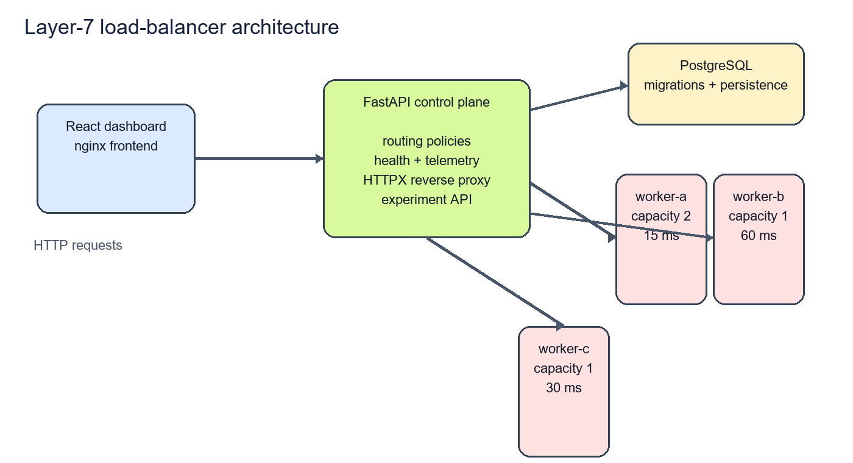
Figure 1. System architecture illustration generated from the implemented Compose topology.

5. Database Design and Implementation
SQLAlchemy models and Alembic migrations persist BackendNode, TelemetrySample, RoutingDecision, ModelVersion, ExperimentRun, ExperimentMetric, and raw experiment observations. Admin operations use a configured token; arbitrary client-supplied upstream URLs are not accepted.

6. Machine-Learning Methodology
A RandomForestRegressor predicts upstream latency from CPU percentage, memory percentage, active requests, latency EWMA, network RTT, error rate, capacity weight, and request class. A fixed feature schema and model version are stored. Training uses successful calibration decisions with a chronological 80/20 split; evaluation outcomes were not used for tuning.
Profile | MAE ms | RMSE ms
uniform | 165.279 | 198.315
heterogeneous | 174.701 | 206.411
bursty | 124.507 | 161.801
mixed | 176.897 | 206.991

7. Experimental Methodology
The normal matrix was 3 policies × 4 profiles × 3 repetitions = 36 runs. Each used a 5-second warm-up, 30-second measurement interval, concurrency 4, fixed repetition seeds, identical worker configuration, and a benchmark-safe telemetry freshness window. Percentiles use client-observed latency; throughput uses the measurement duration; error rate uses all requests.

8. Results and Analysis
Profile | Policy | P50 | P95 | P99 | Throughput/s | Error
uniform | Round Robin | 66.349 | 101.793 | 121.655 | 57.778 | 0
uniform | Least Connections | 58.216 | 113.226 | 127.259 | 61.156 | 0
uniform | AI latency | 292.014 | 628.114 | 864.003 | 11.322 | 0
heterogeneous | Round Robin | 66.059 | 208.071 | 230.158 | 49.589 | 0
heterogeneous | Least Connections | 60.490 | 145.489 | 230.958 | 56.356 | 0
heterogeneous | AI latency | 316.042 | 661.133 | 813.602 | 11.333 | 0
bursty | Round Robin | 68.280 | 112.783 | 137.384 | 39.911 | 0
bursty | Least Connections | 60.040 | 115.255 | 134.403 | 42.311 | 0
bursty | AI latency | 328.262 | 583.311 | 712.816 | 9.611 | 0
mixed | Round Robin | 66.756 | 207.806 | 231.465 | 50.000 | 0
mixed | Least Connections | 61.022 | 135.841 | 229.689 | 56.844 | 0
mixed | AI latency | 317.892 | 616.824 | 739.085 | 11.222 | 0

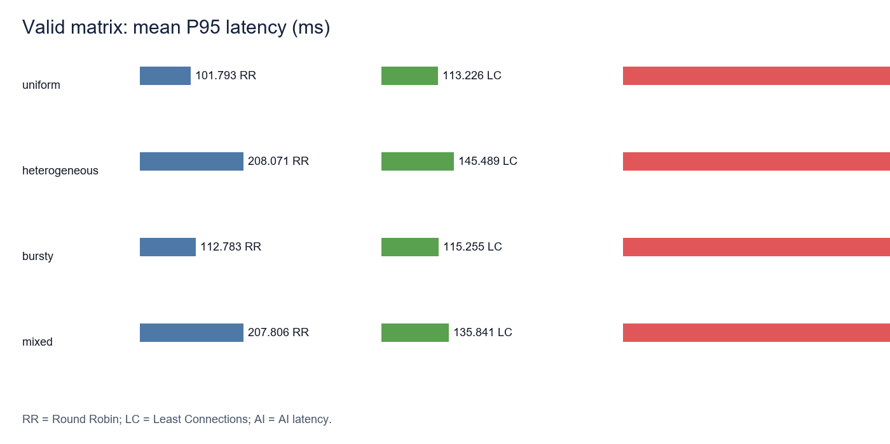
Figure 2. Mean P95 latency from the valid 36-run matrix.
AI was slower and lower-throughput in all profiles. Mean client latency was approximately 75.498 ms for Round Robin, 68.545 ms for Least Connections, and 359.527 ms for AI. The measured AI inference p50 was approximately 52.041 ms. The implementation also performs telemetry queries and predictor loading/validation in the request path. These observations support an overhead contribution, but do not isolate every causal component.

9. Failure-Mode Evaluation
Scenario | Repetitions | Observed result
Backend disabled | 3 | 10/10 requests succeeded; disabled worker excluded; recovery passed
Worker HTTP 503 | 3 | 8 successes and 4 API 502 responses per 12-request repetition
Slow worker timeout | 3 | 4 successes and 2 API 502 responses per 6-request repetition
Missing model | 3 | 5/5 succeeded through AI fallback per repetition
Stale telemetry | 3 | 503 NO_HEALTHY_BACKENDS; health refresh restored service

10. Security, Reliability, and Limitations
Admin endpoints require a configured token, registered backends prevent open-proxy behaviour, and request bodies/personal data are not stored. Limitations are local Docker execution, simulated delays, one artifact, one concurrency level, three repetitions, and no statistical significance claim. Earlier stale-telemetry batches remain preserved but excluded from normal comparisons.

11. Conclusion and Future Work
The project completed its implementation and controlled evaluation objectives. The tested AI policy did not outperform either conventional baseline. Future work should first benchmark separately versioned predictor and telemetry caching, then evaluate more concurrency levels, independent calibration data, drift detection, and a Mininet/SDN extension.

References
- G. Liu et al., “Traffic load balancing in data center networks: A comprehensive survey,” Computer Science Review, vol. 57, 2025, DOI: 10.1016/j.cosrev.2025.100749.
- D. W. D. Wu et al., “Reinforcement learning for communication load balancing: approaches and challenges,” Frontiers in Computer Science, 2023, DOI: 10.3389/fcomp.2023.1156064.
- NGINX, “Using nginx as HTTP load balancer,” nginx.org documentation.
- scikit-learn User Guide, scikit-learn.org.
- FastAPI Tutorial, fastapi.tiangolo.com.
- Docker Compose documentation, docs.docker.com.
- Project methodology and source notes, docs/12-research-and-sources.md.

Appendix A. Reproduction Commands
Copy-Item .env.example .env
# Set local ADMIN_TOKEN and POSTGRES_PASSWORD
docker compose -f deployment\docker-compose.yml up --build
$env:PYTHONPATH=(Resolve-Path .\backend).Path
python -m app.experiment_cli --matrix --duration 30 --warmup 5 --concurrency 4 --repetitions 3 --wait 2
python -m pytest -q .\backend\tests
npm --prefix .\frontend run build

Appendix B. Institutional Placeholders
Complete institution, department, student, supervisor, academic-year, certificate, declaration, signature, formatting, and page-limit requirements using the official institutional template.

