**Madras Institute of Technology, Anna University**

**Department of Computer Technology**

**Project Title**: Crop Recommendation System using Machine Learning Techniques.

**Domain**: Machine Learning, Image Processing.

**Project Members**:

1. S. Krishna Prasad **2.** B. Siva Sreedharan **3.** S. Jaishanth

**Guide:** Dr. P. Varalakshmi

**Introduction:**

This document proposes a crop recommendation system using Deep Learning and Support Vector Machine (SVM).The farmer provides the crop field image as an input to the application. In the pre-processing stage, Denoising is done and as a result, filtering the image retaining it’s necessary portions. The segmentation stage uses a 2 stage algorithms containing Simple Linear Iterative Clustering (SLIC) followed by Nystrom based spectral clustering. SVM prefixed by Spatial Spectral Schrodinger Eigen Maps (SSSE) is used as a classification method. The classified image along with the Ground truth statistical data is used to recommend the suitable crop for each crop field using collaborative filtering.

**Project objective:**

* Collect satellite images for agricultural crop monitoring.
* Classify the image based on Soil type, moisture content, weather conditions, pH value, organic nitrogen etc.
* Perform satellite image processing with respect to textural and spatial features.
* Analyse crop patterns with the help of past records and map them with calculated data.
* Monitor crop yield and find ways for increasing it.
* Recommend profitable crops for each land type.

**Literature Survey:**

Xiang Xu et.al. (2016) present a new technique based on multiple morphological component analysis (MMCA) that exploits multiple textural features for decomposition of remote sensing images. The proposed MMCA framework separates a given image into multiple pairs of morphological components (MCs) based on different textural features, with the ultimate goal of improving the signal-to-noise level and the data separability. A distinguishing feature of the proposed approach is the possibility to retrieve detailed image texture information, rather than using a single spatial characteristic of the texture. In this paper, four textural features: content, coarseness, contrast, and directionality (including horizontal and vertical), are considered for generating the MCs.

X.D. Bai et.al. (2014) presents an efficient two-stage image segmentation method which takes advantage of modified SLIC segmentation and Nyström based spectral clustering. With the modified SLIC approach utilized in the first stage, Nyström based spectral clustering method is used to cluster the segmented regions instead of the pixels in the image to bring the final result. Therefore, the memory requirement and the computational complexity are significantly reduced. To verify the proposed algorithm, it is applied to images of different characters and compared with six other famous image segmentation approaches.

Nathan D. Cahill et.al. (2015) presents we an extended LE- and SE-based spatial-spectral dimensionality reduction algorithms to situations where partial knowledge of class labels exists, for example, when a subset of pixels has been manually labeled by an expert user. This partial knowledge is incorporated through the use of cluster potentials, turning each underlying algorithm into an instance of SE. Using publicly available data, it is shown that incorporating this partial knowledge improves the performance of subsequent classiﬁcation algorithms.

Monali Paul et.al.(2016) analysis the Soil Behaviour and Prediction of Crop Yield using Data Mining Approach.Yield prediction is very popular among farmers these days, which particularly contributes to the proper selection of crops for sowing. This makes the problem of predicting the yielding of crops an interesting challenge. Earlier yield prediction was performed by considering the farmer's experience on a particular field and crop. This work presents a system, which uses data mining techniques in order to predict the category of the analyzed soil datasets. The category, thus predicted will indicate the yielding of crops. The problem of predicting the crop yield is formalized as a classification rule, where Naive Bayes and K-Nearest Neighbor methods are used.

**Architecture:**

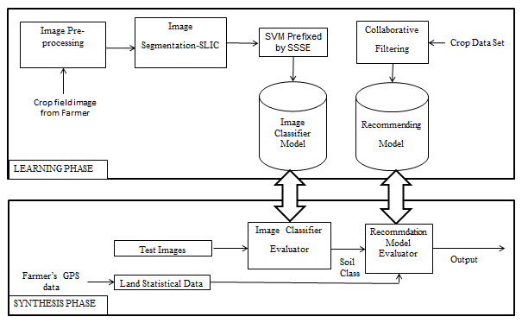

**Intended Output:**

Suitable crops for the field image uploaded by the farmer.

Crop Monitoring suggestions to address problems in crop yield.