**OUTPUT: (Server & Client)**

C:\ex>java Server

Server Waiting for image

Client connected.

Image Size: 67KB

C:\ex>java Client

Client is running.

Reading image from disk.

Sending image to server.

Image sent to server.

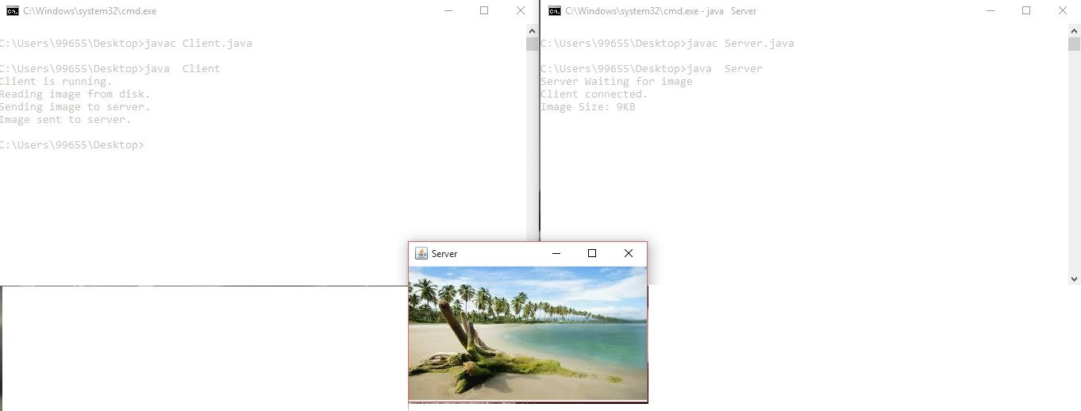

**Result:**

**OUTPUT:**

Server

Y:\networks\remote>javaServerrpc

Client

Y:\networks\remote>javaClientrpc

Enter String

Calc

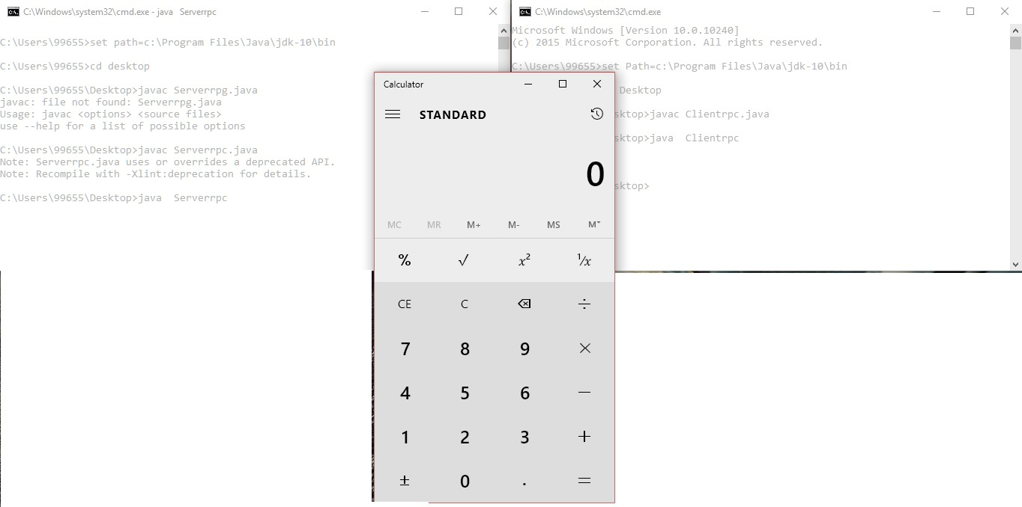

**Result:**