|  |  |
| --- | --- |
| **Ex.No:** | **Write a code simulatingARP/RARPprotocols.** |
| **Date:** |
|  | |

**Program: (Serverarp)**

import java.io.*;

import java.net.*;

importjava.util.*;

classServerarp

{

public static void main(String args[])

{try{

ServerSocketobj=new ServerSocket(139);

Socket obj1=obj.accept();

while(true){

DataInputStream din=new DataInputStream(obj1.getInputStream());

DataOutputStreamdout=new DataOutputStream(obj1.getOutputStream());

String str=din.readLine();

String ip[]={"165.165.80.80","165.165.79.1"};

String mac[]={"6A:08:AA:C2","8A:BC:E3:FA"};

for(int i=0;i<ip.length;i++)

{if(str.equals(ip[i]))

{

dout.writeBytes(mac[i]+'\n');

break;

}}

obj.close();

}}

catch(Exception e)

{

System.out.println(e);

}}}

**Program: (Clientarp)**

import java.io.*;

import java.net.*;

importjava.util.*;

classClientarp

{

public static void main(String args[])

{try{

BufferedReader in=new BufferedReader(new InputStreamReader(System.in));

Socket clsct=new Socket("127.0.0.1",139);

DataInputStream din=new DataInputStream(clsct.getInputStream());

DataOutputStreamdout=new DataOutputStream(clsct.getOutputStream());

System.out.println("Enter the Logical address(IP):");

String str1=in.readLine();

dout.writeBytes(str1+'\n');

String str=din.readLine();

System.out.println("The Physical Address is: "+str);

clsct.close();

}catch (Exception e){

System.out.println(e);

}}}

**Program: (Serverrarp)**

import java.io.*;

import java.net.*;

importjava.util.*;

class Serverrarp12

{

public static void main(String args[])

{try{

DatagramSocket server=new DatagramSocket(1309);

while(true){

byte[] sendbyte=new byte[1024];

byte[] receivebyte=new byte[1024];

DatagramPacket receiver=new

DatagramPacket(receivebyte,receivebyte.length);

server.receive(receiver);

String str=new String(receiver.getData());

String s=str.trim();

System.out.println(s);

InetAddressaddr=receiver.getAddress();

int port=receiver.getPort();

String ip[]={"165.165.80.80","165.165.79.1"};

String mac[]={"6A:08:AA:C2","8A:BC:E3:FA"};

for(int i=0;i<ip.length;i++)

{if(s.equals(mac[i])){

sendbyte=ip[i].getBytes();

DatagramPacket sender=new

DatagramPacket(sendbyte,sendbyte.length,addr,port);

server.send(sender);

break;

}}

break;

}}

catch(Exception e)

{

System.out.println(e);

}}}

**Program: (Clientrarp)**

import java.io.*;

import java.net.*;

importjava.util.*;

class Clientrarp12

{

public static void main(String args[])

{try{

DatagramSocket client=new DatagramSocket();

InetAddressaddr=InetAddress.getByName("127.0.0.1");

byte[] sendbyte=new byte[1024];

byte[] receivebyte=new byte[1024];

BufferedReader in=new BufferedReader(new InputStreamReader(System.in));

System.out.println("Enter the Physical address (MAC):");

String str=in.readLine();

sendbyte=str.getBytes();

DatagramPacket sender=new

DatagramPacket(sendbyte,sendbyte.length,addr,1309);

client.send(sender);

DatagramPacket receiver=new DatagramPacket(receivebyte,receivebyte.length);

client.receive(receiver);

String s=new String(receiver.getData());

System.out.println("The Logical Address is(IP): "+s.trim());

client.close();

}

catch(Exception e){

System.out.println(e);

}}}

**Output: (ARP)**

E:\networks>javaServerap E:\networks>javaClientap EntertheLogicaladdress(I):

165.165.80.80

ThePhysical Address is:6A:08:AA:C2

**Output: (RARP)**

I:\ex>javaServerrarp12

I:\ex>javaClientrarp12

Enter thePhysical address (MAC):

6A:08:AA:C2

TheLogical Address is(IP): 165.165.80.80

**Result:**

|  |  |
| --- | --- |
| **Ex.no:** | **Write a code simulating PING and TRACEROUTE commands** |
| **Date:** |

**Program: (pingserver)**

//pingserver.java

import java.io.*;

import java.net.*;

import java.util.*;

import java.text.*;

classpingserver

{

public static void main(String args[])throws Exception{

ServerSocketss=new ServerSocket(5555);

Socket s=ss.accept();

int c=0;

while(c<4)

{

DataInputStream dis=new DataInputStream(s.getInputStream());

PrintStream out=new PrintStream(s.getOutputStream());

String str=dis.readLine();

out.println("Reply from"+InetAddress.getLocalHost()+";

Length"+str.length());

c++;}

s.close();

}}

**Program: (pingclient)**

import java.io.*;

import java.net.*;

import java.util.Calendar;

class pingclient

{

public static void main(String args[])throws Exception

{

String str; int c=0; long t1,t2;

Socket s=new Socket("127.0.0.1",5555);

DataInputStream dis=new DataInputStream(s.getInputStream());

PrintStream out=new PrintStream(s.getOutputStream());

while(c<4)

{

t1=System.currentTimeMillis();

str="Welcome to network programming world";

out.println(str);

System.out.println(dis.readLine());

t2=System.currentTimeMillis();

System.out.println(";TTL="+(t2-t1)+"ms");

c++;}

s.close();

}}

**Output : (ping)**

I:\ex>java pingserver

I:\ex>java pingclient

Reply fromDESKTOP-SM00JT9/127.0.0.1;Length36;

TTL=47ms

Reply fromDESKTOP-SM00JT9/127.0.0.1;Length36;

TTL=0ms

Reply fromDESKTOP-SM00JT9/127.0.0.1;Length36;

TTL=0ms

Reply fromDESKTOP-SM00JT9/127.0.0.1;Length36;

TTL=0ms

**Result:**

|  |  |
| --- | --- |
| **Ex.no:** | **Create a socket for HTTPforweb page uploadand download** |
| **Date:** |

**Program: (Server)**

import java.net.*;

import java.io.*;

import java.awt.image.*;

import javax.imageio.*;

import javax.swing.*;

class Server {

public static void main(String args[]) throws Exception{

ServerSocket server=null;

Socket socket;

server=new ServerSocket(4000);

System.out.println("Server Waiting for image");

socket=server.accept();

System.out.println("Client connected.");

InputStream in = socket.getInputStream();

DataInputStream dis = new DataInputStream(in);

intlen = dis.readInt();

System.out.println("Image Size: " + len/1024 + "KB");

byte[] data = new byte[len]; dis.readFully(data);

dis.close();

in.close();

InputStreamian = new ByteArrayInputStream(data);

BufferedImagebImage = ImageIO.read(ian);

JFrame f = new JFrame("Server");

ImageIcon icon = new ImageIcon(bImage);

JLabel l = new JLabel();

l.setIcon(icon);

f.add(l);

f.pack();

f.setVisible(true);

}}

**Program: (Client)**

Import javax.swing.*;

import java.net.*;

import java.awt.image.*;

import javax.imageio.*;

import java.io.*;

import java.awt.image.BufferedImage;

import java.io.ByteArrayOutputStream;

import java.io.File;

import java.io.IOException;

import javax.imageio.ImageIO;

public class Client{

public static void main(String args[]) throws Exception{

Socket soc;

BufferedImageimg = null;

soc=new Socket("localhost",4000);

System.out.println("Client is running. ");

try {

System.out.println("Reading image from disk. ");

img = ImageIO.read(new File("Mani.jpg"));

ByteArrayOutputStreambaos = new ByteArrayOutputStream();

baos.flush();

ImageIO.write(img, "jpg", baos);

byte[] bytes = baos.toByteArray();

baos.close();

System.out.println("Sending image to server. ");

OutputStream out = soc.getOutputStream();

DataOutputStream dos = new DataOutputStream(out);

dos.writeInt(bytes.length);

dos.write(bytes, 0, bytes.length);

System.out.println("Image sent to server. ");

dos.close();

out.close();

}catch (Exception e) {

System.out.println("Exception: " + e.getMessage());

soc.close();

}soc.close();

}}

**OUTPUT: (Server & Client)**

C:\ex>java Server

Server Waiting for image

Client connected.

Image Size: 67KB

C:\ex>java Client

Client is running.

Reading image from disk.

Sending image to server.

Image sent to server.

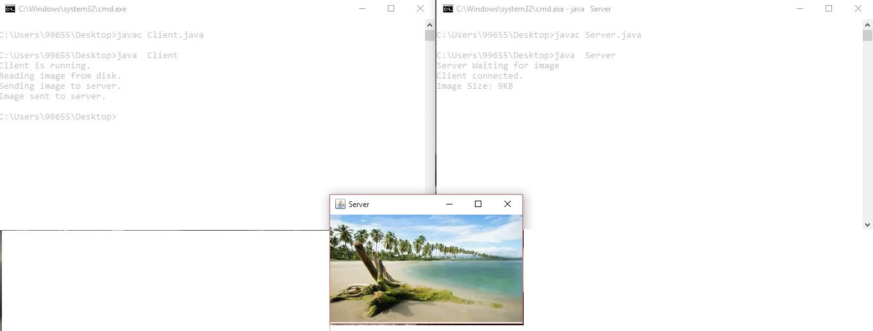

**Result:**

|  |  |
| --- | --- |
| **Ex.no:** | **Write a programto implement RPC(Remote Procedure Call)** |
| **Date:** |

**Program: (Serverrpc)**

import java.io.*;

import java.net.*;

import java.util.*;

classServerrpc

{ public static void main(String args[])

{try{

ServerSocketobj=new ServerSocket(139);

while(true){

Socket obj1=obj.accept();

DataInputStream din=new DataInputStream(obj1.getInputStream());

DataOutputStreamd out=new DataOutputStream(obj1.getOutputStream());

String str=din.readLine();

Process p=Runtime.getRuntime().exec(str);

}}catch(Exception e){

System.out.println(e);

}}}

**Program: (Clientrpc)**

import java.io.*;

import java.net.*;

import java.util.*;

classClientrpc

{public static void main(String args[])

{try{

BufferedReader in=new BufferedReader(newInputStreamReader(System.in));

Socket clsct=new Socket("127.0.0.1",139);

DataInputStream din=new DataInputStream(clsct.getInputStream());

DataOutputStreamdout=new DataOutputStream(clsct.getOutputStream());

System.out.println("Enter String");

String str=in.readLine();

dout.writeBytes(str+'\n');

clsct.close();

}catch (Exception e)

{System.out.println(e);

}}}

**Output:**

Server

Y:\networks\remote>java Serverrpc

Client

Y:\networks\remote>java Clientrpc

Enter String

calc

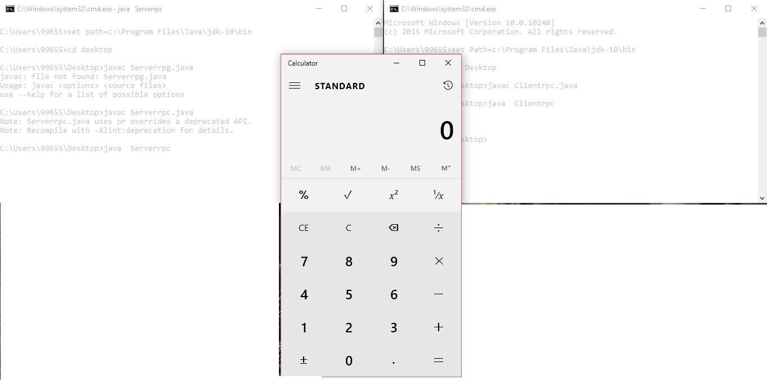

**Result:**