Advanced Network Security

Simulation and Verification of HTTP and DNS Services in a Secured Network Environment

Introduction:

The world is interconnected with secure and efficient communication and being the most important to modern networking systems. The project focuses on implementing and verifying the network topology with crucial services like HTTPS and DNS. I have configured routers, switches, and servers to simulate in real-time where devices communicate effortlessly also ensure data integrity and reliability.

The goal is to build a functional and scalable network interface. Configure the HTTP and DNS services to handle the requests. Analysing and verifying the data flow using Cisco Packet Tracer simulation tools.

**Components Required:**

Routers: To connect and manage the traffic with various networks.

Switches: To enable device communication in the network.

DNS Server: To resolve domain names into IP address.

HTTP server: Will respond to web requests from client devices.

PC’s: Represents clients DNS and HTTP requests.

**Configuring the Network:**

Unique IP addresses have been assigned to PC and servers.

The packet forwarding to the routers configures.

DNS and HTTP servers resolve domain names and responds to requests.

Routing and switching mechanisms are implemented.

Results and Simulation:

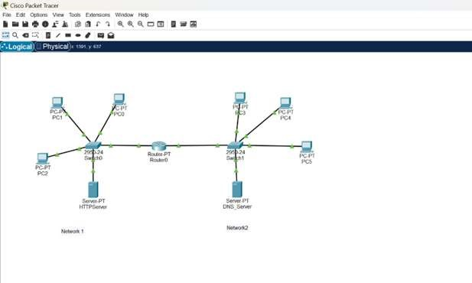

Network consisting of two LAN’s Network 1 and Network 2

These networks are interconnected using Router0.

HTTP and DNS servers for functionality.

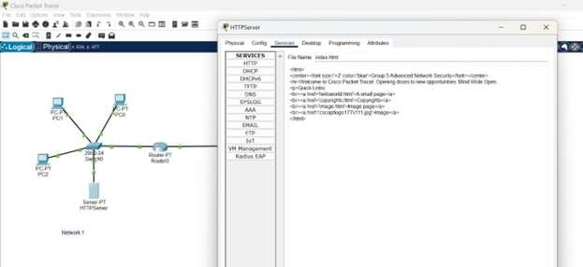

Data flow: DNS Request

PC sending domain name query to DNS server

DNS server will respond to resolved IP address.

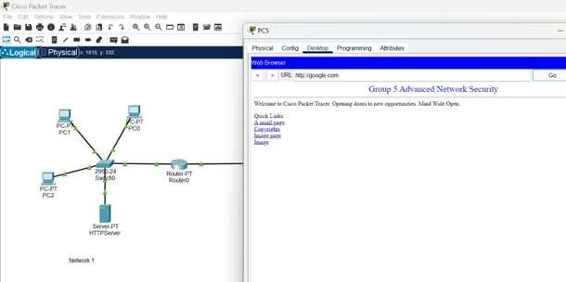

HTTP request:

PC using the resolved IP address and sends requests to HTTP server.

HTTP server processes the requests and responds.

The data is now transfers to routers and switches.

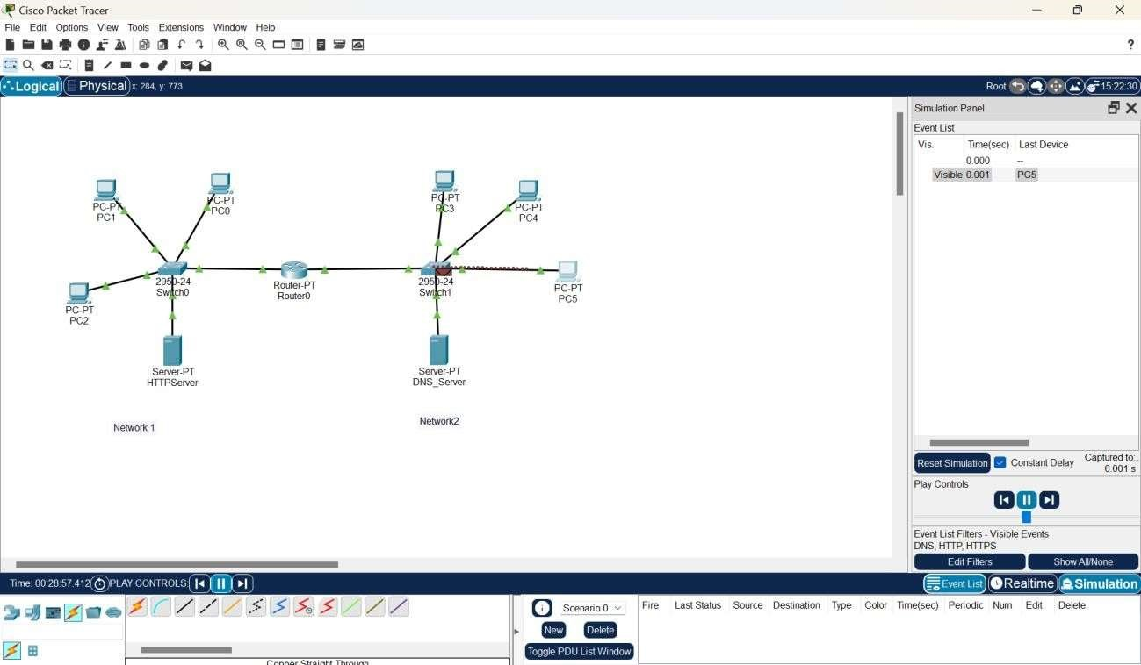

The data is now at the switch,

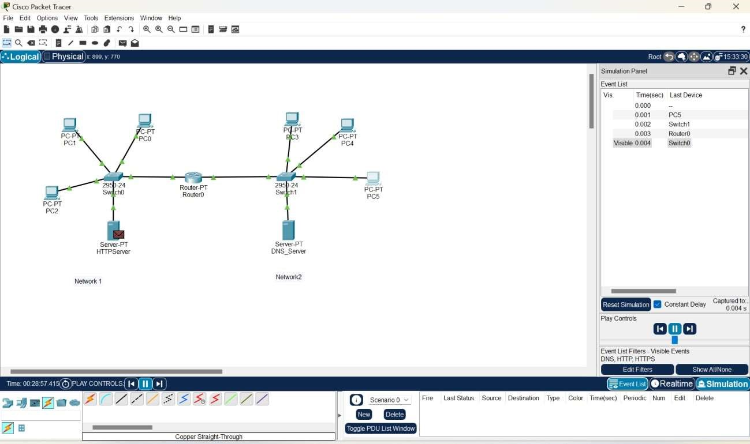

The data is now at the HTTP server, being processed by the PC, switch and router the data reached to HTTP server.

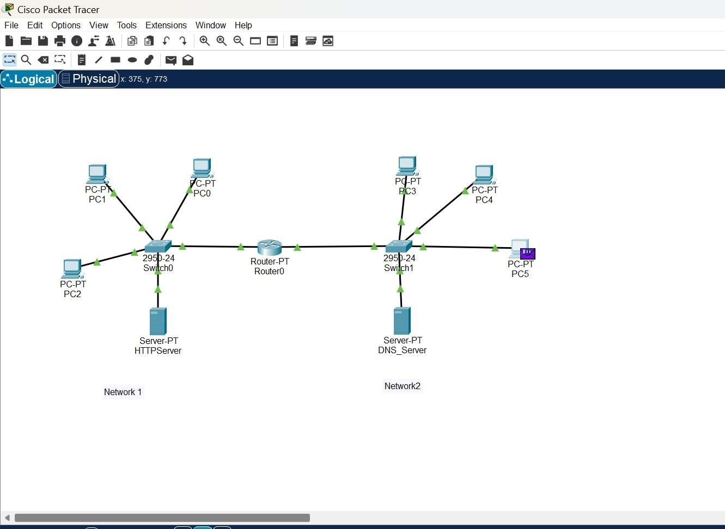

The client PC has the data,

At where the TLS conformed the traffic port 433 and encrypted HTTP port 80.

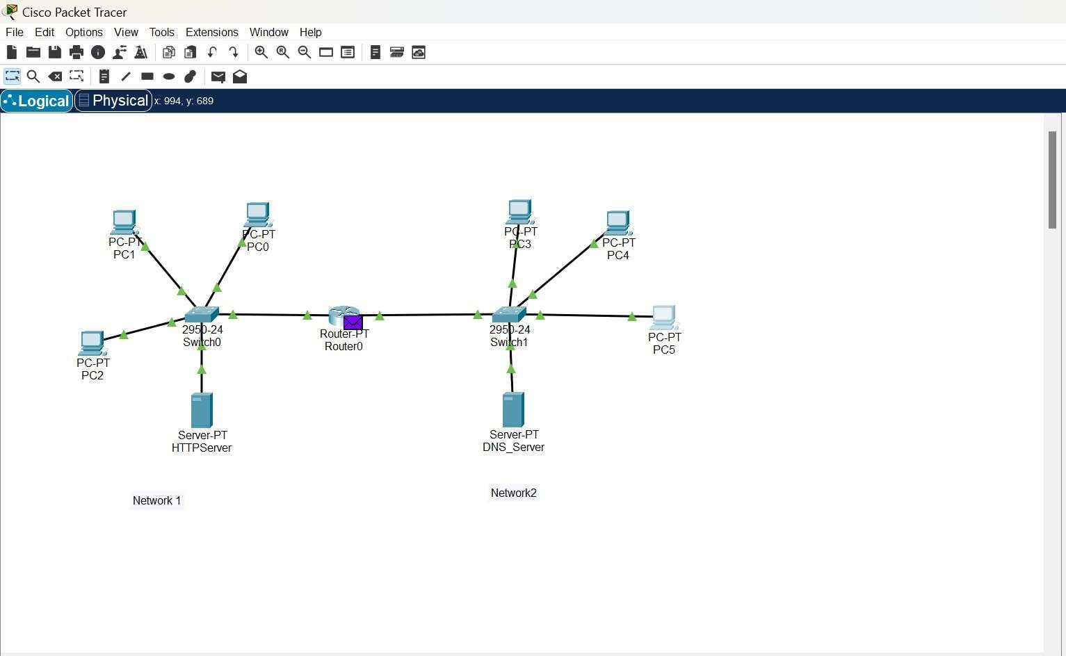

The data is now at the router0,

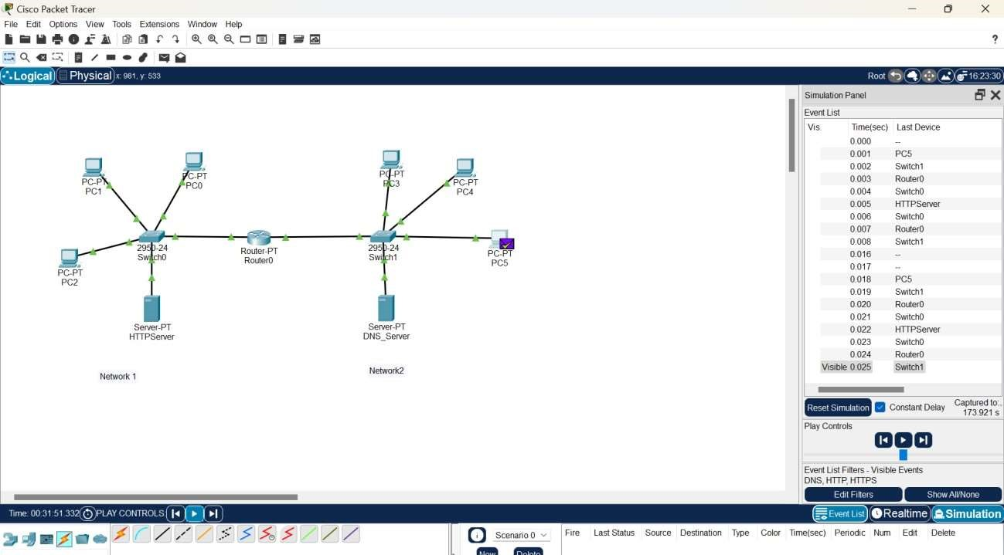

The simulated output of the data has been successfully sent where it changes the colour of the data.

**Conclusion:**

Simulated network topology with HTTP and DNS server services. Verified secure, efficient, scalable communication among the devices.