**Question 1**

Step 1: Create a new Git repository.

Step 2: Create a file and commit changes.

Step 3: View the commit history of your repository.

Step 4: Open the file you created earlier and make some changes to it.

Step 5: Check the file you modified is now marked as "modified" and unstaged.

Hint (git status)

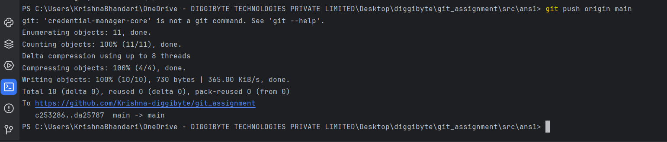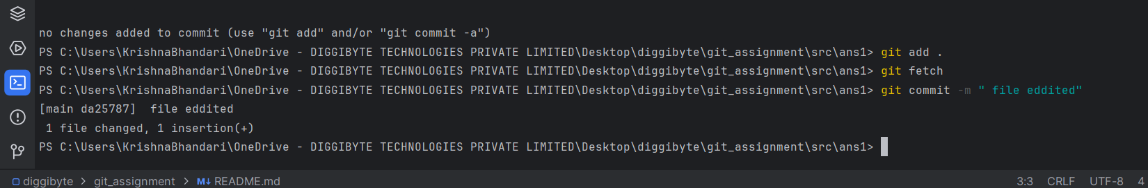Step 6: Stage the changes you made to the file and commit the changes to the repository.

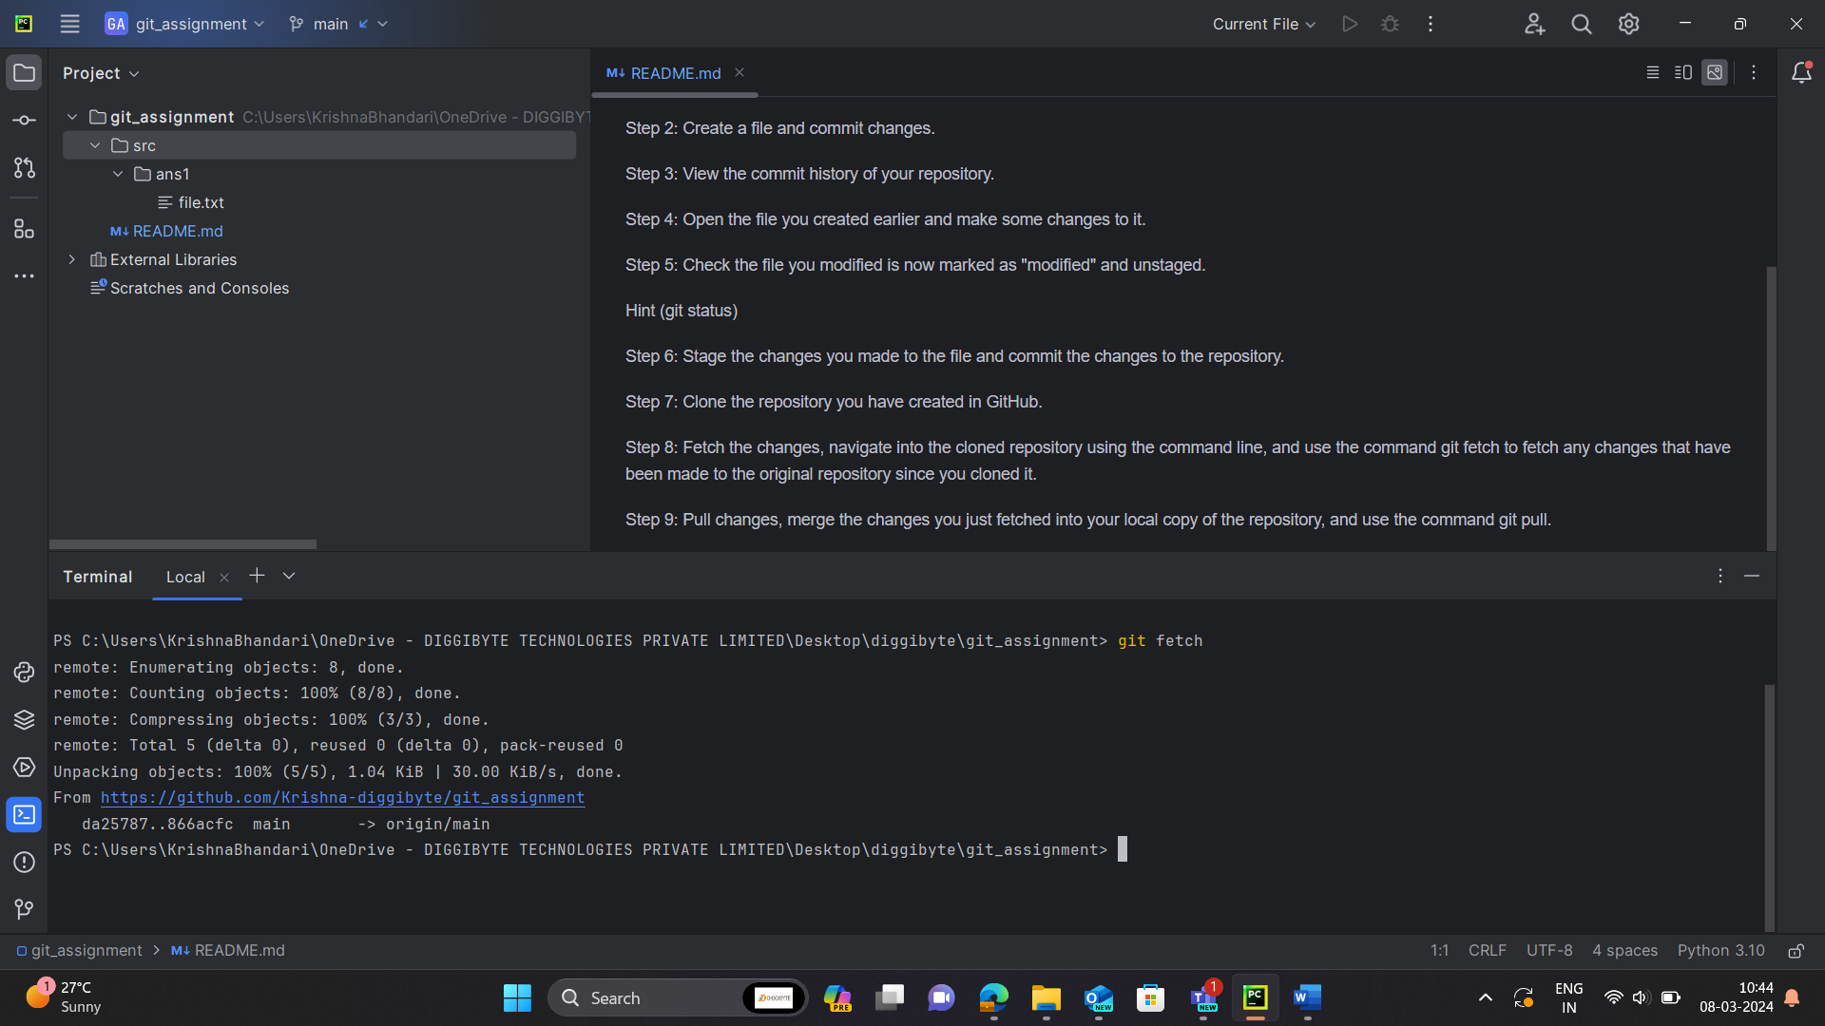Step 8: Fetch the changes, navigate into the cloned repository using the command line, and use the command git fetch to fetch any changes that have been made to the original repository since you cloned it.

Step 9: Pull changes, merge the changes you just fetched into your local copy of the repository, and use the command git pull.