INDUSTRIAL TRAINING REPORT
Conducted at
Emcure Pharmaceuticals (Zuventus Healthcare Limited R&D Centre) Pune.

Submitted to

Appasaheb Birnale College of Pharmacy, Sangli.

In partial fulfillment of the requirements for the degree of
Bachelor of Pharmacy
Shivaji University, Kolhapur

Submitted By
Miss. Apurva Anil Jagtap
Final Year B. Pharm. (Sem- VIII)
PRN. No. 2022092172

ACADEMIC YEAR 2025- 2026


Appasaheb Birnale College of Pharmacy, Sangli.

CERTIFICATE
This is to certify that, Miss. Apurva Anil Jagtap, a student of Appasaheb Birnale College of Pharmacy, Sangli, has completed her industrial training from 15th July 2025 to 15th August 2025 at Emcure Pharmaceuticals (zuventus Healthcare Limited R&D Centre Hinjewadi Pune (Maharashtra), India, during the period of her study in B. Pharm. Course & has submitted report on it.
This work has been done originally by our student.
Date: 10/10/25

Mr. Bahubali N. Patil |  | Mr. Ganesh R. Gadekar
Assistant TPO |  | TPO
Dr. Sanaulla A. Tamboli
Principal


Appasaheb Birnale College of Pharmacy, Sangli.
DECLARATION
I hereby declare that the industrial project work is carried out by me in accordance with Rules and Syllabus for the Bachelor of Pharmacy (B. Pharm.) Course regulations 2014 (Pharmacy Council of India, New Delhi) at Emcure Pharmaceuticals (Zuventus Healthcare Limited, Hinjewadi, Pune. (Maharashtra), India.

Date: 10/10/25

Miss. Apurva Anil Jagtap
Final Year B. Pharm. (Sem- VIII)
PRN No: 2022092172

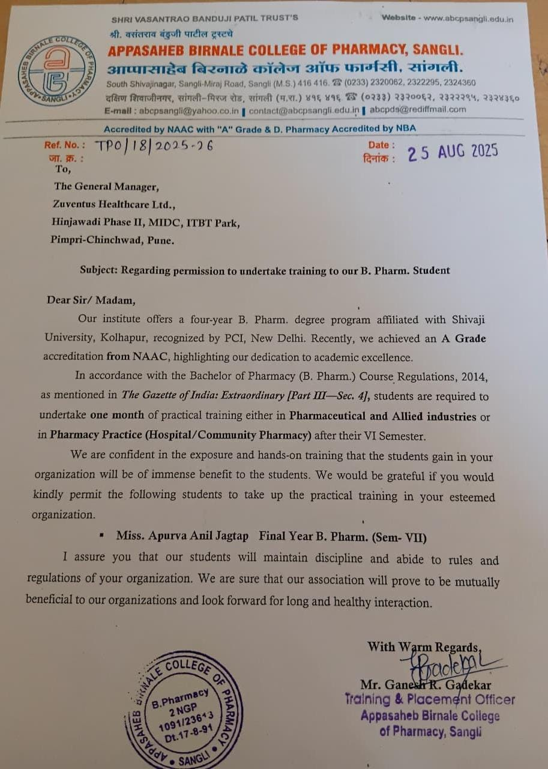

Certificate
