**Name of Application** : Notepad++ (64-bit x64)

**Manufacturer**: Notepad++ Team

**Version**: 8.8.3

**Source Type** : EXE (When double clicked it again start the installation process.)

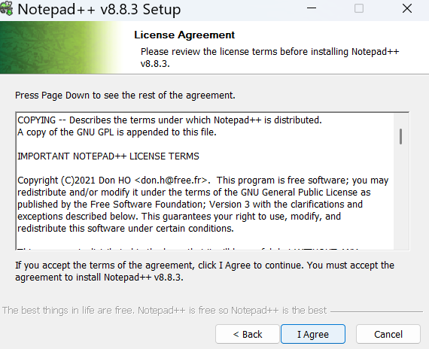

**Size: 17.4 MB**

**Number of shortcuts**:1) Start Menu -> Notepad++ 2)Desktop

**Installation Dir**: C:\Program Files\Notepad++

**Installation commandline**:

**Uninstallation Commandline**:

**Installation Steps** :

**Step:1**-

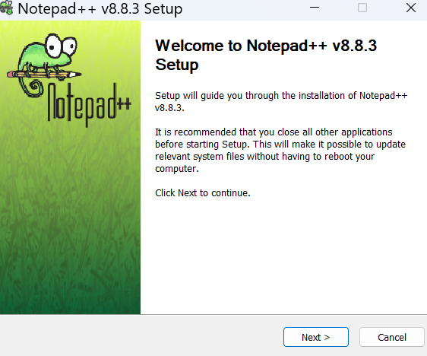

**Step 2**: It got installed and in search bar below icon is visible:

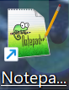  
  
**In ARP (Add and Remove Program) it makes below entry**:

