Name of Application : winrar-x64-713

Manufacturer: winrar GMBH

Version: 6.10.0

Source Type : EXE (Double clicking again install the source)

Size:

Number of shortcuts:

Installation Dir: C:\Program Files\WinRAR

Installation commandline:

Uninstallation Commandline:

Installation Steps :

Step 1:

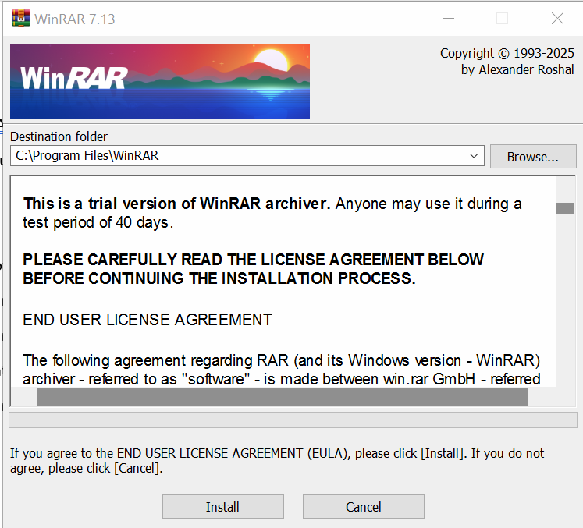

Step 2: It got installed and in search bar below icon is visible:

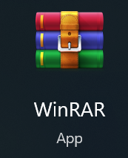

In ARP (Add and Remove Program) it makes below entry:



Repackaging process: