**Name of Application** : VLC media player

**Manufacturer**: VideoLAN

**Version**: 3.0.21

**Source Type** : EXE (When I double clicked it again start the installation process.)

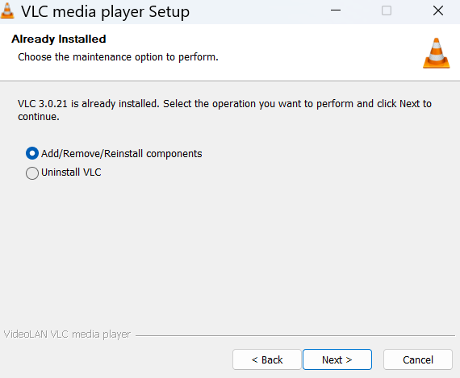

**Size**:

**Number of shortcuts**:Start Menu,Desktop.

**Installation Dir**: C:\Program Files (x86)\VideoLAN\VLC

**Installation Commandline**:

**Uninstallation Commandline**:

**Installation Steps** :

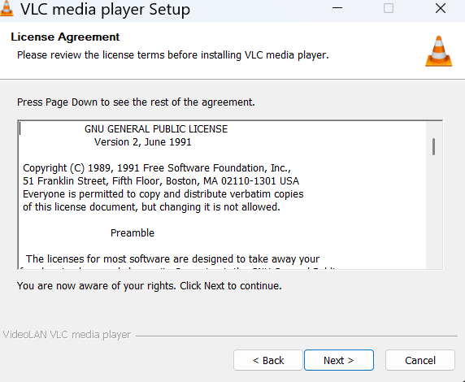**Step 1**:

**Step 2**: It got installed and in search bar below icon is visible:

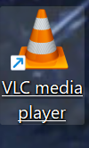  
**In ARP (Add and Remove Program) it makes below entry**:

