**INSTALLATION STEPS (Downloading the sysinternals suite package):**

1. **Download:** Go to the official [Microsoft Sysinternals](https://learn.microsoft.com/en-us/sysinternals/downloads/) page. You'll find a link to download the Sysinternals Suite as a .zip file.
2. **Extract:** Unzip the downloaded file to a folder on your computer, for example, C:\Sysinternals.
3. **Use:** You can run the tools directly from this folder.
4. **Process Monitor:**

Introduction**:** This is an advanced monitoring tool from the Sysinternals Suite that combines the functionality of the older FileMon and RegMon utilities.

Use**:** It provides a comprehensive, real-time view of file system, registry, and process/thread activity.

It's a key tool for **troubleshooting difficult application problems**, especially those related to file or registry access permissions, DLL loading issues, and application crashes.

It can also be used for **malware analysis** to see what files and registry keys a malicious program is accessing.

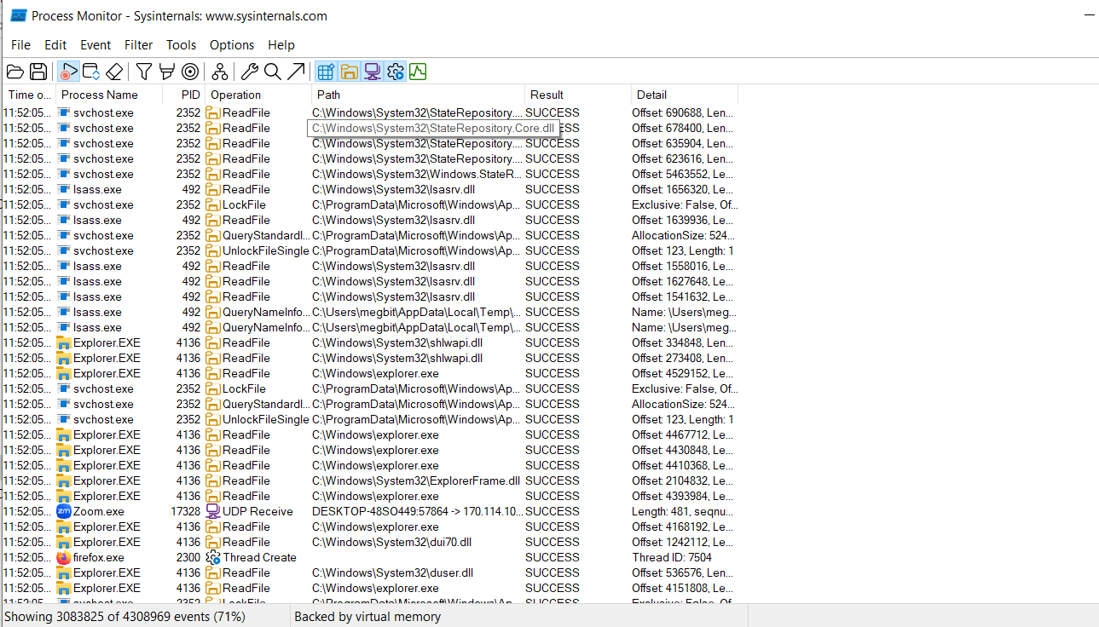

1. **Process Explorer**

**Introduction:** A much more advanced and powerful tool from the Sysinternals Suite.

**Use:**

It goes far beyond the basic capabilities of Task Manager.

Process Explorer is a debugging and troubleshooting tool for power users and administrators.

It provides a detailed, hierarchical view of processes and their threads, DLLs, and handles. Key uses include:

* Identifying which process is locking a file.
* Viewing the full command line and parent/child relationships of processes.
* Analyzing a process's security properties.
* Detecting malware by checking for unsigned processes or unusual process behavior.

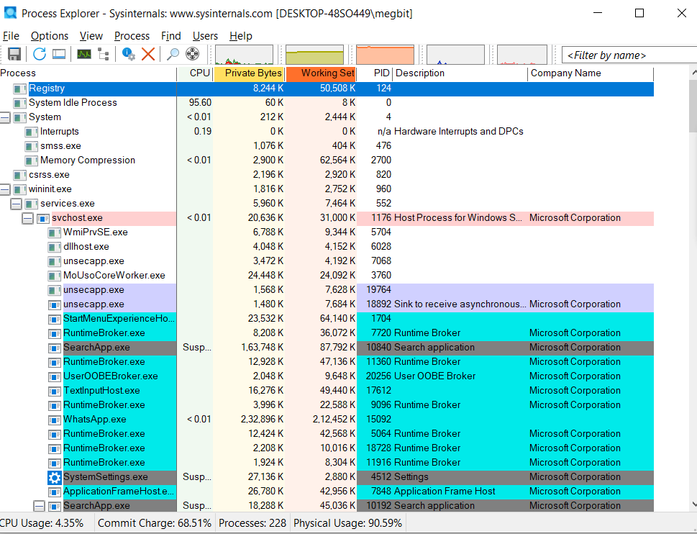

1. **AutoLogon:**

Autologon enables you to easily configure Windows’ built-in autologon mechanism.

Instead of waiting for a user to enter their name and password, Windows uses the credentials you enter with Autologon, which are encrypted in the Registry, to log on the specified user automatically.

**Useful for automated systems or test environments** where user interaction isn't required after a reboot.

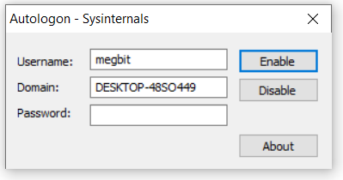

1. **WhoIs**:

**Use:** A command-line utility for **querying public "whois" directory information** about a domain name or IP address.

It's used for network troubleshooting and security investigations to identify the owner and contact details of a website or IP address.

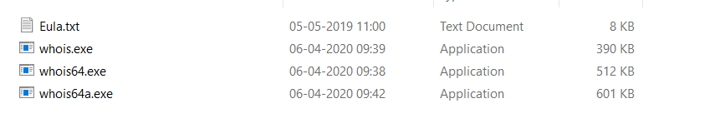

1. **LogonSessions:**

It lists the currently active logon sessions and, if you specify the -p option, the processes running in each session.

This is a debugger extension for Windows debuggers like WinDbg.

It helps in analyzing user logon sessions by providing a unique LogonId, which can be used to trace all processes and activities tied to a specific user's login.

This is crucial for **investigating security incidents and understanding the scope of a breach.**

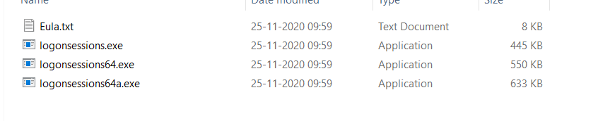

1. **Sysmon***:*

**Use:** A powerful system service and device driver that **continuously monitors and logs system activity to the Windows event log**.

It provides detailed logs for process creation, network connections, and file modifications, making it a critical tool for security monitoring and threat detection.

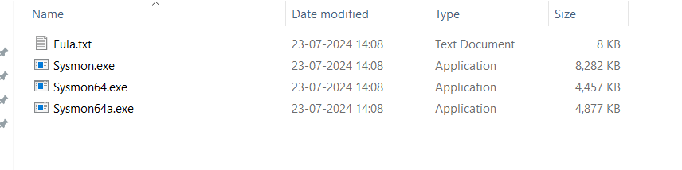

1. **psTools:**

**Use:** A suite of command-line tools that includes PsExec and others for **managing and troubleshooting both local and remote Windows systems**.

The suite offers various functionalities like viewing process information, managing services, and gathering system data.

*The tools included in the PsTools suite, which are downloadable as a package, are:*

* [*PsExec*](https://learn.microsoft.com/en-us/sysinternals/downloads/psexec) *- execute processes remotely*
* [*PsFile*](https://learn.microsoft.com/en-us/sysinternals/downloads/psfile) *- shows files opened remotely*
* [*PsGetSid*](https://learn.microsoft.com/en-us/sysinternals/downloads/psgetsid) *- display the SID of a computer or a user*
* [*PsInfo*](https://learn.microsoft.com/en-us/sysinternals/downloads/psinfo) *- list information about a system*
* [*PsPing*](https://learn.microsoft.com/en-us/sysinternals/downloads/psping) *- measure network performance*
* [*PsKill*](https://learn.microsoft.com/en-us/sysinternals/downloads/pskill) *- kill processes by name or process ID*
* [*PsList*](https://learn.microsoft.com/en-us/sysinternals/downloads/pslist) *- list detailed information about processes*
* [*PsLoggedOn*](https://learn.microsoft.com/en-us/sysinternals/downloads/psloggedon) *- see who's logged on locally and via resource sharing (full source is included)*
* [*PsLogList*](https://learn.microsoft.com/en-us/sysinternals/downloads/psloglist) *- dump event log records*
* [*PsPasswd*](https://learn.microsoft.com/en-us/sysinternals/downloads/pspasswd) *- changes account passwords*
* [*PsService*](https://learn.microsoft.com/en-us/sysinternals/downloads/psservice) *- view and control services*
* [*PsShutdown*](https://learn.microsoft.com/en-us/sysinternals/downloads/psshutdown) *- shuts down and optionally reboots a computer*
* [*PsSuspend*](https://learn.microsoft.com/en-us/sysinternals/downloads/pssuspend) *- suspends processes*
* [*PsUptime*](https://learn.microsoft.com/en-us/sysinternals/downloads/pssuptime) *- shows you how long a system has been running since its last reboot (PsUptime's functionality has been incorporated into* [*PsInfo*](https://learn.microsoft.com/en-us/sysinternals/downloads/psinfo)

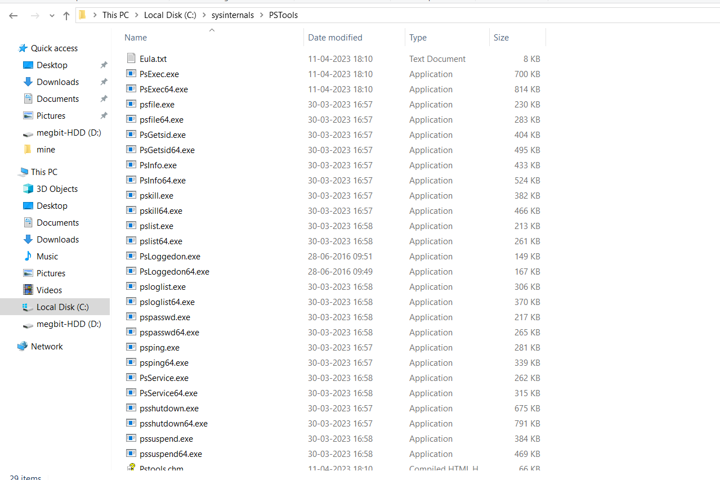

1. ***PsExec-***

* **Use:** A command-line tool for **executing processes on remote systems.**
* It allows administrators to run commands or scripts on other computers without needing to install any client software on them, making it an invaluable tool for remote administration and debugging.

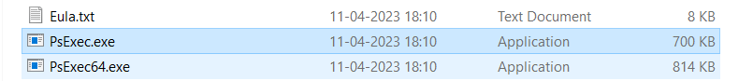

1. ***RegMon –***

* **Use:** A now-discontinued Sysinternals tool for **monitoring real-time registry access**.
* Its functionality has been integrated into **Process Monitor.**
* It was used to debug registry-related problems by tracking which applications were interacting with the registry.