Configuration Manager cmdlets
PowerShell from the Configuration Manager console
The easiest method to open PowerShell is directly from the Configuration Manager console.
- Launch the Configuration Manager console. In the upper-left corner, there's a blue rectangle. Select the white arrow in the blue rectangle, and choose Connect via Windows PowerShell .
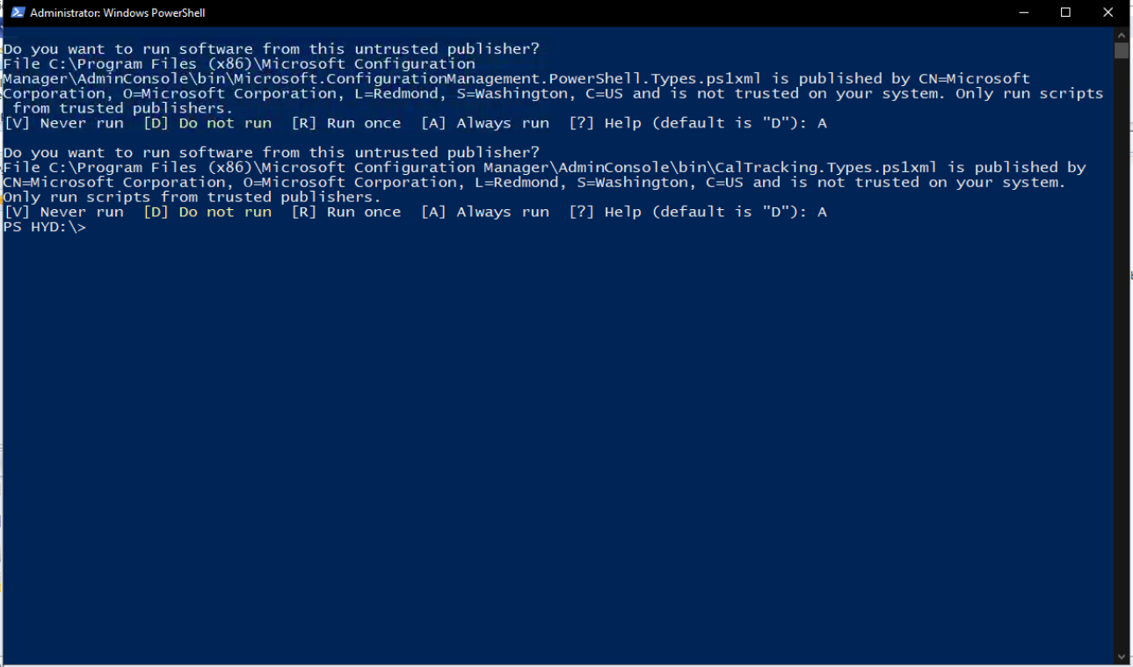
Connect via Windows PowerShell ISE :-
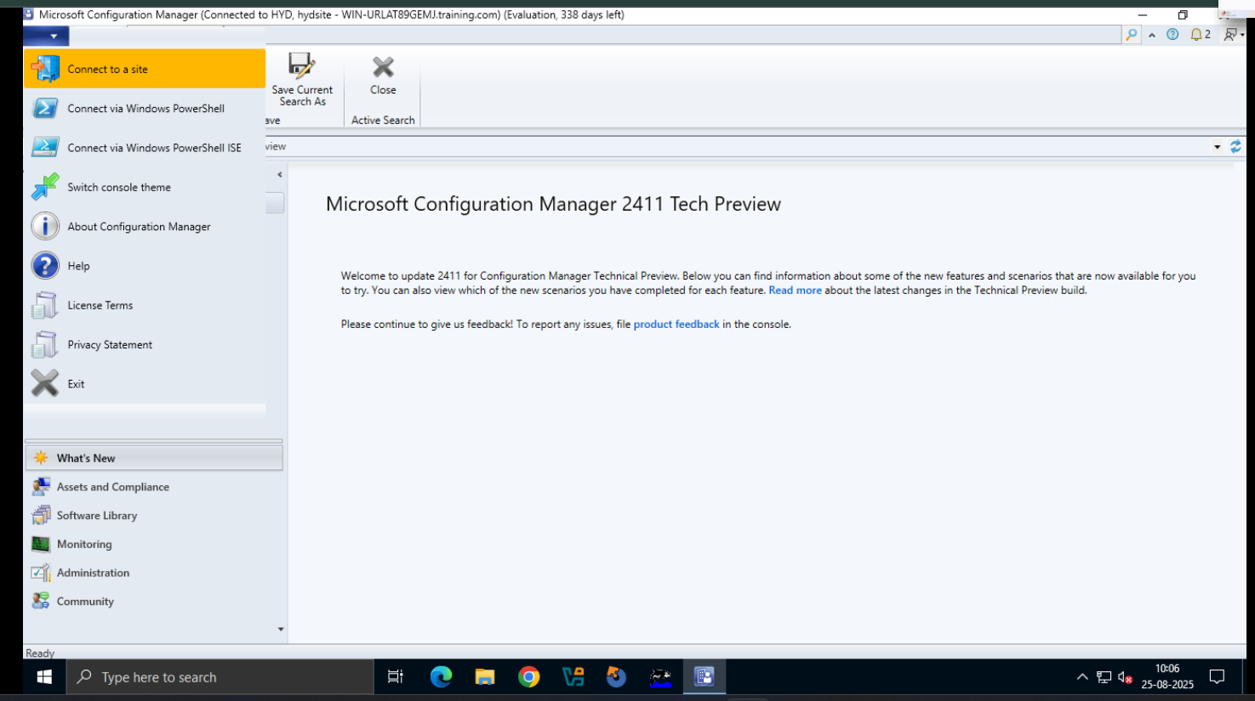
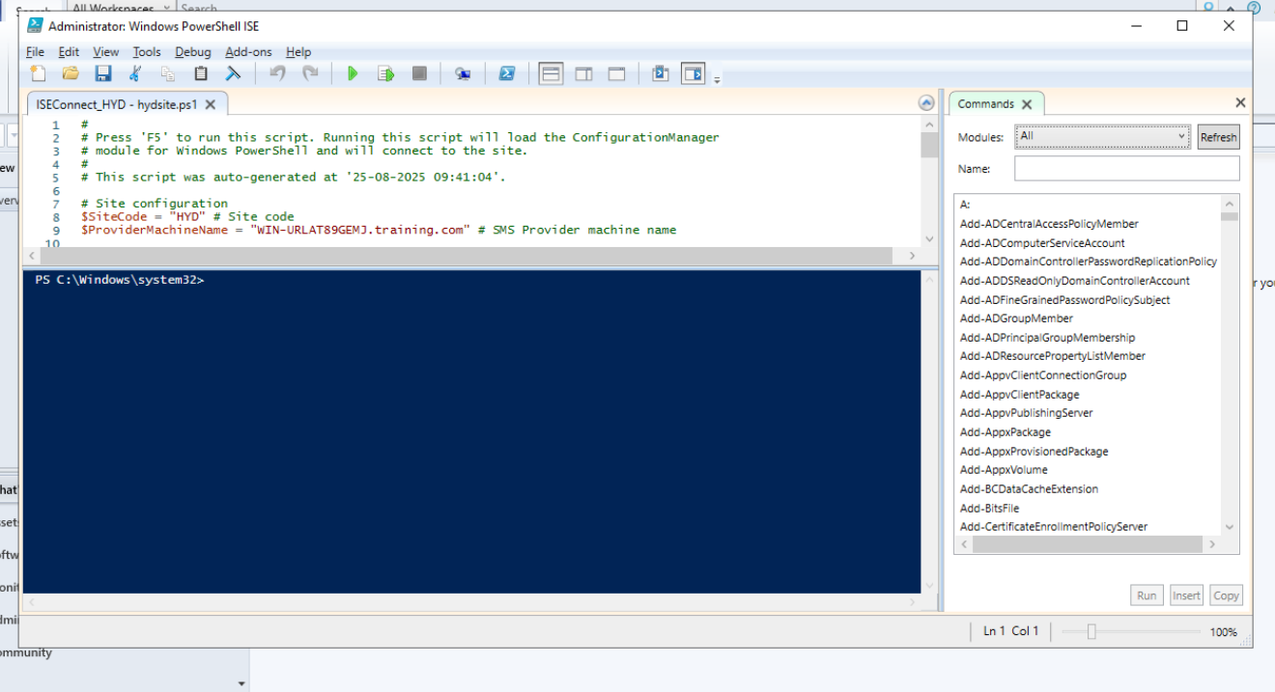
- After Windows PowerShell loads, you'll see a prompt that contains your site code. For example, if the site code is "ABC", the prompt looks like: PS ABC:\>
- To verify it works, use the Get-CMSite cmdlet. This cmdlet returns information about the Configuration Manager site you're currently connected to and any child sites. For example, the site server name, installation director, site name, and version.
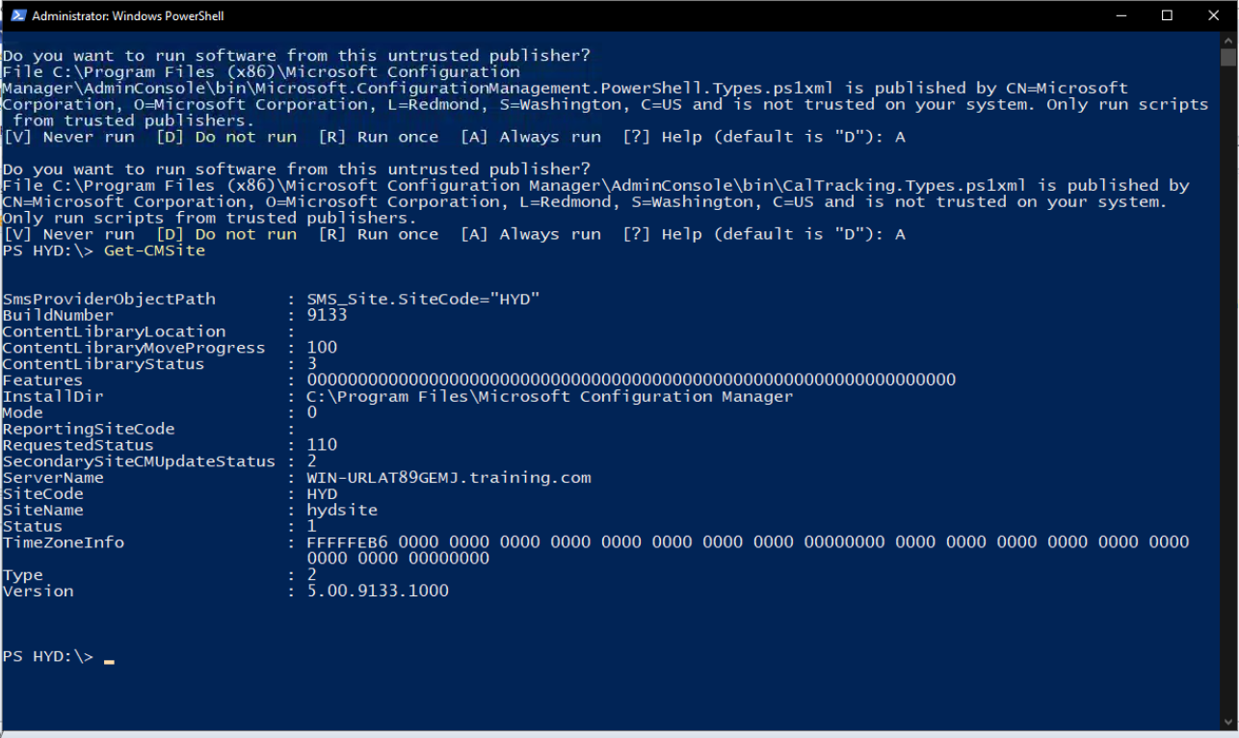

Import the Configuration Manager PowerShell module
Connect to Configuration Manager from an existing Windows PowerShell session by manually loading the Configuration Manager module.
- Open a Windows PowerShell session from the Start menu.
- Import the Configuration Manager module by using the Import-Module cmdlet. Specify the path to the Configuration Manager module, or change to the directory that contains the module. By default, the module is at the following path: C:\Program Files (x86)\Microsoft Endpoint Manager\AdminConsole\bin\ConfigurationManager.psd1
when you install the Configuration Manager console, the path to the module is now added to the system environment variable, PSModulePath. For more information, see about_PSModulePath. With this change, you can import the module just by its name: Import-Module ConfigurationManager.

After you import the module, use the following commands to check the module version and path:
(Get-Module -Name ConfigurationManager).Version
(Get-Module -Name ConfigurationManager).Path

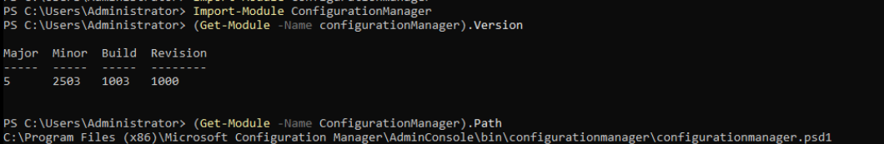
The following example changes to the module's directory and then imports it:
Set-Location 'C:\Program Files (x86)\Microsoft Endpoint Manager\AdminConsole\bin'
Import-Module .\ConfigurationManager.psd1

You can also use the SMS_ADMIN_UI_PATH environment variable. For example:
Set-Location "$env:SMS_ADMIN_UI_PATH\..\"

Also, you can use the cd alias to change directories instead of the Set-Location cmdlet.
If it's the first time importing the Configuration Manager module on this computer, you may need to create the site drive. For example:
New-PSDrive -Name "ABC" -PSProvider "CMSite" -Root "siteserver.contoso.com" -Description "Primary site"

To run the Configuration Manager cmdlets, you need to switch the path to the Configuration Manager site. In the following example, the site code is ABC:
Set-Location ABC:
Confirm that PowerShell properly loaded the Configuration Manager module by using the Get-CMSite cmdlet.

Update help
To get the latest information for the Configuration Manager PowerShell module, use the Update-Help cmdlet.
The computer on which you run this cmdlet needs internet access, specifically pshelpprod.blob.core.windows.net. Then run the following command from an elevated PowerShell session:
Update-Help -Module ConfigurationManager

After you update the Configuration Manager cmdlet help, you can get help about the cmdlets by using the Get-Help cmdlet. For example:
Get-Help Get-CMDevice
Get-Help Get-CMDevice -Examples
Get-Help Get-CMDevice -Parameter *

Common parameters
All Configuration Manager cmdlets support the common PowerShell parameters:
- Debug
- ErrorAction
- ErrorVariable
- InformationAction
- InformationVariable
- OutVariable
- OutBuffer
- PipelineVariable
- Verbose
- WarningAction
- WarningVariable
Support for Powershell version 7 :-

PowerShell 7 runs as pwsh.exe. Earlier versions of PowerShell run as powershell.exe.
The Configuration Manager PowerShell cmdlet library supports PowerShell version 7. For more information on PowerShell 7, including directions on how to download and install it, see Install PowerShell on Windows

Cmdlets that don't support PowerShell version 7
The following cmdlets don't support PowerShell 7:
- Import-CMPackage
- Import-CMDriverPackage
- Import-CMTaskSequence
- Export-CMPackage
- Export-CMDriverPackage
- Export-CMTaskSequence
- Add-CMReportingServicePoint
- Get-CMReportingServicePoint
- Remove-CMReportingServicePoint
- Set-CMReportingServicePoint

Known issues with PowerShell version 7
- You can't launch PowerShell 7 directly from the Configuration Manager console. Manually start PowerShell 7, and then import the Configuration Manager module.
- Current support is only for the Configuration Manager cmdlets. Other features of Configuration Manager that rely on PowerShell may not support version 7. For example, Run Scripts, CMPivot, or the Run PowerShell Script task sequence step.

If a cmdlet returns an error, use the following command to get exception details:

$Error[0].Exception | Format-List * -Force
