Nexthink
Nexthink is a software company that specializes in Digital Employee Experience (DEX) management. It provides IT teams with a platform to gain real-time analytics, automation, and end-user feedback to proactively identify and resolve IT issues that impact employee productivity and satisfaction.
In simple terms, while other tools might manage devices from the IT side, Nexthink focuses on what the employee is actually experiencing. It gives IT departments a "helicopter view" of the entire digital environment from the user's perspective.
Key Features and Capabilities
- Real-Time Analytics: Nexthink uses an agent installed on each device to collect real-time data on everything from application crashes and system slowness to network connectivity issues and CPU usage. It then uses AI to analyze this data and identify the root cause of problems.
- Proactive Issue Resolution: By analyzing real-time data, Nexthink can detect problems before they become widespread. It allows IT to proactively fix issues, sometimes without the user even knowing there was a problem, which significantly reduces the number of support tickets.
- Employee Feedback: The platform includes a feature to send targeted, two-way communications to employees, such as pop-up surveys or notifications. This helps IT gather sentiment and context directly from users, which is crucial for understanding the full impact of a technical issue.
- Automation and Remediation: Nexthink can automate the resolution of common problems through pre-built or custom scripts, saving IT time and effort. For example, it can automatically clean up disk space on a user's device if it falls below a certain threshold.
- Digital Experience Score (DEX Score): The platform provides a quantifiable score that combines technical performance data with employee sentiment. This allows organizations to measure, track, and benchmark the digital experience of their workforce.
Nexthink vs. Microsoft Intune
While both are valuable in a modern IT environment, they serve different primary purposes:
- Microsoft Intune is a Unified Endpoint Management (UEM) solution. Its main function is to enforce policies, secure devices, and deploy applications. It is a control and management tool for the IT administrator.
- Nexthink is a Digital Employee Experience (DEX) platform. Its main function is to provide visibility, insights, and automation to improve the end-user's experience. It is a monitoring, analysis, and proactive-remediation tool.
They are complementary, not competing, solutions. Intune is used to manage the technology, while Nexthink is used to measure how that technology is actually performing for the employee and to provide insights that help IT improve and automate their services. Many organizations use both in tandem for a comprehensive approach to IT management and employee support.

Given the enterprise nature of both Microsoft Intune and Nexthink, the concepts of "registering" and "logging in" are different from consumer-facing services. You don't simply create a personal account; instead, your organization signs up for a license, and you are granted access as an administrator or end-user.
Here are the steps for services based on your role.
For Nexthink
1. Registering for the Service (For Organizations)
Similar to Intune, an organization registers by becoming a Nexthink customer. The initial setup is handled by Nexthink's onboarding team.
- Onboarding: After an organization purchases a license, Nexthink provides the customer's main point of contact with an initial onboarding email. This email contains the URL for their unique cloud instance and the initial administrator credentials.
2. Logging in (For Administrators)
Administrators use the credentials provided in the onboarding email to log in for the first time.
- Go to Your Instance URL: Access the unique URL provided by Nexthink (e.g., [your-instance].[region].nexthink.cloud).
- Sign in: Use the initial username and password from the onboarding email. You will be prompted to change your password for security.
- SAML / SSO: Most large organizations will then configure Single Sign-On (SSO) using a service like Microsoft Entra ID or Okta so that administrators can log in with their standard corporate credentials.
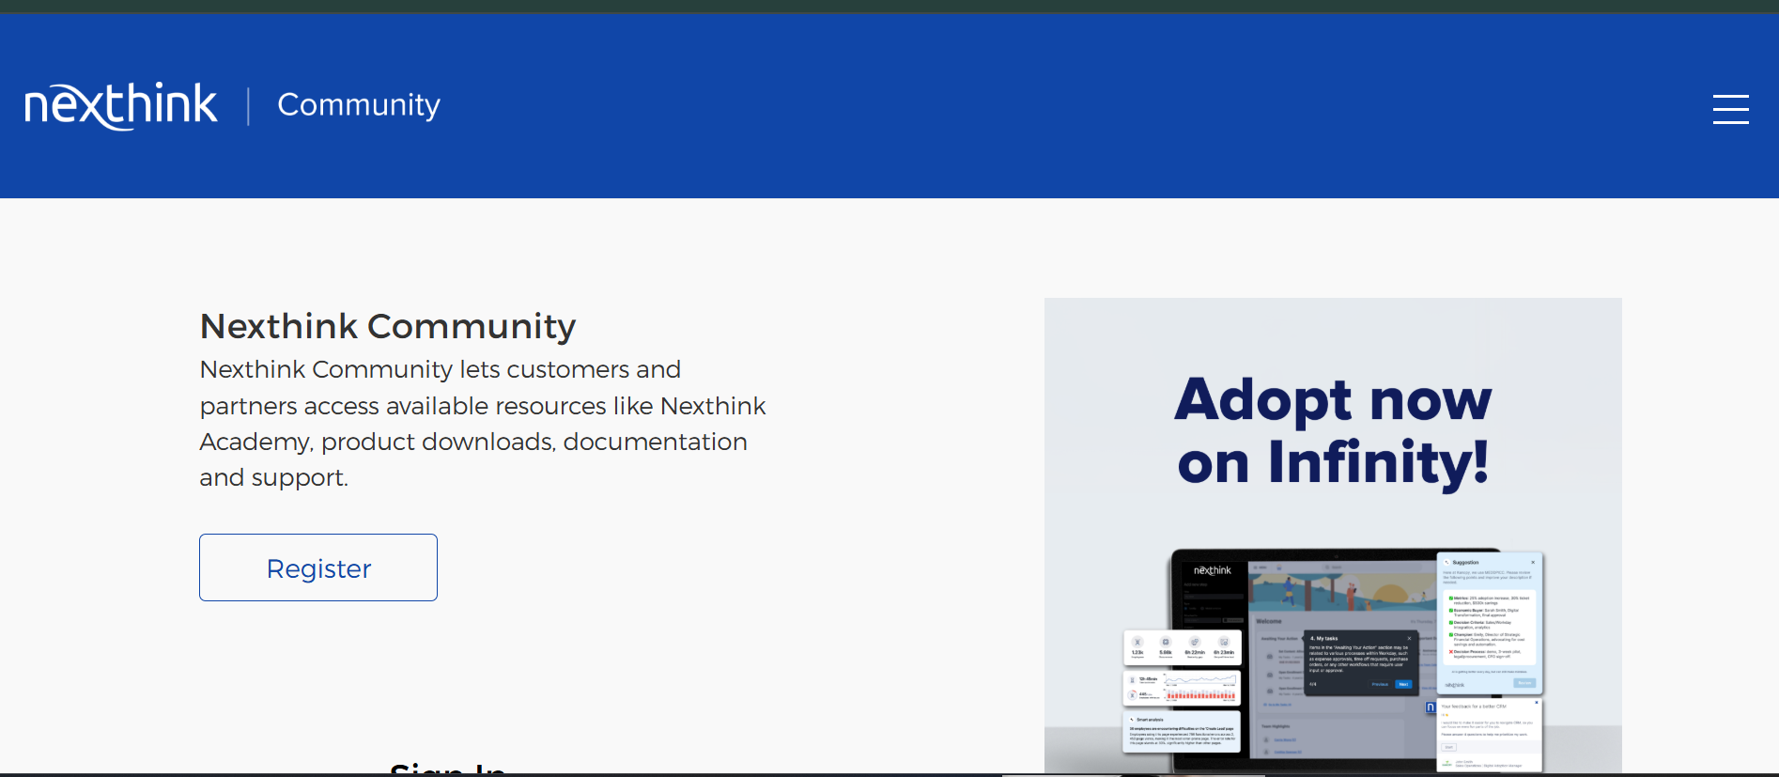
3. Registering/Logging in (For End-Users)
End-users do not have to register or log in to a portal for Nexthink. The Nexthink service runs silently as an agent (called the Collector) on their device. It collects data and can present pop-up notifications or surveys to the user as configured by the IT department, but it does not require a user to sign in.
