WEEK 3 TASK
Advanced Data Analysis and Visualization in Logistics
Python-Based Exploratory Data Analysis, Visualization and Operational Insights

1. Executive Summary
The Week 3 analysis uses the provided cleaned logistics dataset containing 2,001 shipment records. The data covers 2017-01-01 to 2018-01-01 and includes delivery performance, shipment characteristics, distance, weight, quantity, transportation cost, sales value and operational priority. Overall, 52.2% of shipments were delivered on time, while 47.8% experienced at least one day of delay. Among delayed shipments, the average delay was 1.50 days. The analysis identifies distance and shipment weight as important cost drivers, while regional and shipping-mode differences highlight opportunities for improving delivery reliability.

2. Dataset Structure and Data Quality
The dataset contains 17 variables. They can be grouped into shipment identifiers/date fields, categorical operational fields, continuous logistics measures, and performance indicators.
Variable Group | Examples | Purpose
Shipment information | Shipment_ID, Order_Date | Identify and timestamp shipments
Operational categories | Shipping_Mode, Region, Market, Priority | Compare service and geographic performance
Shipment characteristics | Distance_km, Shipment_Weight_kg, Order_Quantity | Measure physical/logistical workload
Performance and financials | Scheduled_Days, Actual_Delivery_Days, Delay_Days, On_Time | Evaluate delivery reliability
Cost/value | Shipping_Cost, Sales_Value, Cost_per_Unit | Assess cost efficiency and commercial value
Data-quality check: there are 0 missing values and 0 exact duplicate rows. One Shipment_ID (SHP101724) appears twice with different distance values, so it should be flagged for source-data validation rather than automatically deleted.

3. Exploratory Data Analysis

3.1 Central Tendency and Spread
Variable | Mean | Median | Std. Dev. | Min | Max
Distance_km | 927.48 | 811.27 | 574.36 | 20.00 | 2338.11
Shipment_Weight_kg | 14.03 | 12.27 | 7.31 | 1.48 | 32.00
Order_Quantity | 3.21 | 3.00 | 1.53 | 1.00 | 10.00
Scheduled_Days | 3.28 | 4.00 | 0.93 | 1.00 | 4.00
Actual_Delivery_Days | 3.77 | 4.00 | 1.47 | 1.00 | 8.00
Shipping_Cost | 94.05 | 90.74 | 29.63 | 23.45 | 172.34
Sales_Value | 344.42 | 319.11 | 145.63 | 72.33 | 957.98
Delay_Days | 0.72 | 0.00 | 0.89 | 0.00 | 5.00
On_Time | 0.52 | 1.00 | 0.50 | 0.00 | 1.00
Cost_per_Unit | 37.35 | 30.42 | 24.78 | 5.98 | 172.34
The average actual delivery time is 3.77 days compared with an average scheduled time of 3.28 days. Average shipping cost is 94.05, while the average shipment distance is 927.48 km. The mean order quantity is 3.21 units.

3.2 Distribution of Delivery Time
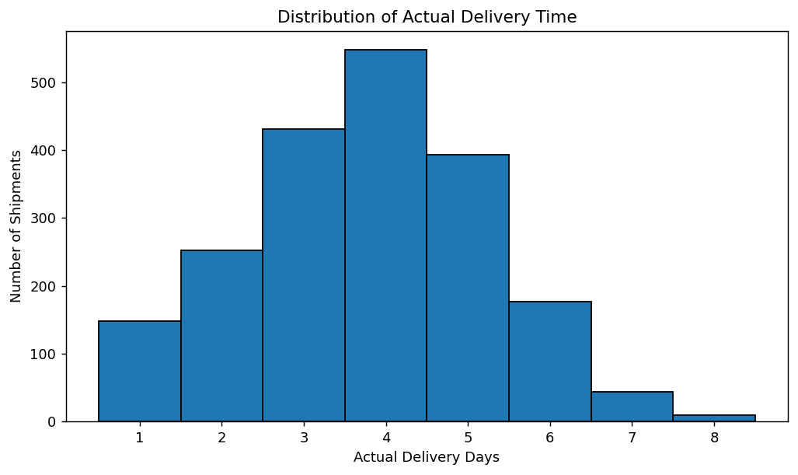
Interpretation: Actual delivery time is concentrated around 3–5 days, but the distribution extends to 8 days. The presence of longer deliveries indicates that a subset of shipments creates service-level risk. This makes delivery-time monitoring useful for identifying bottlenecks and prioritizing exception management.

3.3 Correlation Analysis
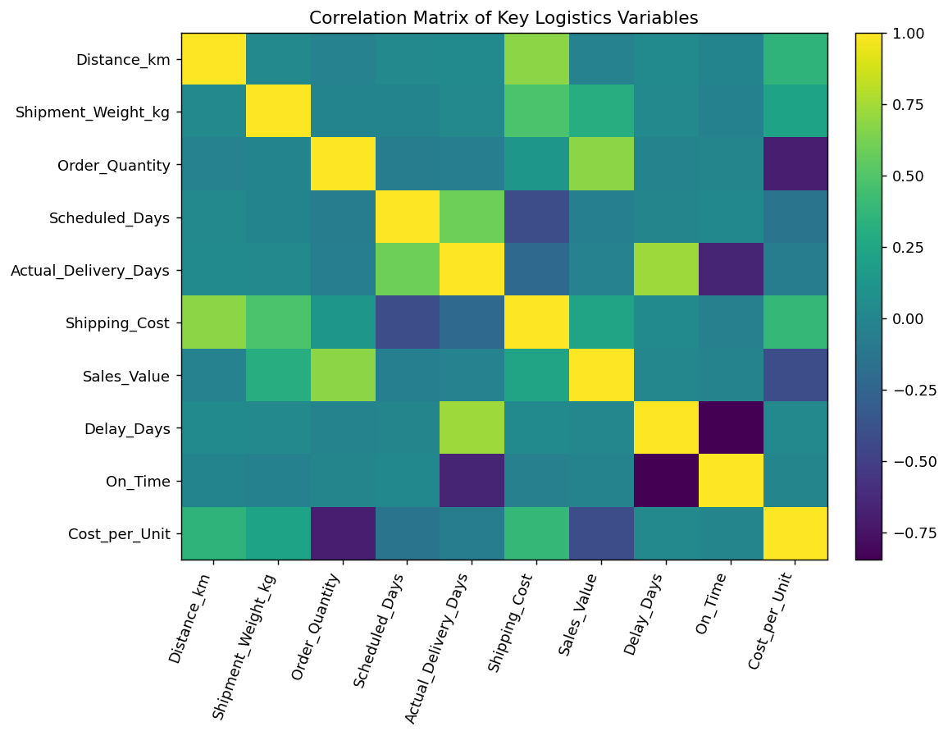
Shipping cost has a strong positive correlation with distance (r=0.680) and a moderate positive correlation with shipment weight (r=0.475). Order quantity is strongly negatively correlated with cost per unit (r=-0.686), indicating that larger orders benefit from lower average transportation cost per item. Actual delivery days are strongly related to delay days (r=0.733), while delay days and On_Time show a strong negative relationship (r=-0.843), as expected.

4. Logistics Performance Visualizations

4.1 Shipping Mode Performance
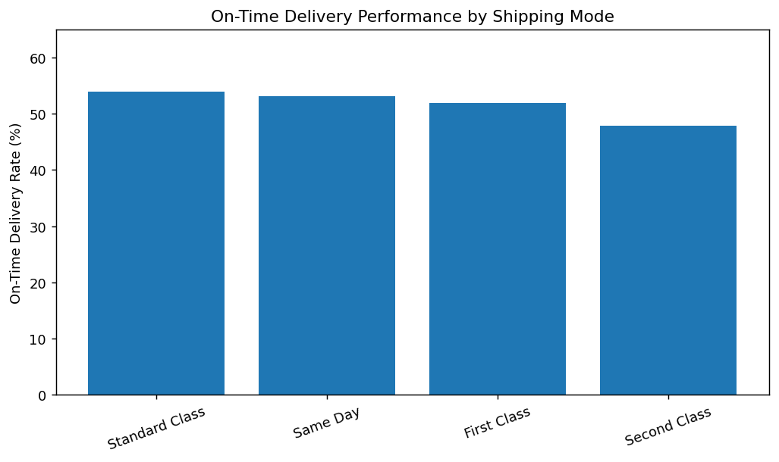
Standard Class has the highest observed on-time rate at 53.9%, while Second Class has the lowest at 47.9%. Standard Class also carries the largest shipment volume (1,130 shipments). A bar chart is appropriate because it makes category-level performance differences easy to compare.

4.2 Distance as a Cost Driver
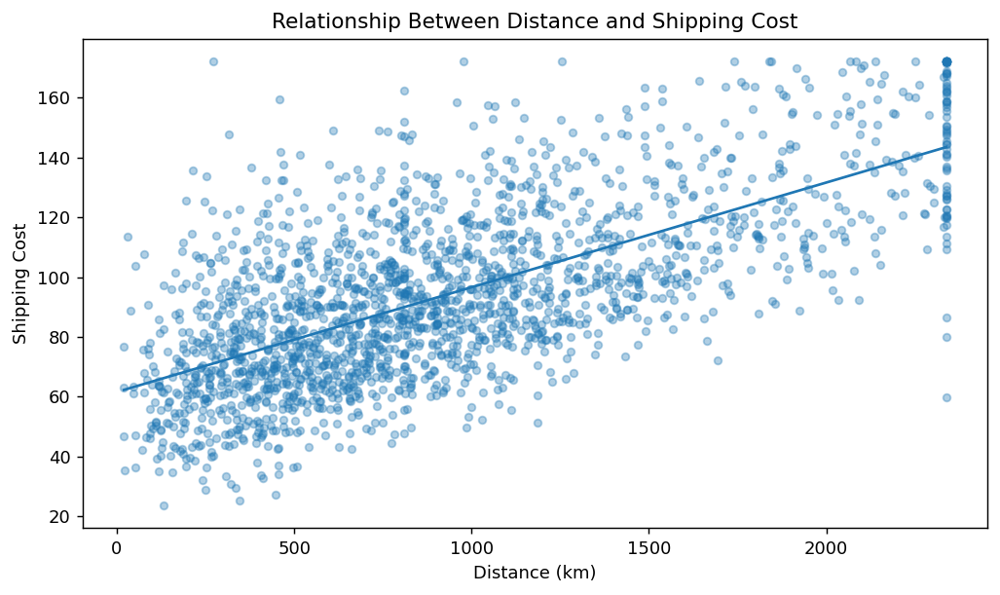
The correlation between distance and shipping cost is 0.680, demonstrating a clear cost relationship. Average shipping cost rises from 72.79 for the shortest-distance quartile to 122.22 for the longest-distance quartile. The scatter plot is useful because it shows both the overall trend and individual shipment variation.

4.3 Regional Delivery Reliability
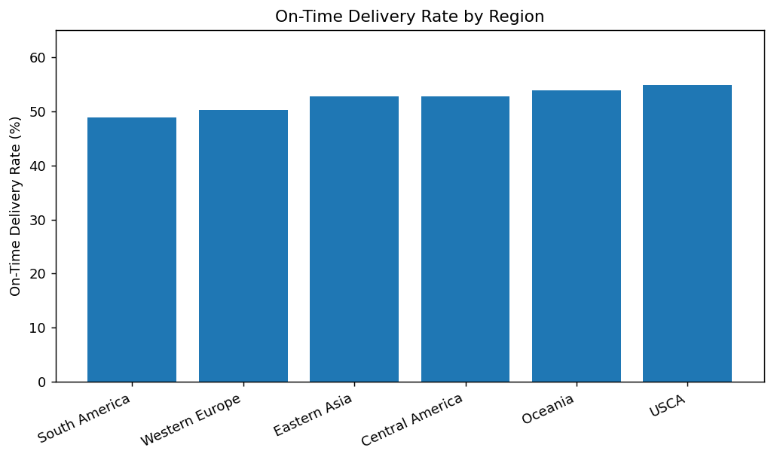
USCA records the highest on-time rate (54.8%), while South America records the lowest (48.8%). The difference suggests that geographic conditions, route design, carrier performance or customs/handling processes may need region-specific investigation. A ranked bar chart clearly exposes the lowest-performing regions.

4.4 Monthly Trend
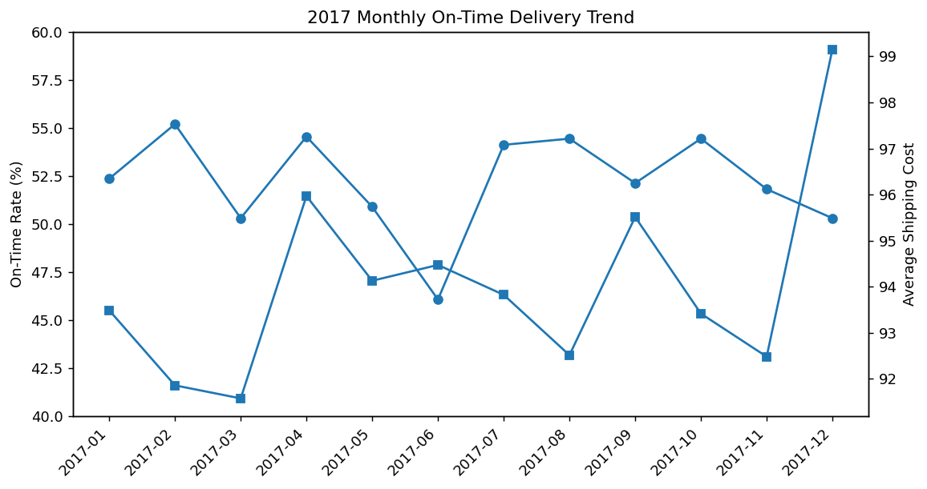
During 2017, monthly on-time performance varies rather than following a strong monotonic trend. The highest on-time rate occurred in 2017-02 (55.2%), while the lowest occurred in 2017-06 (46.1%). The trend chart is useful for monitoring seasonality or operational deterioration over time. The single record dated January 2018 was excluded from this monthly comparison so that it would not distort the 2017 trend.

4.5 Product Category Comparison
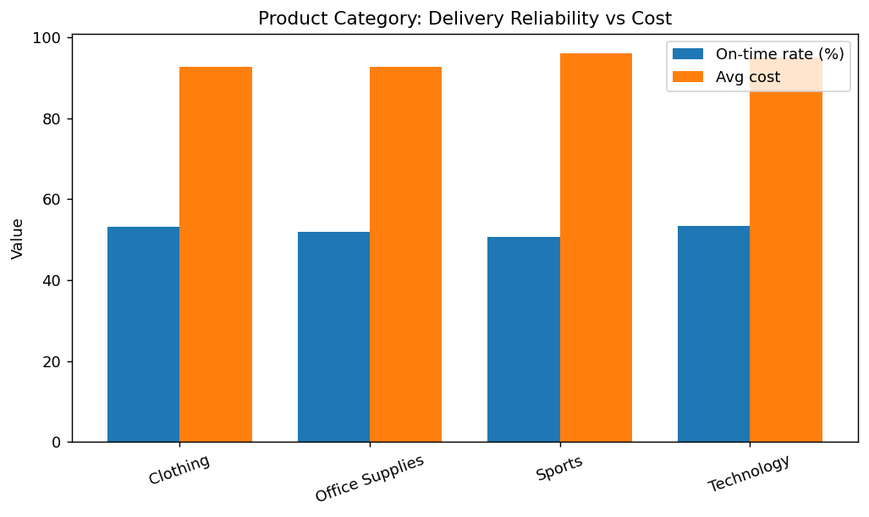
Technology has the highest on-time rate (53.4%), whereas Sports has the highest average shipping cost (96.07) and a relatively lower on-time rate (50.6%). This comparison can help logistics managers investigate whether particular product types require different packaging, handling or routing.

5. Key Performance Tables

5.1 Shipping Mode Summary
Mode | Shipments | On-Time % | Avg Delay | Avg Delivery | Avg Cost
Standard Class | 1130 | 53.9% | 0.70 | 4.42 | 85.83
Same Day | 113 | 53.1% | 0.71 | 1.71 | 129.15
First Class | 326 | 51.8% | 0.70 | 2.50 | 109.89
Second Class | 432 | 47.9% | 0.78 | 3.56 | 94.40

5.2 Regional Summary
Region | Shipments | On-Time % | Avg Delay | Avg Cost
South America | 334 | 48.8% | 0.76 | 92.78
Western Europe | 348 | 50.3% | 0.78 | 96.15
Eastern Asia | 313 | 52.7% | 0.69 | 94.09
Central America | 309 | 52.8% | 0.68 | 92.26
Oceania | 319 | 53.9% | 0.71 | 94.97
USCA | 378 | 54.8% | 0.68 | 93.87

6. Analytical Insights
- Delivery reliability is a major improvement opportunity: only 52.2% of shipments are on time.
- Nearly half of the shipments (47.8%) have at least one day of delay; delayed shipments average 1.50 days late.
- Distance is the clearest observed transportation-cost driver, with a correlation of 0.680.
- Shipment weight also contributes to cost (correlation 0.475), supporting weight-aware routing and carrier pricing analysis.
- Order consolidation improves unit economics: order quantity and cost per unit have a correlation of -0.686.
- South America is the weakest region by on-time performance (48.8%), so it should be prioritized for route/carrier investigation.
- Sports has the highest average shipping cost (96.07) and only 50.6% on-time delivery, making it a useful category for targeted process review.
- Standard Class handles 1,130 shipments and achieves a 53.9% on-time rate, making it operationally important because of its high volume.

7. Recommendations
- Implement exception-based monitoring for shipments whose actual delivery time exceeds the scheduled date, with alerts for high-priority and long-distance shipments.
- Review carrier and route performance in South America and other low-performing regions before changing network-wide policies.
- Use distance and weight as inputs to transportation-cost forecasting and route optimization models.
- Encourage shipment consolidation where service-level requirements allow, because higher order quantities are associated with lower cost per unit.
- Analyze the Sports category separately for packaging, dimensional weight, handling time and carrier assignment.
- Track monthly on-time rate, average delay, average shipping cost and cost per unit in a logistics dashboard to identify emerging operational problems.
- Validate the repeated Shipment_ID in the source system before production reporting because the two records contain different distance values.

8. Methodology and Python Tools
Python was used for data loading, cleaning checks, descriptive statistics, grouping, correlation analysis and visualization. Pandas was used for tabular data manipulation; NumPy supported numerical operations; Matplotlib produced the charts; python-docx was used to compile the final report.

Code Excerpt
df = pd.read_csv("Week2_Logistics_Cleaned_Data.csv")
df["Order_Date"] = pd.to_datetime(df["Order_Date"])
# Descriptive statistics
print(df.describe())
# Correlation analysis
num_cols = ["Distance_km", "Shipment_Weight_kg", "Order_Quantity",
"Scheduled_Days", "Actual_Delivery_Days",
"Shipping_Cost", "Sales_Value", "Delay_Days",
"On_Time", "Cost_per_Unit"]
print(df[num_cols].corr())
# Grouped logistics performance
mode = df.groupby("Shipping_Mode").agg(
shipments=("Shipment_ID", "count"),
on_time_rate=("On_Time", "mean"),
avg_delay=("Delay_Days", "mean"),
avg_cost=("Shipping_Cost", "mean")
)
# Visualization
plt.scatter(df["Distance_km"], df["Shipping_Cost"], alpha=0.35)
plt.xlabel("Distance (km)")
plt.ylabel("Shipping Cost")
plt.title("Distance vs Shipping Cost")
plt.show()

9. Conclusion
The analysis demonstrates how logistics data can be converted into actionable operational intelligence. The dataset shows an overall on-time delivery rate of 52.2% and a substantial delay burden. Cost analysis indicates that distance and weight are important drivers, while grouped analysis reveals meaningful differences across regions, shipping modes and product categories. Combining these visualizations with continuous KPI monitoring can help logistics teams reduce delays, improve route and carrier decisions, and control transportation costs.

10. Deliverables
The following supporting Python script was created alongside this report:
/mnt/data/week3_logistics_outputs/week3_logistics_analysis.py
All seven visualization outputs are embedded in this report and are also saved separately in the Week 3 output folder.

