MACHINE LEARNING CAPSTONE PROJECT

Customer Churn Prediction
Using Custom Logistic Regression
A scratch NumPy implementation benchmarked against Scikit-Learn

Student | Krishna Kumawat
Course | BTech - Computer Science & Engineering
Institution | JECRC University, Jaipur
Academic Year | 3rd Year
Report Date | 31 August 2026
Project objective: identify customers at risk of leaving a telecom service so that retention actions can be prioritized.

Executive Summary
This capstone project develops a binary customer churn classifier using Logistic Regression implemented from scratch with NumPy. The project follows a complete machine learning workflow: exploratory data analysis, data cleaning, feature engineering, categorical encoding, train-test splitting, feature scaling, class imbalance handling, model training, evaluation, and benchmarking against Scikit-Learn.
The dataset contains 7,043 telecom customers and 21 original columns. The target variable, Churn, is imbalanced: 5,174 customers did not churn and 1,869 customers churned. To give the minority churn class appropriate importance, class weights were incorporated into the custom weighted binary cross-entropy loss and gradient calculations.
The custom Logistic Regression model achieved 74.10% accuracy, 50.78% precision, 78.34% recall, 61.62% F1 score, and 0.8401 ROC-AUC. The Scikit-Learn benchmark produced almost identical performance, which provides practical validation that the custom implementation reproduces the expected behavior of Logistic Regression.

1. Problem Statement and Objective
Telecom companies lose revenue when customers discontinue their service. The goal of this project is to predict which customers are likely to churn, so that the business can focus retention efforts such as targeted offers, improved support, plan recommendations, or contract incentives on customers with higher predicted risk.
- Build Logistic Regression from scratch using NumPy rather than relying only on a library model.
- Handle real-world preprocessing issues and class imbalance.
- Evaluate the model using Accuracy, Precision, Recall, F1 Score, Confusion Matrix, and ROC-AUC.
- Benchmark the custom model against Scikit-Learn Logistic Regression.
- Translate model and EDA results into actionable business insights.

2. Dataset Overview
The project uses the Telco Customer Churn dataset (file: WA_Fn-UseC_-Telco-Customer-Churn.csv). It contains customer demographic information, subscribed services, account and contract details, charges, payment method, and the churn outcome.
Dataset Property | Value
Rows | 7,043
Original columns | 21
Target | Churn
No churn | 5,174 (73.46%)
Churn | 1,869 (26.54%)
Final encoded shape | 7,043 x 32
Model input features | 31
The target distribution shows a clear imbalance toward non-churn customers. This is important because a model that focuses only on overall accuracy could under-detect the customers the business most wants to identify.

3. Exploratory Data Analysis
EDA was used to understand customer behavior before modeling. The analysis focused on tenure, contract type, monthly charges, internet service, technical support, online security, payment method, paperless billing, senior citizen status, dependents, and partner status.
Feature | Observed association with churn
Contract | Month-to-month customers had a 42.71% churn rate, compared with 11.27% for one-year and 2.83% for two-year contracts.
Internet service | Fiber optic customers had a 41.89% churn rate, higher than DSL at 18.96%.
Tech Support | Customers without Tech Support had a 41.64% churn rate versus 15.17% for customers with Tech Support.
Online Security | Customers without Online Security had a 41.77% churn rate versus 14.61% for customers with it.
Payment method | Electronic check had the highest observed churn rate at 45.29%.
Paperless billing | Paperless billing customers showed 33.57% churn versus 16.33% for non-paperless customers.
Senior citizen | Senior citizens showed 41.68% churn versus 23.61% among non-senior customers.
Dependents / Partner | Customers without dependents or a partner showed higher churn rates than their counterparts.
Tenure / Monthly charges | Churned customers tended to have shorter tenure and generally higher monthly charges.
These are associations observed in the dataset; they should not be interpreted as proof of causation.
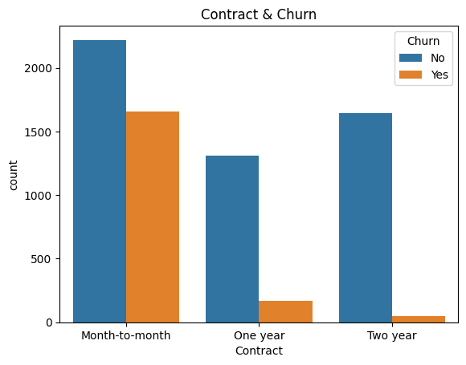
Figure 1. Contract type and churn counts.
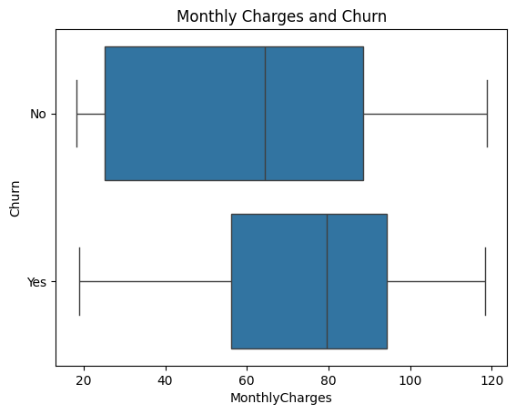
Figure 2. Monthly charges distribution by churn status.

4. Data Cleaning and Feature Engineering
The dataset did not contain standard null values initially, but TotalCharges was stored as an object column. Converting it to numeric revealed 11 blank-string entries. Those rows corresponded to customers with tenure equal to zero, so TotalCharges was filled with 0 rather than using a mean/median value or deleting the rows.
- Removed customerID because it is an identifier rather than a predictive behavioral feature.
- Converted TotalCharges to numeric and handled the 11 resulting missing values with 0.
- Verified category consistency, including legitimate categories such as No internet service and No phone service.
- Created Total_Services by counting selected subscribed services with value Yes.
- Mapped binary categorical variables to 0/1.
- Applied one-hot encoding with drop_first=True to multi-category features.
- Used an 80/20 stratified train-test split with random_state=42.
- Standardized input features with StandardScaler fitted only on the training set.

5. Class Imbalance Handling
The training set contained 4,139 non-churn samples and 1,495 churn samples. Balanced class weights were calculated so that errors on the minority churn class received more importance during training.
Class | Training count | Weight
0 - No Churn | 4,139 | ~0.68
1 - Churn | 1,495 | ~1.88
This weighting intentionally makes the model more sensitive to churn customers. In a retention use case, missing an actual churner can be more costly than contacting some customers who would have stayed.

6. Logistic Regression Implemented from Scratch
The custom classifier was written with NumPy. It uses a linear score, a sigmoid activation to convert the score into a probability, weighted binary cross-entropy loss, and gradient descent to update the model parameters.
Linear score: z = Xw + b
Sigmoid probability: p = 1 / (1 + exp(-z))
Weighted loss: -mean(sample_weight * [y*log(p) + (1-y)*log(1-p)])
Gradient descent: w = w - learning_rate*dw; b = b - learning_rate*db
The model initialized 31 weights to zero with a bias of zero, used a learning rate of 0.1, and trained for 2,000 iterations. Probabilities were clipped to a very small numerical range before logarithms were calculated to avoid log(0).
The weighted training loss decreased from 0.6931 at the beginning to approximately 0.4820 at the end, indicating that the optimization process learned a better decision boundary over the training iterations.
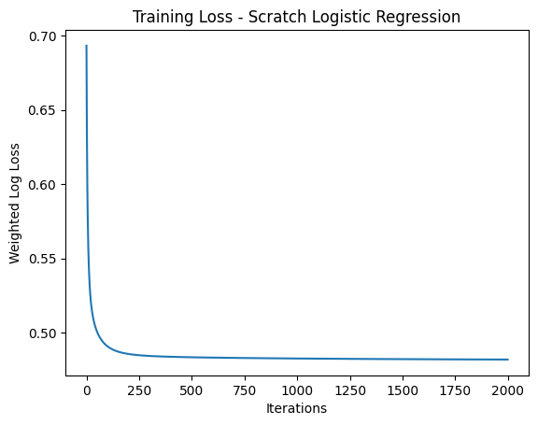
Figure 3. Weighted log-loss across 2,000 training iterations.

7. Model Evaluation
Predicted churn probabilities were converted to class predictions using a 0.5 threshold. Because the target is imbalanced and the business objective emphasizes finding churners, the evaluation considers multiple metrics rather than accuracy alone.
Metric | Scratch Logistic Regression | Scikit-Learn Logistic Regression
Accuracy | 74.10% | 73.88%
Precision | 50.78% | 50.52%
Recall | 78.34% | 78.34%
F1 Score | 61.62% | 61.43%
ROC-AUC | 0.8401 | 0.8415
The custom model correctly identified 293 churn customers and 751 non-churn customers. It missed 81 actual churners and incorrectly flagged 284 non-churn customers as churn. The 78.34% recall is particularly relevant for retention because the model captures a large majority of customers who actually churned.
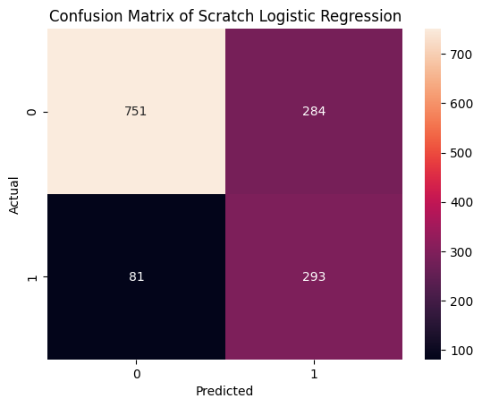
Figure 4. Confusion matrix for the custom Logistic Regression model.

8. Benchmark Against Scikit-Learn
A Scikit-Learn LogisticRegression model was trained on the same scaled training data with class_weight="balanced", max_iter=2000, and random_state=42. Its results are almost identical to the custom implementation. The custom model has slightly higher accuracy, precision, and F1, while the Scikit-Learn model has a slightly higher ROC-AUC; recall is exactly the same.
This close agreement is strong practical evidence that the from-scratch implementation correctly captures the main mechanics of Logistic Regression and class-weighted binary classification.

9. Business Insights and Recommendations
- Prioritize retention outreach for month-to-month customers, especially those with short tenure.
- Investigate service quality, pricing, or value perception among fiber optic customers because this segment shows comparatively high churn.
- Promote Tech Support and Online Security where suitable, as customers without these services showed substantially higher churn rates.
- Consider incentives that encourage movement from month-to-month contracts to longer-term contracts.
- Review the electronic-check customer journey and target high-risk users of this payment method with proactive retention communication.
- Use model probabilities to rank customers by churn risk instead of treating every customer equally.
The model should be used as a decision-support tool. A high-risk prediction identifies a customer for closer attention; it does not establish the reason the customer will leave.

10. Challenges and Solutions
Challenge | How it was handled
TotalCharges stored as object | Converted with pd.to_numeric(errors="coerce"); 11 blanks became NaN and were set to 0 because they corresponded to tenure=0 customers.
Class imbalance | Calculated class weights and applied per-sample weighting to the custom loss and gradients; used class_weight="balanced" for the Scikit-Learn benchmark.
Numerical stability in log-loss | Clipped predicted probabilities before applying logarithms to prevent log(0).
Fair comparison | Used the same stratified split and the same scaled feature matrices for both custom and Scikit-Learn models.

11. Limitations and Future Improvements
- The analysis is based on a single historical dataset, so performance may change on customers from another telecom provider or time period.
- The default 0.5 threshold is not necessarily the business-optimal threshold; future work could tune the threshold based on retention cost and expected customer value.
- The project focuses on Logistic Regression. Tree-based models such as Random Forest, Gradient Boosting, or XGBoost could be compared in future work.
- Cross-validation and hyperparameter tuning could provide a more robust estimate of generalization performance.
- Model monitoring would be required if the classifier were deployed because customer behavior and service offerings can change over time.

12. Conclusion
This project successfully implemented a class-weighted Logistic Regression classifier from scratch using NumPy for customer churn prediction. The complete workflow covered data understanding, EDA, cleaning, feature engineering, encoding, scaling, imbalance handling, manual optimization, evaluation, and benchmarking.
The custom model achieved 74.10% accuracy, 78.34% recall, 61.62% F1 score, and 0.8401 ROC-AUC. Its performance closely matched the Scikit-Learn benchmark, demonstrating that the scratch implementation is functioning as intended. From a business perspective, the model can help prioritize customers for retention efforts, while the EDA highlights customer segments that deserve further investigation and targeted action.

Appendix: Final Model Results
Item | Result
Scratch confusion matrix | [[751, 284], [81, 293]]
Initial weighted loss | 0.693147
Final weighted loss | 0.481996
Training iterations | 2,000
Learning rate | 0.1
Test split | 20% stratified
Random state | 42

