**Zomato Restaurant analysis report**

1. What is the total no. of tables present in the data?

**Ans** There are two tables present in the data. One table represent the raw data of Zomato company and second table represent the country data.

1. What is the total no. of attributes present in the data?

**Ans** There 20 attributes present in raw data table and 2 attributes present in country description table.

Fig2.1 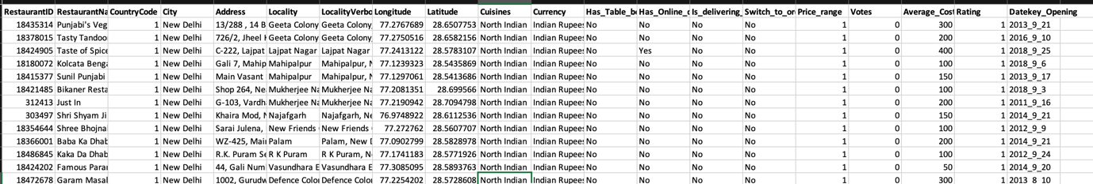

Fig 2.2

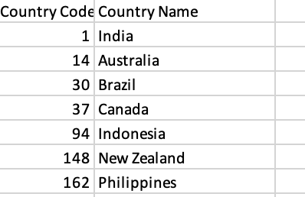

1. How many categorical columns are there in the data? [Search about categorical and continuous data, and try to answer this question]

Ans Categorical describes objects doesn’t involve measurable and there are total 11 columns in data set are categorical columns such as restaurant name, countryname, city, address, locality , LocalityVerbose, Cuisines, Currency, Has_Table_booking, Has_Online_delivery, Is_delivering_now, Switch_to_order_menu.

Continuous data represent measurement on continuous scale and there are total 8 columns are in continuous scale such as RestaurantID, country code, Longitude, Latitude, Price_range, Votes, Average_Cost_for_two, Rating Datekey_Opening.

1. The data consists of some inconsistent and missing values so ensure that the data used for further analysis is cleaned.

Ans Firstly In the given dataset date_key opening there are date written in wrong format which is not acceptable in excel so with the help of find and replace I changed format to date.

Fig 4.1

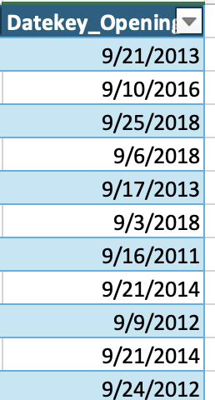

With the help of count blank function found 9 missing values in cuisines column and with the help of filter removed this blank columns to clean data for further analysis.

Fig 4.2

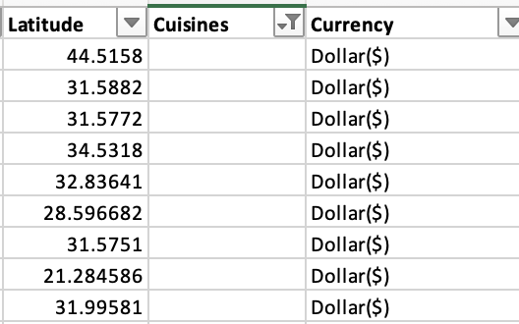

Added 2 new column currency exchange rate and standard cost that is INR of average of two person by converting other currency to INR.

Fig4.3

1. Using the LookUp functions, fill up the countries in the original data using the country code.

**Ans** For filling up the countries in the original data using the country code we will use vlookUp function =VLOOKUP([@CountryCode],country_description!$A$1:$B$16,2).

Fig 5.1

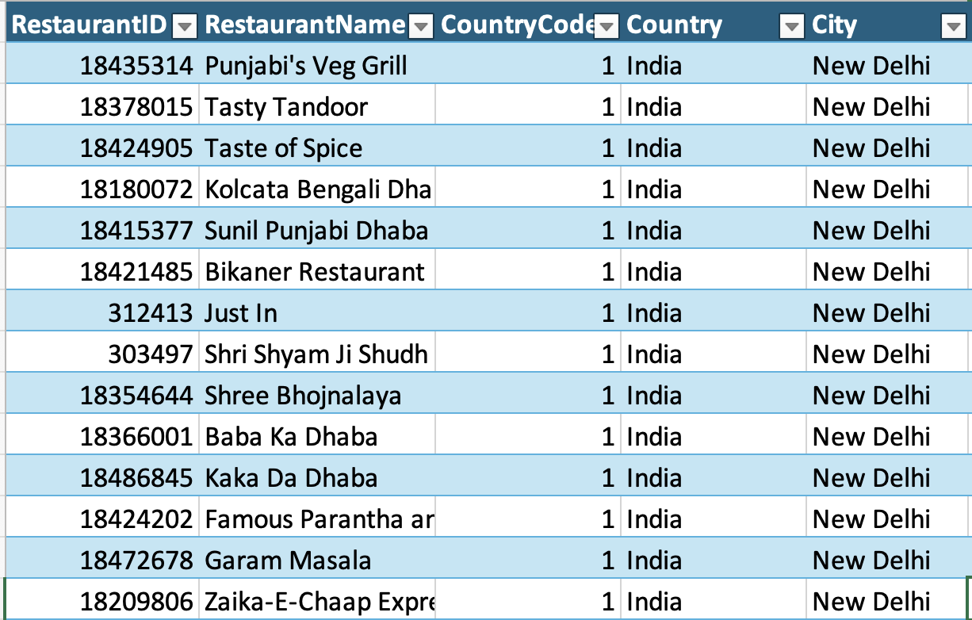

1. Create a table to represent the number of restaurants opened in each country.

Ans To create a table to represent the number of restaurants opened in each country we will use pivot table and count function in restaurant id because restaurant id is unique id given to each restaurant.

Fig 6.1

1. Also, the management wants to look at the number of restaurants opened each year, so provide them with something here.

Ans With the help of TEXT function we converted date to year and then by pivot table we found total number of restaurant opened in each year.

Fig 7.1

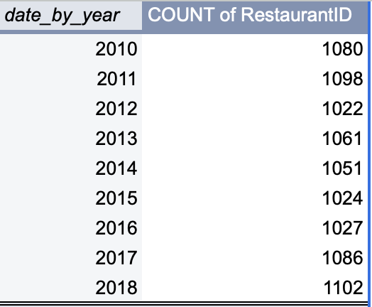

Fig 7.2

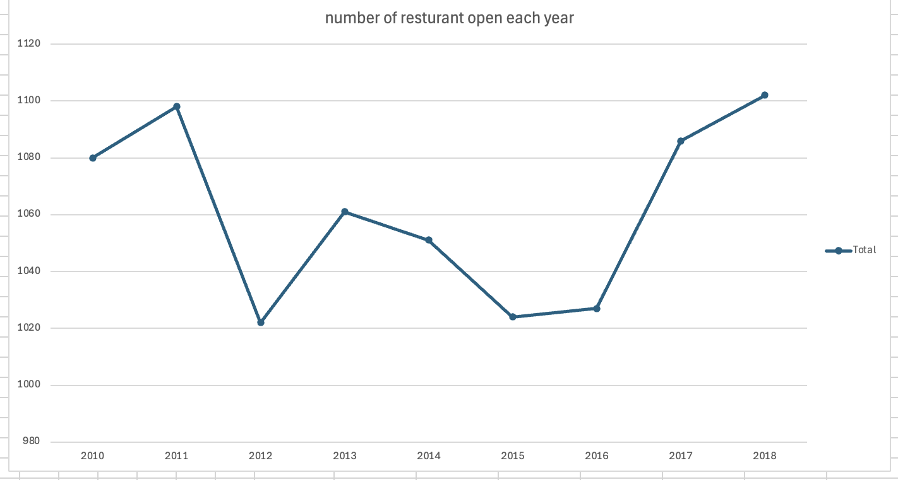

1. What is the total number of restaurants in India in the price range of 4?

Ans There are total 388 restaurant in India in the price range of 4. To find total number of restaurant I used sort and filter function like by sorting country to India and price range to 4 to find total restaurant falling in this category.

Fig 8.1

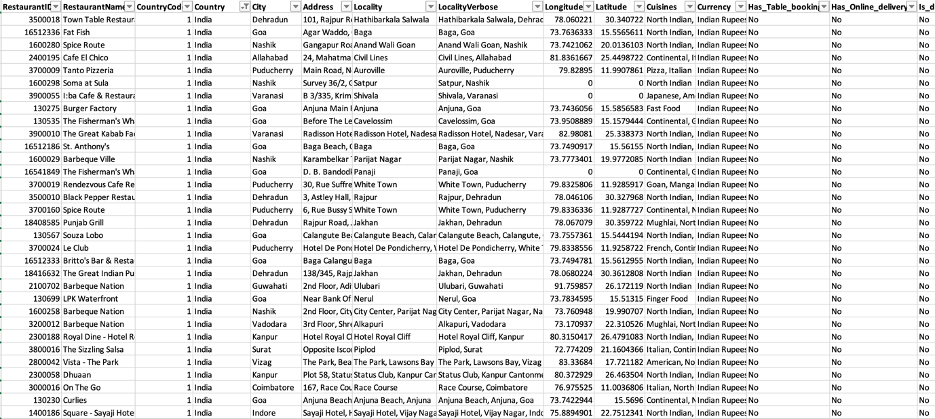

1. What is the average number of voters for the restaurants in each country according to the data?

Ans With the help of pivot table I filter average number of voters for the restaurant in each country

Fig 9.1

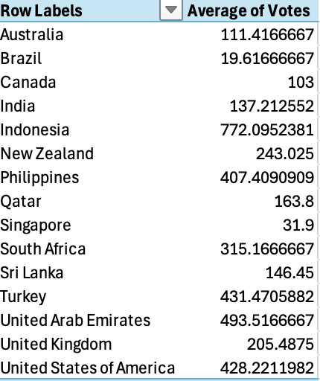

Fig 9.2

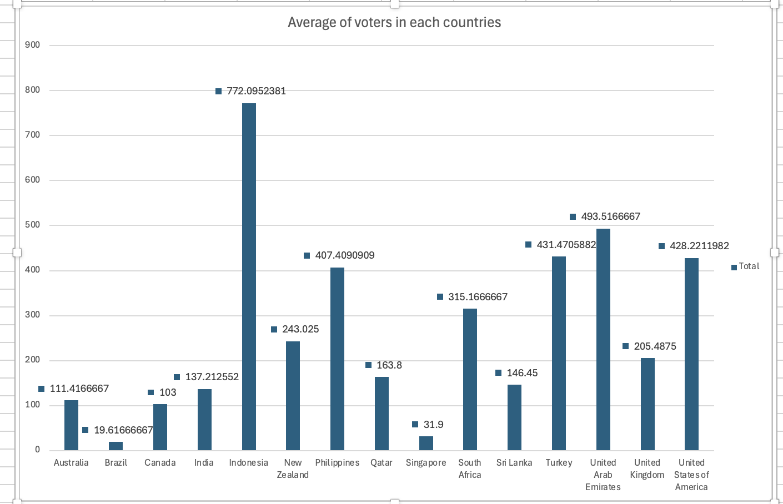

With the help graph it’s easy to understand most number of average voters for the restaurant are in Indonesia and least number voters are in Brazil.

1. Calculate the average rating for all the restaurants that have price range < 4 and provide online delivery. Use only the “IF” function, Logical Operators, and Aggregation functions to solve this problem. **[Note: Don’t use Conditional aggregation in this question.]**

**Ans** To calculate average rating of all the restaurant we will use averageifs function. Averageifs function is used to calculate average with multiple condition.

Formula of averagifs function is =AVERAGEIFS($T$2:$T$9552,$Q$2:$Q$9552,"<4",$N$2:$N$9552,"Yes")

The average rating of all the restaurants we got after applying the formula is 2.89.

1. Using Conditional formatting highlight the rows of restaurants that are located in the countries or cities that you’ve suggested to the management for opening new restaurants.

Ans approach: to highlight the rows of restaurants that are located in the countries or cities we will use following step:

I attempted to apply conditional formatting, but due to a technical error, I was unable to achieve the desired outcome.

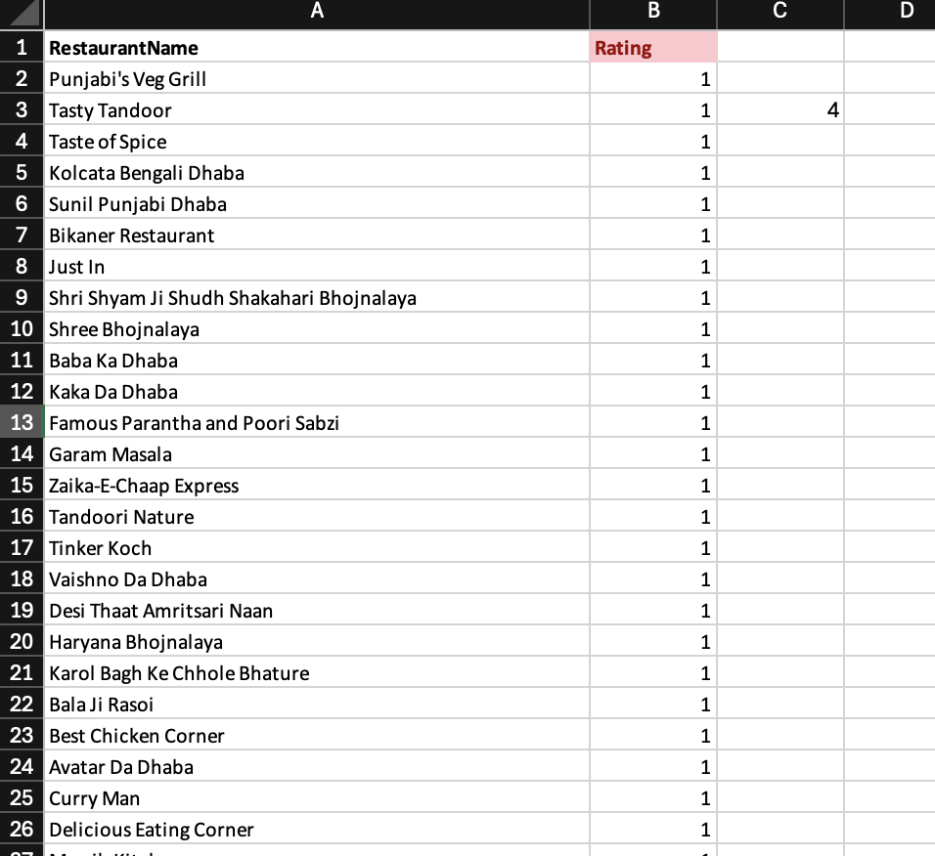

1. Create a new customized price column that consists of the abbreviation/symbol of the currency along with the Average_cost_for_two value. [Use string operations to do this task]

Ans Approach :- Extracted currency symbol from currency column with the help of text to column function and named as currency symbol.

Merged currency symbol column with average cost of two column with the help of CONCAT function and named as customised price

Fig 12.1

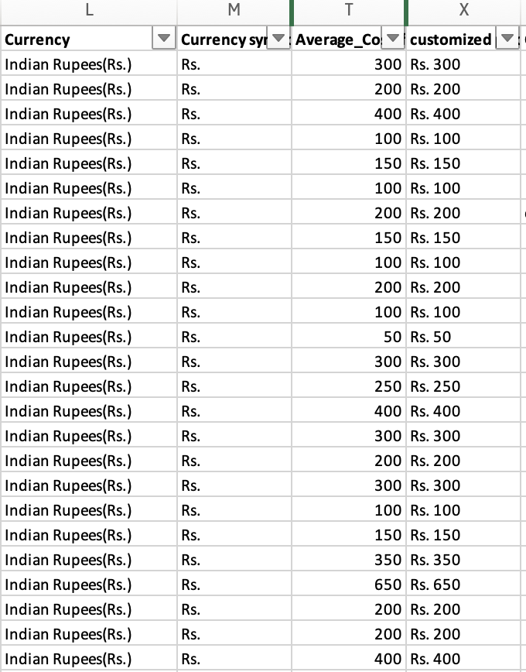

1. How can you create an array formula in Excel or Google Sheets to count the number of restaurants listed that do not offer online delivery, are in the lowest price range, and have an average cost for two people less than or equal to 250 Indian Rupees?

Ans Array formula that can perform multiple calculation on one more items in the array.

In this scenario, we have three conditions to consider:

1. **Online Delivery**: We do not offer online delivery, so we apply a condition of "no" in the online delivery column.
2. **Price Range**: The lowest price range is set at 1. Therefore, we apply a condition that the price must be equal to 1.
3. **Average Cost for Two People**: The average cost for two people must be less than or equal to 250. Thus, we apply a condition of less than or equal to 250.

By applying these conditions and then multiplying the results, we can sum them up to achieve our desired result of 1828.

Array formula =SUM((O:O="No")*(R:R=1)*(Z:Z<=250))

By applying array formula we got the result 1828

**Subjective Question:**

1. Suggest a few countries where the team can open newer restaurants with lesser competition. Which visualization/technique will you use here to justify the suggestions?

Ans Approach : The countries like Philippines, Turkey, Indonesia are few countries where we have highest average ratings and the restaurant count are less that’s why here chances of getting competition are less. With the help of bar chart we will able to identify those countries who have highest average ratings and the numbers of restaurant present in that countries.

Fig1.1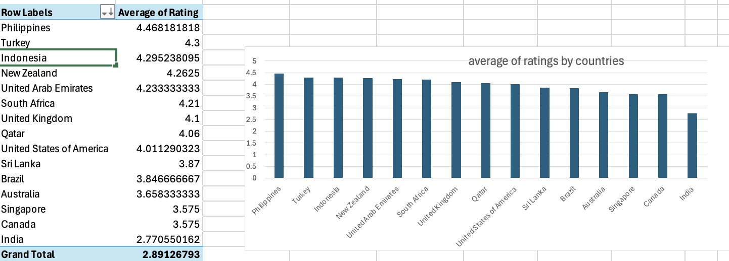

Above bar graph show the average ratings of all the countries, where top 3 are Philippines, Turkey, Indonesia.

Fig 1.2

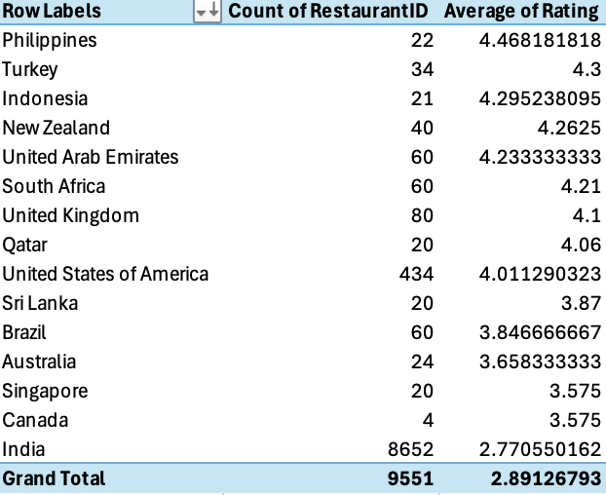

Above chart represent the count of restaurant in each countries here we can see that again Philippines, Turkey, Indonesia are those countries where restaurant counts are least that’s why we have opportunity to open new restaurants in this countries.

1. Come up with the names of States and cities in the suggested countries suitable for opening restaurants.

Ans Approach : To determine the optimal states and cities for opening restaurants in the Philippines, Turkey, and Indonesia, we utilized a pivot table.

In this pivot table, we organized the data with countries, states, and cities as rows, while including a count of existing restaurants. This approach allowed us to analyse how many restaurants are currently present in each state and city, providing valuable insights into market saturation and potential opportunities for new establishments.

Fig2.1 A graph on a white background

Description automatically generated

Fig 2.2

Fig 2.3

Insight: Figure 2.1 illustrates the distribution of restaurants across various cities in the Philippines. Notably, Mandaluyong City and Taguig City each have the highest number of restaurants, totalling four. In contrast, Quezon City and Tagaytay City have the fewest, with only one restaurant each.

Figure 2.2 presents data for Turkey, highlighting two cities: Ankara, which has 20 restaurants, and Istanbul, with 14 restaurants.

In Figure 2.3, the restaurant distribution in Indonesia is depicted, showing that Jakarta has the highest number of restaurants at 16, while Bandung has only one restaurant.

Overall, the Philippines exhibits a relatively even distribution of restaurants among its cities, whereas Indonesia’s restaurant presence is predominantly concentrated in Jakarta.

Recommendation: In the Philippines, it is advisable to concentrate on individual cities since they exhibit a nearly uniform number of restaurants. In contrast, Turkey should prioritize expansion in Istanbul, where the restaurant count is lower compared to other cities. For Indonesia, a strategic focus on cities like Bogor and Tangerang is essential, particularly by analyzing and understanding the preferred cuisines of the local population.

1. According to the countries you suggested, what is the current quality regarding ratings for restaurants that are open there?

**Ans** Approach: To evaluate the quality ratings of restaurants in specific cities, we create a pivot table that incorporates countries, cities, and their average ratings. Furthermore, we use a bar graph to illustrate the differences in ratings among various cities.

Fig 3.1

Insights: In the Philippines, Santa Rosa has the lowest rating among nine cities, with a score of 3.8, while Quezon City boasts the highest rating of 4.8. Other cities, including Taguig City, Tagaytay City, Mandaluyong City, and Makati City, have similar ratings ranging from approximately 4.5 to 4.6.

In Turkey, two cities have comparable ratings of around 4.3. Meanwhile, in Indonesia, Bogor holds the lowest rating at 3.85 among four cities, while Jakarta has the highest rating of 4.35.

Recommendation : The overall average rating of the three countries stands at 4.35, which is a commendable score. However, for cities like Quezon City, where the average rating is notably lower, it is essential to delve into the specific cuisines offered by local restaurants.

To enhance the dining experience and improve ratings, I recommend the following strategies:

• Analyse Customer Preferences: Conduct surveys or gather feedback to understand which cuisines are less favoured by customers in Quezon City. Identifying unpopular dishes can guide menu adjustments.

• Diversify Menu Options: If certain cuisines do not appeal to customers, consider introducing variations or alternatives that align better with local tastes. This could involve modifying existing dishes or incorporating popular regional Flavors.

• Promote Popular Dishes: Highlight and promote dishes that receive positive feedback. Effective marketing of these items can attract more customers and elevate overall ratings.

By focusing on these areas, restaurants in Quezon City can potentially improve their ratings and enhance customer satisfaction.

1. Also, what is the current expenditure on food in the suggested countries, so we can keep our financial expenditure in control?

Ans Approach : To analyse the current expenditure on food in Indonesia, the Philippines, and Turkey, we utilized a pivot table that included data on the average cost for two persons in each country. This approach allows for an organized comparison of food costs across the three nations.

For enhanced clarity and understanding of the data, we employed a pie chart. Pie charts are effective visual tools that represent data proportions, making it easier to grasp the relative expenditure on food in each country at a glance. This method of visualization is particularly useful in decision-making contexts, as it simplifies complex numerical data into an easily interpretable format.

Fig 4.1

Insights : The average cost for two people is highest in Philippines at ₹ 2345.95, while Turkey has the lowest average cost at ₹ 204.65 and in Indonesia its ₹ 1502.12.

Recommendation: The Philippines presents an ideal market for restaurant expansion due to its moderate average food expenditure among consumers. This balanced spending level suggests a promising opportunity for growth in the restaurant.

1. Come up with the names of restaurants from the recommended states that are our biggest competitors and also those that are rated in the lower brackets, i.e. 1-2 or 2-3.

Ans Approach : To identify the biggest competitors in the restaurant, I am focusing on restaurants in the Philippines, as the distribution of restaurants across cities is relatively uniform, making it easier to compare and assess competition. We will utilize a pivot table that includes the country, restaurant name, and average ratings. Additionally, a bar chart will be employed to visually represent and analyse the rating patterns effectively.

Fig 5.1

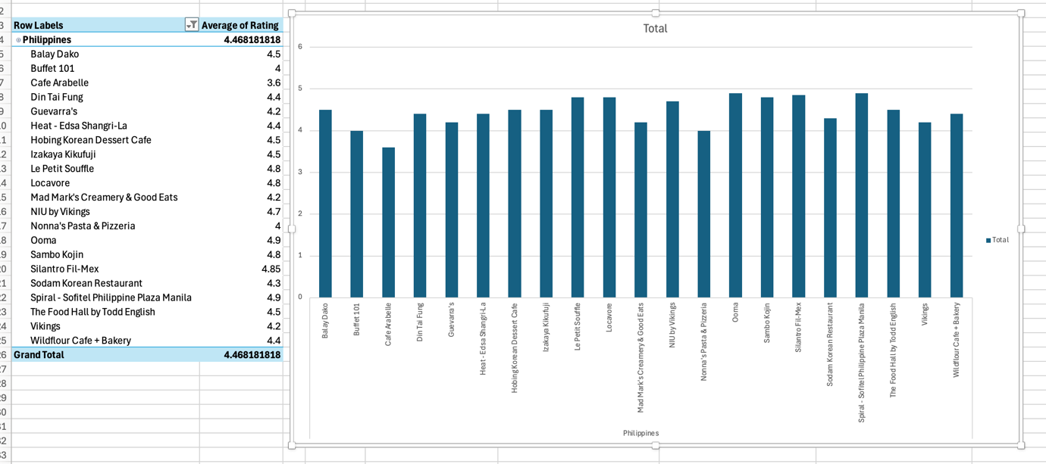

Insights : The highest-rated restaurants include Le Petit Soufflé, Locavore, Sodam Korean Restaurant, and Ooma, all of which have ratings exceeding 4.8. In contrast, Café Arabelle has the lowest rating at 3.6. Additionally, there are more than 11 restaurants that surpass the national average rating of 4.46. Notably, there are no restaurants rated in the lower tiers of 1-2 or 2-3.

Recommendation: I recommend Café Arabelle, which currently has the lowest rating among the restaurants. It would be beneficial to revise the cuisine menu based on customer preferences. Additionally, it’s important to analyze whether customers prefer ordering online or booking a table, and make adjustments accordingly.

1. Which cuisines should we focus on in the newer restaurants to get better feedback? Does the choice of cuisines affect the restaurant ratings?

Ans Approach : To analyse the types of cuisines preferred by different countries, we can utilize a pivot table that organizes data into three key components: countries, cuisines preferred by those countries, and the number of ratings each cuisine receives. This approach allows for a clear comparison of preferences across various nations.

To simplify and visualize the results derived from the pivot table, a bar chart can be employed. This chart will effectively display the number of ratings for each cuisine, making it easier to identify trends and preferences at a glance.

Fig 6.1

Insights : In Indonesia, most people prefer sushi and Sundanese cuisine, which have received the highest average ratings. In the Philippines, European, Asian, Indian, and Japanese sushi are particularly favoured. When considering Turkey, bar food and world cuisine rank as the top preferences among the majority. Notably, Japanese sushi is celebrated in both Indonesia and the Philippines, with both countries giving it an impressive average rating of 4.9.

1. According to our current data, should we go for online delivery and table booking? Does that affect the customer’s ratings?

As To understand the impact of online delivery and table booking we used two types of graphs one is bar chart and second is pie chart.

Fig 7.1

With the help of Bar chart we can clearly understand online delivery and table booking have impact in rating as we can see in all the three countries none of the customer said yes for online delivery that indicated we should go for table Booking but as we can see that Indonesia and Turkey customers are not interested in table booking only Philippines customers selected yes for table booking.

Fig 7.2

With the help of Pie chart we understand how many customers prefer table booking in Philippines and it’s impact on rating of restaurant. As we can see 14 restaurant out of 22 preferred table Booking and also they gave 4.49 average rating to the restaurant means the ratings and the table Booking are related to each other and in Philippines those who chosen table booking gave more ratings to the restaurant.

1. Should the team keep the rate of cuisines higher? Will that affect the feedback? According to our data are the rates of cuisines and ratings, correlated?

Ans Approach : To explore the relationship between cuisine rates and their ratings, I initially created a pivot table to calculate the average ratings and average costs in Indian Rupees (INR) for the cuisines from Indonesia, the Philippines, and Turkey. Subsequently, I visualized this data using a scatter plot to better understand the correlation between these variables. I also utilized the correlation function to determine the relationship between the average rating and the average cost in two standard currencies (INR).

The formula is:

=CORREL(Table2[[#All],[Rating]],Table2[[#All],[avg_cost_of_2_standard_currency_INR(₹)]])

Value is:



Fig8.1

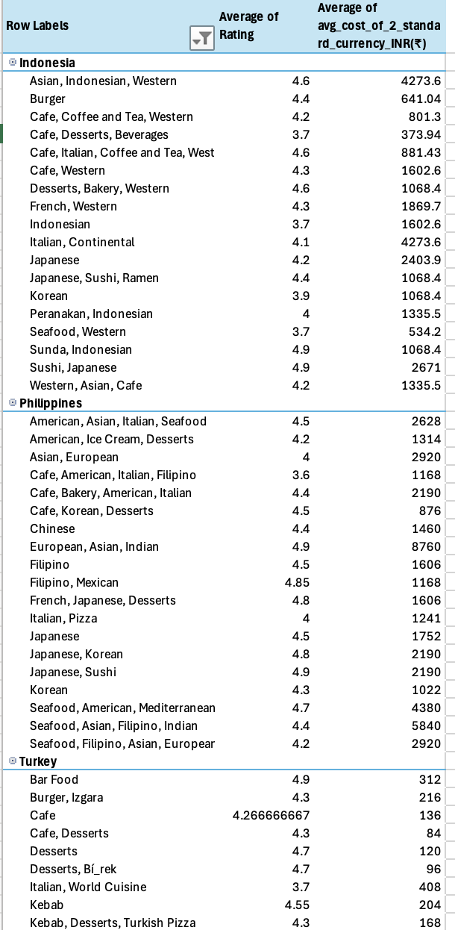

Fig 8.2

Insights: A correlation value of approximately 0.3424 suggests a positive relationship between average ratings and average costs. This indicates that as the average rating increases, there is a tendency for the average cost to also increase, albeit slightly. However, the correlation strength is relatively weak, implying that the relationship is not very robust.

The graph further illustrates this point, showing an upward trend but not a significant rise. Thus, while there is a slight increase in average cost with higher ratings, the correlation does not indicate a strong or definitive relationship between these two variables.

1. What is the distribution of the number of restaurants of different price ranges in all the countries?

Ans To understand the distribution of number of restaurants of different price ranges in all the country all the countries used pie chart.

Fig 9.1

Fig 9.2

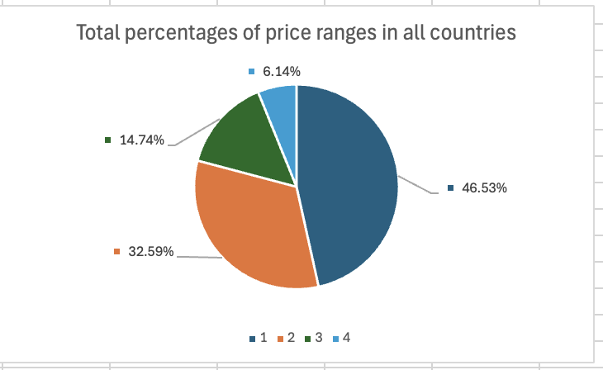

With reference of pie chart we can clearly see price range of one hold majority of percentage that 46.53 followed by price range of two then three and last four. But if remove India, then we can see that in table the price range of three and four hold majority of percentage compared to price range of one and two.

1. Explain your approach in brief for suggesting countries/cities in order to open new restaurants, if the objective and subjective questions would have not been given to assist you. **[you have to give bullet pointers in order to answer this question]**

**Ans**

* To understand kind of data and attributes.
* To find error, missing values, irrelevant values, outliers and remove them.
* To streamline the data by merging data from different tables.
* Utilizes various functions, such as aggregate functions, lookup functions, and conditional statements, to generate more specific data.
* To create pivot table to understand the data and compare data to find valuable insights.
* To achieve a clearer understanding of your data, consider using visualization tools such as pie charts and graphs.
* First to understand number of votes each countries restaurant got and then identify countries where we got majority of votes.
* To find of top rating restaurant in particular countries
* To understand number of restaurant created in recent years
* To understand types of cuisines most of the voters like.
* To examine the price ranges prefer by customers
* To understand the like online delivery or table booking system

**DASHBOARD**

