Unit 1
Importance of Textile WET Processing
Textile wet processing is crucial in the textile industry because it enhances the quality, appearance, and functionality of fabrics. The process involves various treatments applied to textiles using water or other liquids, and it plays a key role in turning raw fabrics into finished products. Here are some key points that highlight the importance of textile wet processing:
1. Improving Fabric Quality
Wet processing helps in refining the quality of fabrics by removing impurities, dust, and natural oils. It makes the fabric softer, smoother, and more uniform, leading to a better feel and enhanced durability.
2. Coloring and Dyeing
Dyeing is a critical step in textile wet processing. It adds vibrant colors to fabrics, making them visually appealing. Different dyeing techniques such as batch dyeing, continuous dyeing, and garment dyeing give textiles the desired shade and consistency. Proper dyeing is essential for color fastness and resistance to fading over time.

3. Enhancing Fabric Properties
Wet processing allows the enhancement of fabric properties like moisture absorption, resistance to shrinkage, and breathability. Special finishes can be applied to fabrics to make them water-resistant, stain-resistant, flame-retardant, or UV-protective.

4. Finishing for Aesthetic Appeal
Finishing treatments like calendaring, embossing, and softening are applied during the wet processing phase to improve the appearance and feel of fabrics. These finishes give textiles a smooth, glossy, or textured surface based on the desired product.

5. Fabric Softness and Comfort
Textiles are often treated with softeners during wet processing to improve comfort and wearability. Softening agents can enhance the texture of fabrics, making them more comfortable to wear, especially in clothing.

6. Functional Finishes
Wet processing enables the application of functional finishes like wrinkle resistance, easy care, anti-bacterial properties, and anti-odor treatments. These finishes improve the performance and functionality of textiles in a variety of applications, from casual wear to industrial textiles.

6. Fabric Softness and Comfort
Textiles are often treated with softeners during wet processing to improve comfort and wearability. Softening agents can enhance the texture of fabrics, making them more comfortable to wear, especially in clothing.

7. Functional Finishes
Wet processing enables the application of functional finishes like wrinkle resistance, easy care, anti-bacterial properties, and anti-odor treatments. These finishes improve the performance and functionality of textiles in a variety of applications, from casual wear to industrial textiles.

Need for preparatory Process
Natural fibre contains impurities like waxes, pectin, protein, dust dirt. Added undesirable matter like sizes to impart strength which makes it hydrophobic. Hence the preparatory process is done to convert the hydrophobic nature of raw textile material to hydrophilic nature.
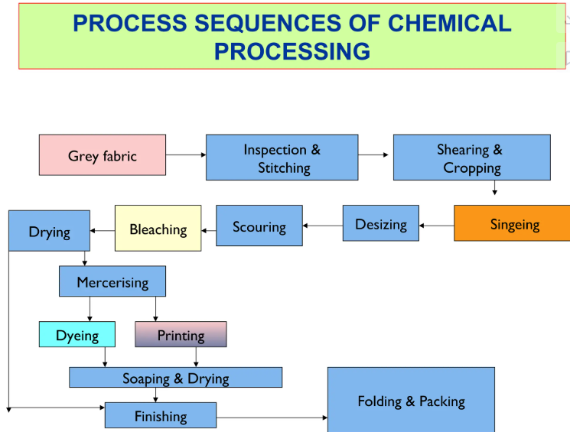
• Pretreatment:
Objective: To prepare the fabric for further processing by removing impurities(natural and added), enhancing fabric properties, and improving dye absorption. To improve appearance of fabric(Whiteness),to make suitable for other process like Dyeing, Printing and finishing. This step includes several operations such as shearing and cropping, singeing, desizing, scouring, bleaching and mercerisation.
• Shearing and Cropping
Objective: To trim the fabric surface and remove uneven fibers (like fuzz or nap) in order to create a smooth, uniform surface. This is typically done on fabrics like velvets or fleece. Cropping involves cutting or trimming the pile or surface fibers of a fabric. It's typically used to remove excess pile from fabrics like terry cloth or pile fabrics to give them a uniform appearance

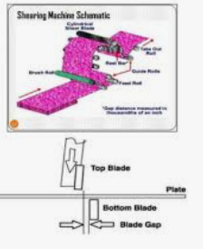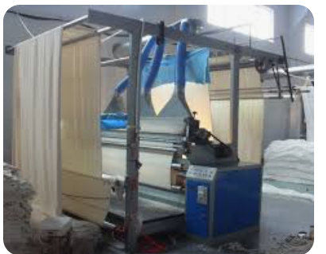
• Singeing:
Objective: To burn off excess fibers or fuzz from the fabric surface to improve smoothness and brightness. This is usually done by passing the fabric over a flame or heated wire, preventing any loose fibers from interfering with the fabric's final appearance. The word singe means” burn superficially or burn lightly”. The process removes protruding fibres from the textile substrate.It improve smoothness/ uniform surface of the textile substrate.
Types of Singeing
- Plate singeing
- Roller singeing
- Gas Singeing
Plate singeing machine
In this type of singeing machine, the cloth passes over and in contact with one or two heated curved copper plates. The thickness of the plates ranges from 1 to 2 inches. The heating of the plates is done by a suitable burning arrangement of gas mixed with air.
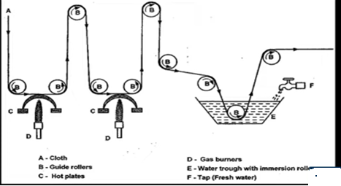
Plate singeing machine
b) Roller Singeing machine
In this type of singeing machine the cloth passes over a hollow cylinder which revolves slowly in the opposite direction of the goods. The hollow cast iron or copper cylinder is fired internally. The fabric gets singed and runs through water bath for quenching and plaited.
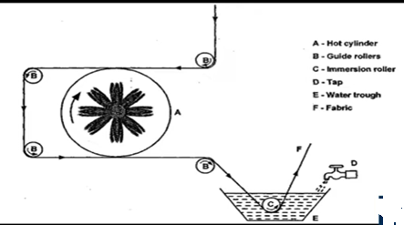
Roller Singeing Machine
3) Gas singeing machine
It is most commonly used technique for woven goods. It consists of two or more burners and are adjustable with respect to width and thickness. When the cloth is drawn over the flame at high speed, the flame impinges on its surface and burns the protruding fibres, without damaging the cloth. The flame is adjusted to burn the interstices of warp and weft. Once the singeing is completed, fabric is passed through the trough of water followed by two-roller padding mangle.
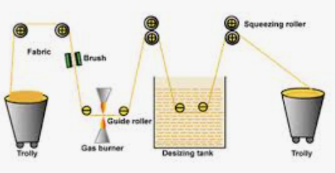
• Desizing:
Objective: To remove the sizing agents (starches, gums, or resins) applied to fabrics during weaving. These agents are used to stiffen the fabric during production, but they need to be removed before further treatments like dyeing and finishing to ensure the fabric accepts dyes properly.
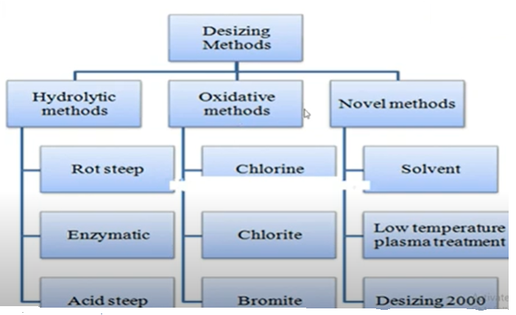
Hydrolytic desizing
Rot steeping: An inexpensive method that involves passing the fabric through warm water
Acid Steeping- The fabric is steeped in dilute acid solution (HCl /H2SO4) for one hour at 50°C with material to liquor ratio (MLR) 1:20. The starch present in the cloth is liquefied and solubilised starch is removed by washing. Since, acids can attack cellulose; precaution has to be taken to avoid tendering of cotton fabric. It is essential to neutralize the fabric to avoid hydrolytic damage. The fabric should be washed first with hot water after desizing, since cold water reduces the solubility of de- graded products present in the fabric.
Enzyme desizing: Enzymes are categorized into different types such as; vegetable, animal and bacteria. Malt extract based enzyme (amylase) is usually preferred for enzymatic desizing of cotton fabric under neutral pH. They are activated in a wide range of temperature and pH levels based on the type of enzyme. The main advantage of enzyme desizing is that when the temperature increases beyond the optimum level (i.e., 75- 80°C), fabric damage is avoided since the enzyme itself gets deactivated. The fabric is immersed in enzyme solution for 1 to 2 hours at 60° C - 80°C thoroughly washing with hot water and then with normal water.
Conditions for enzymatic desizing.
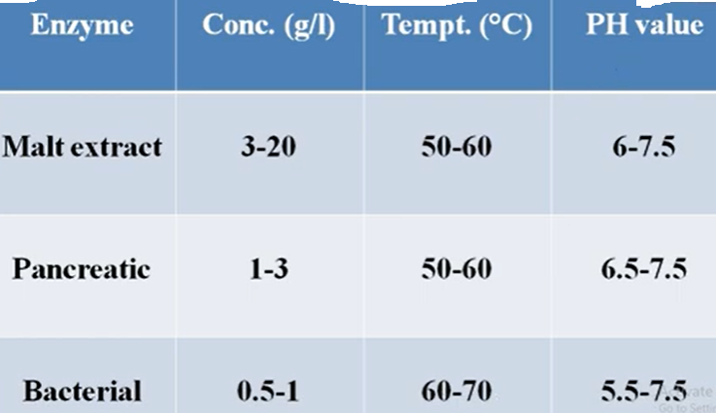
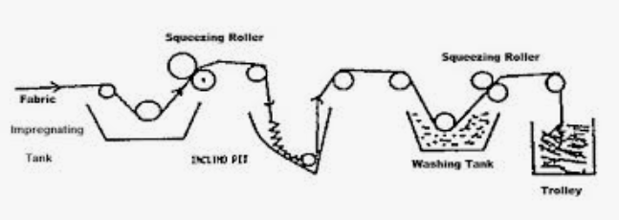
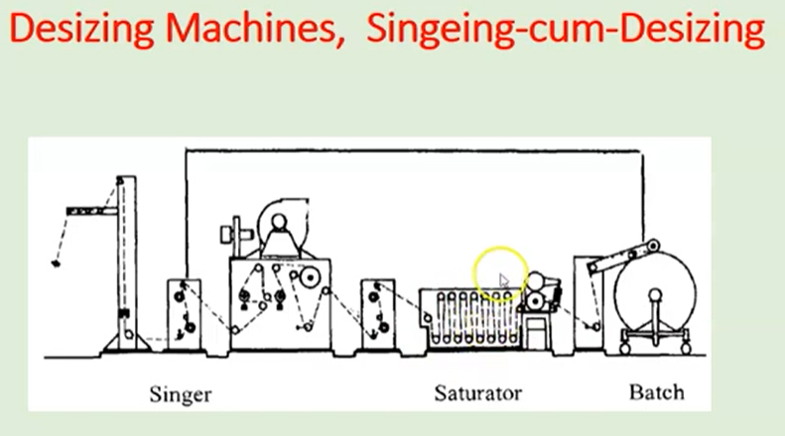
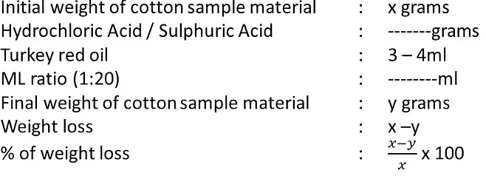
• Scouring:
Objective: To remove natural oils, dirt, and other impurities from the fabric, particularly for cotton and wool. This makes the fabric more receptive to dye and other treatments. Scouring helps to clean the fabric, making it more absorbent.
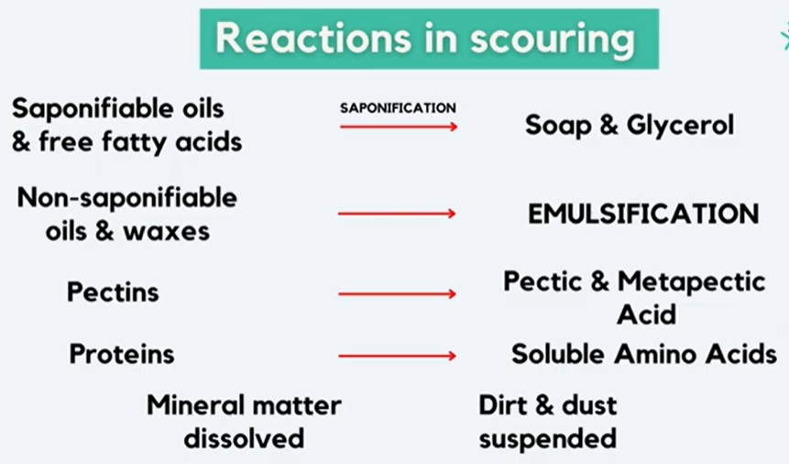
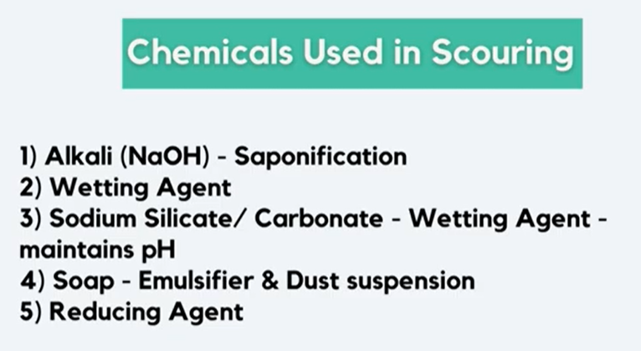
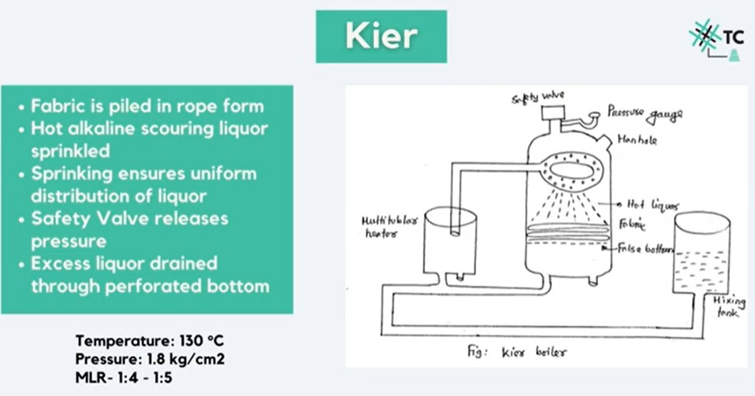
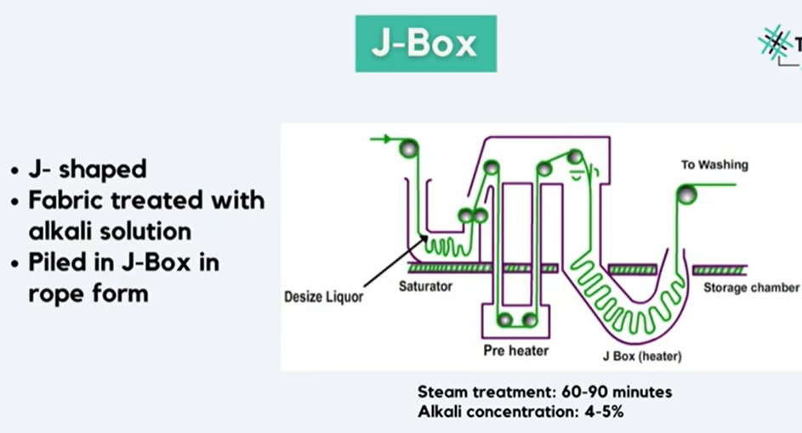
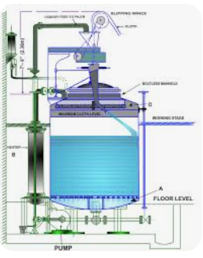
• Bleaching:
Objective: To whiten or lighten the fabric by removing or altering the natural color. This is typically done using strong oxidizing agents like hydrogen peroxide or sodium hypochlorite, and it's often used before dyeing to ensure uniform color absorption.
• Mercerisation:
Objective: To improve the luster, strength, and dye affinity of cotton fabrics. This is done by treating the fabric with sodium hydroxide (caustic soda), which causes the fibers to swell and changes their structure, resulting in improved characteristics.
• Dyeing:
Objective: To add color to the fabric by applying dyes in a liquid form. The aim is to achieve the desired color fastness and aesthetic appearance. This process is crucial for creating the wide range of colors used in textile products.
• Printing:
Objective: To apply specific designs or patterns onto the fabric, usually through a technique like screen printing, rotary printing, or digital printing. Unlike dyeing, which typically colors the entire fabric, printing adds color in distinct areas to create patterns.
• Finishing:
Objective: To enhance the fabric’s final appearance, texture, or performance. Finishing includes processes such as softening, waterproofing, wrinkle resistance, or flame resistance. This can also include aesthetic finishes like embossing or adding gloss.

