MedTrack Healthcare Management System
Project Documentation

Project Description:
MedTrack is a Flask healthcare management application for patients, doctors, and administrators. It supports registration, clinician discovery, appointment scheduling, medical history, diagnosis records, role-specific dashboards, and notifications. Local Mode provides JSON-backed storage for development. On EC2, AWS Mode can use an attached IAM instance profile so Boto3 retrieves temporary AWS credentials without keys in .env.

Scenarios

Scenario 1: Patient appointment booking
A patient registers, browses clinician profiles, selects a date and available time, and submits a booking. MedTrack stores the appointment and can publish an SNS update.

Scenario 2: Doctor review and diagnosis
A doctor reviews visits and schedule, opens patient history, updates appointment status, and records a diagnosis linked to the visit.

Scenario 3: Role-specific administration
An administrator reviews users, appointments, diagnoses, and notifications through protected routes.

Project Scope and Technologies
• Application: Python, Flask, Jinja, HTML, CSS, JavaScript.
• Data: six DynamoDB tables and GSIs in AWS Mode; JSON-backed local storage in Local Mode.
• Notifications: Amazon SNS in AWS Mode and a local notification mock in Local Mode.
• Identity: Flask sessions, Werkzeug password hashing, Patient, Doctor, and Admin roles.
• Deployment: EC2 with IAM instance profile; Gunicorn/Nginx production path.

Technical Architecture:
The browser sends requests to Flask routes and blueprints. The application validates input and applies role checks. Model classes use local storage or DynamoDB. The notification service uses a local publisher or Amazon SNS. EC2 instance-profile credentials are obtained through Boto3.
Architecture flow: Browser UI → Flask routes and role checks → application models → Local JSON storage or DynamoDB. Notification service → local log or SNS. EC2 IAM instance profile → Boto3 credential provider chain → DynamoDB and SNS.

Component Description:
• Presentation: responsive Jinja templates and shared styles.
• Application: app factory registers authentication, patient, doctor, admin, and API blueprints.
• Persistence: app/models/dynamodb.py and app/models/local_storage.py.
• Notifications: app/services/sns.py dispatches appointment and diagnosis alerts.
• Cloud access: Boto3 standard provider chain, including EC2 instance-profile credentials.

Pre-requisites:
• Python 3 and pip; install packages with pip install -r requirements.txt.
• For AWS Mode, an EC2 instance with attached IAM instance profile and network access to AWS APIs.
• An SNS topic and required DynamoDB tables/GSIs in the selected region.
• A private production SECRET_KEY and FLASK_DEBUG=False on EC2.

Project Workflow:

Milestone 1: Architecture and environment
Set up Flask, blueprints, local persistence, and AWS service adapters.

Milestone 2: Core healthcare workflows
Implement registration, role routing, doctor discovery, booking, schedule review, diagnosis, history, and notifications.

Milestone 3: Data model and AWS resources
Create six DynamoDB tables and the indexes used by model queries; configure SNS topics.

Milestone 4: EC2 IAM role
Attach an IAM role through an instance profile. Boto3 retrieves and refreshes temporary metadata credentials; do not store keys in .env.

Milestone 5: Run and validate
Export AWS region/topic values, initialize tables if needed, run python app.py, and check /health.

AWS EC2 Setup Without Stored AWS Keys
Attach the EC2 instance profile, clone the repository, and install dependencies. Export only non-secret AWS configuration. This example sends both notification types to one SNS topic.
git clone <repository-url>
cd medtrack-aws-healthcare-system
pip install -r requirements.txt
export AWS_MODE=auto
export AWS_DEFAULT_REGION=us-east-1
export SNS_TOPIC_ARN=arn:aws:sns:us-east-1:ACCOUNT_ID:MedTrack-Alerts
export FLASK_ENV=production
export FLASK_DEBUG=False
export SECRET_KEY="$(python3 -c 'import secrets; print(secrets.token_hex(32))')"
# One-time DynamoDB setup requires dynamodb:CreateTable and dynamodb:UpdateTable
python scripts/init_dynamodb.py
# Start the app
python app.py
The EC2 role supplies credentials automatically. The runtime role needs the DynamoDB read, write, query, and scan actions used by the app and sns:Publish on the configured topic. Initial setup also needs dynamodb:CreateTable and dynamodb:UpdateTable. Normal app startup does not create tables.
The direct Flask server listens on port 5000. Restrict inbound TCP 5000 to a trusted source for a preview. For public production traffic, use Gunicorn behind Nginx with HTTPS.

How AWS Credentials Are Discovered
In AWS_MODE=auto, MedTrack asks Boto3 for credentials through its standard provider chain. On EC2, Boto3 retrieves and refreshes temporary credentials from the attached instance profile. AWS_DEFAULT_REGION is supported; AWS_REGION takes precedence if both are set. If the role is missing or an AWS client cannot initialize, startup fails visibly. The /health response reports mode, database_backend, and AWS region.

Security and Operational Notes
• Never commit AWS access keys or production secrets.
• Grant only required DynamoDB/SNS actions; limit SNS publish to the configured topic.
• Use a strong private SECRET_KEY. Changing it invalidates existing sessions.
• Set FLASK_DEBUG=False, restrict inbound access, and use HTTPS behind a production proxy.
• Project materials do not establish regulatory compliance or production readiness for real patient data.

Exploring the Website’s Web Pages:
Screenshots supplied for this documentation. Account values are blurred in selected images.

Home Page
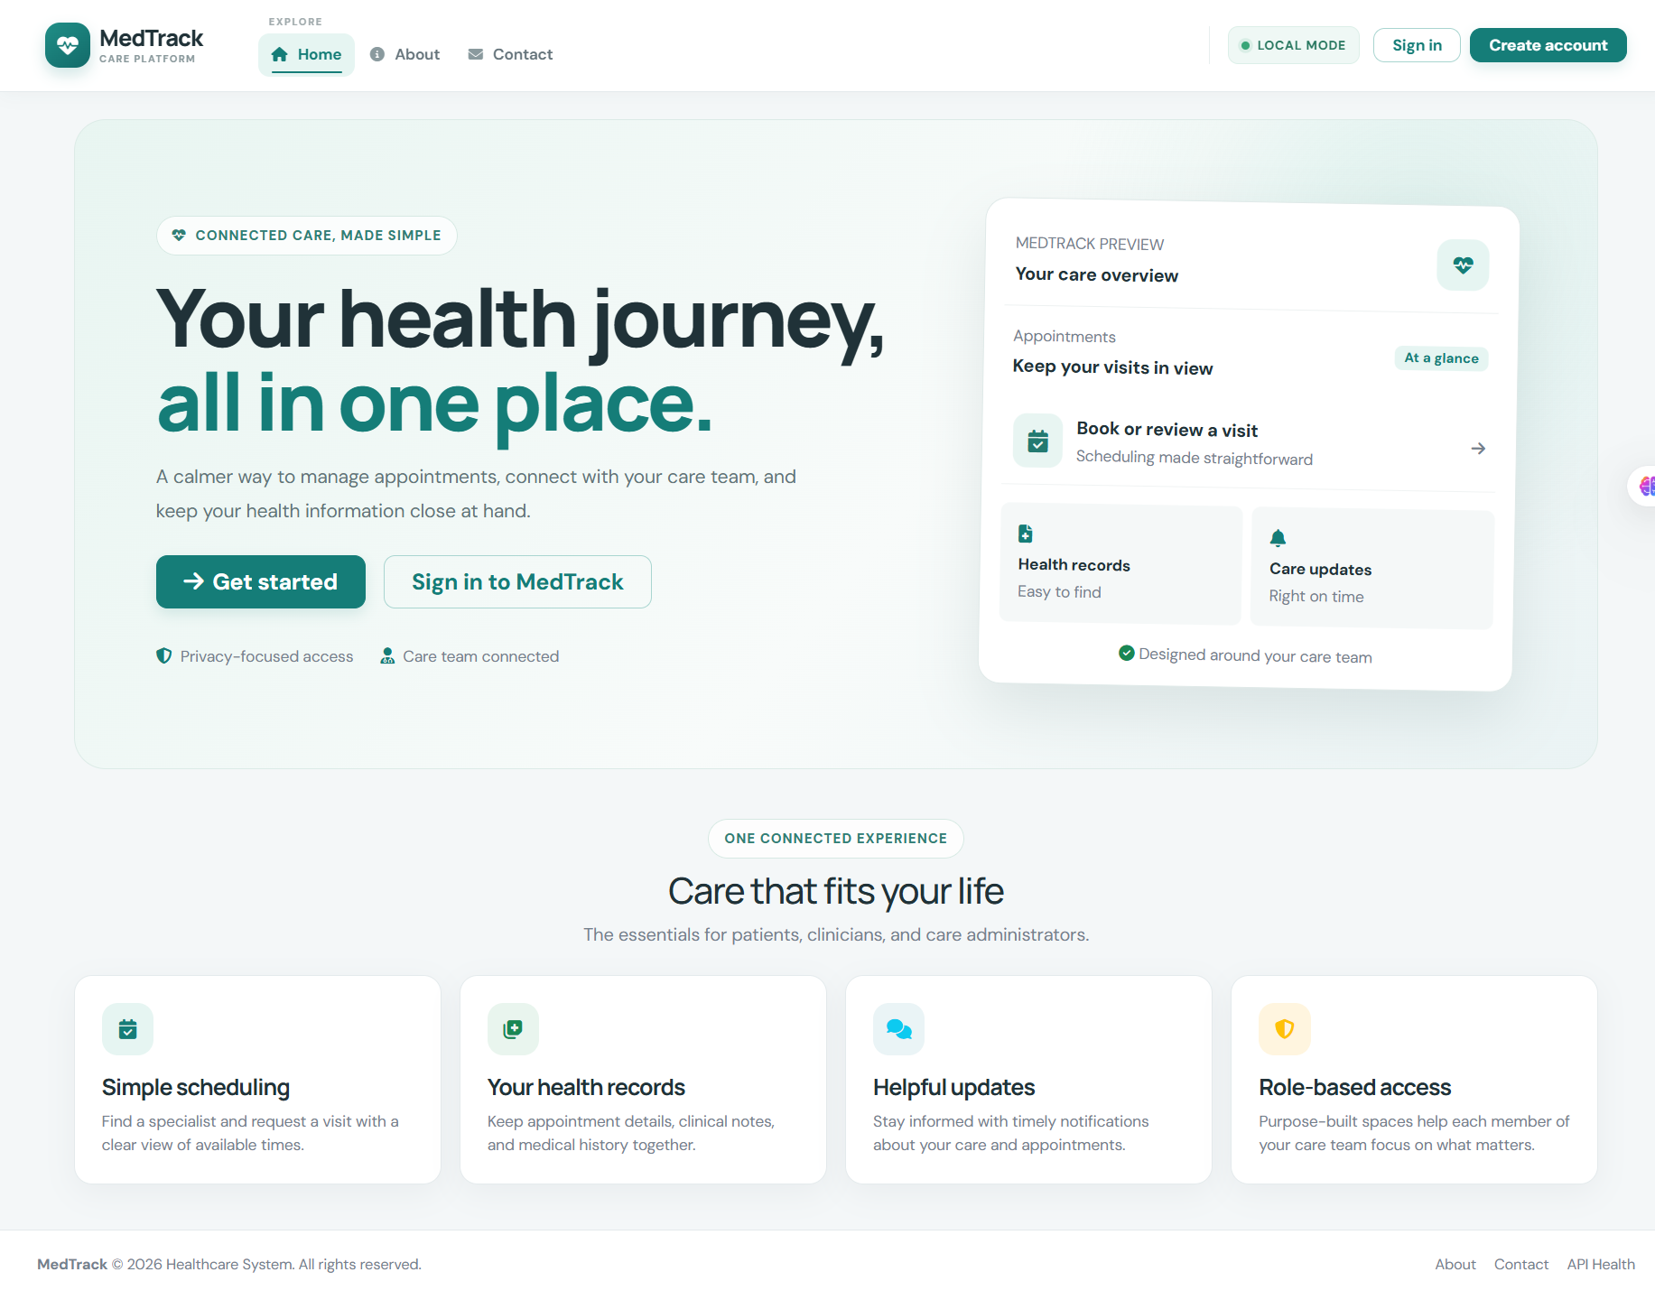
Figure 1. MedTrack public home page.

Create Account
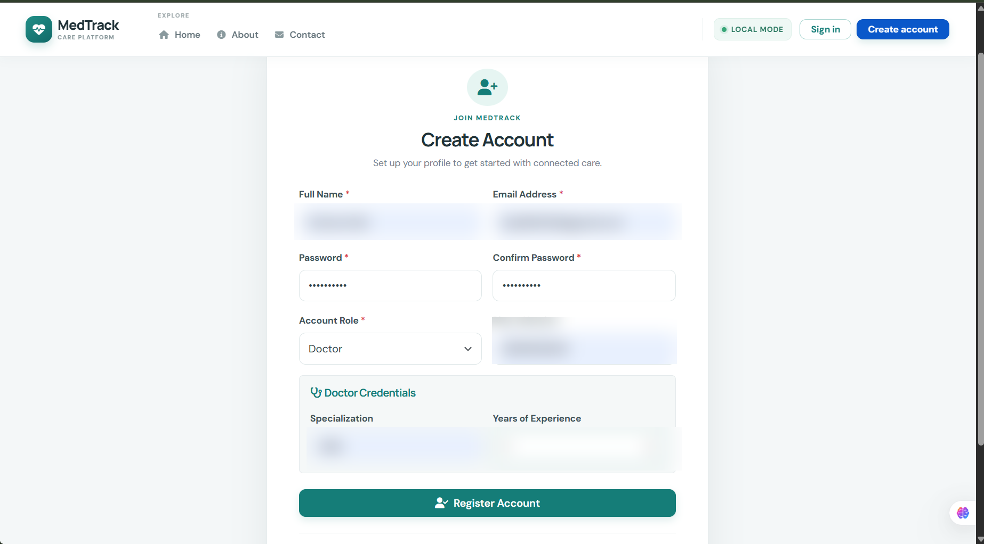
Figure 2. Account creation form; personal values redacted.

Doctor Schedule
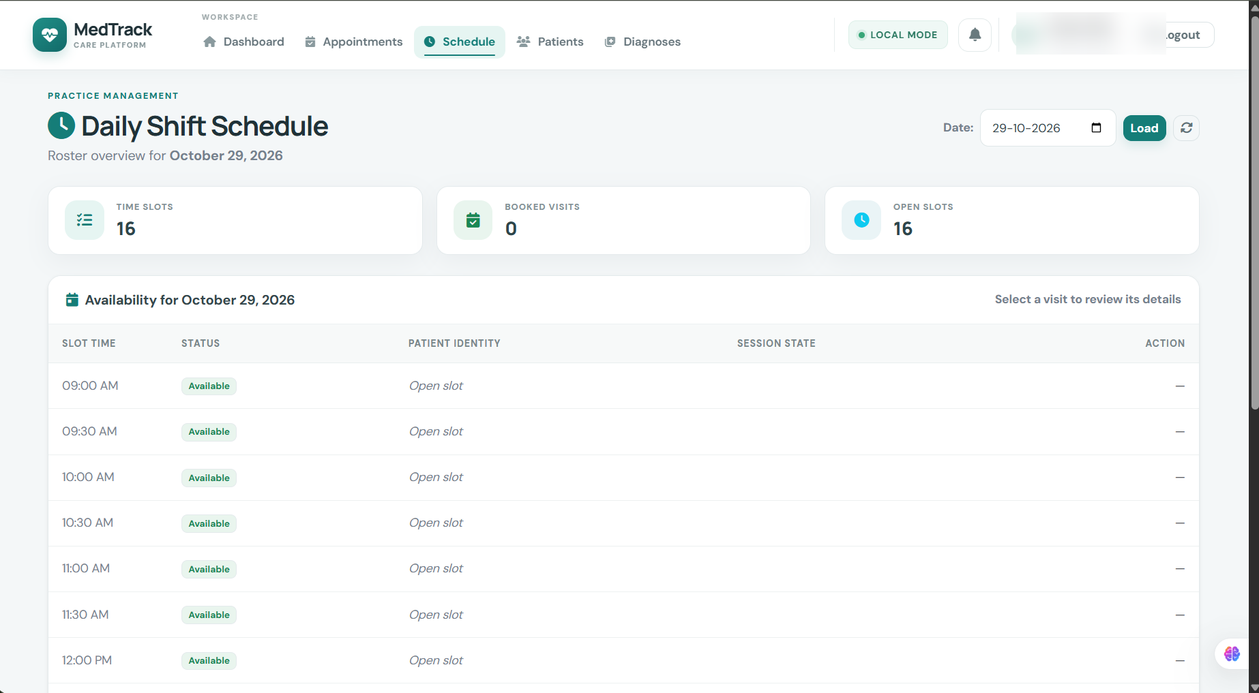
Figure 3. Doctor schedule; account details redacted.

Doctor Dashboard
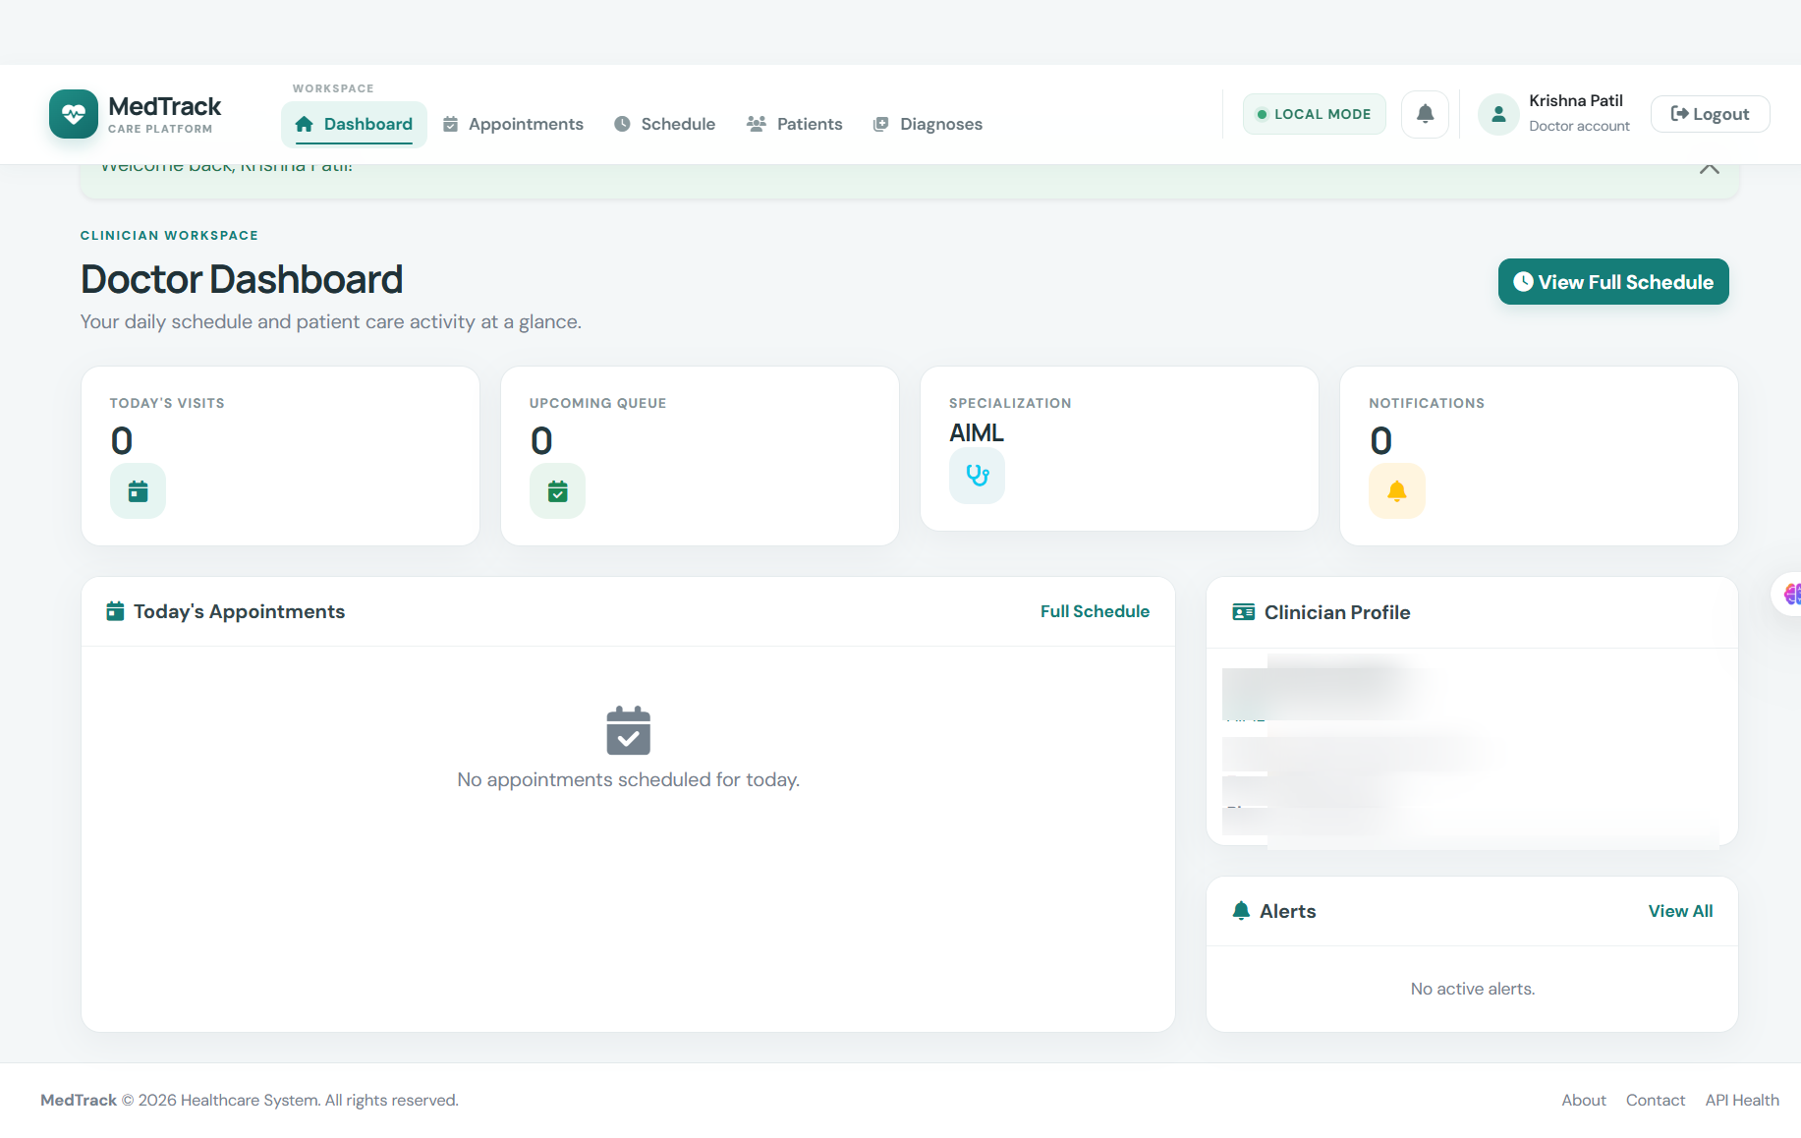
Figure 4. Doctor dashboard; personal identifiers redacted.

Book Appointment
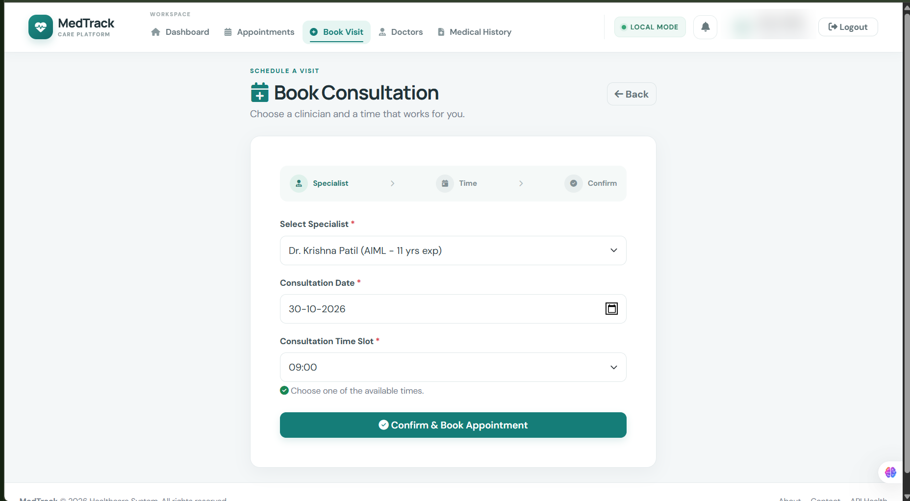
Figure 5. Patient appointment booking; account details redacted.

Patient Doctor Directory
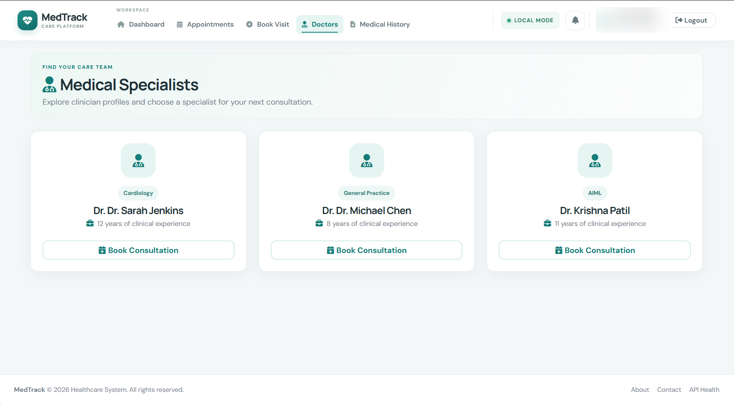
Figure 6. Patient clinician directory.

Conclusion
MedTrack combines role-specific healthcare workflows with Flask, DynamoDB, and SNS. Its EC2 path uses an attached IAM instance profile for automatically retrieved AWS credentials. Region and SNS topic values are environment configuration; AWS keys stay outside the application environment.

