Gaining a Statistical Edge in Soccer Prediction using Machine Learning
Role of Meta-Statistics in Match Prediction
Team 20 — Kenche Srujana (PES1UG24CS227), Krishna Keerthan Reddy D R (PES1UG24CS237) | UE24CS352A — Machine Learning, PES University
1. Problem Statement
Predicting the outcome of a football match (Home win, Draw, or Away win) is a three-class classification problem. Naive approaches lean on raw per-match statistics (goals, shots) which are themselves outcomes of the match being predicted, so simple averages of them carry limited forward-looking signal. This project tests whether replacing raw statistics with meta-statistics — engineered features summarizing a team's broader context (strength rating, recent form, head-to-head history, rest, and the betting market's own prediction) — gives a measurably better predictive edge.
2. Dataset
English Premier League match data from football-data.co.uk, covering six seasons (2019/20–2024/25, ~2,280 matches). Each record has the match date, teams, full-time score/result, shot counts, and average closing betting odds across bookmakers. Data is fetched live inside the notebook at runtime — no manual download required.
3. Approach
Leakage prevention. Every feature for a match uses only information available strictly before kickoff. Matches are processed in chronological order, maintaining running per-team state (Elo rating, recent results, goal difference, head-to-head record), updated only after a match's features are recorded.
Two feature sets, compared head-to-head using identical models:
- Baseline (raw statistics): rolling averages (last 5 matches) of each team's own goals scored, goal difference, and shots.
- Meta-statistics: Elo rating difference (dynamic strength rating, K=20, +100 home advantage), form difference (points/game, last 5), goal-difference trend, rest-day difference, head-to-head home win rate, and de-vigorized market-implied win/draw/loss probability.
Train/test split is chronological, not random: the first five seasons train the model; the most recent season (2024/25) is held out entirely as the test set, mirroring the real-world task of predicting future matches from past data.
Models: Logistic Regression and Random Forest, trained identically on each feature set (median imputation for early-season missing history, standard scaling), so any accuracy difference is attributable to the features, not the model.
4. Implementation Overview
The pipeline (notebooks/Soccer_Match_Prediction.ipynb) runs end-to-end: (1) download and concatenate 6 seasons of CSVs, (2) clean columns, parse dates, compute de-vigorized market probabilities, (3) exploratory analysis of result/goal distributions, (4) leakage-free feature engineering via the chronological Elo/form loop, (5) chronological train/test split, (6) train Logistic Regression and Random Forest on baseline, meta-statistic, and combined feature sets, evaluating accuracy, macro-F1, and log-loss, and (7) confusion matrix and feature-importance analysis for the best-performing feature set.
5. Results
Test set: held-out 2024/25 season (380 matches).
Feature Set | Model | Accuracy | F1 (macro) | Log-loss
Majority-class baseline | - | 0.408 | - | -
Baseline (raw stats) | LogReg | 0.505 | 0.378 | 1.022
Baseline (raw stats) | RandForest | 0.500 | 0.372 | 1.049
Meta-statistics | LogReg | 0.545 | 0.409 | 0.977
Meta-statistics | RandForest | 0.542 | 0.409 | 0.966
Combined | LogReg | 0.542 | 0.406 | 0.981
Combined | RandForest | 0.537 | 0.405 | 0.977

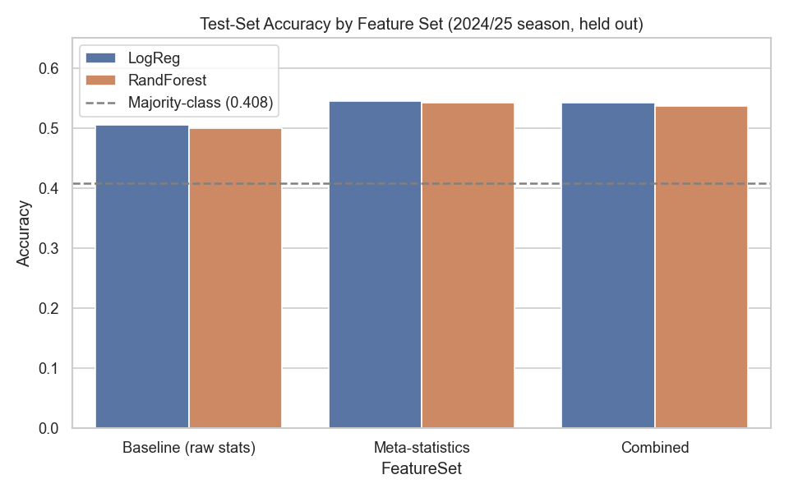
Figure 1. Test-set accuracy by feature set and model, vs. majority-class floor.
By feature importance, market-implied probability and Elo rating difference are the two strongest individual predictors (Figure 2).
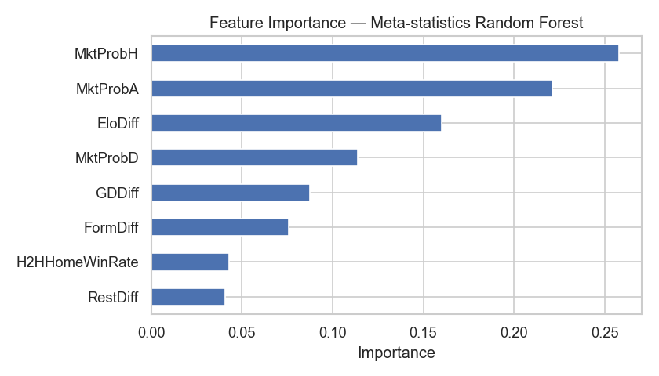
Figure 2. Feature importance, meta-statistics Random Forest.
6. Conclusions
- A majority-class guess (“always predict Home win”) reaches ~41% accuracy — the floor any useful model must beat.
- Raw per-match statistics, rolling-averaged, barely clear that floor (~50%).
- Meta-statistics give a clear, consistent lift over the raw-stats baseline (~4 points of accuracy, lower log-loss) for both a linear and a tree-based model, showing the effect comes from the features, not the model choice.
- Combining both feature sets does not beat meta-statistics alone — raw rolling stats add little beyond what Elo, form, and market odds already capture.
- This supports the project's thesis: aggregated, context-aware “meta” statistics carry a genuine statistical edge over raw per-match numbers for predicting soccer match outcomes.
Limitations & future work: no player-level data (injuries, lineups, transfers) is used; results are specific to one league. Future work could add gradient boosting with tuned hyperparameters, multi-league generalization, and recency-weighted Elo updates.

