**N-Queens using Hill Climbing**

**Algorithm:**

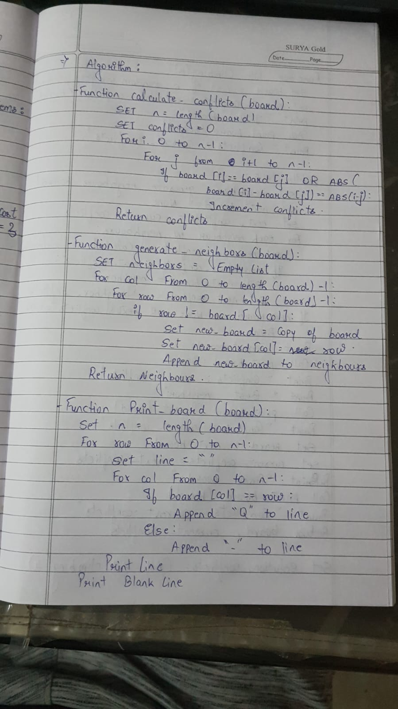

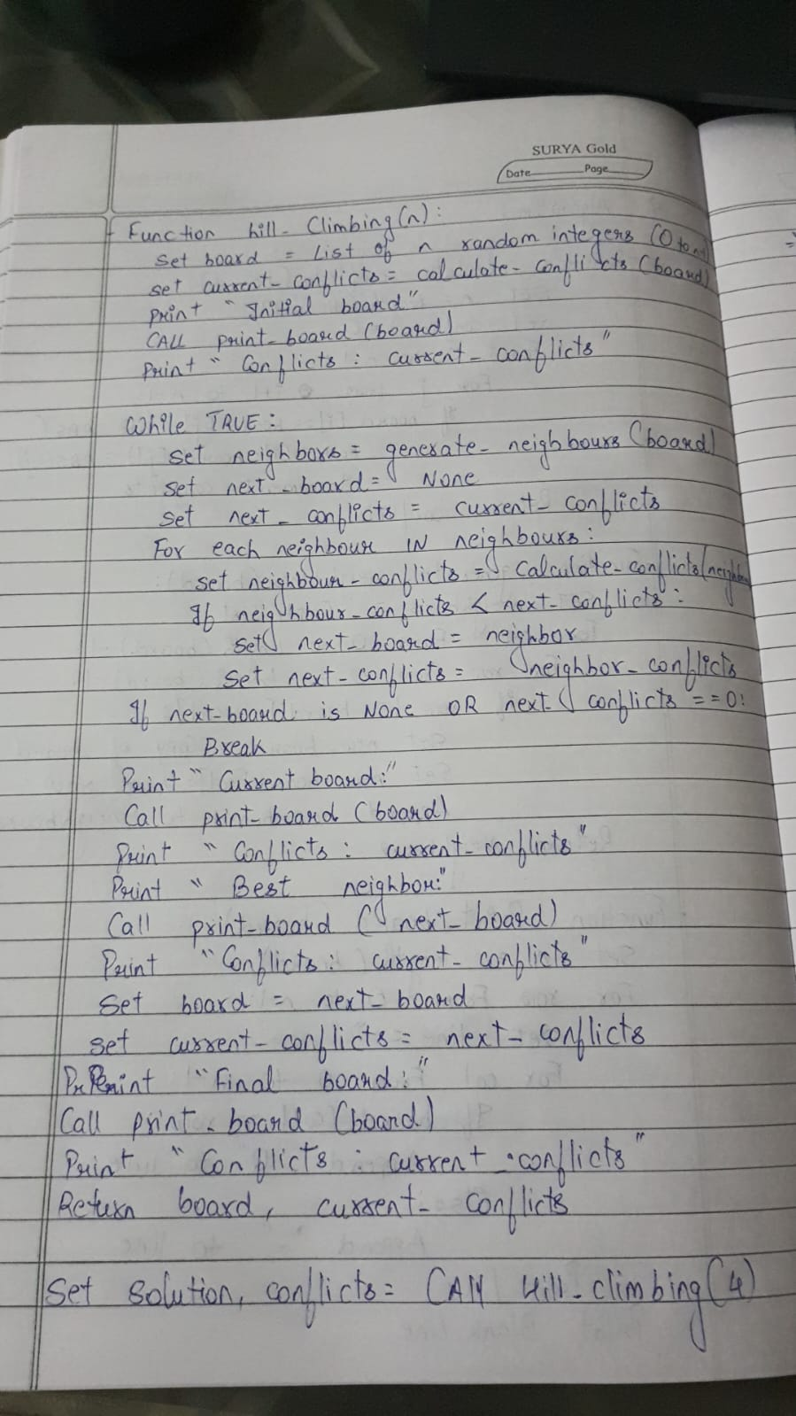

**State Space Tree:**

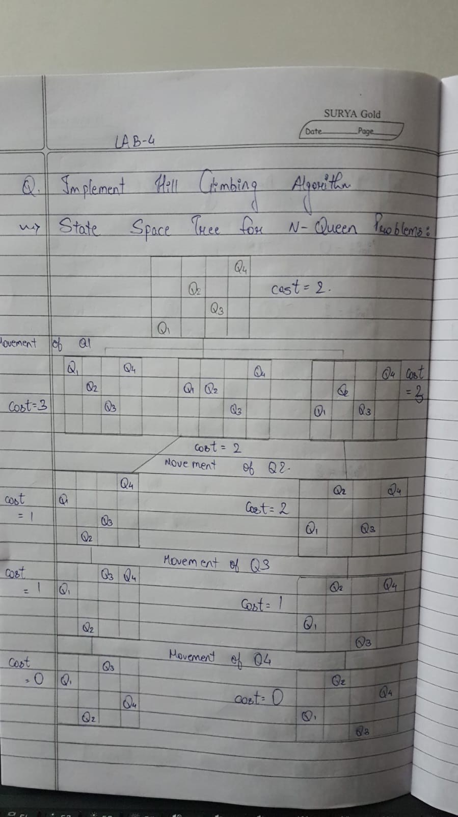

**Code:**

import random

def calculate_conflicts(board):

n = len(board)

conflicts = 0

for i in range(n):

for j in range(i + 1, n):

if board[i] == board[j] or abs(board[i] - board[j]) == abs(i - j):

conflicts += 1

return conflicts

def generate_neighbors(board):

neighbors = []

for col in range(len(board)):

for row in range(len(board)):

if row != board[col]:

new_board = board[:]

new_board[col] = row

neighbors.append(new_board)

return neighbors

def print_board(board):

n = len(board)

for row in range(n):

line = ""

for col in range(n):

line += "Q " if board[col] == row else ". "

print(line)

print()

def hill_climbing(n):

board = [random.randint(0, n - 1) for _ in range(n)]

current_conflicts = calculate_conflicts(board)

print("Initial board:")

print_board(board)

print(f"Conflicts: {current_conflicts}")

while True:

neighbors = generate_neighbors(board)

next_board = None

next_conflicts = current_conflicts

for neighbor in neighbors:

neighbor_conflicts = calculate_conflicts(neighbor)

if neighbor_conflicts < next_conflicts:

next_board = neighbor

next_conflicts = neighbor_conflicts

if next_board is None or next_conflicts == 0:

break

print("Current board:")

print_board(board)

print(f"Conflicts: {current_conflicts}")

print("Best neighbor:")

print_board(next_board)

print(f"Conflicts: {next_conflicts}")

board = next_board

current_conflicts = next_conflicts

print("Final board:")

print_board(board)

print(f"Conflicts: {current_conflicts}")

return board, current_conflicts

n = 4

solution, conflicts = hill_climbing(n)

print("Solution:", solution)

print("Conflicts:", conflicts)

**Output:**

Initial board:

. Q . .

Q . Q .

. . . .

. . . Q

Conflicts: 3

Current board:

. Q . .

Q . Q .

. . . .

. . . Q

Conflicts: 3

Best neighbor:

. Q . .

. . Q .

Q . . .

. . . Q

Conflicts: 1

Final board:

. Q . .

. . Q .

Q . . .

. . . Q

Conflicts: 1

Solution: [2, 0, 1, 3]

Conflicts: 1