WEEK-4
Mandatory Hands-On
Hands on 1
Create a Spring Web Project using Maven

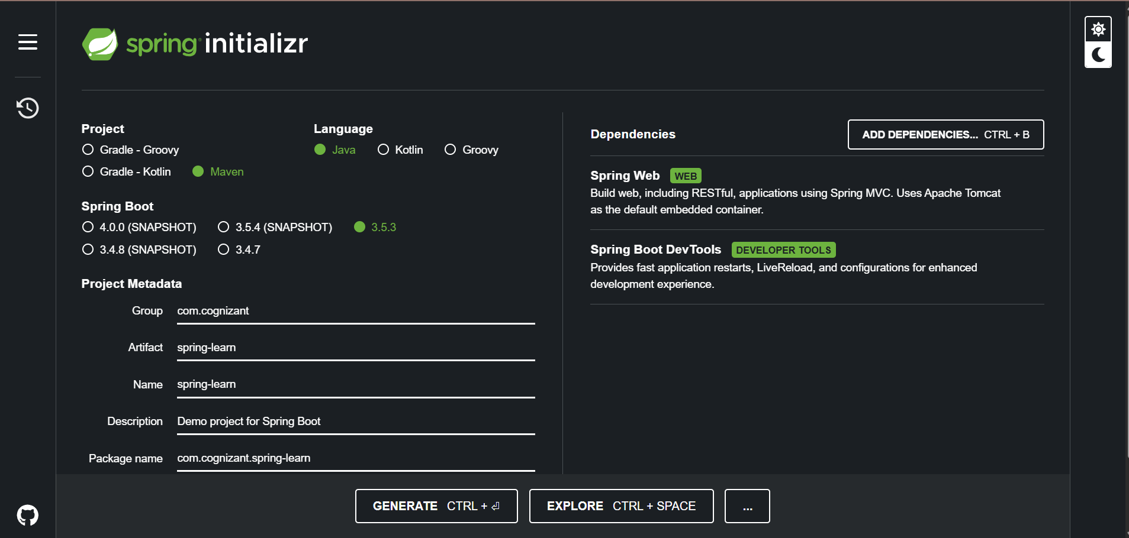
Code:
SpringLearnApplication.java
package com.cognizant;

import org.springframework.boot.SpringApplication;
import org.springframework.boot.autoconfigure.SpringBootApplication;

@SpringBootApplication
public class SpringLearnApplication {
public static void main(String[] args) {
System.out.println("SpringLearnApplication started...");
SpringApplication.run(SpringLearnApplication.class, args);
}
}

OUTPUT:
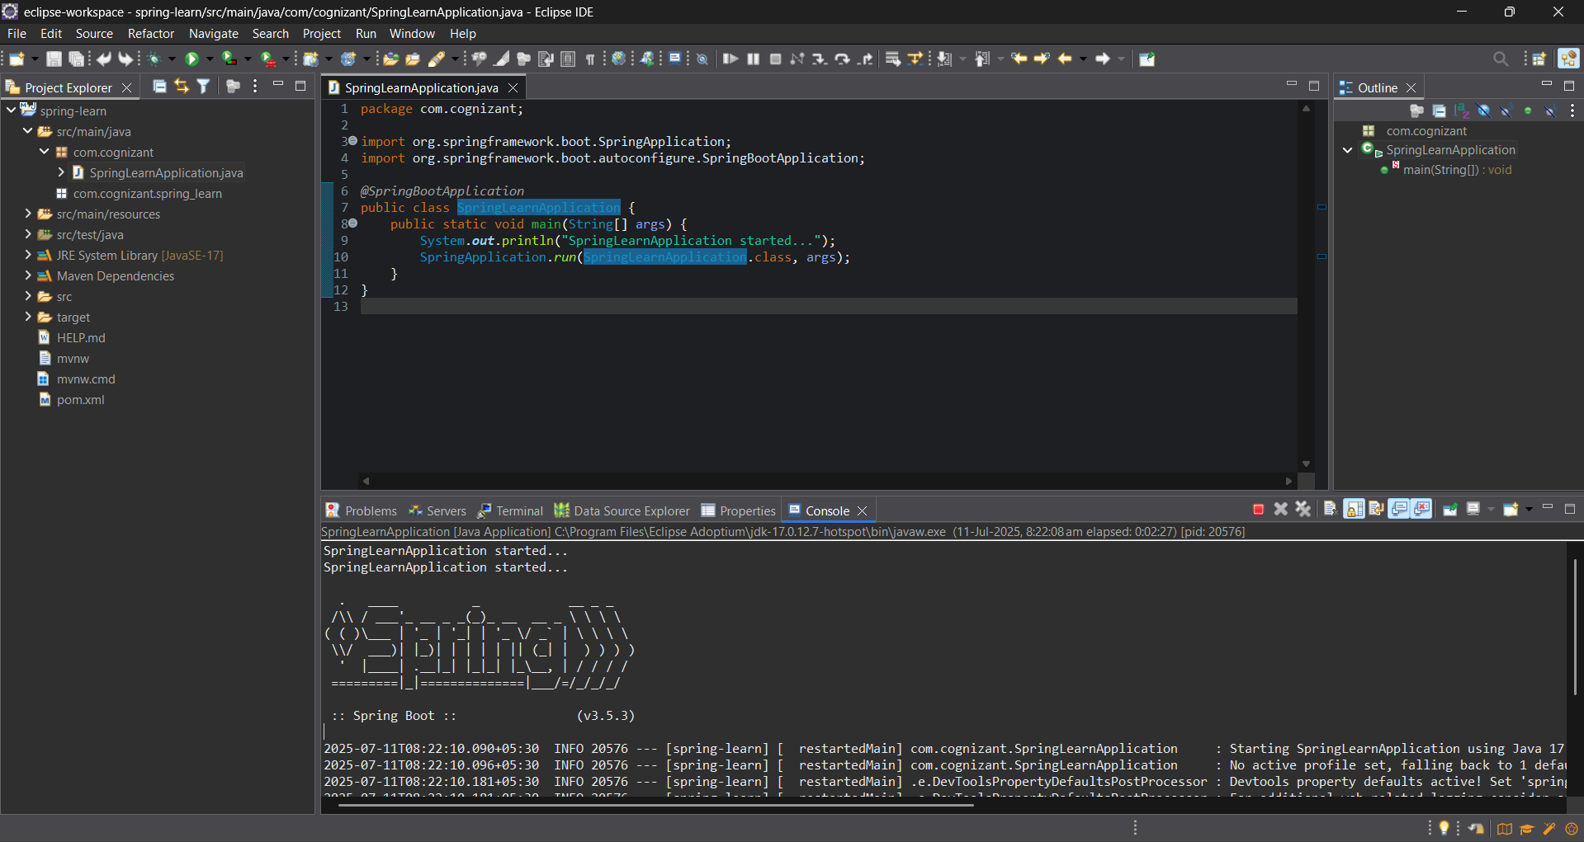
Hands on 2
Spring Core – Load SimpleDateFormat from Spring Configuration XML
SpringLearnApplication.java
package com.cognizant;

import java.text.ParseException;
import java.text.SimpleDateFormat;
import java.util.Date;

import org.springframework.context.ApplicationContext;
import org.springframework.context.support.ClassPathXmlApplicationContext;
import org.springframework.boot.SpringApplication;
import org.springframework.boot.autoconfigure.SpringBootApplication;

@SpringBootApplication
public class SpringLearnApplication {

public static void main(String[] args) {
SpringApplication.run(SpringLearnApplication.class, args);
displayDate();
}

public static void displayDate() {
ApplicationContext context = new ClassPathXmlApplicationContext("date-format.xml");

SimpleDateFormat format = context.getBean("dateFormat", SimpleDateFormat.class);

try {
Date date = format.parse("31/12/2018");
System.out.println("Parsed Date: " + date);
} catch (ParseException e) {
System.out.println("Date parsing failed: " + e.getMessage());
}

((ClassPathXmlApplicationContext) context).close(); // Good practice to close the context
}
}
Date-format.xml
<?xml version="1.0" encoding="UTF-8"?>
<beans xmlns="http://www.springframework.org/schema/beans"
xmlns:xsi="http://www.w3.org/2001/XMLSchema-instance"
xsi:schemaLocation="http://www.springframework.org/schema/beans
https://www.springframework.org/schema/beans/spring-beans.xsd">

<bean id="dateFormat" class="java.text.SimpleDateFormat">
<constructor-arg value="dd/MM/yyyy" />
</bean>

</beans>

OUTPUT:
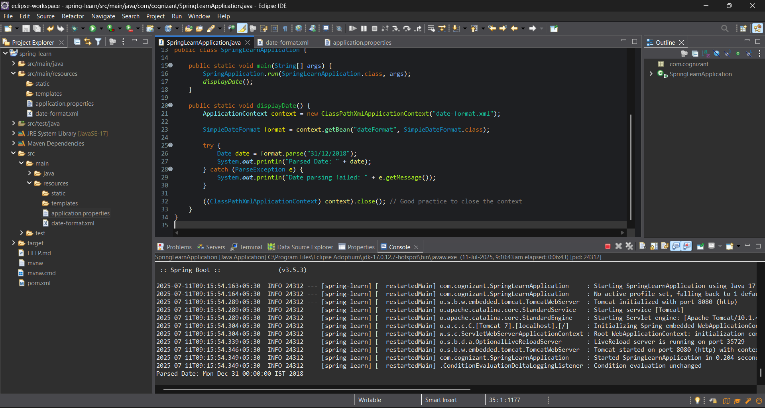

Hello World RESTful Web Service
Write a REST service in the spring learn application created earlier, that returns the text "Hello World!!" using Spring Web Framework.
HelloController.java
package com.cognizant.springlearn.controller;
import org.slf4j.Logger;
import org.slf4j.LoggerFactory;
import org.springframework.web.bind.annotation.GetMapping;
import org.springframework.web.bind.annotation.RestController;
@RestController
public class HelloController {
private static final Logger LOGGER = LoggerFactory.getLogger(HelloController.class);
@GetMapping("/hello")
public String sayHello() {
LOGGER.info("START - sayHello()");
String response = "Hello World!!";
LOGGER.info("END - sayHello()");
return response;
}
}
OUTPUT:
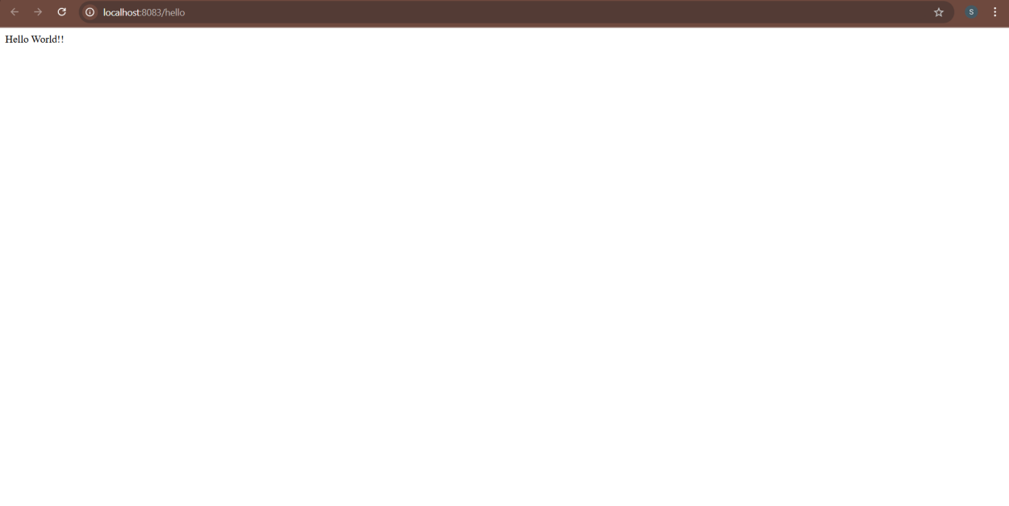
REST - Country Web Service
Write a REST service that returns India country details in the earlier created spring learn application.
Country.java
package com.cognizant.springlearn.model;

public class Country {
private String code;
private String name;

public Country() {}

public Country(String code, String name) {
this.code = code;
this.name = name;
}

public String getCode() {
return code;
}

public void setCode(String code) {
this.code = code;
}

public String getName() {
return name;
}

public void setName(String name) {
this.name = name;
}

@Override
public String toString() {
return "Country [code=" + code + ", name=" + name + "]";
}
}
Country.xml:
<?xml version="1.0" encoding="UTF-8"?>
<beans xmlns="http://www.springframework.org/schema/beans"
xmlns:xsi="http://www.w3.org/2001/XMLSchema-instance"
xsi:schemaLocation="http://www.springframework.org/schema/beans
https://www.springframework.org/schema/beans/spring-beans.xsd">

<bean id="in" class="com.cognizant.springlearn.model.Country">
<property name="code" value="IN" />
<property name="name" value="India" />
</bean>

</beans>

CountryController.java:
package com.cognizant.springlearn.controller;

import org.slf4j.Logger;
import org.slf4j.LoggerFactory;
import org.springframework.web.bind.annotation.RequestMapping;
import org.springframework.web.bind.annotation.RestController;
import org.springframework.context.ApplicationContext;
import org.springframework.context.support.ClassPathXmlApplicationContext;

import com.cognizant.springlearn.model.Country;

@RestController
public class CountryController {

private static final Logger LOGGER = LoggerFactory.getLogger(CountryController.class);

@RequestMapping("/country")
public Country getCountryIndia() {
LOGGER.info("START - getCountryIndia()");
ApplicationContext context = new ClassPathXmlApplicationContext("country.xml");
Country country = (Country) context.getBean("in");
LOGGER.info("END - getCountryIndia()");
((ClassPathXmlApplicationContext) context).close();
return country;
}
}

OUTPUT:
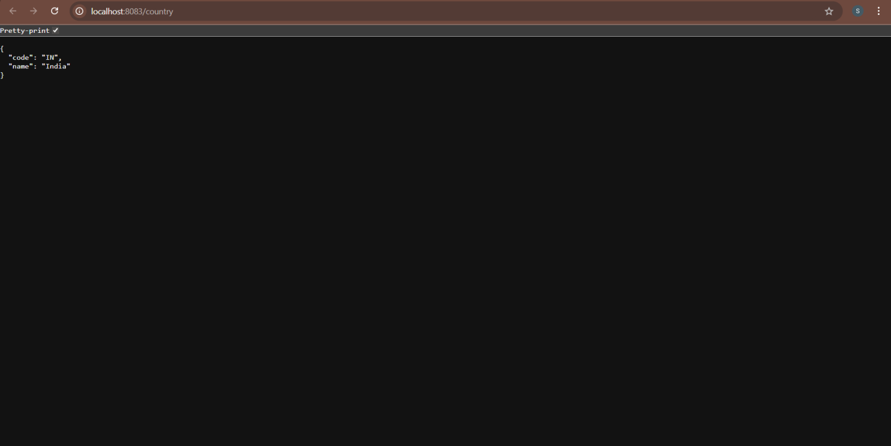

REST - Get country based on country code
Write a REST service that returns a specific country based on country code. The country code should be case insensitive.
Country.java:
package com.cognizant.springlearn.model;

public class Country {
private String code;
private String name;

public Country() {
}

public Country(String code, String name) {
this.code = code;
this.name = name;
}

public String getCode() {
return code;
}

public void setCode(String code) {
this.code = code.toUpperCase();
}

public String getName() {
return name;
}

public void setName(String name) {
this.name = name;
}
}
Country.xml
<?xml version="1.0" encoding="UTF-8"?>
<beans xmlns="http://www.springframework.org/schema/beans"
xmlns:xsi="http://www.w3.org/2001/XMLSchema-instance"
xsi:schemaLocation="http://www.springframework.org/schema/beans
https://www.springframework.org/schema/beans/spring-beans.xsd">

<bean id="countryList" class="java.util.ArrayList">
<constructor-arg>
<list>
<bean class="com.cognizant.springlearn.model.Country">
<property name="code" value="IN"/>
<property name="name" value="India"/>
</bean>
<bean class="com.cognizant.springlearn.model.Country">
<property name="code" value="US"/>
<property name="name" value="United States"/>
</bean>
<bean class="com.cognizant.springlearn.model.Country">
<property name="code" value="JP"/>
<property name="name" value="Japan"/>
</bean>
</list>
</constructor-arg>
</bean>

</beans>
CountryController.java:
package com.cognizant.springlearn.controller;

import com.cognizant.springlearn.model.Country;
import com.cognizant.springlearn.service.CountryService;
import org.slf4j.Logger;
import org.slf4j.LoggerFactory;
import org.springframework.beans.factory.annotation.Autowired;
import org.springframework.web.bind.annotation.*;

@RestController
public class CountryController {

private static final Logger LOGGER = LoggerFactory.getLogger(CountryController.class);

@Autowired
private CountryService countryService;

@GetMapping("/country/{code}")
public Country getCountry(@PathVariable String code) {
LOGGER.info("START - getCountry");
Country country = countryService.getCountry(code);
LOGGER.info("END - getCountry");
return country;
}
}
CountryService.java:
package com.cognizant.springlearn.service;

import com.cognizant.springlearn.model.Country;
import org.springframework.context.ApplicationContext;
import org.springframework.context.support.ClassPathXmlApplicationContext;
import org.springframework.stereotype.Service;

import java.util.List;

@Service
public class CountryService {

private ApplicationContext context;

public Country getCountry(String code) {
context = new ClassPathXmlApplicationContext("country.xml");
List<Country> bean = (List<Country>) context.getBean("countryList");
List<Country> countryList = bean;

return countryList.stream()
.filter(c -> c.getCode().equalsIgnoreCase(code))
.findFirst()
.orElse(null);
}
}

OUTPUT:

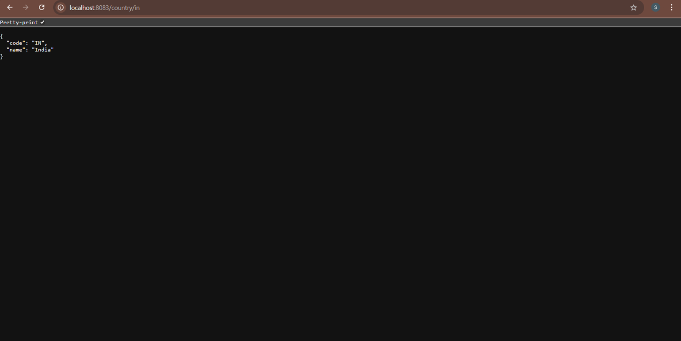

Create authentication service that returns JWT
As part of first step of JWT process, the user credentials needs to be sent to authentication service request that generates and returns the JWT.
Ideally when the below curl command is executed that calls the new authentication service, the token should be responded. Kindly note that the credentials are passed using -u option.
JwtUtil.java:
package com.cognizant.springlearn.util;

import io.jsonwebtoken.Jwts;
import io.jsonwebtoken.SignatureAlgorithm;
import org.springframework.stereotype.Component;

import java.util.Date;

@Component
public class JwtUtil {

private final String secretKey = "yourSecretKey";

public String generateToken(String username) {
return Jwts.builder()
.setSubject(username)
.setIssuedAt(new Date(System.currentTimeMillis()))
.setExpiration(new Date(System.currentTimeMillis() + 1000 * 60 * 60)) // 1 hour
.signWith(SignatureAlgorithm.HS256, secretKey)
.compact();
}
}
AuthenticationController.java:
package com.cognizant.springlearn.controller;

import com.cognizant.springlearn.util.JwtUtil;
import jakarta.servlet.http.HttpServletRequest;
import org.springframework.beans.factory.annotation.Autowired;
import org.springframework.http.HttpStatus;
import org.springframework.web.bind.annotation.*;
import org.springframework.web.server.ResponseStatusException;

import java.util.Base64;
import java.util.HashMap;
import java.util.Map;

@RestController

public class AuthenticationController {

@GetMapping("/authenticate")
public Map<String, String> authenticate(@RequestHeader("Authorization") String authHeader) {
// Decode the header manually (Basic Auth comes in encoded format)
String base64Credentials = authHeader.substring("Basic".length()).trim();
byte[] credDecoded = Base64.getDecoder().decode(base64Credentials);
String credentials = new String(credDecoded);
String[] values = credentials.split(":", 2);
String username = values[0];
String password = values[1];

// Validate credentials (for demo: accept any fixed username/pwd)
if (!username.equals("user") || !password.equals("pwd")) {
throw new ResponseStatusException(HttpStatus.UNAUTHORIZED, "Invalid Credentials");
}

// Generate dummy JWT token (or use a JWT library)
String token = "dummy-jwt-token-for-" + username;

Map<String, String> response = new HashMap<>();
response.put("token", token);
return response;
}
}
SecurityConfig.java:
package com.cognizant.springlearn.config;

import org.springframework.context.annotation.Bean;
import org.springframework.context.annotation.Configuration;
import org.springframework.security.config.annotation.web.configuration.EnableWebSecurity;
import org.springframework.security.web.SecurityFilterChain;
import org.springframework.security.config.annotation.web.builders.HttpSecurity;

@Configuration
@EnableWebSecurity
public class SecurityConfig {

@Bean
public SecurityFilterChain filterChain(HttpSecurity http) throws Exception {
http
.csrf(csrf -> csrf.disable())
.authorizeHttpRequests(auth -> auth
.requestMatchers("/authenticate").permitAll()
.anyRequest().authenticated()
)
.httpBasic();
return http.build();
}
}

OUTPUT:
