Week2:
Ex1: Control Structures
Database setup:
In order to implement the required scenarios, a database with Customers and Loans tables is required. So, I have taken two tables Customers and Loans using PL/SQL. I also inserted the values into both the tables.
Customers Table:
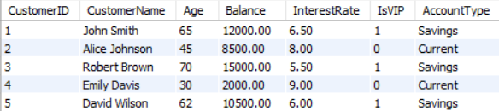

Loans Table:
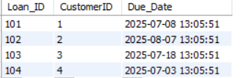

Scenario 1: The bank wants to apply a discount to loan interest rates for customers above 60 years old.
Question: Write a PL/SQL block that loops through all customers, checks their age, and if they are above 60, apply a 1% discount to their current loan interest rates.
Code:
BEGIN
FOR cust IN (
SELECT CustomerID, InterestRate
FROM CUSTOMERS
WHERE Age > 60
) LOOP
UPDATE CUSTOMERS
SET InterestRate = cust.InterestRate - 1
WHERE CustomerID = cust.CustomerID;

DBMS_OUTPUT.PUT_LINE('1% discount applied to customer ID: ' || cust.CustomerID);
END LOOP;

COMMIT;
END;
/
Output:
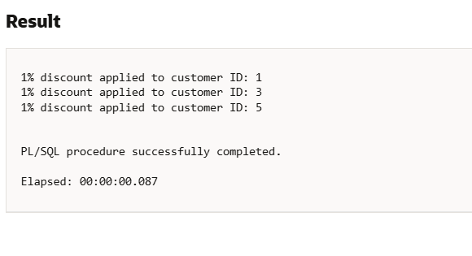
Scenario 2: A customer can be promoted to VIP status based on their balance.
Question: Write a PL/SQL block that iterates through all customers and sets a flag IsVIP to TRUE for those with a balance over $10,000.
Code:
BEGIN
FOR cust IN (
SELECT CustomerID, Balance
FROM CUSTOMERS
WHERE Balance > 10000
) LOOP
UPDATE CUSTOMERS
SET IsVIP = 1
WHERE CustomerID = cust.CustomerID;

DBMS_OUTPUT.PUT_LINE('Customer ID ' || cust.CustomerID || ' promoted to VIP (Balance: ' || cust.Balance || ')');
END LOOP;

COMMIT;
END;
Output:
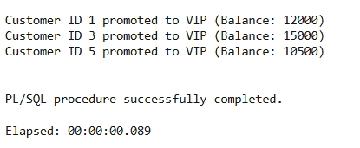

Scenario 3: The bank wants to send reminders to customers whose loans are due within the next 30 days.
Question: Write a PL/SQL block that fetches all loans due in the next 30 days and prints a reminder message for each customer.
Code:
BEGIN
FOR loan_rec IN (
SELECT l.Loan_ID, l.Due_Date, c.CustomerID, c.CustomerName
FROM LOANS l
JOIN CUSTOMERS c ON l.CustomerID = c.CustomerID
WHERE l.Due_Date BETWEEN SYSDATE AND SYSDATE + 30
) LOOP
DBMS_OUTPUT.PUT_LINE('Reminder: Loan ID ' || loan_rec.Loan_ID ||
' for Customer "' || loan_rec.CustomerName ||
'" (ID: ' || loan_rec.CustomerID ||
') is due on ' || TO_CHAR(loan_rec.Due_Date, 'YYYY-MM-DD'));
END LOOP;
END;
Output:
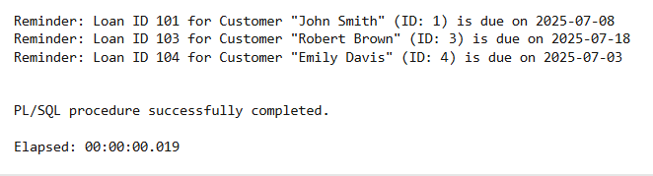

Ex3: Stored Procedures
Scenario 1: The bank needs to process monthly interest for all savings accounts.
Question: Write a stored procedure ProcessMonthlyInterest that calculates and updates the balance of all savings accounts by applying an interest rate of 1% to the current balance.
Code:
CREATE OR REPLACE PROCEDURE ProcessMonthlyInterest IS
BEGIN
FOR acc IN (
SELECT CustomerID, Balance
FROM CUSTOMERS
WHERE AccountType = 'Savings'
) LOOP
UPDATE CUSTOMERS
SET Balance = Balance + (acc.Balance * 0.01)
WHERE CustomerID = acc.CustomerID;

DBMS_OUTPUT.PUT_LINE('Interest applied to Savings Account - Customer ID: ' || acc.CustomerID);
END LOOP;

COMMIT;
END;
Output:
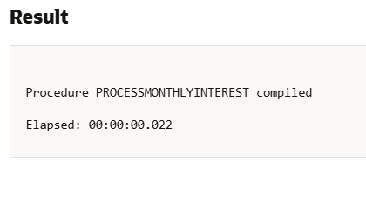
Scenario 2: The bank wants to implement a bonus scheme for employees based on their performance.
Question: Write a stored procedure UpdateEmployeeBonus that updates the salary of employees in a given department by adding a bonus percentage passed as a parameter.
Let us take an Employees table for this for better understanding.
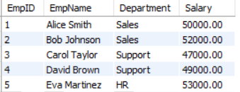

Code:
CREATE OR REPLACE PROCEDURE UpdateEmployeeBonus (
p_department IN VARCHAR2,
p_bonus_pct IN NUMBER
)
IS
BEGIN
UPDATE EMPLOYEES
SET Salary = Salary + (Salary * p_bonus_pct / 100)
WHERE Department = p_department;

DBMS_OUTPUT.PUT_LINE('Bonus of ' || p_bonus_pct || '% applied to department: ' || p_department);

COMMIT;
END;
/
BEGIN
UpdateEmployeeBonus('Sales', 10);
END;
/
After applying UpdateEmployeeBonus,the table becomes:
Output:
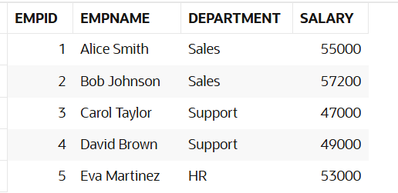

Scenario 3: Customers should be able to transfer funds between their accounts.
Question: Write a stored procedure TransferFunds that transfers a specified amount from one account to another, checking that the source account has sufficient balance before making the transfer.
Code:

CREATE OR REPLACE PROCEDURE TransferFunds (
p_from_customer_id IN NUMBER,
p_to_customer_id IN NUMBER,
p_amount IN NUMBER
)
IS
v_from_balance NUMBER;
BEGIN
-- Get sender's balance
SELECT Balance INTO v_from_balance
FROM CUSTOMERS
WHERE CustomerID = p_from_customer_id;

-- Check for sufficient funds
IF v_from_balance < p_amount THEN
RAISE_APPLICATION_ERROR(-20001, 'Insufficient balance for transfer.');
END IF;

-- Deduct from sender
UPDATE CUSTOMERS
SET Balance = Balance - p_amount
WHERE CustomerID = p_from_customer_id;

-- Add to receiver
UPDATE CUSTOMERS
SET Balance = Balance + p_amount
WHERE CustomerID = p_to_customer_id;

DBMS_OUTPUT.PUT_LINE('Transferred ' || p_amount ||
' from Customer ID ' || p_from_customer_id ||
' to Customer ID ' || p_to_customer_id);

COMMIT;
END;
/

-- Call the procedure to transfer funds
BEGIN
TransferFunds(1, 2, 2000); -- Transfer 2000 from John Smith to Alice Johnson
END;
/

-- View final balances
SELECT CustomerID, CustomerName, Balance FROM CUSTOMERS;
Output:
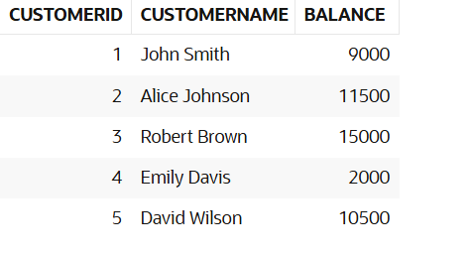
If there is insufficient balance to transfer, it shows this message:
ORA-20001: Insufficient balance for transfer.

