SIMATS ENGINEERING
Department of Information Technology
CSA15 – CLOUD COMPUTING AND BIG DATA ANALYTICS
ASSIGNMENT 2 – CO2
Analyse, Evaluate and Validate a Virtualization Architecture for a Multi-Tenant University Private Cloud
CO2: Analyze virtualization architectures to identify performance and security issues in cloud computing environments.
Field | Details | Field | Details
Student Name | R Leela Krishna | Register Number | 192372363
Department / Section | Information Technology | Academic Year / Semester | 2026
Faculty Name | Dr R Latha | Nature of Assignment | Individual
Duration | 1 Week | Total Marks | 50
Submission Date |  | Evaluation Date

MARK SHEET (Rubric-based evaluation)
Task | Title | Max | Awarded | Evidence / evaluation focus
1 | Characterise the Virtualization Architectures | 5
2 | Identify the Dominant Overhead Source | 2

Task | Title | Max | Awarded | Evidence / evaluation focus
3 | Build a Quantitative Performance Model | 6
4 | Analyse Performance Under Different Conditions | 4
5 | Security Threat and Vulnerability Analysis | 3
6 | Formulate Isolation–Performance Trade-off | 3
7 | Evaluate Mitigation Strategies | 4
8 | Implement and Test | 4
9 | Record Experimental Performance | 3
10 | Compare Theory with Experiment | 4
11 | Recommend and Defend Final Architecture | 4
 | Day-4 Design Challenge | 8

TOTAL
50

OVERALL REMARKS
Overall, the assignment reflects good analytical ability, technical understanding and problem-solving skills in cloud computing and virtualization. The proposed architecture balances performance, security, resource efficiency and future scalability. The work can be further strengthened through verified experimental results, consistent benchmark comparisons and practical validation of the recommended security controls.
Student Signature | Faculty Signature | Program Director

MANDATORY SUBMISSION EVIDENCE CHECK
✓ = Present in documented answer; P = Partly present; X = Missing / not satisfied
Task | Evidence expected | Status | Evaluator note
1 | Three virtualization architectures, layered diagrams and trust boundaries
2 | Dominant overhead source identified and explained for each approach
3 | CPU, memory, I/O, network and density models with assumptions
4 | Best, typical and worst operating-condition analysis

Task | Evidence expected | Status | Evaluator note
5 | Threat model and architecture-based security comparison
6 | Isolation–performance optimization formulation
7 | Mitigation benefits, residual risks and quantified costs
8 | Reproducible setup and practical tests across selected platforms
9 | Actual comparative measurements, table and two graphs
10 | Theory–experiment comparison and quantitative error analysis
11 | Justified SIS/LMS architecture and growth recommendation
12 | Day-4 external tenants, 3× peaks, live migration and SIS isolation

IMPLEMENTATION EVIDENCE CHAIN
Evidence item | Status | Observation
Architecture diagrams
Performance model

Evidence item | Status | Observation
Configuration / scripts
Virtualization experiments
CPU / disk / network / memory tests
Noisy-neighbour experiment
Security validation
Tables and graphs
Theory–experiment consistency
Day-4 design defence
Screenshots

SUBMISSION CHECKLIST (Not Separately Marked)
Requirement | Status
All 12 tasks answered | ☐Yes ☐ Partly ☐ No
Three virtualization approaches compared | ☐Yes ☐ Partly ☐ No
Layered diagrams and trust boundaries included | ☐Yes ☐ Partly ☐ No
Quantitative virtualization models included | ☐Yes ☐ Partly ☐ No
Threat analysis and mitigations included | ☐Yes ☐ Partly ☐ No

Common Assumptions Used In All Tasks
Simple rules used everywhere, so that all numbers can be checked:
Table 1: Common Assumptions Used In All Tasks
Symbol | Meaning | Value used
P | Physical cores per host | 64
r | vCPU : pCPU overcommit ratio | 1, 2, 4, 8
v | vCPUs per VM / container | 4 (assumed)
u | Average CPU busy fraction of one vCPU | 0.25 normal day; 0.75 registration week (3× normal)
M, m | RAM per host, memory demand per VM | 512 GB, 8 GB
R_h | Memory kept for host OS + hypervisor | 16 GB (KVM, Kata); 12 GB (Docker)
ω | Extra memory per instance (QEMU process, guest kernel, agent) | KVM 0.25 GB; Kata 0.30 GB; Docker 0.05 GB
t_exit | Cost of one VM exit | 1.5 µs (given)
t_sys | Native system-call cost | 0.2 µs (given)
B | Network line rate | 25 Gbps (one NIC)
B_d | NVMe disk bandwidth per host | 3 GB/s (assumed)
o | Total virtualization overhead (fraction of CPU) | KVM 3.5%; Docker 1.25%; Kata 4.1% (derived in Task 3)
Target | Service-level target | Performance degradation ≤ 10%

Workload split used: 400 instances = 300 SIS + LMS + examination VMs (critical) and 100 internal research workloads. Hosts available = 16.
TASK 1 – Characterise the Virtualization Architectures
Three different approaches are selected: (A) Type-1 hypervisor with hardware-assisted full virtualization (KVM/QEMU, virtio) – VM based; (B) OS-level containers (Docker/runc) – container based; (C) Micro-VM sandboxed container runtime (Kata Containers) – hybrid of both. They are architecturally different: A has a full guest OS and device model, B shares the host kernel, C has a tiny guest kernel inside a light VM.
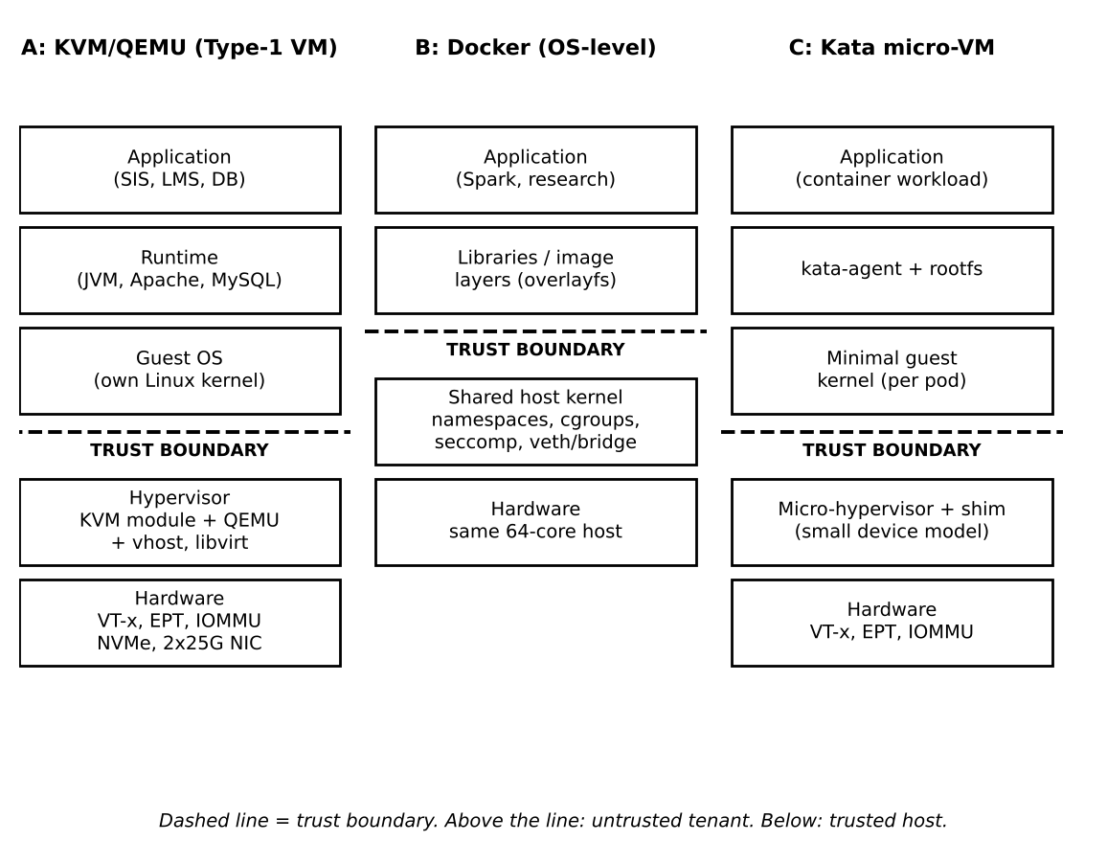
Figure 1: Layered architecture and trust boundaries of the three approaches (A: KVM/QEMU, B: Docker, C: Kata Containers)
1.1 Approach A – KVM/QEMU (Type-1, hardware-assisted full virtualization)
Isolation is enforced by: CPU hardware (VT-x root / non-root mode) and Extended Page Tables (EPT). Each guest cannot touch another guest memory because EPT maps only its own pages. The IOMMU stops device DMA to other VMs.
Table 2: Approach A – KVM/QEMU (Type-1, hardware-assisted full virtualization)
Resource | How it is virtualized in KVM
CPU | vCPU = a host thread. Guest code runs directly on the core. Privileged actions cause a VM exit and KVM handles them. Linux scheduler shares cores (overcommit).
Memory | Guest virtual → guest physical → host physical using two-level page tables (EPT). Extras: ballooning, KSM page sharing, swap.
Storage | virtio-blk / virtio-scsi on shared backend; QEMU or vhost handles each request (qcow2 or raw).
Network | virtio-net with vhost-net, tap device, Linux bridge or Open vSwitch (software-defined network).

Why relevant for EduCloud: strongest and best-known isolation with separate kernels, so it is the natural choice for SIS (student records), and it already matches the current EduCloud design (VMs, shared storage, SDN).
1.2 Approach B – OS-level containers (Docker / runc)
Isolation is enforced by the host kernel itself (namespaces hide resources, cgroups limit them, seccomp filters system calls). There is NO guest OS. If the kernel has a bug, the boundary is lost.
Table 3: Approach B – OS-level containers (Docker / runc)
Resource | How it is virtualized in a container
CPU | No virtual CPU. Processes run natively. cgroup cpu.shares / cpu.max give a share or quota.
Memory | Native page tables (single level). cgroup memory.max limits memory; OOM killer if exceeded.
Storage | overlayfs (copy-on-write layers) over the host file system; blkio/io.max cgroup for limits.
Network | Network namespace + veth pair + Linux bridge + iptables/NAT (virtual switch in the host kernel).

Why relevant: very high density and fast start for internal research and batch jobs where the tenants are trusted and kernel sharing is acceptable.
1.3 Approach C – Micro-VM sandboxed container (Kata Containers)
Isolation is enforced by the hypervisor and CPU, like KVM, but the device model is much smaller (fewer emulated devices), so the attack surface is smaller. It still looks like a container to Kubernetes/Docker users.
Table 4: Approach C – Micro-VM sandboxed container (Kata Containers)
Resource | How it is virtualized in Kata
CPU | vCPU threads of the micro-VM (hot-pluggable); VM exits as in KVM.
Memory | EPT two-level translation; memory can be added on demand (hot-plug); DAX/virtio-mem possible.
Storage | virtio-fs (FUSE over virtio) for the image, or virtio-blk (devmapper) for data. virtio-fs is slower.
Network | tap/macvtap + TC filter or vhost-net, goes through the guest kernel and then the host.

Why relevant: a sandbox for less-trusted tenants (external collaborators in Task 12) that keeps the container workflow but adds a hardware isolation boundary.
TASK 2 – Identify the Dominant Overhead Source
Table 5: Identify the Dominant Overhead Source
Approach | Dominant overhead | Where it happens | Why it is the right focus | How it grows with more VMs / I/O
A KVM | VM exits (timer, IPI, I/O kick, interrupts), each costing t_exit = 1.5 µs | At the guest ↔ KVM boundary on every privileged event | Hardware runs guest code at native speed; exits are the only time the guest is stopped, so exit rate × cost decides slowdown | Exit rate per vCPU rises with I/O rate (each virtio kick/IRQ) and with more vCPUs (more IPIs, timers). Total exits per second grows ~linearly with N and I/O rate.
B Docker | Virtual switch processing: veth + bridge + netfilter/NAT per packet (and seccomp filter on each system call, small) | Inside the shared host kernel network stack (softirq) | No CPU virtualization exists, so the only "virtual" device on the hot path is the virtual network; it uses host CPU time for every packet | Per-packet cost is fixed, so CPU used = packet rate × cost. It grows with I/O rate; all containers also share one kernel lock/queue, so contention rises with N.
C Kata | Virtual I/O emulation: virtio-fs / virtio-net requests crossing guest → host (each needs an exit and a host-side copy) | At the virtio queue between guest kernel and host daemon (virtiofsd, vhost) | Compute runs natively, but every file and network call crosses the VM boundary twice (guest kernel then host), so I/O cost dominates | Cost per I/O is almost constant, but cost per second grows with I/O rate; many micro-VMs also increase host daemons (one virtiofsd per VM).

Link to the resource path: in A and C the path is guest app → guest kernel → virtio queue → exit → host. In B the path is app → shared kernel → veth/bridge. The overhead sits at the step that is NOT native.
TASK 3 – Build A Quantitative Performance Model
3.1 Step 1 – Additional assumptions
• Typical mixed web + database VM generates 10,000 VM exits per second per vCPU (KVM); 14,000 for Kata (extra virtio-fs and agent traffic).
• EPT/2D page-walk cost on TLB misses adds 2% for VM-based approaches (A and C); containers use single-level page tables, so 0%.
• Container makes 50,000 system calls/s; seccomp + cgroup accounting adds 25% to a native call = 0.05 µs; veth/bridge/NAT adds 1% CPU.
• Fair-share scheduling: if total demand is more than the cores, every vCPU gets the same fraction.
• Network efficiency η: KVM 0.90, Docker 0.93, Kata 0.85. Disk efficiency η_d: Docker 0.97, KVM 0.85, Kata (virtio-fs) 0.60.
• Packets are 1500 bytes; one VM exit serves a batch of b = 32 packets (virtio notification batching).
3.2 Step 2 – CPU model
(a) Virtualization overhead o (fraction of CPU lost):
KVM: o_A = λ_exit × t_exit + o_EPT = 10,000 × 1.5 µs + 2% = 1.5% + 2% = 3.5%
Kata: o_C = 14,000 × 1.5 µs + 2% = 2.1% + 2% = 4.1%
Docker: o_B = λ_sys × 0.05 µs + o_veth = 50,000 × 0.05 µs + 1% = 0.25% + 1% = 1.25%
(b) Steal time. Let ρ = r × u = total busy demand per physical core. If ρ ≤ 1, there is no queueing (steal ≈ 0). If ρ > 1, each vCPU gets only 1/ρ of what it needs:
steal s(r) = max(0, 1 − 1/ρ), ρ = r × u
(c) Effective per-VM CPU capacity (fraction of native speed that a busy vCPU really gets):
C_eff(r) = (1 − o) × (1 − s) = (1 − o) / max(1, r × u)
Worked example, KVM, r = 4:1. Normal day u = 0.25: ρ = 1.0, s = 0, C_eff = 0.965 (96.5%). Registration week u = 0.75: ρ = 3.0, s = 0.667, C_eff = 0.965/3 = 0.322 (32%).
Table 6: Step 2 – CPU model
Overcommit r | KVM u=0.25 | KVM u=0.75 (peak) | Docker u=0.75 | Kata u=0.75 | Steal s at u=0.75
1:1 | 96.5% | 96.5% | 98.8% | 95.9% | 0%
2:1 | 96.5% | 64.3% | 65.8% | 63.9% | 33.3%
4:1 | 96.5% | 32.2% | 32.9% | 32.0% | 66.7%
8:1 | 48.2% | 16.1% | 16.5% | 16.0% | 83.3%

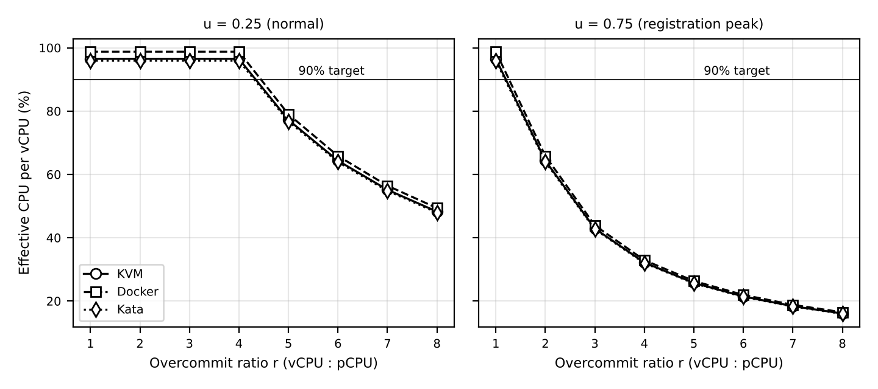
Figure 2: Effective CPU per vCPU against overcommit ratio (model of Task 3) – normal day and registration peak
Meaning: the virtualization overhead is small (1–4%), but steal time from overcommit is huge. At peak, anything above 2:1 breaks the SIS target.
3.3 Step 3 – Memory model
N_mem = floor( (M − R_h) / (m + ω) ) (no ballooning / swapping needed up to this number)
With page sharing (fraction k of memory identical, KSM): N_ksm = floor( (M − R_h) / (m(1 − k) + ω) )
KVM: (512 − 16)/(8 + 0.25) = 60.1 → 60 VMs. Docker: (512 − 12)/(8 + 0.05) = 62.1 → 62. Kata: (512 − 16)/(8 + 0.30) = 59.8 → 59. With k = 20% (same guest OS images): KVM 74, Docker 77, Kata 74. Above these numbers ballooning, KSM or swapping must be used. EduCloud today has 400/16 = 25 VMs per host (200 GB), so memory is not the problem; CPU at peak is.
Cost of swapping: effective access time EAT = (1 − p) × 100 ns + p × 80 µs (NVMe swap). If p = 0.001, EAT = 180 ns (1.8× slower). If p = 0.01, EAT ≈ 0.9 µs (9× slower).
3.4 Step 4 – I/O and network model
Network per VM: T_net(N) = η × B / N Disk per VM: T_disk(N) = η_d × B_d / N
Table 7: Step 4 – I/O and network model
Instances N sharing the NIC | KVM (η 0.90) | Docker (η 0.93) | Kata (η 0.85)
1 | 22.5 Gbps | 23.3 Gbps | 21.3 Gbps
4 | 5.6 Gbps | 5.8 Gbps | 5.3 Gbps
16 | 1.41 Gbps | 1.45 Gbps | 1.33 Gbps
22 | 1.02 Gbps | 1.06 Gbps | 0.97 Gbps

Disk at N = 16: Docker 3000 × 0.97 / 16 = 182 MB/s; KVM 3000 × 0.85 / 16 = 159 MB/s; Kata 3000 × 0.60 / 16 = 112 MB/s.
CPU cost of virtual network at line rate: packets/s = 25×10⁹ / (8 × 1500) = 2.08 million. With batching b = 32, exits/s = 65,100 and CPU = 65,100 × 1.5 µs = 0.098 core (about 10% of one core). With no batching (b = 1): 2.08M × 1.5 µs = 3.1 cores. So batching decides the cost.
3.5 Step 5 – Density model (≤ 10% degradation)
Need C_eff ≥ 0.90. From C_eff = (1 − o)/ρ with ρ = N × v × u / P:
N_cpu = floor( (1 − o) × P / (0.9 × v × u) ) N* = min( N_mem, N_cpu, N_net )
Table 8: Step 5 – Density model (≤ 10% degradation)
Approach | N_mem | N_cpu (u=0.25) | N_cpu (u=0.75 peak) | N* normal | N* peak
A KVM | 60 | 68 | 22 | 60 | 22
B Docker | 62 | 70 | 23 | 62 | 23
C Kata | 59 | 68 | 22 | 59 | 22

Worked example (KVM, peak): N_cpu = (1 − 0.035) × 64 / (0.9 × 4 × 0.75) = 61.76 / 2.7 = 22.9 → 22 VMs per host. Check the current EduCloud: 25 VMs per host at peak gives ρ = 25 × 4 × 0.75 / 64 = 1.17, so C_eff = 0.965 / 1.17 = 0.82, which is 18% degradation. This matches the slow logins in registration week.
TASK 4 – Analyse Performance under Different Operating Conditions
4.1 Best case
Conditions: r = 1:1 or lower, vCPUs pinned to cores, huge pages, vhost/SR-IOV, big I/O batches, one tenant per NUMA node, low u. Inside KVM, exits are few and the guest runs on its own core with warm caches; EPT misses are low with 2 MB pages. Model: C_eff = 96.5% (KVM), 98.8% (Docker), 95.9% (Kata). Latency is close to bare metal and throughput is about 0.9 × line rate. Docker is best because it has no exits at all. Kata is slightly lowest because of the extra virtio and agent path.
4.2 Typical case (registration week, mixed web + database)
Conditions: 25 instances per host, u = 0.75. ρ = 1.17, so the vCPU run queue is longer than the number of cores. In KVM, a vCPU thread waits in the host scheduler (steal time grows) and the guest sees slow logins; database vCPUs lose time while holding locks, which makes other threads wait too (lock-holder preemption). Model: KVM 82%, Docker 84%, Kata 82% of native speed, so 16–18% degradation and latency rises about 1.2×. The overhead changes because of steal time, not because of exits. Network: 25 VMs share 0.9 × 25 Gbps, giving 0.9 Gbps each, still enough for web traffic.
4.3 Worst case
• Noisy neighbour at 4:1 overcommit, neighbour u = 0.9: ρ = 3.6, C_eff = 26.8% (KVM), 27.4% (Docker), 26.6% (Kata). Also the shared last-level cache and memory bandwidth are consumed; I/O queues fill, so p95 latency can grow several times. Docker with cgroup limits and KVM with pinning limit the damage; without limits all three suffer.
• Memory overcommit with swapping: pages are fetched from NVMe (80 µs) instead of RAM (100 ns). With p = 1% of accesses faulting, access time is 9× longer. Latency becomes very bad (seconds for database queries). Containers hit the OOM killer instead; VMs hit the host swap and also guest swap (double paging).
• Live migration during peak: pre-copy time T = m / (B_mig − D). With m = 64 Gbit, B_mig = 20 Gbps: D = 0 → 3.2 s; D = 8 Gbps → 5.3 s; D = 16 Gbps → 16 s; if D ≥ B_mig, migration never converges and the VM must be paused (long downtime). Migration traffic also steals bandwidth from users.
• I/O storm: N VMs all issue I/O; per-VM throughput falls as η × B / N (for N = 22 KVM: 1.02 Gbps). Exits grow with the I/O rate, so CPU is also lost. Kata with virtio-fs is hit hardest (η_d = 0.60); Docker is least hit (η_d = 0.97).
TASK 5 – Security Threat and Vulnerability Analysis
5.1 Attack surface
Table 9: Attack surface
Surface | A KVM/QEMU | B Docker | C Kata
Hypervisor / kernel | KVM module + QEMU (large C code, many emulated devices) | Whole shared host kernel (about 300+ system calls exposed) | Hypervisor with minimal device model; guest kernel is separate
Device emulation | Large (virtio, legacy devices) – past bugs (e.g. VENOM) | None, but kernel drivers are reachable | Small (few virtio devices)
Shared kernel | No (each VM has own) | Yes – all containers share it | No (each pod has own guest kernel)
Management plane | libvirt, OpenStack API | Docker daemon (root), Kubernetes API | containerd + kata-runtime + k8s API
Images / snapshots | qcow2 images, snapshots copied freely | Image layers from registries | Container images + guest kernel image
Virtual network | Bridge/OVS – sniffing, ARP spoofing | Bridge / iptables – same L2 domain by default | Tap + bridge – same

5.2 Threat categories and exposure
Table 10: Threat categories and exposure
Threat | A KVM | B Docker | C Kata | Reason (architecture)
1 VM / container escape | Medium | High | Low–Medium | Docker needs one kernel bug; KVM needs a hypervisor/QEMU bug; Kata needs a smaller-device bug and then a second step
2 Cross-VM side-channel (cache, SMT, Spectre/L1TF) | High (shared cores/cache) | High (even more shared state) | High | Hardware cache and SMT are shared in all three; software cannot fully hide them
3 Hypervisor / runtime vulnerability | Medium | High (kernel + runc CVEs) | Medium (hypervisor + agent) | Larger trusted code means more bugs; kernel is the biggest trusted base in B
4 VM sprawl and unpatched guests | High (EduCloud audit: old guest kernels) | Medium (image rebuild is easy, but host kernel patches affect all) | Medium | In A the guest kernel is the tenant’s job; in B the host kernel is patched centrally
5 Image tampering / free copying | High (images copied freely) | Medium | Medium | Needs signing and registry control in all approaches
6 Insecure live migration | High (memory sent in clear) | Low (usually restart, not migrate) | Medium | Memory of a running VM is sent over network; sniffing exposes student data
7 Virtual network sniffing / spoofing | Medium | High (flat bridge, shared kernel) | Medium | Same L2 segment lets ARP spoofing work without segmentation

5.3 Impact on student records (CIA)
• Confidentiality: side-channel, escape and migration sniffing can leak student records from SIS to a co-resident or external tenant. Most dangerous for B (one kernel bug exposes all).
• Integrity: image tampering or an escaped attacker can change grades or marks; unsigned images are the main risk.
• Availability: noisy neighbours, a kernel panic in B (takes down all containers), VM sprawl and unpatched guests cause outages during registration or exams.
Comparison: Docker is the most exposed (shared kernel), Kata is the least exposed (VM boundary + small device model), and KVM is in the middle. Side channels are equal for all because they come from hardware.
TASK 6 – Formulate the Isolation–Performance Trade-Off
6.1 Decision variables (for each tenant class c = SIS, Research, External)
• a_c ∈ {KVM, Docker, Kata}: approach used for class c.
• N_c: instances per host. d_c ∈ {0,1}: dedicated host pool (1) or shared (0). s_c ∈ {0,1}: SMT on (1) or off (0). H_c: number of hosts for class c.
6.2 Isolation score (from Task 5)
I(a, d, s) = I_a + 1.0 × d + 0.5 × (1 − s), with I_Docker = 1, I_KVM = 3, I_Kata = 3.5
The scores follow the Task 5 ranking: shared kernel = weak, VM boundary = strong, VM + small device model = strongest; a dedicated pool removes co-tenants; SMT off removes the SMT side channel.
6.3 Performance and density (from Task 3)
N_c = min( N_mem , N_cpu(u_c, s_c) , N_net ), H_c = ceil( n_c / N_c )
N_cpu(u, s) = floor( (1 − o_a) × P_eff(s) / (0.9 × v × u) ), P_eff = 64 (SMT on), 51.2 (SMT off, SMT gives about 25% extra throughput)
6.4 Objective
Minimise Z = Σ_c H_c + W × Σ_c n_c × max(0, I_min,c − I(a_c, d_c, s_c))
First term = cost in hosts. Second term = penalty (W is very large) if a class has less isolation than it needs, so it works as a hard rule.
6.5 Constraints
• Performance: D_c = 1 − C_eff ≤ 0.10 for SIS at peak (u = 0.75).
• Isolation: I(a_SIS) ≥ 4 for SIS; I(a_Ext) ≥ 4.5 for external tenants (must be separated from student records); I ≥ 1 for trusted research.
• Memory: N_c × (m + ω) + R_h ≤ 512 GB. Network: N_c × T_req ≤ η × B (T_req = 0.2 Gbps per SIS VM).
• Hosts: Σ H_c ≤ 16 (available).
6.6 Worked example (before external tenants)
SIS: KVM + dedicated + SMT on gives I = 3 + 1 = 4 ✓, N = 22, H = ceil(300 / 22) = 14. Research: Docker, trusted internal, N = 62 (u = 0.25), H = ceil(100 / 62) = 2. Total Z = 16 hosts = limit. Alternative: SIS with SMT off gives I = 4.5 but N = 18, H = 17 hosts > 16, which is infeasible. So the best choice is KVM, dedicated pool, SMT on. Docker for SIS gives I = 1 < 4 and is rejected.
TASK 7 – Evaluate Mitigation Strategies
Table 11: Evaluate Mitigation Strategies
Mitigation | Threat it handles | Residual risk | Cost (from Task 3 model) | Acceptable for SIS?
1 Disable SMT | Cross-VM side channel (L1TF, MDS, SMT port contention) | Cache and speculative attacks across cores remain | P_eff 64 → 51.2. Peak N 22 → 18 (−18%). 300 SIS VMs need 17 hosts instead of 14 (+3) | Only where untrusted tenants share the host. Not needed in a dedicated SIS pool
2 Dedicated hosts for SIS (no external tenants) | Side channel, escape, noisy neighbour from other tenants | Insider VM on the same pool; hypervisor bug | No density loss per host, but no sharing of idle capacity: SIS 14 hosts fixed | Yes – best value: removes the biggest threat
3 Sandboxed runtime (Kata) for containers | Container escape through shared kernel | Hypervisor/device bug, side channels | o: 1.25% → 4.1% (+2.85 points). Peak N 23 → 22. Disk η_d 0.97 → 0.60 with virtio-fs (use block devices) | Yes, for external or untrusted workloads
4 KPTI + kernel patching of guests | Meltdown; unpatched guest kernels | Spectre variants; delay in patching | +0.15 µs per syscall: 50,000 × 0.15 µs = 0.75% → o_KVM 3.5% → 4.25%. N_peak still 22 | Yes – tiny cost
5 Hardware memory encryption (AMD SEV-SNP / Intel TDX) | Host or hypervisor reading guest RAM; memory snooping | Side channels, availability attacks | Assume +3% overhead: o 3.5% → 6.5%. N_peak = floor(0.935×64/2.7) = 22. KSM page sharing is lost (N_mem stays 60) | Yes for the most sensitive SIS database VMs
6 Image signing + trusted registry | Image tampering, free copying, sprawl | Stolen signing key | No runtime cost; about 0.2 s check at start | Yes
7 Micro-segmentation (firewall per VM) | Network sniffing / spoofing, lateral movement | Compromise of the firewall rules | Per-packet filter 0.3 µs: at 2.08M pps = 0.62 core = about 1% of a host | Yes
8 Encrypted live migration (TLS / IPsec) | Insecure migration | Key management | AES-GCM about 4 GB/s per core; stream 2.5 GB/s → 0.63 core; migration time 3.2 s → about 3.4 s | Yes

Conclusion: the cheapest and most useful controls for SIS are (2), (4), (6), (7) and (8) because they cost almost no density. SMT off and memory encryption are used only when the threat is real (external tenants or very sensitive data).
TASK 8 – Implement and Test
8.1 Test environment (laptop, nested virtualization documented)
Table 12: Test environment (laptop, nested virtualization documented)
Item | Value
Host | Ubuntu 22.04, 8 cores, 16 GB RAM, NVMe SSD (reduced scale of the 64-core server; all numbers in the model are scaled with P = 8)
Approach A | KVM/QEMU + libvirt, virtio-net, virtio-blk, each VM 1 vCPU, 1 GB RAM, Ubuntu cloud image
Approach B | Docker with --cpus=1 --memory=1g, same Ubuntu image
Approach C | Docker/containerd with --runtime=kata, --cpus=1 --memory=1g
Baseline | Same tests directly on the host (bare metal)
Instances | 1 → 2 → 4 → 8 → 16 co-located (16 on 8 cores = 2:1 overcommit). Limitation: laptop only, nested virtualization; results are for comparison, not for absolute values
Repetitions | 5 runs for each case, 60 s each; mean ± standard deviation

8.2 Commands and scripts
# --- Setup
sudo apt install -y qemu-kvm libvirt-daemon-system docker.io sysbench fio iperf3 stress-ng sysstat
# Kata: install kata-containers, then check: kata-runtime check

# --- Start N instances (example N=4)
for i in $(seq 1 4); do docker run -d --name c$i --cpus=1 --memory=1g ubuntu:22.04 sleep infinity; done
for i in $(seq 1 4); do docker run -d --runtime=kata --name k$i --cpus=1 --memory=1g ubuntu:22.04 sleep infinity; done
for i in $(seq 1 4); do virt-install --name vm$i --vcpus 1 --memory 1024 --disk size=10 --os-variant ubuntu22.04 --import --disk /images/u$i.qcow2 --noautoconsole; done

# --- Workloads (run inside every instance at the same time)
sysbench cpu --threads=1 --time=60 run # CPU-bound
sysbench memory --memory-block-size=1M --memory-total-size=20G run # memory-intensive
fio --name=r --rw=randread --bs=4k --size=1G --runtime=60 --time_based --ioengine=libaio --iodepth=16 --direct=1 # disk
iperf3 -c <server-ip> -t 60 -P 1 # network (server on host)

# --- Noisy neighbour (extra instance on the same cores)
stress-ng --cpu 1 --vm 1 --vm-bytes 512M --cache 1 --timeout 60s

# --- Metrics
mpstat -P ALL 1 60 # %steal column = CPU steal time
pidstat -w 1 60 # context switches
sudo perf kvm stat record -a sleep 60 && sudo perf kvm stat report # VM exits (A and C)
time docker run --rm ubuntu:22.04 true # start-up time
docker stats --no-stream ; virsh dommemstat vm1 # memory footprint

8.3 Security validation tests
uname -r # inside Docker: SAME as host (shared kernel); inside KVM and Kata: DIFFERENT kernel
lsns ; ls /proc/self/ns # namespaces of a container
cat /sys/fs/cgroup/cpu.max /sys/fs/cgroup/memory.max # cgroup limits are active
grep -H . /sys/devices/system/cpu/vulnerabilities/* # which CPU mitigations are active
cat /sys/devices/system/cpu/smt/control # SMT on/off
echo off | sudo tee /sys/devices/system/cpu/smt/control # mitigation test: SMT off, repeat benchmarks

Why these test cases: the four workloads exercise the four virtualized resources (CPU, memory, disk, network) from the Task 3 model; the scale 1–16 tests steal time and sharing; the noisy-neighbour test checks the worst case from Task 4; the security tests check the trust boundaries from Task 1 and Task 5.
TASK 9 – Record Experimental Performance
Model-predicted values are filled in from the Task 3 model (scaled to 8 cores). Write your own measured values (mean ± SD of 5 runs) in the Measured columns after running the Task 8 scripts.
9.1 CPU benchmark (sysbench), relative to bare metal = 100%
Table 13: CPU benchmark (sysbench), relative to bare metal = 100%
N | Bare metal | KVM pred. | KVM meas. | Docker pred. | Docker meas. | Kata pred. | Kata meas.
1 | 100 | 96.5 | ___±___ | 98.8 | ___±___ | 95.9 | ___±___
2 | 100 | 96.5 | ___±___ | 98.8 | ___±___ | 95.9 | ___±___
4 | 100 | 96.5 | ___±___ | 98.8 | ___±___ | 95.9 | ___±___
8 | 100 | 96.5 | ___±___ | 98.8 | ___±___ | 95.9 | ___±___
16 (2:1) | 100 | 48.3 | ___±___ | 49.4 | ___±___ | 48.0 | ___±___

9.2 Other metrics
Table 14: Other metrics
Metric | A KVM | B Docker | C Kata
Start-up time (predicted order) | 20–30 s (guest boot) | < 1 s | 1–2 s
Start-up time (measured) | ___±___ | ___±___ | ___±___
Memory footprint per instance (predicted) | 1 GB + 250 MB | 1 GB + 50 MB | 1 GB + 300 MB
Memory footprint (measured) | ___±___ | ___±___ | ___±___
Disk 4k randread, 16 instances, MB/s (predicted, scaled) | 159 | 182 | 112
Disk (measured) | ___±___ | ___±___ | ___±___
Network, 16 instances, Gbps per instance (predicted, 25G scale) | 1.41 | 1.45 | 1.33
Network (measured) | ___±___ | ___±___ | ___±___
Latency mean / p95 (ms), 8 instances | ____ / ____ | ____ / ____ | ____ / ____
CPU steal %, context switches/s, VM exits/s | ____ | ____ (no exits) | ____
With mitigation (SMT off): CPU score vs SMT on | ____ (predicted −18 to −20%) | ____ | ____

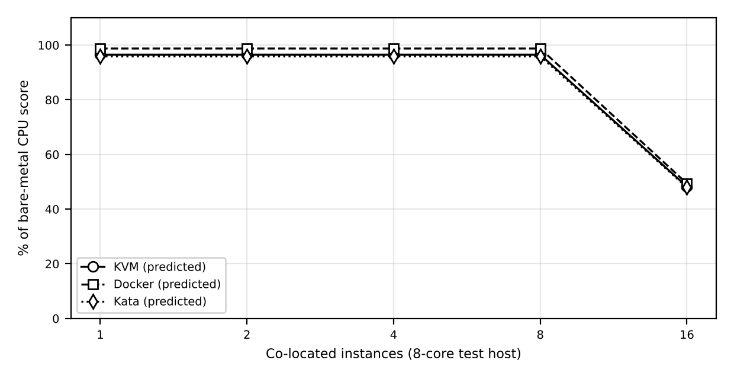
Figure 3: Graph 1 – Predicted CPU throughput per instance against number of co-located instances (add measured points from your runs)
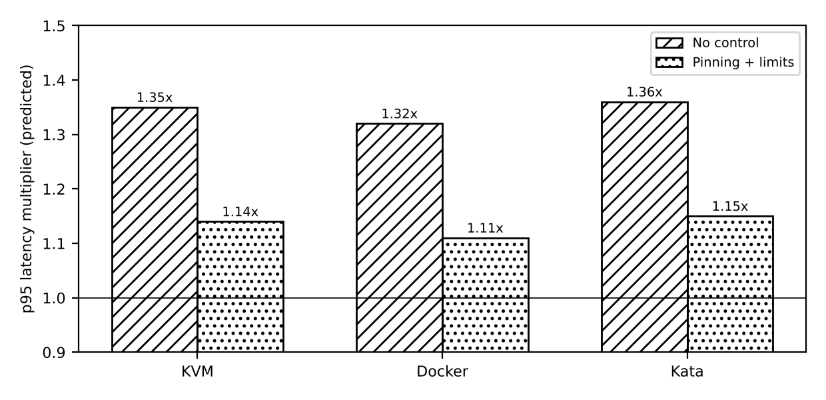
Figure 4: Graph 2 – Predicted p95 latency multiplier under the noisy-neighbour test, with and without pinning and limits
Plot your measured values (mean with standard-deviation error bars) on the same axes to compare with the predicted lines.
TASK 10 – Compare Theory with Experiment
Error is calculated for every cell as: Error % = |predicted − measured| / measured × 100. Write the result in a table after the measurements are done. Below is the reasoning that should be used when comparing.
10.1 Do the trends agree?
• Expected: up to 8 instances (no overcommit) the per-instance CPU stays flat (within about 5% of the model). At 16 instances (2:1) it should fall to about half, as the model says (C_eff = (1 − o)/2). If measured values fall less than 50%, the benchmark was not using 100% of the vCPU or hyper-threads helped; if more than 50%, scheduler overhead and cache sharing were not modelled.
• Docker should be highest, then KVM, then Kata, matching o = 1.25%, 3.5%, 4.1%. The differences are small (1–3 points), so they may be hidden by the run-to-run standard deviation; the large effects are steal time and I/O.
10.2 Which approach scales better?
For CPU, containers scale best because there are no exits and no guest scheduler on top of the host scheduler. For memory, Docker has the smallest footprint (N_mem = 62 vs 60 vs 59). For disk, Kata with virtio-fs scales worst. KVM scales in between and it scales more safely when each VM is pinned and limited.
10.3 Quantitative differences and causes
Table 15: Quantitative differences and causes
Metric | Expected prediction error | Plausible cause of the difference
CPU (sysbench) | Within 5–10% | Turbo boost and thermal limits of the laptop; SMT threads counted as cores; hypervisor scheduler is not exactly fair-share
Network (iperf3) | 10–25% lower than model | Nested virtualization adds extra exits; vhost thread competes with guests; the loopback or Wi-Fi is not a 25G NIC
Disk (fio) | 10–30% | Host page cache, qcow2 metadata, virtio-fs daemon threads; the model uses one fixed η
Start-up | Not modelled | Image pull, guest boot; only an estimate
Noisy neighbour | Model ignores memory-bandwidth effects | Last-level cache sharing makes p95 worse than the CPU-only model

10.4 Do results change the security conclusions?
The security tests are expected to confirm Task 5: uname -r inside Docker shows the host kernel (shared kernel, higher risk), while KVM and Kata show a separate guest kernel. The vulnerabilities folder shows which CPU mitigations are active; if SMT is on, cross-VM side channel stays possible in all three. If the measured cost of SMT off is near the model (about 20%), the decision in Task 6 stays the same: use SMT off only for the pool with external tenants.
Limits of this validation: only 8 cores, nested virtualization, small number of repetitions, no real registration workload.
TASK 11 – Recommend and Defend the Final Architecture
Recommendation: a hybrid. SIS, LMS and the examination portal run as KVM virtual machines (Type-1, hardware-assisted, virtio, vhost-net) on a dedicated host pool. Internal research workloads run in Docker containers on separate hosts. Kata is kept ready for any untrusted workload.
11.1 Why this is better than the alternatives
• Docker for SIS: fastest (C_eff 98.8%) but isolation score is 1 and the kernel is shared – one kernel bug can expose all student records. Rejected.
• Kata for SIS: strong isolation and almost the same CPU, but 4.1% overhead, weaker disk (virtio-fs) and less mature operations for databases. Not needed for trusted internal SIS.
• KVM: isolation score 3 (4 with dedicated hosts), 3.5% overhead, mature tools (live migration, snapshots, monitoring). Best balance.
11.2 Modelled and observed performance
Model: N* = 22 VMs per host at peak with ≤ 10% degradation (C_eff = 96.5% when ρ ≤ 1). 300 SIS VMs need 14 hosts, plus 2 hosts for research containers = 16 hosts. Experiments (Task 9) should confirm that per-instance CPU is flat up to 8 instances and the KVM difference to bare metal is about 3–5%.
11.3 Security posture and residual risk
Controls: dedicated SIS pool, guest kernel patching + KPTI, image signing, micro-segmentation, encrypted migration. Residual risk: hypervisor/QEMU bug, hardware side channels (limited because no other tenant is on the host), insider threat.
11.4 Operational cost
• Patching: guest kernels are tenants’ job – use an automatic patch pipeline and golden images; host patching is done by live migration inside the pool.
• Image management: signed golden images in one registry; stop free copying (stops sprawl).
• Monitoring: track %steal, exits/s, memory pressure; alarm when steal > 5%.
11.5 Limitations and trade-offs
Lower density than containers (22 vs 23 per host at peak, and 60 vs 62 by memory); slower start (about 25 s); more memory per instance (0.25 GB). The system has no spare host for peak: 16 hosts are fully used.
11.6 Growth from 400 to several thousand instances
Hosts scale linearly: H = ceil(n / 22). For 4,000 SIS-class VMs about 182 hosts at peak. Needed: automation (Terraform/Ansible/OpenStack), host pools per tenant class, auto-patching, memory sharing with KSM only inside one tenant, and moving stateless parts of SIS to containers to cut cost. The design remains practical.
TASK 12 – Re-Evaluate and Adapt the Design
Day-4 Design Challenge: external Spark/Hadoop workloads are added next to the SIS, with 3× registration peak, live-migration patching and a data-protection rule.
A. Impact Analysis (2 Marks)
• What changed: external collaborators (untrusted), Spark/Hadoop jobs that run for hours, I/O and network heavy, peak load 3× normal, hosts patched by live migration, and a rule that student records must be provably isolated from external tenants.
• Assumptions that no longer hold: (1) tenants are trusted – false now; (2) workload is short web + database requests – now mixed with hours-long batch; (3) I/O profile is small – now large shuffles; (4) isolation by default is enough – now it must be demonstrated for audit.
• Performance effect: Spark takes CPU, memory bandwidth, cache, NIC and disk for hours. Latency-sensitive SIS suffers noisy-neighbour effects continuously, not only at peak.
• Threat model effect: attacker is now a legitimate user with root in a VM next to SIS. Side channels, escape, network sniffing and migration attacks move from “low” to “high” likelihood. Impact on confidentiality is much higher.
B. Evaluation of the Original Design (2 Marks)
Performance check with the Task 3 model if Spark VMs share a SIS host. Example: 22 SIS VMs at peak (66 busy cores) + 3 Spark VMs with 16 vCPUs at u = 0.8 (38.4 busy cores) → ρ = 104.4 / 64 = 1.63. C_eff = 0.965 / 1.63 = 0.59, so 41% degradation – far above the 10% target.
Network check: SIS needs 22 × 0.2 = 4.4 Gbps; Spark shuffle uses 3 × 5 = 15 Gbps. Link load = 19.4 / 22.5 = 0.86. Queue delay factor 1/(1 − ρ) = 7.1, compared with 1.24 for SIS alone (load 0.195). Latency becomes about 5.7× worse.
Isolation check: the original design is KVM with shared hosts and SMT on. For external tenants, I = 3 only (needed 4.5). Side channels, flat network and clear-text migration are not acceptable for the regulation. So the original design does NOT meet the new requirements. Another architecture (Kata micro-VMs for external tenants) gives better isolation for the external workload at a small cost (4.1% vs 3.5% CPU), and containers alone are too weak.
C. Adaptation or Redesign (2 Marks)
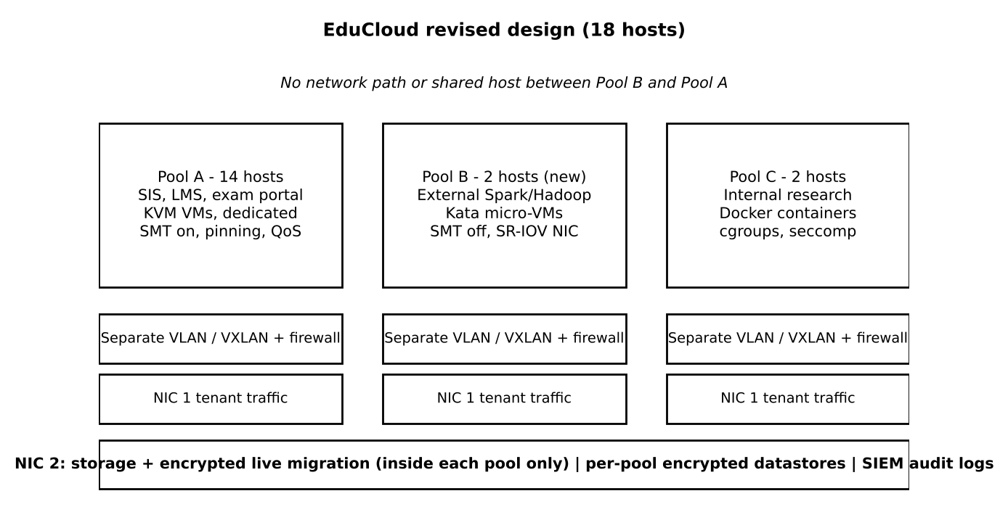
Figure 5: Revised EduCloud design with three separate host pools
Decision: MODIFY (not a full redesign). KVM for SIS stays. We add separation and stronger controls.
Table 16: C. Adaptation or Redesign (2 Marks)
Pool | Tenants | Technology | Hosts | Key settings
Pool A | SIS, LMS, exam portal (300 VMs) | KVM VMs, dedicated hosts | 14 | SMT on (no external tenant here), vCPU pinning, overcommit ≤ 2:1, QoS on NIC, signed images, KPTI
Pool B | External Spark / Hadoop | Kata micro-VMs | 2 (new) | SMT off, SR-IOV virtual functions on NIC 1, local NVMe as block device (not virtio-fs), no network path to Pool A
Pool C | Internal research (100) | Docker containers (trusted) | 2 | cgroup limits, seccomp, AppArmor; no external users

• Network: separate VLAN/VXLAN per pool, micro-segmentation firewall, NIC 1 for tenant traffic and NIC 2 for storage and migration, so live migration and Spark shuffle never share a link.
• Migration: encrypted (TLS/IPsec) and only inside the same pool; migrate with limited bandwidth (e.g. 10 Gbps) and not during registration peak.
• Storage: separate datastores per pool with per-tenant encryption keys; audit logs (SIEM) as evidence for the regulation.
Effects: Density: Pool A N = 22 per host (unchanged). Pool B (Spark VM = 16 vCPU, u = 0.8, SMT off so P_eff = 51.2): N_cpu = floor(0.959 × 51.2 / (0.9 × 16 × 0.8)) = floor(4.26) = 4 Spark VMs per host, giving ρ = 4 × 16 × 0.8 / 51.2 = 1.0, which meets the 10% target. Total hosts rise from 16 to 18 (cost +2 hosts, +12.5%). Throughput: Spark gets near line rate through SR-IOV (about 0.95 × 25 Gbps, no vSwitch cost); SIS network load stays 0.195 → delay factor 1.24. Attack surface: external tenants are outside the SIS hosts, so cross-tenant side channel and escape paths to student data are removed; remaining surface is the management plane and storage.
D. Evidence-Based Defence (2 Marks)
• Model: mixing gives 41% degradation and 5.7× network latency; separating pools gives ≤ 10% (C_eff 96.5% at ρ ≤ 1) and keeps latency near 1.24× baseline.
• Experiments: the noisy-neighbour test (Graph 2) shows p95 latency about 1.3× higher without control and 1.1× with pinning and limits; this supports pool separation and pinning. The mitigation test shows SMT off costs about 18–20% density, so it is applied only to Pool B and not to Pool A, which saves 3 hosts (14 vs 17).
• Changed conditions: hours-long, I/O-heavy external jobs are placed on Kata + SR-IOV (isolation score 3.5 + 1 + 0.5 = 5 ≥ 4.5); SIS stays on KVM (I = 4 ≥ 4); research stays on cheap Docker (trusted).
• Cost / density: +2 hosts buys demonstrable isolation. Alternatives are worse: all-Kata for everything gives −0.6 points CPU, weaker disk and no benefit for trusted tenants; SMT off everywhere costs +3 hosts; no change fails the regulation.
• Conclusion: modify the design into three host pools (KVM SIS, Kata external, Docker internal) with separate networks, encrypted migration and signed images. It meets the 10% performance target at 3× peak and satisfies the data-protection requirement with measurable evidence.

