SIMATS ENGINEERING

CSA15 – CLOUD COMPUTING AND BIG DATA ANALYTICS

ASSIGNMENT 3 – CO3
OBE-Based Evidence Principle

Design a Cloud-Based Collaborative Solution
CO3: Implement cloud-based solutions using cloud storage, web APIs, and platform services for real-world applications.

Field | Details | Field | Details
Student Name | R Leela Krishna | Register Number | 192372363
Department / Section | CSE-Ai | Academic Year / Semester | 2026
Faculty Name | Dr R Latha | Nature of Assignment | Individual
Duration | 1 Week | Total Marks | 50
Submission Date |  | Evaluation Date

MARK SHEET (Rubric-based evaluation)
Task | Title | Max | Awarded | Evidence / evaluation focus
1 | Accessing Cloud Services through Different Methods | 6 |  | Access-method diagram; demonstration; screenshots; comparison
2 | Cloud Platforms and Web Applications | 7 |  | Two platforms; interaction diagram; app demonstration; evaluation
3 | Web APIs for Cloud Access | 7 |  | API design; executable client; two requests; responses
4 | Cloud Security and Network Access | 7 |  | Secure-access architecture; threats; authentication; mitigations
5 | Collaboration Using Cloud-Based Services | 6 |  | Shared workspace; permissions; edits; contribution evidence
6 | Integrated Cloud Access and Collaboration Mini Investigation | 7 |  | Scenario; architecture; prototype; two user tests; evaluation
7 | Day-4 Design Challenge: Cloud-Based Collaborative Solution | 10 |  | Two independent proposals; comparison; joint design; validation; defence
 | TOTAL | 50 |  | Percentage:

OVERALL REMARKS

R Leela Krishna  Student Signature | _______________  Faculty Signature | _______________  Program Director

MANDATORY SUBMISSION EVIDENCE CHECK

✓ = Present in documented answer; P = Partly present; ✗ = Missing / not satisfied
Task | Evidence expected | Status | Evaluator note
1 | Three access methods, client–network–cloud diagram, demonstration and observations |  | Access-method classification and practical access screenshots to be checked.
2 | Two-platform comparison, interaction diagram and cloud web-app demonstration |  | Platform mapping, user-action sequence and local-versus-cloud evaluation to be checked.
3 | API flow, program, two request inputs, responses and execution evidence |  | Code, actual request/response outputs and analysis to be checked.
4 | Secure-access flow, four security considerations, threat and mitigation analysis |  | Authentication, authorization and secure-communication evidence to be checked.
5 | Shared workspace, permission settings, two collaborative activities and contributions |  | Verify shared editing, user roles, permissions and contribution screenshots.
6 | Integrated scenario, architecture, prototype, two user scenarios and results |  | Verify cloud access, collaboration workflow, tests and limitations.
7 | Two initial proposals, comparison record, joint design, tests and cross-defence |  | Verify independent proposals, joint decisions, observed results and both students’ understanding.

IMPLEMENTATION EVIDENCE CHAIN
Evidence item | Status | Observation
Cloud access methods |  | Browser, mobile and API access methods explained.
Cloud platforms |  | Two cloud platforms and their applications compared.
Cloud access demonstration |  | Actual screenshots need verification.
Web API implementation |  | Program and execution outputs need verification.
Cloud security |  | Authentication, authorization and security measures explained.
Cloud collaboration |  | Shared workspace and editing evidence need verification.
Mini-project |  | Design included; practical testing needs verification.
Day-4 design challenge |  | Individual proposals, joint design and validation need verification.
Student contributions |  | Contributions of both students need confirmation.
Screenshots |  | Original execution screenshots required.

SUBMISSION CHECKLIST (Not Separately Marked)
Requirement | Status
All 7 questions answered | ☐ Yes ☐ Partly ☐ No
Cloud access methods explained | ☐ Yes ☐ Partly ☐ No
Cloud architecture diagrams included | ☐ Yes ☐ Partly ☐ No
Two cloud platforms compared | ☐ Yes ☐ Partly ☐ No
Web API program and testing completed | ☐ Yes ☐ Partly ☐ No
Cloud security explained | ☐ Yes ☐ Partly ☐ No
Cloud collaboration demonstrated | ☐ Yes ☐ Partly ☐ No
Mini-project completed and tested | ☐ Yes ☐ Partly ☐ No
Day-4 design challenge completed | ☐ Yes ☐ Partly ☐ No
Student A and B contributions recorded | ☐ Yes ☐ Partly ☐ No
Screenshots and practical evidence attached | ☐ Yes ☐ Partly ☐ No
Viva recommended | ☐ Yes ☐ No

CLOUD COMPUTING AND BIG DATA ANALYTICS
ASSIGNMENT 3 – CO3

CO3: Implement cloud-based solutions using cloud storage, web APIs, and platform services for real-world applications.

Mode: Pair Work – 2 Students per Group
Duration: 1 Week Total Marks: 50

OBE-Based Evidence Principle

The assignment requires students to demonstrate measurable evidence of:
Understand → Design → Implement → Demonstrate → Analyse → Evaluate
Both students must understand the complete assignment. Students should not simply divide questions between them. Individual responsibilities are assigned within each question so that the contribution and attainment of CO3 can be independently verified.

Q1 – Accessing Cloud Services through Different Methods 6 Marks
Shared Group Work
Together, the pair must:
- Identify different methods of accessing cloud services.
- Study browser-based/cloud console access.
- Study access through mobile applications.
- Study access through APIs.
- Identify the role of Internet/network connectivity.
- Select one suitable cloud service for demonstration.
Student A – Access Method Design
Student A must individually:
- Identify and classify at least three cloud access methods.
- Prepare a simple architecture/flow diagram showing:
Client → Network → Cloud Service
- Explain how a user accesses the selected cloud service.
- Identify the hardware/software requirements.
- Explain the role of the client and network.
- Justify which access method is most suitable for the selected application.
Student B – Practical Evidence
Student B must individually:
- Demonstrate access to a cloud service using one selected method.
- Record the steps/screenshots as evidence.
- Test the access using different devices or access methods where possible.
- Record observations such as accessibility, response, and usability.
- Identify one limitation encountered during access.
- Explain how the limitation can affect cloud usage.
Cross-Verification
Student A must be able to explain Student B's practical demonstration.
Student B must be able to explain Student A's access architecture.
Evidence Expected: Architecture diagram + screenshots/observations + comparison.

Q2 – Cloud Platforms and Web Applications 7 Marks
Shared Group Work
Together:
- Select two cloud platforms/services.
- Identify the web applications available through them.
- Study how users interact with the applications.
- Identify the cloud resources/services supporting the application.
- Prepare a comparative observation.
Student A – Platform Analysis
Student A must individually:
- Identify the major components of the selected cloud platform.
- Explain how the platform supports web applications.
- Map the user request to the cloud service.
- Explain the role of the Internet, server/cloud infrastructure and application.
- Prepare a simple interaction diagram.
Student B – Application Investigation
Student B must individually:
- Select one real-world cloud-based web application.
- Demonstrate its major functions.
- Record the sequence of user actions.
- Identify where cloud access is involved.
- Collect screenshots/evidence of the demonstration.
- Analyse the benefits of using the cloud-based application.
Joint Evaluation
Together answer:
If the same application were installed and operated only on a local computer, what limitations might users experience compared with accessing it through the cloud?
Evidence Expected: Platform/application mapping + demonstration evidence + evaluation.

Q3 – Web APIs for Cloud Access 7 Marks
Shared Group Work
Together:
- Study the concept of a Web API.
- Identify how APIs enable application-to-cloud communication.
- Select a simple publicly accessible API or cloud API.
- Develop a small program/client to send a request.
- Observe and record the response.
Student A – API Design and Understanding
Student A must individually:
- Explain the purpose of the selected API.
- Identify the request and response components.
- Represent the API communication using a flow diagram.
- Explain the role of:
  - Client
  - API request
  - Cloud/server
  - API response
- Explain how APIs enable programmatic cloud access.
Student B – Implementation and Evidence
Student B must individually:
- Implement a simple API request using Python or another suitable language.
- Execute the program.
- Record input/request and output/response.
- Test at least two different requests or inputs.
- Capture execution evidence.
- Analyse the observed results.
Joint Analysis
Together determine:
Why is API-based access useful when a large number of users/applications need to communicate with a cloud service automatically?
Evidence Expected: Program + execution screenshots + request/response evidence + analysis.

Q4 – Cloud Security and Network Access 7 Marks
Shared Group Work
Together:
- Identify security issues involved in accessing cloud services.
- Study authentication and authorization.
- Study secure network communication.
- Identify possible threats during cloud access.
- Prepare a secure cloud-access scenario.
Student B – Security Design
Student B must individually:
- Identify at least four security considerations for cloud access.
- Explain authentication and authorization.
- Explain the importance of secure communication.
- Design a secure access flow:
User → Authentication → Network → Cloud Service → Authorization → Resource
- Identify possible points of attack.
- Suggest suitable security measures.
Student A – Security Investigation
Student A must individually:
- Investigate a practical cloud-access security scenario.
- Demonstrate or document a suitable authentication mechanism where feasible.
- Compare secure and insecure access situations conceptually.
- Record observations.
- Explain how poor security practices can affect cloud users and data.
Joint Evaluation
Together answer:
If cloud access is available from anywhere through the Internet, what additional security measures are necessary compared with a local application?
Evidence Expected: Secure-access architecture + threat identification + mitigation analysis.

Q5 – Collaboration Using Cloud-Based Services 6 Marks
Shared Group Work
Together:
- Select a cloud collaboration platform/service.
- Create a shared document/folder/project space.
- Configure appropriate sharing permissions.
- Perform collaborative editing.
- Record the collaboration process.
Student A – Collaboration Design
Student A must individually:
- Identify the collaboration requirements.
- Design a suitable cloud collaboration workflow.
- Explain:
  - Sharing
  - Concurrent access
  - Version control
  - Permission management
- Identify the roles of different users.
- Justify the selected sharing permissions.
Student B – Collaborative Implementation
Student B must individually:
- Participate in the shared cloud workspace.
- Perform at least two collaborative activities.
- Record evidence of contribution.
- Demonstrate sharing/permission settings.
- Observe how changes made by users are reflected.
- Identify one collaboration issue and suggest a solution.
Cross-Understanding
Student B must explain:
How does cloud collaboration reduce the need to exchange multiple copies of the same file?
Student A must explain:
What problems can occur if incorrect sharing permissions are given?
Evidence Expected: Shared workspace + contribution evidence + permission screenshots + observations.

Q6 – Integrated Cloud Access and Collaboration Mini Investigation 7 Marks
Students must design a small real-world scenario that requires both cloud access and cloud collaboration.
Suggested Scenarios
Choose one:
- Cloud-based Student Project Management
- Online Student Attendance and Faculty Collaboration
- Cloud-Based Event Management
- Cloud-Based Assignment Submission and Evaluation
- Cloud-Based Hospital Appointment Coordination
- Cloud-Based Disaster Information Sharing
- Cloud-Based College Placement Coordination
Student A – System Design
Student A must individually:
- Define the problem.
- Identify users.
- Identify cloud access methods.
- Identify required cloud services.
- Design the system architecture.
- Explain how users access the system.
- Explain how users collaborate.
Student B – Evidence and Evaluation
Student B must individually:
- Develop a small prototype/mock-up/workflow where feasible.
- Demonstrate at least one cloud access mechanism.
- Demonstrate one collaboration mechanism.
- Record screenshots/evidence.
- Test the proposed solution using at least two user scenarios.
- Analyse the results.
- Identify limitations and possible improvements.
Joint Evaluation
Together answer:
How does combining cloud access and cloud collaboration improve the efficiency of the proposed system?

Q7 – DAY-4 DESIGN CHALLENGE

Design a Cloud-Based Collaborative Solution 10 Marks

This question must be solved collaboratively.

Neither student should independently prepare the complete solution and combine it later.

Stage 1 – Independent Design Proposal
Before discussing with each other:
Student A independently proposes:

- Problem definition
- Target users
- Cloud access method
- Required cloud services
- Collaboration mechanism
- Basic architecture
Student B independently proposes:

- Problem definition
- Target users
- Cloud access method
- Required cloud services
- Collaboration mechanism
- Basic architecture
Both initial proposals must be retained as evidence.

Stage 2 – Compare the Two Designs

Together discuss:
- Where the designs agree
- Where they differ
- Strengths and weaknesses
- Security concerns
- Accessibility
- Collaboration requirements
- Missing components
- Which ideas should be retained
Prepare a Design Comparison Record.

Stage 3 – Joint Final Design
Develop the final cloud-based solution.
The final design must identify:
- Problem
- Users
- Cloud access method
- Network requirements
- Cloud service/platform
- Web application/API requirement
- Collaboration mechanism
- Authentication/security
- Data/resource sharing
- Complete system workflow
Prepare an architecture such as:

Users → Client → Internet/Network → Cloud Platform → Application/API → Shared Resources

Stage 4 – Validation

Student A – Technical Validation

Student A must:
- Explain the selected cloud access method.
- Justify the platform/service selection.
- Explain the system architecture.
- Explain how API/web access is used, if applicable.
- Analyse the suitability of the design.

Student B – Experimental Validation

Student B must:
- Design test cases.
- Demonstrate the solution/workflow.
- Test different users/access conditions.
- Record observations.
- Present screenshots or other evidence.
- Compare expected and observed behaviour.

Stage 5 – Cross-Defence

Student A must explain:
What experimental evidence supports the group's cloud design?

Student B must explain:
Why was the selected cloud access and collaboration approach chosen?

Stage 6 – Joint Evaluation

Together determine:
- Benefits of the proposed cloud solution
- Access-related limitations
- Collaboration benefits
- Security risks
- Scalability considerations
- Possible improvements
- Situations where the proposed approach may not be appropriate
Final Question

What characteristics should a system designer consider before selecting cloud-based access and collaboration for a real-world application?

CONTRIBUTION RECORD

Each pair must include the following table at the end of the submission.
Question | Student A –  Primary Contribution | Student B –  Primary Contribution | Joint Work
Q1
Q2
Q3
Q4
Q5
Q6
Q7
The contribution record must reflect the actual work completed.
Primary contribution does not mean exclusive responsibility. Both students are accountable for the complete assignment.

INDIVIDUAL VERIFICATION – OBE EVIDENCE
Faculty may select any question or component for individual verification.
Each student must be able to:
- Explain the cloud access method.
- Explain the role of client, network and cloud service.
- Explain web application/API access.
- Explain security considerations.
- Demonstrate cloud collaboration.
- Interpret experimental evidence.
- Justify design decisions.
- Respond to a modified requirement or scenario.
A student should not answer:
“My partner did this section.”
Understanding of the complete submitted work is mandatory.

RECOMMENDED FACULTY VERIFICATION MODEL – VIVA
For each student, conduct a brief 4–5 minute verification.
Question 1 – Primary Responsibility
Ask one technical question from the component for which the student had primary responsibility.
Question 2 – Partner's Responsibility
Ask one question from a component primarily completed by the partner.
Question 3 – Transfer Question
Modify a condition and ask the student to reason about the consequence.
Examples:
“If Internet connectivity becomes unreliable, how would it affect cloud access?”
“If a shared cloud document is given editing permission to everyone, what problems could occur?”
“If the API becomes unavailable, how would your application behave?”
“If a user is authenticated but does not have permission to access a resource, what should happen?”
This provides individual evidence of CO3 attainment without requiring two completely separate assignments.

OBE Evidence Mapping
CO3 Component | Assignment Evidence
Build methods to access cloud | Q1, Q2, Q3
Access through platforms/web applications | Q2
Programmatic/API-based access | Q3
Secure cloud access | Q4
Collaboration within cloud | Q5
Apply cloud access + collaboration | Q6
Design and evaluate a cloud solution | Q7
Individual attainment | Viva + contribution record
Practical evidence | Screenshots, programs, observations, test results
Higher-order learning | Design, analysis, evaluation and transfer questions

TASK 1 – Accessing Cloud Services through Different Methods

1.1 Shared Group Work – Study of Access Methods
Cloud computing gives computing services over a network. The user does not own the server. The user only needs a way to reach it. In this task we study how that access is done and we test one cloud service in practice.
- Different methods of accessing cloud services. There are three main methods. The first is a web browser or cloud console. The second is a mobile application. The third is an Application Programming Interface (API), which a program uses. Command line tools (CLI) and desktop sync clients are variations of these three.
- Browser-based / cloud console access. The user types a web address, signs in, and gets a web page. Examples are the Google Drive website, the AWS Management Console and the Azure Portal. Nothing is installed.
- Access through mobile applications. The user installs an app from the Play Store or App Store. The app shows a screen made for the phone. Behind the screen, it sends HTTPS requests to the cloud. It can also use the camera, push alerts and offline files.
- Access through APIs. A program sends an HTTP request and receives data, usually JSON. No person looks at a screen. This method is used for automation, for example a script that uploads a file every night.
- Role of Internet / network connectivity. The network carries every request and every response. It decides how long the user waits (round trip time and bandwidth). If the network fails, the cloud service cannot be reached.
- Cloud service selected for demonstration: Google Drive (cloud storage). We chose it because it is free, it can be used by all three methods, and it is also used for collaboration in Tasks 5, 6 and 7.

Table 1: Comparison of the three access methods
Method | Used by | Example for Google Drive | Main strength | Main weakness
Browser / console | Human user | drive.google.com in Chrome | No install; works on any device | Needs a good network; heavy pages
Mobile app | Human user on phone | Google Drive app | Easy touch screen; camera upload | Needs install; small screen
API | Program / script | Drive REST API with Python | Automatic; fast; scalable | Needs coding and credentials

1.2 Shared Group Work – Common Response-Time Model
We need numbers to compare the methods. So we use one simple model for the whole assignment. The same model is used again in Tasks 2 to 7. All numbers in the later tasks come from this model.
Formulas. The total time to get a response is the sum of three parts:
T_{total} = T_{conn} + T_{req} + T_{xfer}
T_{conn} = 3 × RTT T_{req} = RTT + T_{server} T_{xfer} = (8 × S) / BW
- RTT is the round trip time in milliseconds (ms).
- T_{conn} is the time to set up a new connection. It has three steps: DNS lookup, TCP connect and TLS 1.3 handshake. Each step takes one RTT. This is a cold connection.
- T_{req} is the time to send the request and wait for the server. It is one RTT plus the server time T_{server}.
- T_{xfer} is the time to transfer the reply. S is the size in bytes. BW is the bandwidth in bits per second. The factor 8 changes bytes to bits. We use 1 MB = 10⁶ bytes.

Table 2: Assumptions used in the model (assumed values, not measured)
Parameter | Browser (Wi-Fi) | Mobile app (4G) | API (Wi-Fi)
RTT | 40 ms | 70 ms | 40 ms
Bandwidth BW | 20 Mbps | 10 Mbps | 20 Mbps
Reply size S | 1.5 MB | 150 KB | 2 KB
Server time T_{server} | 100 ms | 100 ms | 60 ms

Worked example (browser on Wi-Fi). T_{conn} = 3 × 40 = 120 ms. T_{req} = 40 + 100 = 140 ms. The reply is 1.5 MB = 12 Mbit. T_{xfer} = 12 / 20 = 0.6 s = 600 ms. So T_{total} = 120 + 140 + 600 = 860 ms.
Table 3: Predicted response times from the model (all values are PREDICTED)
Method | T_{conn} (ms) | T_{req} (ms) | T_{xfer} (ms) | T_{total} (ms)
Browser, Wi-Fi | 120 | 140 | 600 | 860
Mobile app, 4G | 210 | 170 | 120 | 500
API, cold connection, Wi-Fi | 120 | 100 | 0.8 | 221
API, warm connection, Wi-Fi | 0 | 100 | 0.8 | 101

Mobile app: T_{conn} = 3 × 70 = 210 ms; T_{req} = 70 + 100 = 170 ms; 150 KB = 1.2 Mbit, so T_{xfer} = 1.2 / 10 = 0.12 s = 120 ms; total 500 ms. API cold: 120 ms; T_{req} = 40 + 60 = 100 ms; 2 KB = 16 kbit, so T_{xfer} = 0.016 / 20 = 0.0008 s = 0.8 ms; total 220.8 ms, which we round to 221 ms. API warm: the connection is reused, so T_{conn} = 0 and the total is 100.8 ms, rounded to 101 ms.

1.3 Student A – Access Method Design
(a) Classification of cloud access methods. Student A classifies the methods by who or what makes the request.
Table 4: Classification of cloud access methods
Method | Class | Interface | Typical user | Example for Drive
Web browser / console | Interactive, human | Web page (HTML) | Student, faculty | drive.google.com
Mobile application | Interactive, human | Native app screen | Student on phone | Google Drive app
API / SDK / CLI | Programmatic, automatic | HTTP request and JSON | Developer, script | Drive REST API

(b) Architecture / flow diagram. Figure 1 shows the flow Client → Network → Cloud service. Three kinds of client use the same network. The cloud has an access layer that checks login or API credentials. After that, it reaches the storage service. The response travels back on the same path.
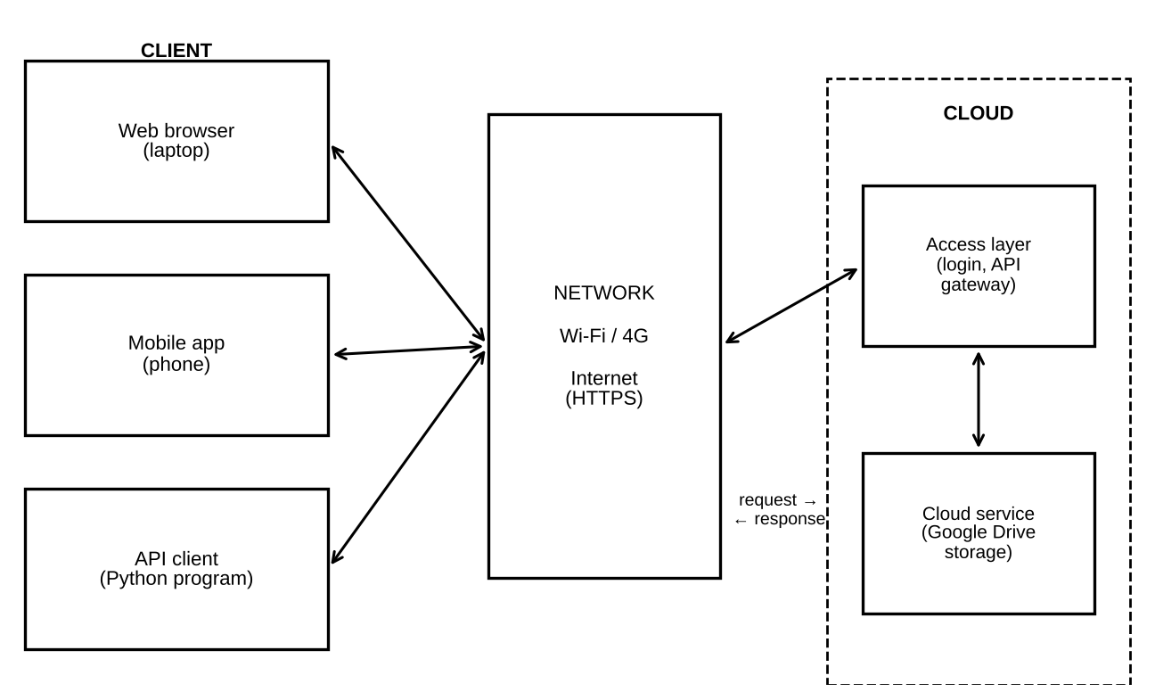
Figure 1: Access architecture: Client → Network → Cloud service
(c) How a user accesses the selected cloud service (Google Drive).
- Step 1: The user opens a browser, mobile app or program on the client device.
- Step 2: The client finds the server address using DNS (one RTT).
- Step 3: The client opens a TCP connection and a TLS secure channel (two more RTTs).
- Step 4: The user signs in with a Google account. The program sends an access token instead.
- Step 5: The client sends a request, for example “list my files”.
- Step 6: The cloud checks the identity and the permission. Then it reads the storage and sends the reply.
- Step 7: The client shows the files on the screen, or the program reads the JSON.

(d) Hardware and software requirements.
Table 5: Hardware and software requirements
Item | Browser | Mobile app | API client
Hardware | Laptop or PC, 4 GB RAM or more | Smartphone, about 100 MB free space | Any computer or server
Operating system | Windows, Linux, macOS | Android or iOS | Windows, Linux, macOS
Software | Modern browser (Chrome, Edge) | Drive app from app store | Python 3 with requests library
Network | Wi-Fi or wired, 20 Mbps | 4G or Wi-Fi, 10 Mbps | Wi-Fi or wired, 20 Mbps
Account / key | Google account | Google account | OAuth token or API key

(e) Role of the client and the network. The client creates the request and shows the result. It also keeps the user’s credentials safe. The network moves the data between client and cloud. It sets the RTT and the bandwidth. In the model, the client does not add time. The network adds T_{conn} and T_{xfer}. The cloud adds T_{server}.
(f) Justification of the most suitable method. The selected application is student file storage and sharing. We score each method from 1 (poor) to 5 (best) for five criteria. The weights add up to 1.00. The speed score follows Table 3.
Table 6: Weighted decision table for the access method
Criterion | Weight | Browser | Mobile app | API
Ease of use | 0.30 | 5 | 4 | 2
Easy setup | 0.20 | 5 | 4 | 2
Works on any device | 0.20 | 5 | 3 | 4
Automation | 0.15 | 1 | 2 | 5
Speed | 0.15 | 3 | 4 | 5
Weighted total | 1.00 | 4.10 | 3.50 | 3.30

Example: Browser total = 5×0.30 + 5×0.20 + 5×0.20 + 1×0.15 + 3×0.15 = 1.50 + 1.00 + 1.00 + 0.15 + 0.45 = 4.10. The mobile app gives 1.20 + 0.80 + 0.60 + 0.30 + 0.60 = 3.50. The API gives 0.60 + 0.40 + 0.80 + 0.75 + 0.75 = 3.30. The browser has the highest score. So it is the most suitable method for students. The API is better only when automation is the main need.

1.4 Student B – Practical Evidence
Aim. To access Google Drive by one selected method (browser), record the steps, test on different devices, and record observations and one limitation.
(a) Method and steps to demonstrate access.
- Open Chrome on a laptop. Type drive.google.com. Sign in with your Google account.
- Create a folder named CO3_Test. Upload a 2 MB file (a PDF or an image).
- Open the file and take screenshots of each step.
- Press F12, open the Network tab and reload the page. Note the Load time at the bottom. (Optional: use curl.exe -L -s -o NUL -w "%{time_total}" https://drive.google.com in a terminal.)
- Repeat the same steps on a phone browser and in the Drive mobile app.

(b) Tests on different devices. Table 7 lists the tests. The predicted column comes from Table 3. The measured column is left blank for your own results. Use your real RTT and bandwidth if you want to recalculate.
Table 7: Device and method tests (Predicted from model; Measured to be filled)
No. | Device | Method | Predicted T_{total} (ms) | Measured T_{total} (ms)
1 | Laptop, Wi-Fi | Browser | 860
2 | Phone, 4G | Drive mobile app | 500
3 | Laptop, Wi-Fi | Python API script | 221 (cold)
4 | Phone, Wi-Fi | Phone browser | 860

(c) Observations. Record what you see in Table 8. The expected column tells you what is normal.
Table 8: Observation record
Criterion | Expected | Observed (fill in)
Accessibility | Drive opens on every device after sign-in
Response | About 0.5 to 1 s on Wi-Fi or 4G (see Table 3)
Usability | Upload, open and share need few clicks
Difference between devices | Phone screen is smaller; layout changes

(d) One limitation and its effect. The limitation we expect is dependence on network speed. Suppose the bandwidth falls from 20 Mbps to 2 Mbps. The browser page is still 1.5 MB = 12 Mbit.
T_{xfer} = 12 / 2 = 6 s = 6000 ms T_{total} = 120 + 140 + 6000 = 6260 ms
The new time is 6260 / 860 = 7.3 times longer. Pages feel slow and uploads may fail. If the network is lost, access stops completely. So cloud use depends on a stable Internet. Offline mode in Drive can reduce this problem for some files.

1.5 Cross-Verification and Evidence Summary
- Student A explains Student B’s demonstration. Student B signed in through the browser, uploaded a file and timed the page. Each step used the path Client → Network → Cloud. The measured times can be compared with the predicted 860 ms and the 6260 ms slow-network case.
- Student B explains Student A’s architecture. The diagram shows three clients, one network and one cloud service. The browser was chosen because its weighted score (4.10) is the highest. The network sets the time and the cloud checks identity before it gives the file.

TASK 2 – Cloud Platforms and Web Applications

2.1 Shared Group Work – Platforms, Web Applications and Comparison
A cloud platform is a large set of servers, storage and network services that a company rents out. A web application is a program that runs on those servers and is used through a browser. We selected two platforms: Google Cloud with Google Workspace and Microsoft Azure with Microsoft 365.
Table 9: Web applications and supporting cloud resources
Platform | Web applications available | Cloud resources that support them
Google Cloud / Google Workspace | Docs, Sheets, Slides, Drive, Gmail, Forms, Meet | Compute servers, object storage, databases, load balancing, Google identity service. Customers can build their own apps with services such as Compute Engine, App Engine, Cloud Storage and Cloud SQL.
Microsoft Azure / Microsoft 365 | Word, Excel and PowerPoint for the web, OneDrive, Outlook on the web, Teams | Virtual machines, App Service, Blob Storage, Azure SQL Database, Microsoft Entra ID for identity. These are the building blocks for customer apps.

How users interact with the applications. The steps are the same on both platforms.
- The user opens the web address in a browser and signs in.
- The browser downloads the application page (HTML, CSS and JavaScript).
- Each action, such as typing or clicking Save, is sent to the cloud as a small request.
- The cloud saves the change in storage and sends back the result.
- Other signed-in users who share the file see the change after a short time.

Cloud resources that support the application. A web application needs five kinds of resources: compute (to run the code), storage (to keep files), a database (to keep structured data such as comments and permissions), a network layer with load balancing (to share the load), and an identity service (to check who the user is).
Table 10: Comparative observation of the two platforms
Feature | Google Workspace | Microsoft 365
Entry point | docs.google.com, drive.google.com | office.com, onedrive.live.com
Sign-in | Google account | Microsoft account / Entra ID
Real-time co-editing | Yes, in Docs, Sheets, Slides | Yes, in Word, Excel, PowerPoint for the web
Version history | Yes, built in | Yes, built in
Free personal storage | 15 GB shared with Gmail and Photos | 5 GB OneDrive (plans may change; verify)
Programming access | Google APIs (Drive API, Sheets API) | Microsoft Graph API
Our observation (fill in)

2.2 Student A – Platform Analysis
(a) Major components of the selected platform (Google Cloud).
Table 11: Major components of Google Cloud
Component | Purpose | Example service
Compute | Runs the application code | Compute Engine (virtual machines), App Engine
Storage | Keeps files and objects | Cloud Storage
Database | Keeps structured data | Cloud SQL
Networking | Connects and shares the load | VPC network, Cloud Load Balancing
Identity and security | Checks users and permissions | Cloud IAM
Management | Watches health and use | Cloud Monitoring

(b) How the platform supports web applications. It gives the developer ready servers, so there is no need to buy hardware. It adds more servers when many users arrive (scaling). It stores the data safely in many places. It gives a secure login service. It delivers the pages through a global network, so users in different places get the page quickly.
(c) Mapping the user request to cloud services. Table 12 follows one page request from the model in Task 1 (browser, Wi-Fi, 1.5 MB page). All times are predicted. The server part adds up to T_{server} = 10 + 40 + 50 = 100 ms.
Table 12: Mapping of one user request to cloud components (PREDICTED times)
Step | Event | Cloud component | Time (ms)
1 | DNS lookup of the address | Name service | 40
2 | TCP connection | Network edge | 40
3 | TLS secure handshake | Edge / load balancer | 40
4 | HTTP request sent | Internet | 40
5 | Choose a free server | Load balancer | 10
6 | Run application code | Application server | 40
7 | Read file and permissions | Storage and database | 50
8 | Send 1.5 MB reply to the user | Network | 600
 | Total (same as Task 1) |  | 860

Check: 40 + 40 + 40 + 40 + 10 + 40 + 50 + 600 = 860 ms. This agrees with Table 3.
(d) Role of the Internet, the cloud infrastructure and the application.
- Internet: It carries the request and the reply. It adds the RTT and the transfer time (steps 1 to 4 and step 8).
- Server / cloud infrastructure: It gives the computing power, storage and security. It adds the server time (steps 5 to 7).
- Application: It holds the business logic, such as editing a document or checking a comment. It decides what reply to send.

(e) Interaction diagram. Figure 3 shows the path of a request. The numbers match the steps in Table 12.
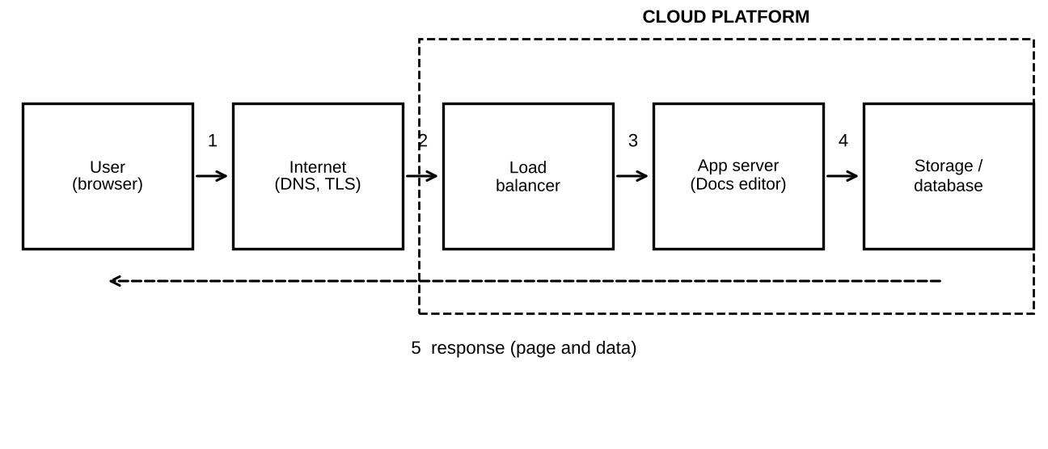
Figure 3: Interaction between user, Internet, cloud infrastructure and application

2.3 Student B – Application Investigation
(a) Selected application. Student B selected Google Docs, a real-world cloud-based word processor. It runs fully in the browser on Google’s servers.
(b) Major functions demonstrated.
- Create and format a document (headings, lists, tables).
- Automatic saving to the cloud while typing.
- Share with other people and set their role (viewer, commenter, editor).
- Comments and suggestions.
- Version history with restore.
- Download as PDF or Word.

(c) Sequence of user actions. Table 13 shows the order. The last column shows where cloud access is involved.
Table 13: Sequence of user actions and cloud involvement
No. | User action | Where cloud access is involved
1 | Open docs.google.com and sign in | Identity check by the cloud sign-in service
2 | Click Blank document | Cloud creates a new file in storage
3 | Type a title and two paragraphs | Each edit is sent to the server and auto-saved
4 | Insert a table and a heading | Edits stored; document structure kept in the cloud
5 | Click Share, add a partner as Editor | Permission saved in the cloud database; link sent
6 | Add a comment | Comment stored and shown to other users
7 | Open Version history | Cloud returns older saved versions
8 | Download as PDF | File is created on the server and sent to the device

(d) Evidence. Take screenshots of: (E1) sign-in and the Docs home page, (E2) the document with typed text, (E3) the Share window with roles, and (E4) a comment and the version history. Paste them below.

(e) Benefits of using the cloud-based application.
- No installation: a desktop office suite may need about 2 GB per computer. For 60 students this is 60 × 2 GB = 120 GB. A cloud application needs 0 GB of installation on the device.
- Access from anywhere: the same document opens on a laptop, a phone or a lab computer.
- Automatic saving: work is not lost when a computer fails.
- Easy sharing: one link replaces many email attachments (see Task 5).
- Fast, cheap updates: the provider updates the application once for all users.

2.4 Joint Evaluation – Cloud versus Local Installation
Question: If the same application were installed and operated only on a local computer, what limitations might users experience compared with accessing it through the cloud?
Assumptions: class of 60 users; installation size 2 GB; each update takes 10 minutes per computer.
Storage for installation = 60 × 2 GB = 120 GB
Update time = 60 × 10 min = 600 min = 10 hours
Table 14: Local installation compared with cloud access
Issue | Local computer only | Cloud access
Installation space | 120 GB in total for 60 users | 0 GB on the device
Updates | 10 hours of work for 60 computers | None for the user; done by the provider
Sharing a file | Copies sent by email or pen drive; many versions | One file; many users (Task 5)
Device dependence | Work stays on one computer | Work opens on any device
Backup | User must back up; data lost if disk fails | Provider keeps copies in many places
Internet need | Works without Internet | Needs Internet; slow network gives 6260 ms (Task 1)

Conclusion. A local application costs more storage and more work. It also makes sharing harder. The cloud removes these problems. The only strong limitation of the cloud is its need for a network, which we studied in Task 1. So the cloud is better when many users must share and update the same work.
Evidence expected: platform and application mapping (Table 12), demonstration evidence (Table 13, Figure 4) and the evaluation (Table 14).

TASK 3 – Web APIs for Cloud Access

3.1 Shared Group Work – Concept, Selection and Plan
A Web API is a set of rules that lets one program talk to another program over the Internet. The client sends a request to a web address (the endpoint). The server does the work and sends a response. The response is usually JSON, which is text that a program can read easily.
- Study of the concept. A Web API works like a waiter in a restaurant. The client gives an order (request). The kitchen (cloud server) prepares it. The waiter brings back the food (response).
- How APIs enable application-to-cloud communication. The API gives a fixed address and fixed rules. Any program in any language can follow them. So a phone app, a website and a script can all use the same cloud service.
- Selected API. The public weather API of Open-Meteo (https://api.open-meteo.com/v1/forecast). It needs no key and no sign-up. It runs on cloud servers and returns JSON. It is simple and safe to test.
- Program to send a request. A short Python program using the requests library (Section 3.3).
- Observing the response. The program prints the status code, the time taken and the JSON text. These are recorded in Table 18.

3.2 Student A – API Design and Understanding
(a) Purpose of the selected API. The API gives weather data for a place. The client sends the latitude and longitude. The server replies with the current temperature and wind speed. The purpose in this assignment is to show how a program can use a cloud service without a person using a browser.
(b) Request and response components.
Table 15: Components of the API request
Component | Value in our program | Meaning
Method | GET | Ask the server to give data
Endpoint (URL) | https://api.open-meteo.com/v1/forecast | Address of the service
Query parameters | latitude, longitude, current | Tell the server what we want
Headers | User-Agent, Accept (added by the library) | Describe the client and the format
Body | None | GET does not send a body

Table 16: Components of the API response
Component | Expected content (PREDICTED structure) | Meaning
Status line | 200 OK (valid) or 400 (bad input) | Result of the request
Headers | Content-Type: application/json | Format of the body
Body: location | latitude, longitude, timezone, elevation | Place that was used
Body: units | current_units | Units such as °C and km/h
Body: data | current: time, temperature_2m, wind_speed_10m | The weather values

The values of temperature and wind change with time. We cannot predict them, so they are measured in Section 3.3.
(c) Flow diagram. Figure 5 shows the API communication. The numbers show the order of the steps.
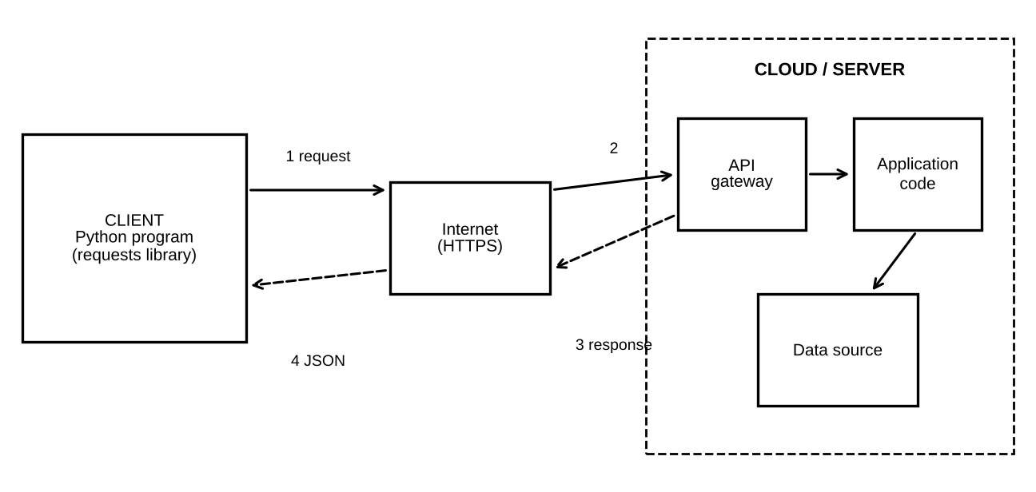
Figure 5: API communication flow between client and cloud server
(d) Role of each part.
Table 17: Roles in the API communication
Part | Role
Client | The Python program. It builds the request, sends it, and reads the reply.
API request | An HTTP GET message with the endpoint and parameters.
Cloud / server | Receives the request, checks the input, finds the data and builds the reply.
API response | A status code and a JSON body that the program can use.

(e) How APIs enable programmatic cloud access. The API has a fixed format. So a program can ask the cloud for data, or send data to the cloud, again and again with no person. The same code can be put inside a mobile app, a web server or a scheduled job. This is what makes automatic cloud use possible.

3.3 Student B – Implementation and Evidence
(a) Set up. Install Python 3. Then run: pip install requests. Save the program below as api_test.py.
import time
import requests

URL = "https://api.open-meteo.com/v1/forecast"

def call_api(name, lat, lon):
params = {"latitude": lat, "longitude": lon,
"current": "temperature_2m,wind_speed_10m"}
print("Request for:", name, params)
start = time.time()
try:
r = requests.get(URL, params=params, timeout=10)
except requests.exceptions.RequestException as e:
print("API not reachable:", e)
return
ms = (time.time() - start) * 1000
print("Status code:", r.status_code)
print("Time (ms):", round(ms))
print("Response:", r.text[:300])
print()

call_api("Test 1 Tirupati", 13.63, 79.42)
call_api("Test 2 Chennai", 13.08, 80.27)
call_api("Test 3 invalid latitude", 200, 79.42)

(b) Execute. Run: python api_test.py. The program makes three requests. Tests 1 and 2 are valid and use two different inputs (two cities). Test 3 sends a wrong latitude (200) on purpose, to see how the API reports an error. The try/except block also shows how the program behaves if the API is not available.
(c) Predicted values and measured results. The time is predicted with the model of Task 1 for an API call on Wi-Fi with a new connection: T_{total} = 120 + 100 + 0.8 = 221 ms. The status codes are the ones described in the API documentation. Please verify them in your own run.
Table 18: API test record (Predicted from model; Measured to be filled)
Test | Input | Predicted status | Predicted time (ms) | Measured status | Measured time (ms) | Response text
1 | Tirupati 13.63, 79.42 | 200 | 221
2 | Chennai 13.08, 80.27 | 200 | 221
3 | Latitude 200 (invalid) | 400 | 221

The weather values in the response body (temperature and wind speed) are not predicted. Copy them from your output into the last column.

(d) Analysis of the observed results. After the run, compare the results with Table 18.
- If Tests 1 and 2 return status 200, the API access works. The two JSON bodies should have the same structure but different values, because the places are different.
- If Test 3 returns status 400, the server checks its input and refuses bad data. This is good API design.
- If the measured time is close to 221 ms, the model is good. If it is much higher, the network is slower than the assumed 40 ms RTT. Calculate your own RTT from the measured time.
- Using requests.Session() keeps the connection open. Then T_{conn} = 0 and the predicted time falls from 221 ms to 101 ms.

3.4 Joint Analysis – Why API Access Is Useful for Many Users
Question: Why is API-based access useful when a large number of users or applications need to communicate with a cloud service automatically?
Formula (Little’s law). The average number of requests being served at the same time is L = λ × W. Here λ is the request rate (requests per second) and W is the time for one request (seconds).
Assumptions. Each of N clients sends 12 requests per hour (one every 5 minutes). So λ = N × 12 / 3600 = N / 300. W is taken from Table 3: 0.860 s for a browser page, 0.221 s for an API call with a cold connection and 0.101 s for an API call with a warm connection. A person needs about 30 s to do one manual request.
Worked example for N = 10,000 clients. λ = 10,000 / 300 = 33.3 requests per second. L (browser) = 33.3 × 0.860 = 28.7. L (API cold) = 33.3 × 0.221 = 7.4. L (API warm) = 33.3 × 0.101 = 3.4.
Table 19: Concurrent requests L for different numbers of clients (PREDICTED)
Clients N | λ (req/s) | L browser | L API cold | L API warm
100 | 0.33 | 0.29 | 0.07 | 0.03
1,000 | 3.33 | 2.87 | 0.74 | 0.34
10,000 | 33.33 | 28.67 | 7.37 | 3.37

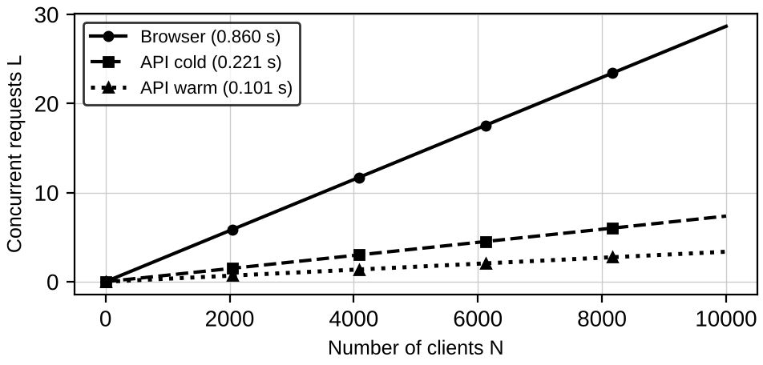
Figure 7: Concurrent requests against number of clients for three access styles
Human effort. Manual access needs 12 × 30 s = 360 s = 6 minutes per client per hour. For 10,000 clients this is 60,000 minutes = 1,000 hours of human work in every hour. This is impossible. An API program needs 0 minutes of human work.
Answer. API access is useful because (1) programs can send requests day and night with no person; (2) each call is small and fast, so the load on the cloud is low (only about 4 concurrent requests for 10,000 clients with warm connections, against about 29 for browser pages); (3) the format is fixed, so many different applications can use the same service; and (4) the cloud can add servers when L grows. Evidence: program, execution screenshot (Figure 6), request and response record (Table 18) and this analysis.

TASK 4 – Cloud Security and Network Access

4.1 Shared Group Work – Security Study
- Security issues in accessing cloud services. Data travels over the public Internet. Many users share the same cloud. Users can be tricked, passwords can be weak, and permissions can be set wrongly.
- Authentication and authorization. Authentication answers “Who are you?” (password, one-time code). Authorization answers “What are you allowed to do?” (read, edit, delete). A user can pass authentication and still be refused by authorization.
- Secure network communication. HTTPS uses TLS. TLS encrypts the data, proves the server’s identity with a certificate, and stops others from changing the data on the way. In our model TLS 1.3 adds one RTT = 40 ms to the first connection (already included in T_{conn} = 120 ms).
- Possible threats. Phishing, weak passwords and brute force, eavesdropping on public Wi-Fi, leaked API keys, too many permissions, lost devices and denial of service (DoS).
- Secure cloud-access scenario. A student opens the class folder from a café Wi-Fi. The student signs in with a password and a one-time code. The connection uses HTTPS. The cloud checks that the student is allowed to open only the student’s own folder.

Risk model. We give each threat a likelihood L and an impact I on a scale of 1 (low) to 5 (high). Risk R = L × I. These scores are our assumed judgement, not measured data. The same scores are used in Task 7.
Table 20: Threat identification and risk before and after controls (assumed scores)
Threat | Attack point | L | I | R | Control (mitigation) | L after | R after
Phishing / stolen password | A1 Login | 4 | 5 | 20 | Two-step verification (MFA) | 2 | 10
Brute-force guessing | A1 Login | 3 | 5 | 15 | Strong password; lockout | 1 | 5
Eavesdropping, fake Wi-Fi | A2 Network | 3 | 4 | 12 | HTTPS (TLS); avoid open Wi-Fi | 1 | 4
Too many permissions | A4 Authorization | 3 | 4 | 12 | Least privilege; review roles | 1 | 4
Leaked API key | A3 Service | 3 | 5 | 15 | Keep keys secret; rotate; expiry | 1 | 5
Lost device | A1 / A5 | 2 | 4 | 8 | Screen lock; remote sign-out | 1 | 4
Denial of service | A3 Service | 2 | 3 | 6 | Rate limits; provider protection | 1 | 3
Total |  |  |  | 88 |  |  | 35

Total risk before controls = 20 + 15 + 12 + 12 + 15 + 8 + 6 = 88. Total risk after controls = 10 + 5 + 4 + 4 + 5 + 4 + 3 = 35. The reduction is (88 − 35) / 88 = 53 / 88 = 60.2%.

4.2 Student B – Security Design
(a) Security considerations (at least four).
- Strong authentication: long passwords and two-step verification.
- Authorization with least privilege: each user gets only the access needed for the job.
- Encryption in transit: HTTPS/TLS for all traffic.
- Protection of keys and tokens: never put them in code that is shared; set expiry dates.
- Logging and monitoring: record sign-ins and sharing changes so that strange actions are seen.
- Device safety and backup: screen lock, updates, and a copy of important data.

(b) Authentication and authorization. Authentication proves identity. For example, the user types a password and then a code sent to the phone. Authorization decides the rights after identity is known. For example, a student may edit the team document but may only view the faculty sheet. In an API, a missing or wrong token gives status 401 (not authenticated). A valid token without the right permission gives status 403 (forbidden).
(c) Importance of secure communication. Without TLS, anyone on the same network can read or change the data. With TLS, the data is encrypted. The server proves its identity. The price is small: one extra RTT of 40 ms at the start of the connection.
(d) Secure access flow and points of attack. Figure 8 shows the flow User → Authentication → Network → Cloud Service → Authorization → Resource. The dashed boxes show where an attacker can act.
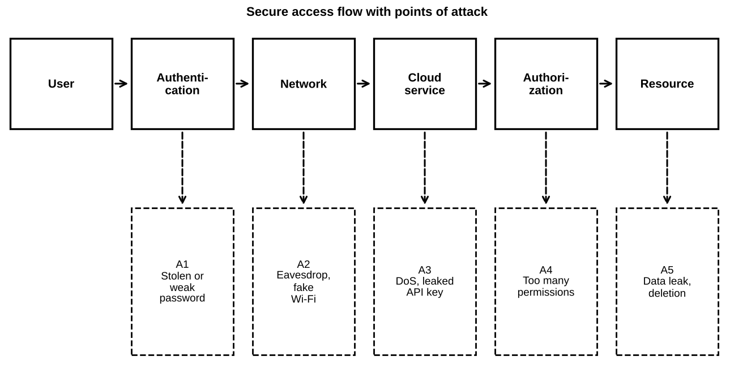
Figure 8: Secure cloud-access flow with five points of attack
Table 21: Points of attack and suitable security measures
Point | Possible attack | Security measure
A1 Authentication | Stolen or weak password, phishing | MFA, strong password, lockout after failed tries
A2 Network | Eavesdropping, fake Wi-Fi | HTTPS/TLS, check the padlock, avoid open Wi-Fi
A3 Cloud service | DoS, leaked API key | Rate limits, key rotation, provider protection
A4 Authorization | Too many permissions | Least privilege, role review, expiry of shared links
A5 Resource | Data leak or deletion | Version history, backup, access logs

4.3 Student A – Security Investigation
(a) Practical scenario investigated. A student works from a café with public Wi-Fi and opens the shared class folder in Google Drive. We study what protects the student and what happens without protection.
(b) Authentication mechanism to demonstrate. Use two-step verification on a Google account.
- Open myaccount.google.com and go to Security.
- Turn on 2-Step Verification (phone prompt or authenticator app).
- Sign out, then sign in again. Note that a password alone is not enough.
- Take screenshots of each step. Hide personal details.

(c) Optional program to show authentication and authorization codes. The site httpbin.org returns 401 without a token, 200 with a token and 403 for a forbidden request.
import requests
url = "https://httpbin.org/bearer"
print("No token :", requests.get(url).status_code)
h = {"Authorization": "Bearer demo-token-123"}
print("With token:", requests.get(url, headers=h).status_code)
print("Forbidden :", requests.get("https://httpbin.org/status/403").status_code)

(d) Check HTTPS. Click the padlock in the address bar and view the certificate. Run curl -vI https://drive.google.com and look for the TLS lines. Open http://neverssl.com to see the “Not secure” warning.
Table 22: Secure and insecure access compared (conceptual)
Situation | Secure access | Insecure access
Login | Password + one-time code | Short password only
Network | HTTPS, encrypted | HTTP or open Wi-Fi, readable
Permission | Only the needed role | Everyone can edit
Key handling | Secret, rotated | Key written in shared code
Result if attacked | Attacker is stopped at A1 | Attacker reads or deletes data

Table 23: Observation record for security tests (Predicted; Observed to be filled)
Test | Predicted result | Observed (fill in)
Sign-in with password only (MFA on) | Access refused until code is entered
API without token | Status 401
API with token | Status 200
Forbidden request | Status 403
http://neverssl.com | Browser shows Not secure

(e) How poor security affects users and data. Weak passwords are easy to guess. The number of possible passwords is S = C^{L}, where C is the number of allowed symbols and L is the length. The time to try all of them is T = S / g, where g is the guess rate. We assume g = 10⁹ guesses per second.
- 8 characters, lowercase only: S = 26⁸ = 2.09 × 10¹¹. T = 208.8 s, about 3.5 minutes.
- 8 characters, letters and digits: S = 62⁸ = 2.18 × 10¹⁴. T = 218,340 s, about 2.5 days.
- 12 characters, letters and digits: S = 62¹² = 3.23 × 10²¹. T = 3.23 × 10¹² s, about 102,000 years.

A cloud service also limits online guesses. At 5 tries per minute (7,200 per day), 62⁸ / 7,200 = 3.0 × 10¹⁰ days. So the user’s short or reused password is the weakest point. If it is stolen, an attacker can read, change or delete the user’s files and can also use the account to attack other users.

4.4 Joint Evaluation – Additional Measures for Internet Access
Question: If cloud access is available from anywhere through the Internet, what additional security measures are necessary compared with a local application?
A local application sits on a private network, but a cloud service can be reached by anyone. So more measures are needed:
Table 24: Additional security measures for Internet-based access
Measure | Why it is needed on the Internet | Threat reduced
Multi-factor authentication | Anyone can try to sign in | Phishing, brute force
HTTPS / TLS | Data crosses many unknown networks | Eavesdropping
Role-based access (IAM) | Many users share the same service | Too many permissions
Key management | Programs hold secret tokens | Leaked API key
Rate limiting and monitoring | Attackers can send many requests | DoS, guessing
Device policy and remote sign-out | Users use phones and public computers | Lost device

With these measures the total risk score falls from 88 to 35 (Table 20), a reduction of 60.2%. Evidence: secure-access architecture (Figure 8), threat identification and mitigation analysis (Table 20, Table 21).

TASK 5 – Collaboration Using Cloud-Based Services

5.1 Shared Group Work – Shared Workspace
We selected Google Drive with Google Docs as the collaboration service. The team has four students (Student A, Student B, Student C and Student D) and one faculty member. The steps below are done together.
- Select the platform: Google Drive and Google Docs, because they are free and need only a browser.
- Create a shared folder: the owner (Student A) creates the folder CO3_Team1 and a document named Project_Report inside it. The file is about 2 MB when images are added.
- Configure sharing permissions: Student A is Owner. Students B, C and D are Editors. The faculty member is Commenter. Link sharing is set to Restricted (only invited people).
- Collaborative editing: the four students open Project_Report at the same time. Each one writes a different section. The faculty member adds comments.
- Record the process: take screenshots of the sharing window, the editing session, the comments and the version history.

Table 25: Users, roles and permissions in the shared workspace
User | Role | Permission | Reason
Student A | Owner | Full control | Creates folder, manages sharing
Students B, C, D | Editor | Edit, comment, view | Write the report
Faculty | Commenter | Comment, view | Gives feedback; cannot change text
Other people | No access | None (Restricted link) | Protects the work

5.2 Student A – Collaboration Design
(a) Collaboration requirements. The team needs: one shared copy of the report; writing by several people at once; a record of every change; different rights for students and faculty; and access from laptop and phone.
(b) Collaboration workflow. Figure 10 shows the workflow. It moves from folder creation to the final locked version.
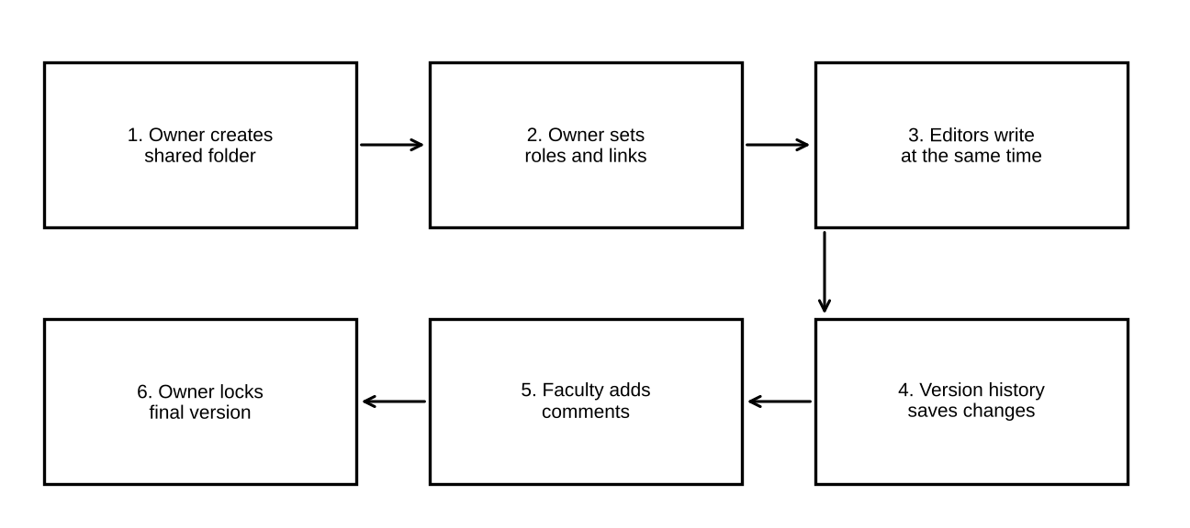
Figure 10: Cloud collaboration workflow for the team report
(c) Explanation of the four key ideas.
- Sharing: the owner invites people by e-mail address and gives each a role. Everyone uses one file through one link.
- Concurrent access: many users edit at the same time. The service merges the small changes from all users. The cursor of each user is shown in a different colour.
- Version control: every change is saved. Version history shows who changed what and when. An old version can be restored. Important points can be given a name, such as “Draft 1”.
- Permission management: the owner can change or remove a role at any time. Roles are Viewer, Commenter and Editor. The owner can also stop editors from re-sharing.

(d) Roles of different users. The owner controls the folder. Editors do the writing. The Commenter reviews. People without a role cannot open the file.
(e) Justification of the permissions. The risk of a damaging edit grows with the number of editors. Assume each editor has a probability p = 0.01 of making a damaging edit (deleting text by mistake) in one week. The probability that at least one damaging edit happens with k editors is:
P = 1 − (1 − p)^{k}
- k = 4 editors: P = 1 − 0.99⁴ = 1 − 0.9606 = 0.0394, which is 3.94%.
- k = 60 editors (whole class): P = 1 − 0.99⁶⁰ = 1 − 0.5472 = 0.4528, which is 45.28%.

So giving edit rights only to the four team members keeps the risk near 4%. Giving edit rights to everyone raises it to about 45%. The faculty member needs only to comment, so Commenter is enough. This is the principle of least privilege.

5.3 Student B – Collaborative Implementation
(a) Participation. Student B accepts the invitation and opens CO3_Team1 from a browser. Student B must take part from a different device than Student A, for example a phone.
(b) Collaborative activities (at least two).
- Activity 1: write section 2 of Project_Report while another student writes section 1 at the same time.
- Activity 2: add a comment to a paragraph written by a partner and resolve one comment.
- Activity 3 (extra): use Suggesting mode, then restore an older version from Version history.

Table 26: Evidence of contribution (to be filled by the students)
Activity | Who | Time | Screenshot no.
Section 1 written
Section 2 written
Comment added and resolved
Version restored

(c) Demonstration of sharing and permission settings. Open Share on the document. Capture the list of users and roles, and the setting “Restricted”.

(d) How changes made by users are reflected. Predicted behaviour: text typed by one user appears on the other users’ screens in about one second on a good network (the server step in the Task 1 model is T_{req} = 140 ms, plus network time). Two users editing the same file keep both edits in one file. Version history shows the author and time. A Commenter cannot edit text. Record what you observe, and the delay in seconds: ________.
(e) One collaboration issue and a solution. Issue: two users edit the same paragraph at the same time and one overwrites the thought of the other. Solution: give each person a separate section, use Suggesting mode for changes in other people’s text, and use named versions so that the owner can return to a good state.

5.4 Cross-Understanding
Student B explains: How does cloud collaboration reduce the need to exchange multiple copies of the same file?
In the cloud there is only one master file. People open it by a link. They do not need to send it. Assume n = 4 people, V = 5 revisions, and a 2 MB file. With e-mail, every revision is sent to the other 3 people. That is 5 × 3 = 15 e-mails. Each person keeps a copy of each revision, so there are 5 × 4 = 20 files of 2 MB. The storage is 20 × 2 = 40 MB. In the cloud, one 2 MB file is kept. Assume the history stores 0.1 MB for each revision, so the history is 5 × 0.1 = 0.5 MB. The storage is 2 + 0.5 = 2.5 MB.
Saving = (40 − 2.5) / 40 = 37.5 / 40 = 93.75%
Everyone also sees the latest version, so nobody works on an old copy.
Student A explains: What problems can occur if incorrect sharing permissions are given?
- If Editor is given to everyone, text can be deleted or changed by mistake. The chance of damage rises from 3.94% to 45.28% (Section 5.2).
- If “Anyone with the link” is chosen, a forwarded link lets outsiders read private work. This is a data leak.
- If a Viewer should have been an Editor, the person cannot work and the team is delayed. If a person who has left the team keeps access, that person can still see or change the work. The owner must review the sharing list often.

Evidence expected: shared workspace (Table 25), contribution evidence (Table 26), permission screenshot (Figure 11) and observations (Section 5.3(d)).

TASK 6 – Integrated Cloud Access and Collaboration Mini Investigation
Selected scenario: Cloud-Based Assignment Submission and Evaluation. In this scenario, students submit an assignment through the cloud. The faculty member reads it, writes feedback and gives marks. Both cloud access and cloud collaboration are needed.

6.1 Student A – System Design
(a) Problem. Today students send assignments by e-mail or pen drive. The faculty member must collect, rename and store each file, and then send the marks back one by one. This is slow and files get lost. We need one place for submission, feedback and marks.
(b) Users.
Table 27: Users of the system
User | Number | Main tasks | Access method
Student | 60 | Upload assignment; read feedback | Laptop browser or phone (Wi-Fi / 4G)
Faculty | 1 | Open files; comment; enter marks | Laptop browser
Administrator (HOD office) | 1 | View marks sheet | Browser

(c) Cloud access methods. Browser access is the main method (highest score 4.10 in Task 1). The phone browser and the Drive mobile app are used by students when away from a computer. An API is not needed in the prototype.
(d) Required cloud services. Google Forms with file upload for submission (with sign-in required), Google Drive for storing files and setting permissions, Google Docs for feedback comments, and Google Sheets for the marks list.
(e) System architecture. Figure 12 shows the architecture. Users reach the cloud through the Internet and Google sign-in. The Form passes each file to a Drive folder. The faculty member writes feedback in Docs and marks in Sheets.
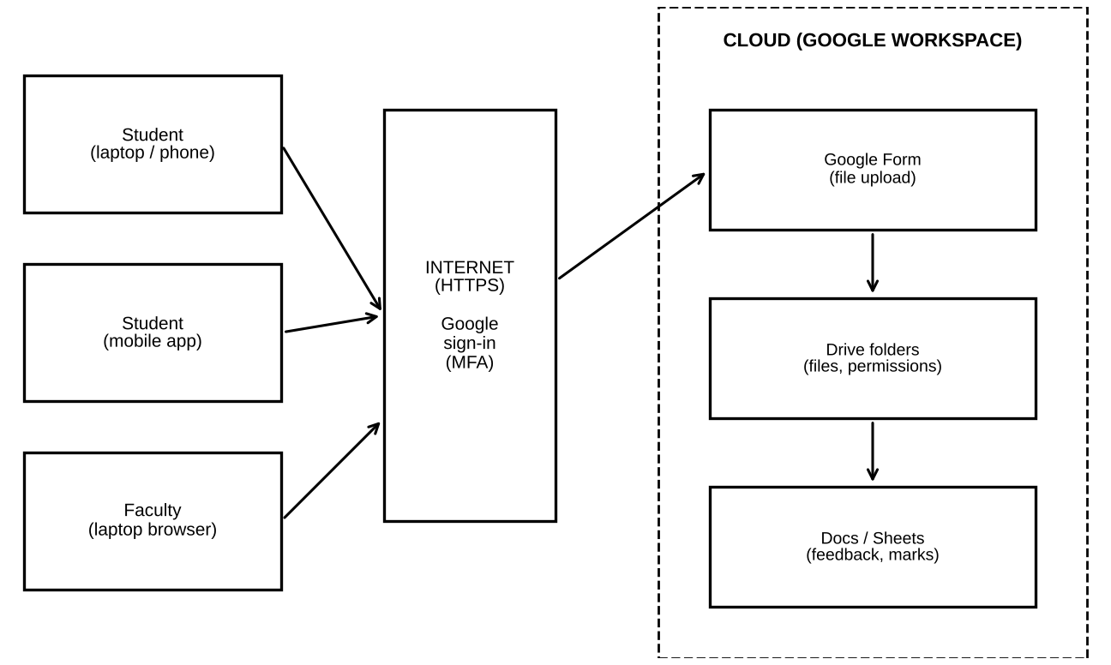
Figure 12: Architecture of the cloud-based assignment submission and evaluation system
(f) How users access the system. Each user opens the link in a browser or the app and signs in with a Google account. The Form accepts a file of up to 10 MB (our test file is 2 MB). Students only see their own upload. The faculty member opens the Drive folder with the Editor role.
(g) How users collaborate. The faculty member and the student work on the same Google Doc for feedback. The faculty member writes comments. The student replies and resolves them. The marks Sheet is shared with the administrator as Viewer. The Form, the folder and the Sheet are the shared resources.

6.2 Student B – Evidence and Evaluation
(a) Prototype / workflow. Build the following mock-up with free Google tools:
- Create a Google Form named “CO3 Assignment Submission”. Turn on “Require sign-in”. Add one file upload question (PDF, maximum 10 MB per file; our test file is 2 MB).
- The Form creates a Drive folder for the uploaded files. Check that only the faculty account can open it.
- Create a Google Doc named Feedback_Student1. Share it with one student as Commenter.
- Create a Google Sheet named Marks. Share it with the administrator as Viewer.

(b) Cloud access mechanism demonstrated. Sign-in through the browser with a Google account, and the upload from a laptop on Wi-Fi and from a phone on 4G. Collaboration mechanism demonstrated: the faculty comments and the student replies in the shared Doc.

(c) Two user scenarios and predicted results. The times use the model of Task 1. A 2 MB upload is 16 Mbit.
- Scenario 1 – Laptop on Wi-Fi (20 Mbps, RTT 40 ms). T_{conn} = 120 ms; T_{req} = 40 + 100 = 140 ms; T_{xfer} = 16 / 20 = 0.8 s = 800 ms. T_{total} = 120 + 140 + 800 = 1060 ms.
- Scenario 2 – Phone on 4G (10 Mbps, RTT 70 ms). T_{conn} = 210 ms; T_{req} = 70 + 100 = 170 ms; T_{xfer} = 16 / 10 = 1.6 s = 1600 ms. T_{total} = 210 + 170 + 1600 = 1980 ms.

Table 28: Test of the proposed solution with two user scenarios (Predicted; Measured to be filled)
Scenario | Action | Predicted | Measured | Result
1 Laptop, Wi-Fi | Student uploads 2 MB file | 1060 ms
1 Laptop, Wi-Fi | Faculty opens Drive and the Doc page | 860 ms
2 Phone, 4G | Student uploads 2 MB file | 1980 ms
2 Phone, 4G | Student opens feedback in the app | 500 ms

(d) Analysis of the results. The predicted upload time is about 1 s on Wi-Fi and about 2 s on 4G. Both are short for a student. The 4G upload is 1980 / 1060 = 1.87 times slower, because the bandwidth is lower and the RTT is higher. If your measured times are close to the predicted ones, the model is reliable. If they are very different, find the reason (slow Wi-Fi, large file, busy network) and note it.
Load check at the deadline. In the worst case all 60 students upload within 60 s. λ = 60 / 60 = 1 upload per second. By Little’s law, L = λ × W = 1 × 1.06 = 1.06, so about 2 uploads are active at one time. The cloud handles this easily.
(e) Limitations and possible improvements.
Table 29: Limitations and improvements
Limitation | Effect | Improvement
Needs Internet; at 2 Mbps a 2 MB upload takes 8260 ms | Late submission near the deadline | Allow a grace period; allow upload from the college network
Uploaded files use the faculty member’s Drive storage (60 × 2 MB = 120 MB = 0.8% of 15 GB) | Storage can fill up over many assignments | Watch the storage; move old files to a department drive
Only Google accounts can sign in | Students without an account cannot submit | Create accounts through the college domain
Marks are typed by hand | Possible typing mistakes | Add a Sheets formula to check totals; use the API later

6.3 Joint Evaluation – Efficiency of Combining Access and Collaboration
Question: How does combining cloud access and cloud collaboration improve the efficiency of the proposed system?
Formula. Efficiency gain = (T_{manual} − T_{cloud}) / T_{manual} × 100%.
Assumed faculty handling times for 60 students (to be replaced by your own timing): manual collection of files (open e-mail, download, rename, save) 3 min per student; manual feedback by e-mail 2 min per student; cloud collection 0.5 min per student (open from the folder); cloud feedback 1 min per student (a comment in the shared Doc).
Table 30: Faculty time for 60 students (assumed times, minutes)
Activity | Manual | Cloud | Calculation
Collect files | 180 | 30 | 60 × 3 = 180; 60 × 0.5 = 30
Give feedback | 120 | 60 | 60 × 2 = 120; 60 × 1 = 60
Total | 300 | 90 | 300 − 90 = 210

Efficiency gain = (300 − 90) / 300 × 100% = 210 / 300 × 100% = 70%
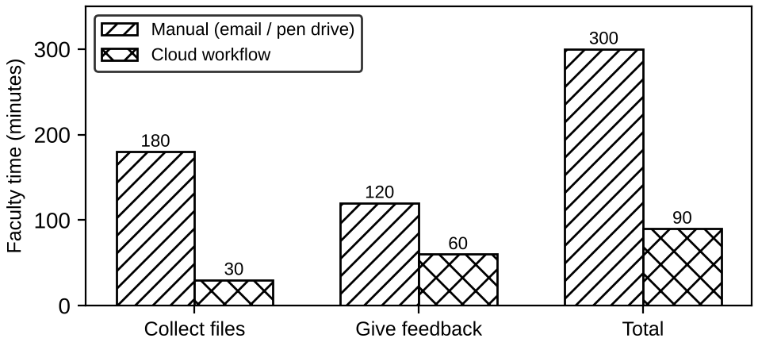
Figure 14: Faculty time for manual and cloud workflows (60 students)
- Access makes submission possible from any device at any time. Each upload takes only 1.06 s on Wi-Fi or 1.98 s on 4G.
- Collaboration puts the file, the feedback and the marks in one place. No copies are sent. The storage saving from Task 5 (93.75% for a 4-person team) applies in the same way.
- Together they reduce the faculty effort by 70% and remove lost files and version mix-ups. The system also keeps a record of who submitted and when.

Evidence expected: system design (Figure 12), prototype evidence (Figure 13), two scenarios (Table 28), analysis and limitations (Table 29) and the efficiency evaluation (Table 30).

TASK 7 – Day-4 Design Challenge: Design a Cloud-Based Collaborative Solution
This task was solved together. Each student first wrote an independent proposal (Stage 1). Then the two designs were compared (Stage 2), a joint final design was made (Stage 3), validated (Stage 4), defended (Stage 5) and evaluated (Stage 6). The proposals below are kept as evidence.

7.1 Stage 1 – Independent Design Proposals
Table 31: Independent proposals made before discussion (retained as evidence)
Item | Student A proposal | Student B proposal
Problem definition | Teams of students keep many copies of project files and lose track of tasks | Assignments are collected by e-mail and pen drive; evaluation is slow
Target users | 15 student teams of 4 and one mentor | 60 students and 1 faculty member
Cloud access method | Browser on laptop over Wi-Fi | Phone app and browser; a script that uses an API
Required cloud services | Google Drive, Docs, Sheets (task board) | Google Forms, Drive, Sheets, Drive/Sheets API
Collaboration mechanism | Shared Docs with Editor roles; comments | Faculty comments on submitted files; shared marks sheet
Basic architecture | Student → Browser → Internet → Google Workspace → Team folder | Student → App → Internet → Form → Drive → Sheet → API script → reminder

7.2 Stage 2 – Comparison of the Two Designs (Design Comparison Record)
Table 32: Design Comparison Record
Aspect | Where they agree / differ | Strength | Weakness
Platform | Agree: both use Google Workspace | Free; known to all students | Depends on one provider
Access | Differ: A browser only; B browser, phone and API | B reaches more users; A is simpler | B needs more setup
Collaboration | Differ: A team work; B faculty feedback | A uses concurrent editing; B gives clear evaluation | A has no evaluation; B has no team work
Security | Neither design lists MFA or roles clearly | — | Missing in both
Accessibility | B supports phones | B works on 4G (1.98 s upload) | A fails if no laptop
Missing components | Network rule, test plan, risk list | — | Both need them

Ideas retained: the browser as main access (Task 1 score 4.10); team folders with roles from design A; the Form, Drive and Sheet chain and the API reminder script from design B. Ideas added: MFA, least-privilege roles, a minimum network rule and a test plan.

7.3 Stage 3 – Joint Final Design
Decision: MODIFY. We keep the Task 6 system (Form, Drive, Docs, Sheets with browser access) and modify it. We do not retain it unchanged and we do not redesign it. The reasons are given with numbers in Table 33.
Table 33: Decision and defence with numbers from earlier tasks
Evidence | Number | Source | Effect on the decision
Browser access score | 4.10 (mobile 3.50, API 3.30) | Task 1 | Retain browser as main access
Upload time, 2 MB | 1.06 s Wi-Fi; 1.98 s 4G | Task 6 | Retain; below the 5 s target
Time saving for faculty | 70% (300 to 90 min) | Task 6 | Retain the Form, Drive and Doc chain
Storage saving, 4-person team | 93.75% (40 MB to 2.5 MB) | Task 5 | Modify: add team folders
Damage chance, 60 editors against 4 | 45.28% against 3.94% | Task 5 | Modify: use least-privilege roles
Total risk score | 88 to 35 (60.2% less) | Task 4 | Modify: add MFA and the controls
API load for 600 users | L = 0.20 (warm) | Task 3 | Modify: add an API reminder script
Slow network (2 Mbps) | 8260 ms upload | Task 1, 6 | Modify: add a minimum network rule

Final design items.
Table 34: Final design specification
Item | Final design
Problem | Slow, unsafe and untracked submission and team work for assignments
Users | 60 students in 15 teams of 4; 1 faculty member; 1 administrator
Cloud access method | Browser (main); Drive mobile app (secondary); API script (automatic reminders)
Network requirements | Bandwidth at least 3.5 Mbps and RTT at most 70 ms (calculated below)
Cloud service / platform | Google Workspace: Forms, Drive, Docs, Sheets
Web application / API requirement | Browser use of Forms and Docs; a Python script with the Sheets API and an OAuth token checks submissions every 5 minutes
Collaboration mechanism | Team folder with Editor roles; faculty as Commenter; real-time editing; version history
Authentication / security | Google sign-in with MFA; HTTPS; link sharing Restricted; least-privilege roles; access log
Data / resource sharing | One folder per team; one Form; one marks Sheet shared as Viewer with the administrator

Network requirement (calculation). We set a target that a 2 MB upload must finish in 5 s (5000 ms). For the worst case in our model (RTT = 70 ms, T_{server} = 100 ms): T_{conn} + T_{req} = 210 + 170 = 380 ms. The time left for transfer is 5000 − 380 = 4620 ms = 4.62 s. The needed bandwidth is BW = 16 Mbit / 4.62 s = 3.46 Mbps, which we round up to 3.5 Mbps. A 2 Mbps network fails the target (8260 ms).
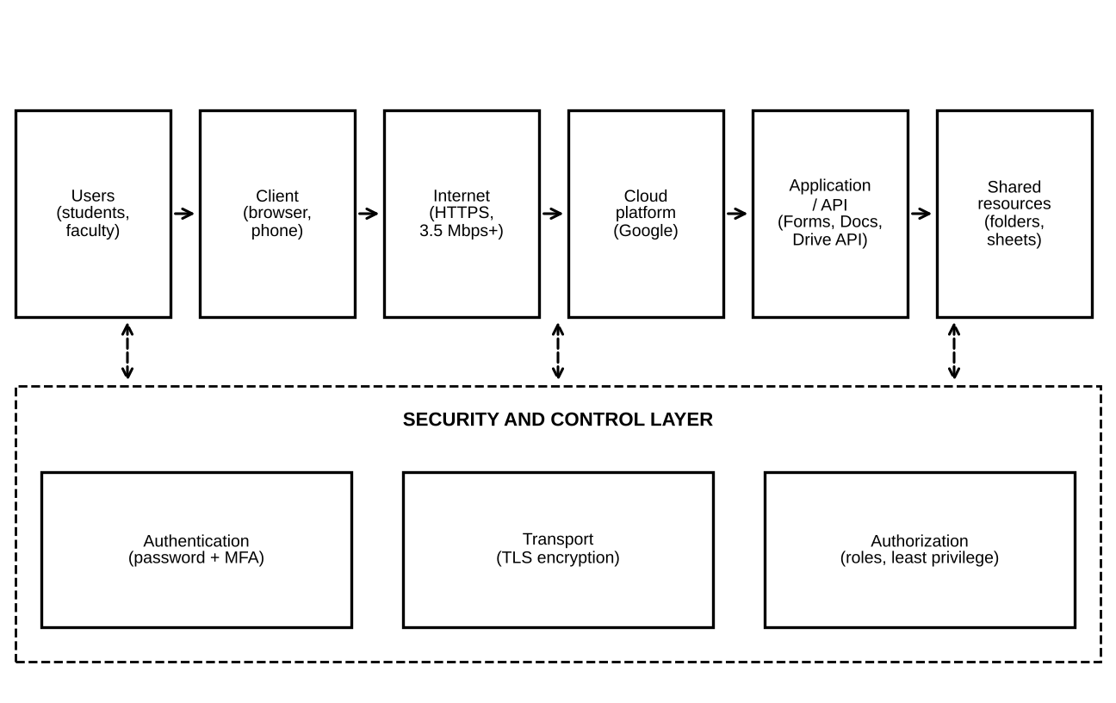
Figure 15: Final architecture: Users → Client → Internet → Cloud platform → Application/API → Shared resources
Complete system workflow.
- The administrator creates the team folders and gives roles (Editor to the 4 members, Commenter to the faculty).
- Students sign in with a password and a code (MFA) from a browser or the app. The connection uses HTTPS.
- Team members write the report together in a shared Doc.
- A student uploads the final file with the Form (about 1 s on Wi-Fi).
- The script reads the Sheet every 5 minutes and sends a reminder to teams that have not submitted.
- The faculty member opens the files, adds comments and enters marks. The administrator views the marks.

7.4 Stage 4 – Validation
Student A – Technical validation.
- Selected access method: the browser. It needs no install, works on lab and personal devices and has the highest weighted score, 4.10.
- Platform choice: Google Workspace gives Forms, Drive, Docs and Sheets under one sign-in. All students already have access. Microsoft 365 would also work (Task 2), but gives only 5 GB of free storage.
- Architecture: the path in Figure 15 is Users → Client → Internet → Cloud → Application/API → Shared resources. The security layer sits across the path.
- Web and API access: users work through the web application. The script uses the API. Its load for 600 users is λ = 600 / 300 = 2 requests per second and L = 2 × 0.101 = 0.20 (warm), or 2 × 0.221 = 0.44 (cold). This is very small.
- Suitability: the design meets the 5 s upload target on Wi-Fi (1.06 s) and 4G (1.98 s). It lowers faculty time by 70% and risk by 60.2%. It is suitable for 60 students and also for 600 students (Stage 6).

Student B – Experimental validation. The test cases are in Table 35. The predicted values come from the model. The observed values and the result must be filled in after the tests.
Table 35: Test cases (Expected = predicted from earlier tasks; Observed to be filled)
ID | Test case / user / condition | Expected behaviour | Observed | Pass / Fail
TC1 | Faculty opens team folder, laptop, Wi-Fi | Page loads in about 860 ms
TC2 | Student uploads 2 MB, laptop, Wi-Fi | About 1060 ms; file in folder
TC3 | Student uploads 2 MB, phone, 4G | About 1980 ms; file in folder
TC4 | Upload on a slow network of 2 Mbps | About 8260 ms; above 5 s target
TC5 | Not signed-in user opens a Restricted link | Access refused
TC6 | Student opens another team’s folder | Access refused (no permission)
TC7 | Commenter (faculty) tries to edit a team Doc | Edit blocked; comment allowed
TC8 | Two members edit one Doc together | Both edits kept; one file
TC9 | Script calls the API with and without a token | Status 200 with token; 401 without; about 221 ms

Demonstration steps. (1) Create the Form, folder, Doc, Sheet and roles. (2) Run TC1 to TC4 with two students on two different devices. (3) Run TC5 to TC7 with a second Google account. (4) Run TC8 with two editors. (5) Run the Python script of Task 3, changed to call the Sheets endpoint with a token (TC9). (6) Take a screenshot of each test.

Comparison of expected and observed behaviour. For timing tests, calculate the deviation:
Deviation (%) = (Observed − Expected) / Expected × 100
Example (for illustration only, not a result): if an upload is observed at 1250 ms and the expected value is 1060 ms, the deviation is (1250 − 1060) / 1060 × 100 = 17.9%. We accept a test if the observed time is below the 5 s target and the deviation is explained. For access tests, a test passes when the observed result is the same as the expected result.

7.5 Stage 5 – Cross-Defence
Student A explains: What experimental evidence supports the group’s cloud design?
- Upload tests TC2 and TC3 show that a 2 MB file uploads in about 1 to 2 s, which is well below the 5 s target. If the measured values agree with the model, the design is proven fast enough.
- TC5 to TC7 show that sign-in and roles block outsiders and wrong users. This supports the risk fall from 88 to 35.
- TC8 shows that one shared file replaces many copies. This supports the 93.75% storage saving.
- TC9 shows that the API gives status 401 without a token and 200 with one. This supports the authentication design.
- TC4 shows the weak point: a 2 Mbps network fails the target. This supports the network rule.

Student B explains: Why was the selected cloud access and collaboration approach chosen?
The browser was chosen because it has the highest score (4.10) and needs no install. Google Workspace was chosen because Forms, Drive, Docs and Sheets work together under one account. Real-time editing with roles was chosen because it cut the storage from 40 MB to 2.5 MB and kept the chance of damage at 3.94% instead of 45.28%. The API script was added because automatic reminders cost almost no load (L = 0.20 for 600 users). MFA and HTTPS were added because they lower the risk by 60.2% and cost only about 40 ms for TLS on a new connection.

7.6 Stage 6 – Joint Evaluation
Table 36: Joint evaluation of the proposed cloud solution
Aspect | Evaluation
Benefits | 70% less faculty time; no lost files; work from any device; 1.06 s upload on Wi-Fi
Access-related limitations | Needs Internet. At 2 Mbps the upload takes 8260 ms. Needs a Google account
Collaboration benefits | One shared file; 93.75% less storage; version history; roles
Security risks | Residual risk score 35 out of the original 88. Main remaining risks: phishing (10) and leaked API key (5)
Scalability | 600 users uploading within 60 s: λ = 10 per second; L = 10 × 1.06 = 10.6, about 11 uploads at once. 6000 users: L = 106 (see Figure 17)
Possible improvements | Add a native mobile app; use an official college domain; add a script to check marks totals; add automatic backup
Situations where it may not be appropriate | No stable Internet; very private data that must stay in the college; very large files (videos); rules that forbid external cloud storage

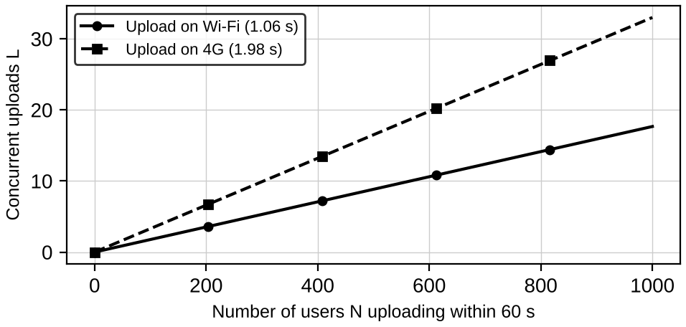
Figure 17: Concurrent uploads against the number of users in a 60 s deadline surge
Scalability formula. λ = N / 60 and L = λ × W. Example for N = 600 on 4G: λ = 10 per second and L = 10 × 1.98 = 19.8, about 20 uploads at the same time. A cloud service can add servers when L grows, so the design scales. A local file server in the college could not do this without new hardware.

7.7 Final Question
What characteristics should a system designer consider before selecting cloud-based access and collaboration for a real-world application?
Table 37: Characteristics to consider before selecting a cloud-based solution
Characteristic | Question to ask | Example from this assignment
Users and devices | Who will use it, and on which devices? | 60 students on laptops and phones
Network quality | Is the Internet fast and stable enough? | At least 3.5 Mbps; 2 Mbps fails
Response time | What delay is acceptable? | Upload under 5 s; model gives 1.06 s
Security and privacy | How sensitive is the data? Who may see it? | Risk 88 to 35 with MFA, HTTPS, roles
Collaboration need | Do many people edit the same data? | Team of 4; 93.75% less storage
Scalability | What if users grow 10 times? | 600 users give about 11 concurrent uploads
Cost and storage | Are free limits enough? | Drive 15 GB; 60 × 2 MB = 120 MB
Availability and backup | What happens if the service is down? | Offline copy and a grace period
Rules and data location | Do laws or the college allow external cloud? | Check institutional policy
Integration (API) | Must other programs connect? | API reminder script, 101 ms warm

Conclusion. The solution is sound when users are many and spread out, when the network is at least 3.5 Mbps, when data is not highly secret, and when several people must work on the same files. It is not suitable without a stable Internet or when rules forbid external cloud storage. With the modifications of Stage 3, the Task 6 system is the final recommended design.

CONTRIBUTION RECORD
The record below shows the primary contribution of each student. Primary contribution does not mean exclusive responsibility. Both students are accountable for the complete assignment. Edit the table so that it shows the work that was actually completed.
Table 38: Group details
Detail | Student A | Student B
Name
Register number
Section

Table 39: Contribution record
Question | Student A – Primary Contribution | Student B – Primary Contribution | Joint Work
Q1 | Access method design, architecture diagram, weighted decision | Practical access, screenshots, observations, limitation | Study of methods; response-time model
Q2 | Platform analysis, request mapping, interaction diagram | Google Docs investigation, screenshots, benefits | Platform selection; comparison; local versus cloud evaluation
Q3 | API design, request/response components, flow diagram | Python program, execution, two tests, analysis | API selection; concurrency analysis
Q4 | Security investigation, authentication demo, secure versus insecure | Security design, secure access flow, attack points | Threat study; risk table; Internet evaluation
Q5 | Collaboration design, workflow, permission justification | Collaborative activities, contribution evidence, issue and solution | Shared workspace; cross-understanding
Q6 | System design and architecture | Prototype, two scenarios, analysis, limitations | Scenario choice; efficiency evaluation
Q7 | Technical validation; independent proposal | Experimental validation; independent proposal | Comparison; final design; cross-defence; joint evaluation

