General instructions

1. The approach of solving the Problem solely depends on the Candidate

2. Make sure to have Draw.io diagrams for the workflowns and application architecture

3. Every configuration, code written should be pushed on git (Private Repo)

4. Your are not permitted to share the doc with anyone, even with your colleagues

Scenario

There is a customer who came to you with a problem to have a custom linux command for his operations. Your task is to understand the problem and create a linux command via bash script as per the instructions.

Command name – internsctl

Command version - v0.1.0Q1 help command

List command

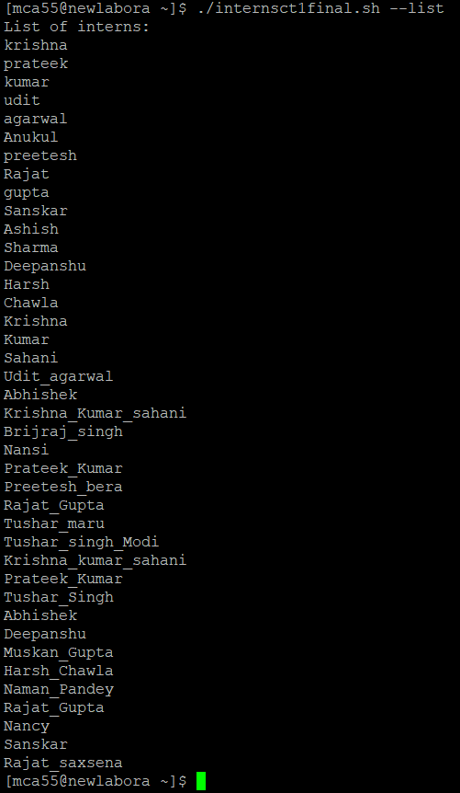

Section A

1. I want a manual page of command so that I can see the full documentation of the command. For example if you execute the command man ls as output we get the doc and usage guidelines. Similarly if I execute man internsctl I want to see the manual of my command.

Ans :Man command

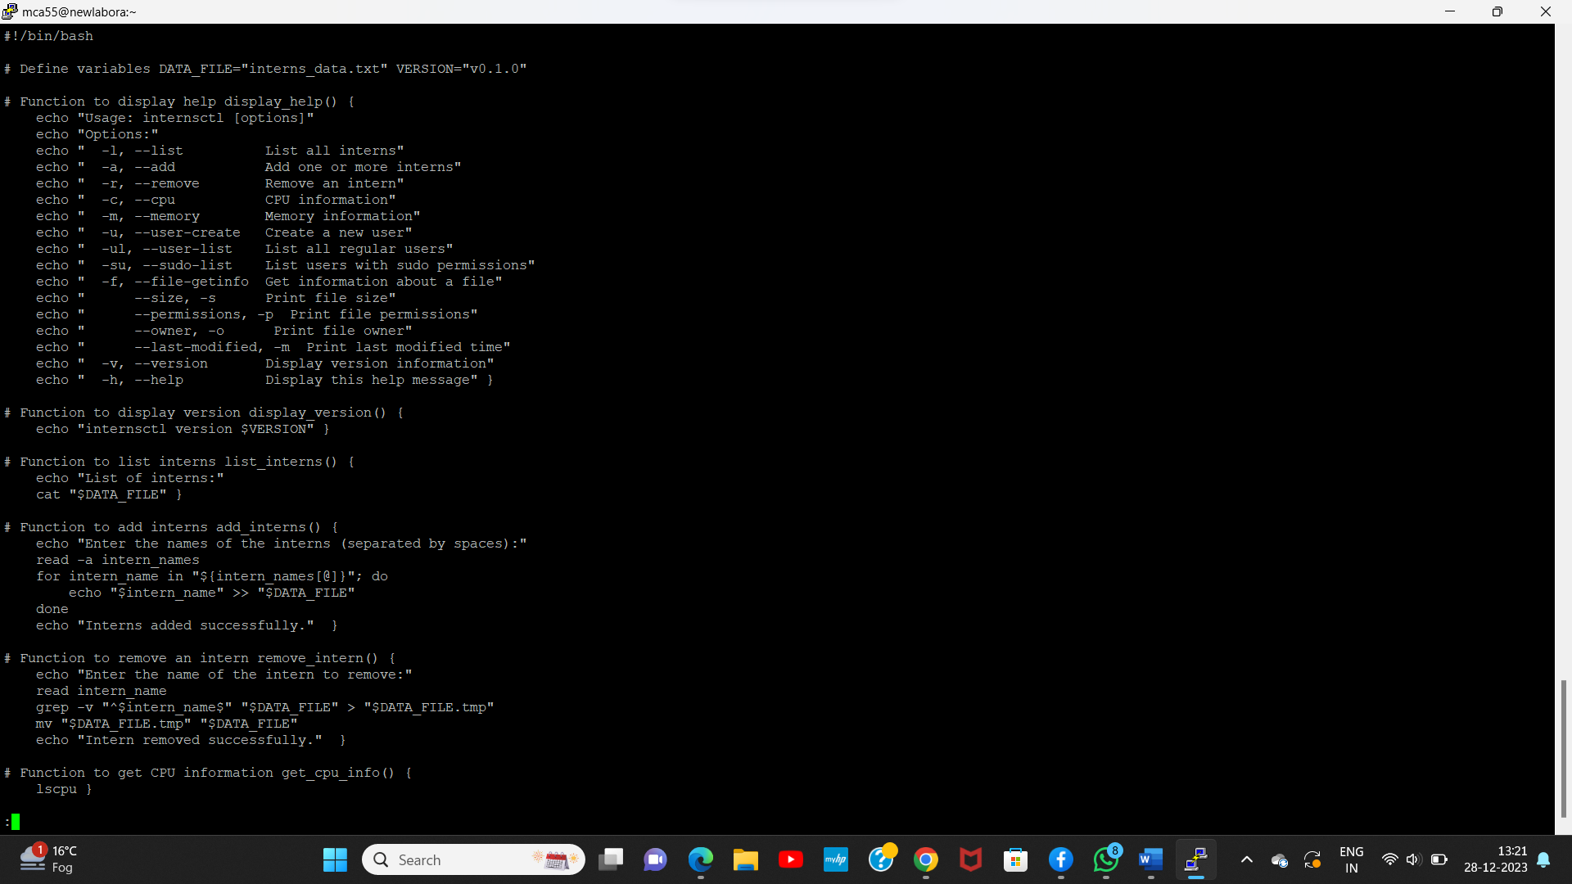

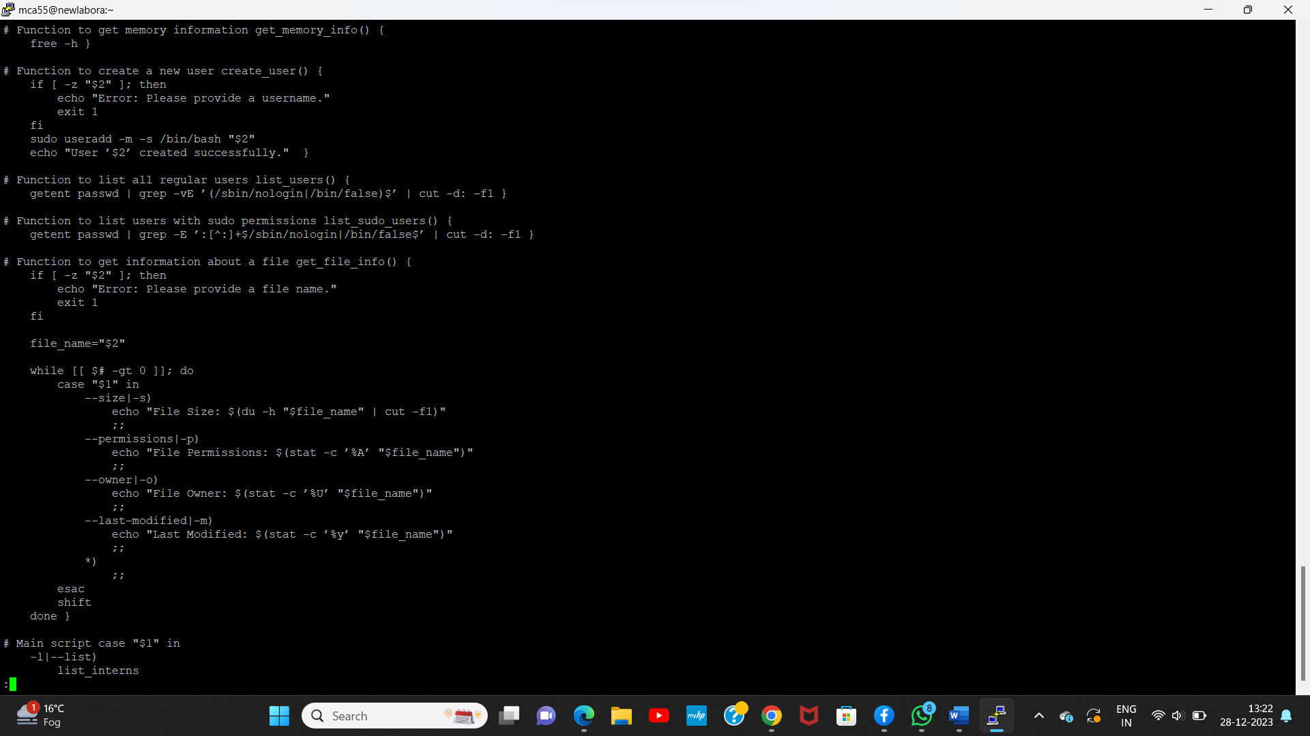

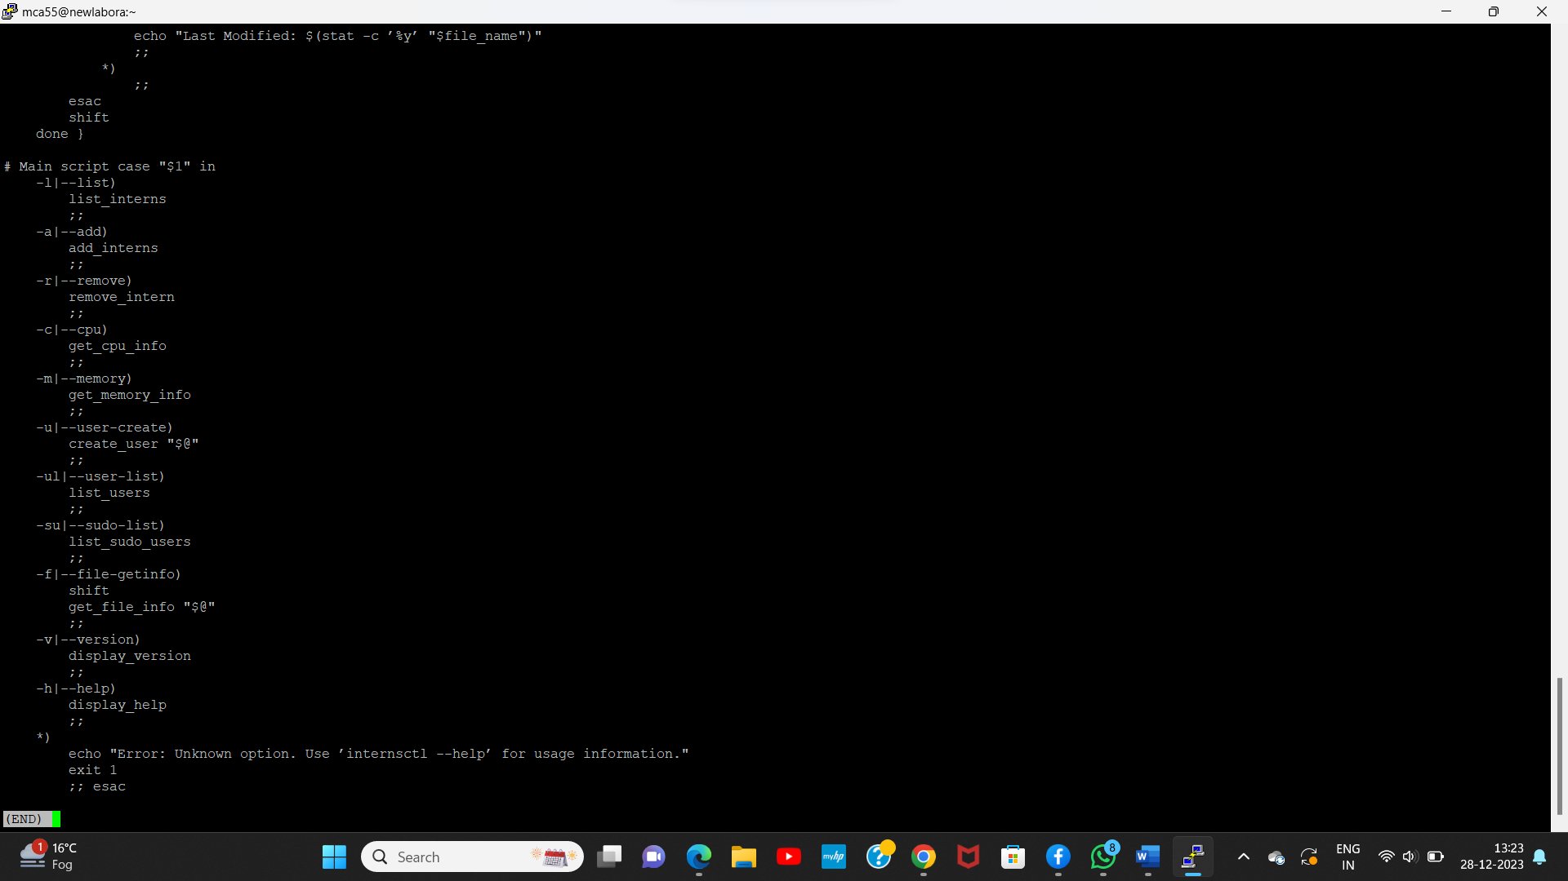

2. Each linux command has an option --help which helps the end user to understand the use cases via examples. Similarly if I execute internsctl --help it should provide me the necessary help

Ans

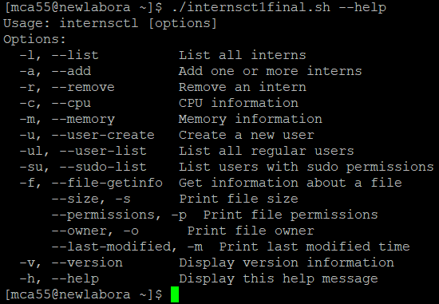

3. I want to see version of my command by executing internsctl –version

Ans



Section B

I want to execute the following command for - Part1 | Level Easy

I want to get cpu information of my server through the following command: $ internsctl cpu getinfo

Ans



I want to get memory information of my server through the following command: $ internsctl memory getinfo

Ans

Get memory information

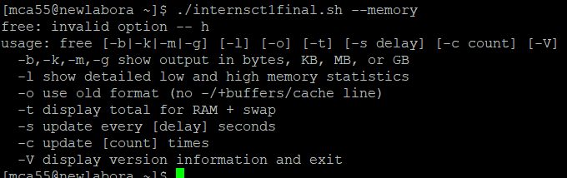

Part2 | Level Intermediate

I want to create a new user on my server through the following command: $ internsctl user create Note - above command should create user who can login to linux system and access his home directory

Ans :Username creation



I want to list all the regular users present on my server through the following command: $ internsctl user list

User list



If want to list all the users with sudo permissions on my server through the following command: $ internsctl user list --sudo-only

Ans :



Part3 | Advanced Level

By executing below command I want to get some information about a file $ internsctl file getinfo Expected Output [make sure to have the output in following format only]

Ls -l intern.txt

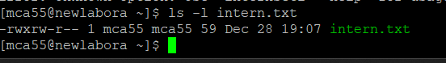

File size -s

