**Test : Add Employee**

Expected Status Code : 201

Actual Status Code : 200

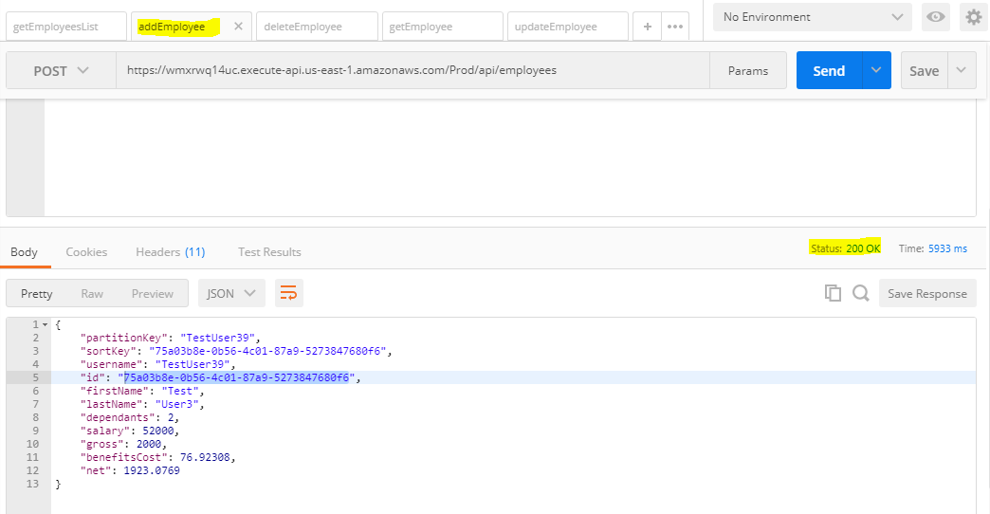

**Test : Delete Employee**

Expected Status Code : 204

Actual Status Code : 200

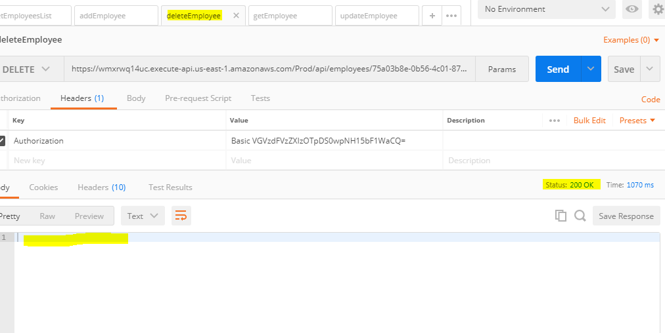

**Test : Get Employee ( After Employee gets Deleted )**

Expected Status Code : 404

Actual Status Code : 200

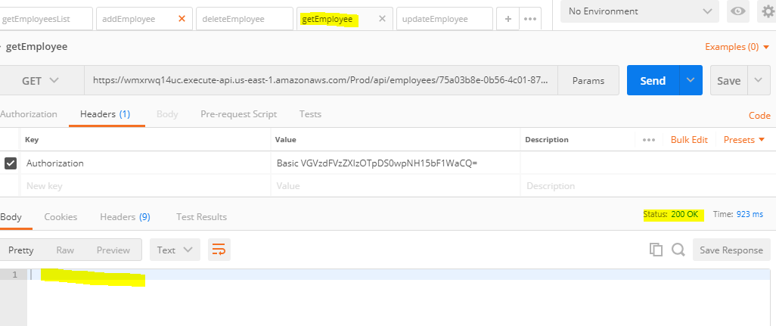

**Test : Update Employee** **( After Employee gets Deleted )**

Expected Status Code : 204

Actual status Code : 200

User able to update a entity even after its get deleted

Salary value is coming 0

Gross value is coming 0

Net pay value is coming in -ve

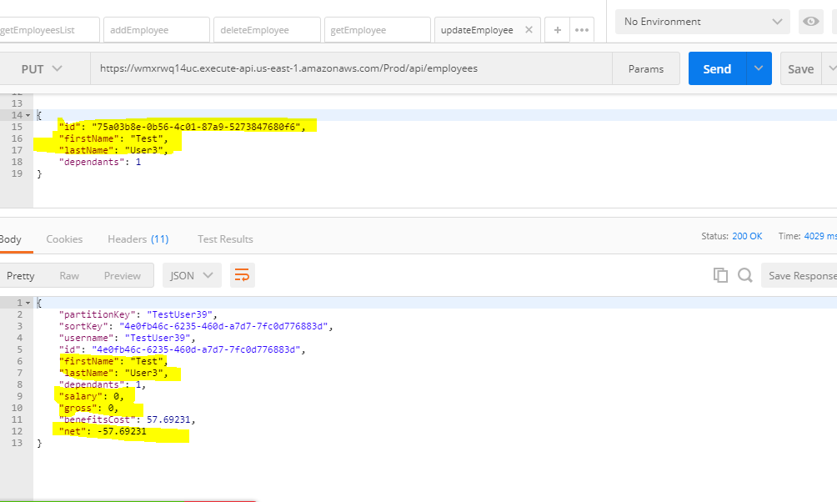

**Test : Add Employee**

User can add employee with First Name and Last Name as numeric value.

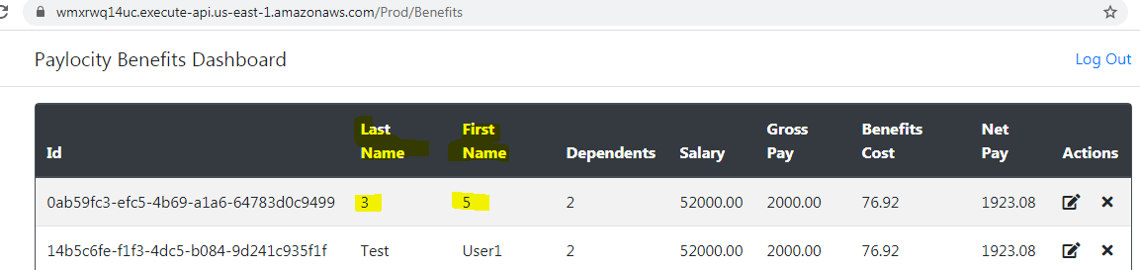

**Test : Add Employee**

No warning/error message for invalid input for dependents field.

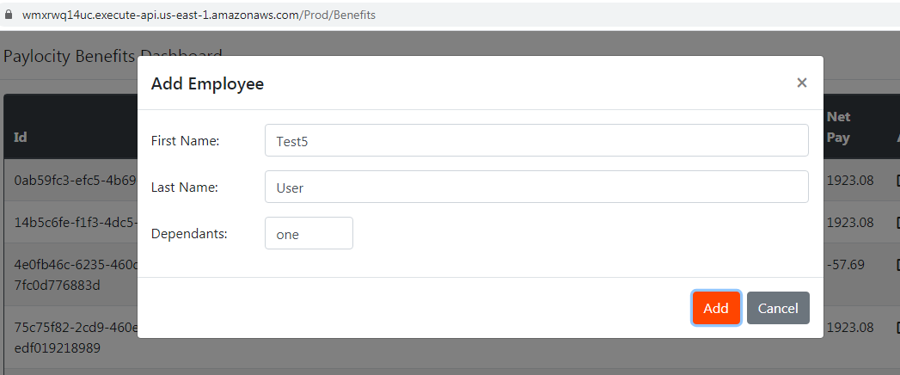

**Test : Add Employee**

No warning/error message for blank inputs for mandatory field.

