# TABLE OF CONTENTS

[TABLE OF CONTENTS i](#_Toc46354975)

[TABLE OF FIGURES iii](#_Toc46354976)

[CHAPTER 1. INTRODUCTION 1](#_Toc46354977)

[1.1. BACKGROUND 1](#_Toc46354978)

[1.2. PROJECT DESCRIPTION 1](#_Toc46354979)

[CHAPTER 2. DATA DESCRIPTION 2](#_Toc46354980)

[2.1. NEIGHBORHOOD 2](#_Toc46354981)

[2.2. DATA SOURCE 2](#_Toc46354982)

[CHAPTER 3. METHODOLOGY 3](#_Toc46354983)

[3.1. DATA EXTRACTION AND CLUSTERING 3](#_Toc46354984)

[3.2. IDENTIFYING SIMILAR NEIGHBORHOODS 4](#_Toc46354985)

[3.3. EXPLORING NEIGHBORHOODS OF CHENNAI AND BANGALORE 6](#_Toc46354986)

[3.3.1 Extracting Zonal information 6](#_Toc46354987)

[3.3.2 Obtain Location data 6](#_Toc46354988)

[3.3.3 Rendering and visualizing location data on folium map 8](#_Toc46354989)

[3.3.4 Explore zones by Foursquare API 9](#_Toc46354990)

[3.3.5 Exploratory data analysis (EDA) 9](#_Toc46354991)

[3.3.6 Data Wrangling 11](#_Toc46354992)

# TABLE OF FIGURES

[Figure 3.1 Data Extraction and clustering process 3](file:///C:\Users\hp\Downloads\Capstone\CAPSTONE_REPORT.docx#_Toc46354996)

[Figure 3.2 Identifying similar neighborhood 5](file:///C:\Users\hp\Downloads\Capstone\CAPSTONE_REPORT.docx#_Toc46354997)

[Figure 3.3 Chennai pincode 6](#_Toc46354998)

[Figure 3.4 Bangalore pincode 6](#_Toc46354999)

[Figure 3.5 Chennai location dataframe 6](#_Toc46355000)

[Figure 3.6 Bangalore location dataframe 6](#_Toc46355001)

[Figure 3.7 Obtaining Chennai coordinates 7](#_Toc46355002)

[Figure 3.8 Obtaining Bangalore coordinates 7](#_Toc46355003)

[Figure 3.9 Chennai map with neighborhoods 8](#_Toc46355004)

[Figure 3.10 Bangalore map with neighborhoods 8](#_Toc46355005)

[Figure 3.11 Venues near Chennai 9](#_Toc46355006)

[Figure 3.12 Venues near Bangalore 9](#_Toc46355007)

[Figure 3.13 Number of venues near Chennai 10](#_Toc46355008)

[Figure 3.14 Number of venues near Bangalore 10](#_Toc46355009)

[Figure 3.15 Counts of number of venues near each neighborhood in Chennai and Bangalore. 10](#_Toc46355010)

[Figure 3.16 Unique categories of venues near Chennai and Bangalore 11](#_Toc46355011)

# INTRODUCTION

## BACKGROUND

Moving is painful even though it is for the career or job of your dreams. Job relocation or temporary housing in a new location is a huge topic of discussion which is mostly commonly occurring scenario for an individual if not so often. There are so many articles and literatures about this topic where one have to make a life decision or choose for the best option possible. Multiple commercial players are available in market some of them include WHRG Group, SHRM, CapRelo Hellolanding etc. to aid and support individual going through relocation specific phase of their life. There are several factors to consider during relocation which include the new cost of living, weather, company’s performance, individual’s relationships, a new home or temporary housing and so on. In case of searching of a new home factors like proximity to essential services, convenience of transport, flexibility of agreements, a new lifestyle etc. have to be considered. Apart from personal relocation there are other specific use cases like traveling nurse housing, corporate housing, inter housing etc.

## PROJECT DESCRIPTION

In this project let us focus on a particular case of relocation where an individual would want to relocate from hometown for a new job. Main focus of the current project is restricted to identifying locations near job place that are similar to places in hometown without loss in generality.

# DATA DESCRIPTION

## NEIGHBORHOOD

Understanding of the neighborhood of the hometown and job location is essential for solving this problem. First hometown is chosen to be Chennai city, India, where Adyar and Kodambakkam are chosen to be zones of importance. Second the job location is chosen to be Bangalore, India, where zones of interest will be obtained in such a way that they are within 10 Km range from the office location of Whitefield area. Once the zone information of the cities are identified it is equally important to obtain the latitude and longitude geographical coordinates of the zones. After obtaining all relevant information, neighborhood of each zone is explored using Foursquare API. Later the neighborhood information is analyzed for similarities and differences. Finally an appropriate neighborhood in the job location similar to hometown is chosen based on the analysis results.

## DATA SOURCE

Zone information is obtained from Wikipedia pages –

* <https://en.wikipedia.org/wiki/List_of_Chennai_Corporation_zones>
* <https://en.wikipedia.org/wiki/List_of_wards_in_Bangalore>

Geographical coordinate information is obtained from –

* <https://indiamapia.com/Chennai.html>
* <https://indiamapia.com/Bangalore.html>

Zonal and geographical information for important regions mentioned in this project are not readily available for direct usage. Hence, the date from the above mentioned pages are gathered and combined appropriately to be used in this project.

# **METHODOLOGY**

## DATA EXTRACTION AND CLUSTERING

In this section, first collect the zonal information data from the mentioned website in the data section. Beautiful soup is used to extract data from HTML, which is useful for web scraping. First, inspect the webpage to identify the class attribute for the table of interest. Raise a get request to fetch the raw HTML content and parse the content. Read the table of interest with the identified class attribute and extract all table information.

After obtaining the zonal information, latitude and longitude location data for each zone is obtained using Geopy, Nominatim package which is commonly used for converting address to location information. The location data is visually rendered on a map using Folium.

Each neighborhood location is explored using foursquare API requests and the JSON response from the API request is processed to obtain only relevant information. The Obtained venue data is explored for total number of venues and unique categories.

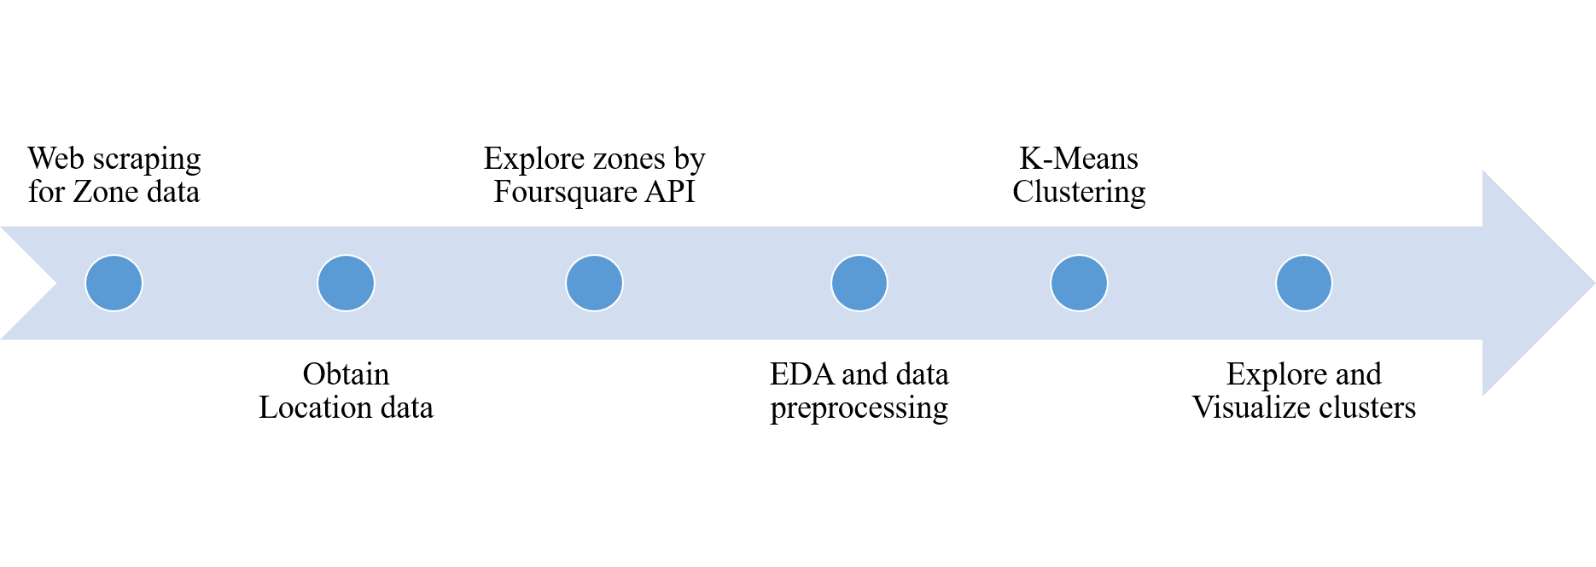

Figure . Data Extraction and clustering process

One hot coding is done to convert the unique categories to venues to numerical data and the average occurrence of a particular category of venue is obtained. Most commonly occurring venues in a given neighborhood are identified and a data frame consisting of the neighborhood and its corresponding 10 most commonly occurring venues is prepared.

K-Means clustering algorithms is used to group the venues based on the similarities of the occurrence of venues. In this project, a cluster value of five is chosen to group the neighborhoods into five different categories. The Clustered information is then visually rendered using folium. Individual cluster groups are explored for their similarities and their descriptions. The complete data extraction and clustering process is shown in Figure 3.1.

## IDENTIFYING SIMILAR NEIGHBORHOODS

The above extraction and clustering process is repeated for two main locations i.e. Chennai or hometown location and Bangalore or job location. Neighborhoods of both job and home location are explored first for similarities. Home location neighborhoods are filtered for regions of interest for comparison with job location neighborhoods. Neighborhoods in job location are filtered based on distance from office area which is chosen to be less than 10 Km.

The radial distance between two latitude and longitude location information is calculated using Geopy geodesic distance calculator module.

One important fact to observe is that the distance obtained is radial or perpendicular distance between two latitude and longitude location data and not road wise distance that is noticed commonly on any navigator like google maps.

The filtered location information from hometown and job location are combined in single data frame. The data is then visualized using folium renderer and explore of sufficient information. Already preprocessed data for previous clustering is used which includes the average occurrence of a particular venue category for each neighborhood.

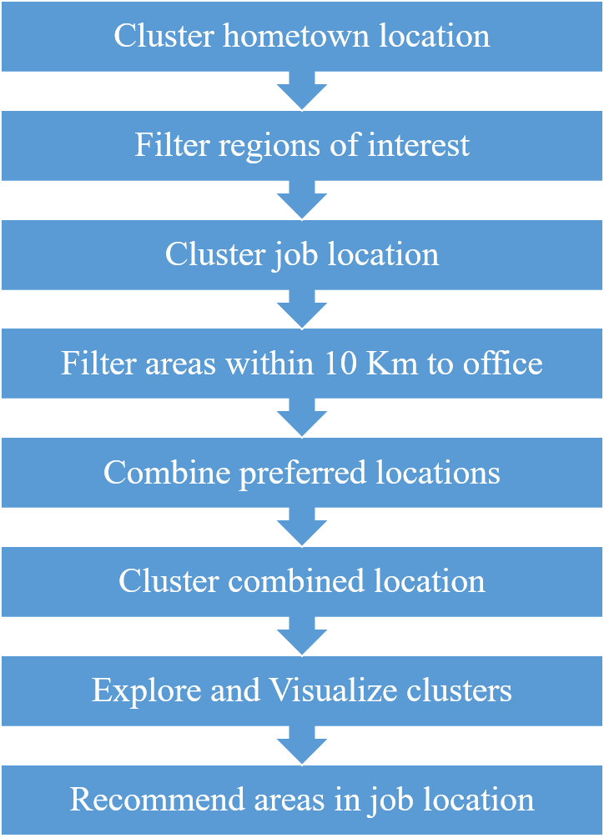

Figure . Identifying similar neighborhood

The combined filtered data is then clustered using K-Means into five groups. The groups are then visualized and explored individually for similarities and descriptions.

The area in job location, which falls in the same group of the hometown, would become the first choice for selection. In case of multiple areas and groups identified, the most similar hometown location is chosen and the job area in the same group, which is closest to office, are recommended. The process for identifying similar neighborhood is shown in Figure 3.2.

## EXPLORING NEIGHBORHOODS OF CHENNAI AND BANGALORE

### Extracting Zonal information

Zones of Chennai and Bangalore are obtained from the website mentioned in data section 2.2 using Beautiful soup. Obtained area and pincode information for Chennai and Bangalore is shown in Figure 3.3 and Figure 3.4 respectively. Total number of Location information include 299 and 295 for Chennai and Bangalore respectively.

|  |  |
| --- | --- |
| C:\Users\hp\Downloads\Capstone\chennai_pincode.PNG  Figure 3.3 Chennai pincode | C:\Users\hp\Downloads\Capstone\bangalore_pincode.PNG  Figure 3.4 Bangalore pincode |

### Obtain Location data

Latitude and longitude location data for Chennai and Bangalore can be obtained either by scraping through the webpages mentioned in section 2.2 or the zone information can be converted to latitude and longitude using the python module Nominatim from Geopy package. In this project the latter approach is used to obtain location information.

|  |  |
| --- | --- |
| C:\Users\hp\Downloads\Capstone\chennai_latlon.PNG  Figure 3.5 Chennai location dataframe | C:\Users\hp\Downloads\Capstone\bangalore_latlon.PNG  Figure 3.6 Bangalore location dataframe |

The obtained location information is stored in pandas dataframe as shown in Figure 3.5 and Figure 3.6. A Snap of output from the Geopy Nominatim package during latitude and longitude extraction is shown in Figure 3.7 and Figure 3.8.

|  |
| --- |
| C:\Users\hp\Downloads\Capstone\chennai_coord.PNG  Figure 3.7 Obtaining Chennai coordinates |
| C:\Users\hp\Downloads\Capstone\bangalore_coord.PNG  Figure 3.8 Obtaining Bangalore coordinates |

Important point to note is Nominatim package does not provide latitude and longitude coordinates for all the available areas. Python package could provide coordinates for 145 out of 299 areas in Chennai and 184 out of 295 areas in Bangalore. Hence only are areas that have valid coordinates are included for further processing.

### Rendering and visualizing location data on folium map

Obtained zonal and coordinate information for areas in Chennai and Bangalore are visualized by rendering it in folium map. Maps of Chennai and Bangalore with neighborhood information is shown in Figure 3.9 and Figure 3.10.

|  |
| --- |
| C:\Users\hp\Downloads\Capstone\chennai_loc_viz_fol.PNG  Figure 3.9 Chennai map with neighborhoods |
| C:\Users\hp\Downloads\Capstone\bangalore_loc_viz_fol.PNG  Figure 3.10 Bangalore map with neighborhoods |

### Explore zones by Foursquare API

Venues near each neighborhood in Chennai and Bangalore are explored using foursquare API through requests module. The obtained JSON file is processed to keep only relevant information and the venue information is stored in pandas dataframe.

|  |
| --- |
| C:\Users\hp\Downloads\Capstone\num_venues_nearby_chennai.PNG  Figure 3.11 Venues near Chennai |
| C:\Users\hp\Downloads\Capstone\num_venues_nearby_bangalore.PNG  Figure 3.12 Venues near Bangalore |

### Exploratory data analysis (EDA)

Obtained venue information from foursquare is then explored for –

* Total number of venues
* Number of venues near each neighborhood
* Unique categories of venues

*Total number of venues*

Total number of venues near Chennai and Bangalore are 3368 and 4600 venues respectively as shown in Figure 3.11 and Figure 3.12.

|  |  |
| --- | --- |
| C:\Users\hp\Downloads\Capstone\num_venues_nearby_chennai.PNG  Figure 3.13 Number of venues near Chennai | C:\Users\hp\Downloads\Capstone\num_venues_nearby_bangalore.PNG  Figure 3.14 Number of venues near Bangalore |

*Number of venues near each neighborhood*

Venues are group based on their neighborhood and the sum or count of all venues near each neighborhood is obtained as shown in Figure 3.15.

|  |  |
| --- | --- |
| **C:\Users\hp\Downloads\Capstone\counts_of_no_of_venues_chennai.PNG** | **C:\Users\hp\Downloads\Capstone\counts_of_no_of_venues_bangalore.PNG** |

Figure . Counts of number of venues near each neighborhood in Chennai and Bangalore.

*Unique categories of venues*

Number of unique categories of venues returned by foursquare API is calculated for neighborhoods near Chennai and Bangalore. As show in the Figure 3.16 it is observed that there are 189 and 249 unique categories of venues are present in Chennai and Bangalore respectively.

|  |
| --- |
| C:\Users\hp\Downloads\Capstone\unique_categ_venue_chennai.PNG |
| C:\Users\hp\Downloads\Capstone\unique_categ_venue_bangalore.PNG |

Figure . Unique categories of venues near Chennai and Bangalore

### Data Wrangling