|  |  |  |  |
| --- | --- | --- | --- |
| **Day And Dates** | **Time** | **Paper Code** | **Paper** |
| **Monday June 6,2022** | 1:00 pm to 4:00 pm | PSCS 401 | Simulation and Modeling |
| **Tuesday June 7,2022** | 1:00 pm to 4:00 pm | PSCS 4021 | Specialization: Track A : Cloud Computing –III(Building cloud & services.) |
| **Wednesday June 8,2022** | 1:00 pm to 4:00 pm | PSCS 4022 | Specialization: Track B : Cyber and Information Security – III(Cryptography and Crypt Analysis.) |
| **Thursday June 9,2022** | 1:00 pm to 4:00 pm | PSCS 4023 | Specialization: Track C : Business Intelligence & Big Data Analytics – III(Intelligent Data Analysis.) |
| **Friday June 10,2022** | 1:00 pm to 4:00 pm | PSCS 4024 | Specialization: Track D : Machine Learning –III(Computational Intelligence.) |
| **Saturday 11,2022** | 1:00 pm to 4:00 pm | PSCS 4025 | Specialization: Track E : Algorithm Analysis –III(Problem Solving.) |

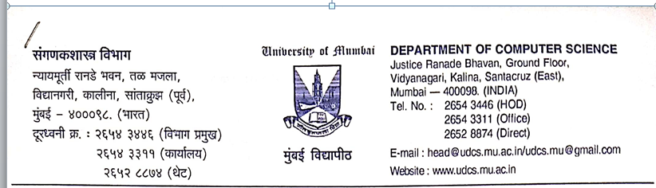

**Examination Time Table – 2022**

**M.Sc. (Computer Science)(Theory)(Semester – IV)**

**M.Sc. (Computer Science)(Practical)(Semester – IV)**

|  |  |  |  |  |
| --- | --- | --- | --- | --- |
| **Day And Dates** | **Time** | **Paper Code** | **Paper** | **Batch No.** |
| Monday June 13, 2022 | 8:30 am to 12:00 pm | |  | | --- | | PSCSP7 | | PSCSP7 | | PSCSP7 | | PSCSP7 |   PSCSP7 | |  | | --- | | Simulation and Modeling | | Specialization: Track A : Cloud Computing –III(Building cloud & services.) | | Specialization: Track B : Cyber and Information Security – III(Cryptography and Crypt Analysis.) | | Specialization: Track C : Business Intelligence & Big Data Analytics – III(Intelligent Data Analysis.) | | Specialization: Track D : Machine Learning –III(Computational Intelligence.) | | Specialization: Track E : Algorithm Analysis –III(Problem Solving.) | | Batch - I |
| Tuesday June 14, 2022 | 8:30 am to 12:00 pm | PSCSP8 | Internship (Presentation and Viva) |  |
| Wednesday June 15, 2022 | 8:30 am to 12:00 pm | PSCSP9 | Project (Presentation and Viva) |  |

|  |  |  |  |  |
| --- | --- | --- | --- | --- |
| **Day And Dates** | **Time** | **Paper Code** | **Paper** | **Batch No.** |
| Monday June 13, 2022 | 1:30 pm to 5:00 pm | |  | | --- | | PSCSP7 | | PSCSP7 | | PSCSP7 | | PSCSP7 |   PSCSP7 | |  | | --- | | Simulation and Modeling | | Specialization: Track A : Cloud Computing –III(Building cloud & services.) | | Specialization: Track B : Cyber and Information Security – III(Cryptography and Crypt Analysis.) | | Specialization: Track C : Business Intelligence & Big Data Analytics – III(Intelligent Data Analysis.) | | Specialization: Track D : Machine Learning –III(Computational Intelligence.) | | Specialization: Track E : Algorithm Analysis –III(Problem Solving.) | | Batch - II |
| Tuesday June 14, 2022 | 1:30 pm to 5:00 pm | PSCSP8 | Internship (Presentation and Viva) |  |
| Wednesday June 15, 2022 | 1:30 pm to 5:00 pm | PSCSP9 | Project (Presentation and Viva) |  |

