Title – Vaccination Record System

Abstract –

The project aims at tracking record of the patients vaccinated at a particular center. It also counts the number of vials used in a particular day

Procedure –

* Pre-registered patients who had appointments verify the documents
* Verification is done with pre-registered data of patients
* New registrations are added to the vaccinated log
* Total number of vaccine vials consumed is tracked for both type of vaccines

Algorithm –

Step 1 – Start

Step 2 – Read adhaar number

Step 3 – check registration status in database

Step 4 – if new user read registration details

Step 5 – if old user check of vaccination status

Step 6 – add the number of vials of vaccine used

Step 7 - print the full day record when asked

Step 8 – Stop.

Flowchart –

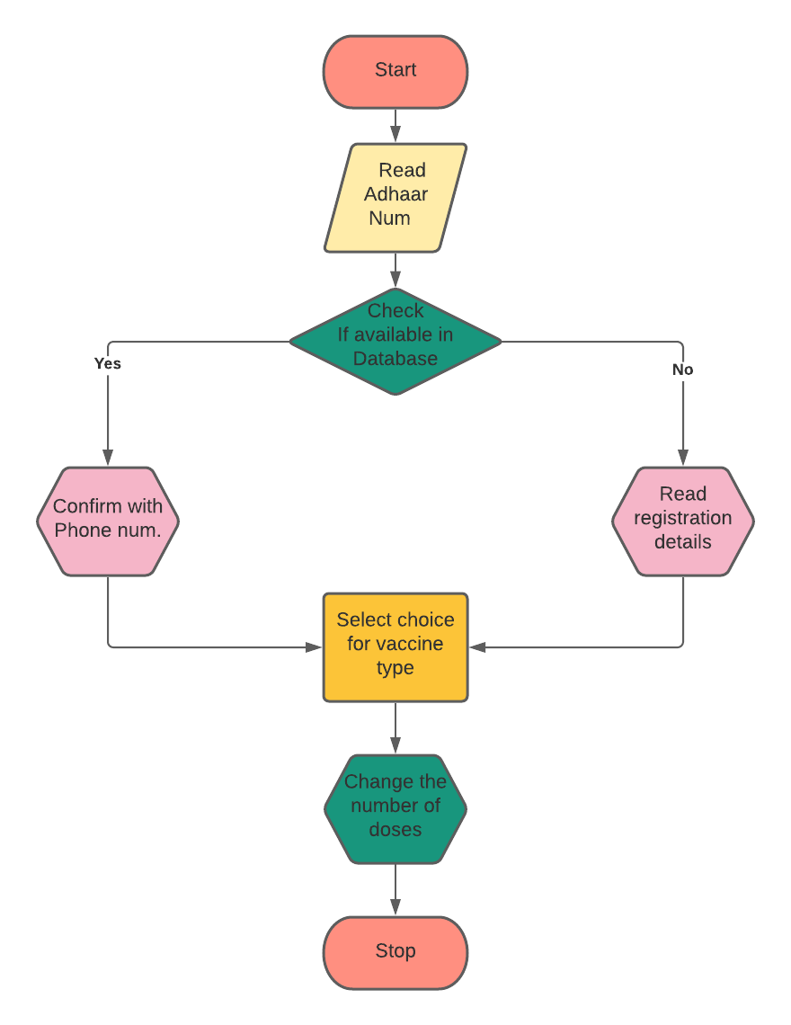

Program -

// Krishna Shrivastava RA2111026010399

// yuvraj singh RA2111026010425

#include <stdio.h>

typedef struct patient

{

    // Structure that stores all details of a patient

    int age ;

    long aadhar ;

    int ph_number ;

    int secret_code ;

    int vaccine_type ;

    int vaccine_doses ;

} patient_details;

// variable patient_log that stores details of upto 1000 patients

patient_details patient_log[1000];

int regist_status(long entred_adhar)

{

    // Checks for registration details of new patients

    patient_log[0].aadhar = entred_adhar;

    int i = 1;

    while (i <= 1000)

    {

        if (patient_log[i].aadhar == patient_log[0].aadhar)

        {

            if (patient_log[i].vaccine_type == 0)

                return 0; // this means registred but not logged in

            else

                return 1; // registred and logeed in

        }

        i++;

    }

    return -1; // not registred

}

// Checks how many doses should be given

int vaccine_status(int i)

{

    if (patient_log[i].vaccine_doses == 0)

    { // not taken any dose

        patient_log[i].vaccine_doses++;

        return 1;

    }

    else if (patient_log[i].vaccine_doses == 1)

    { // taken 1 dose

        patient_log[i].vaccine_doses++;

        return 2;

    }

    else if (patient_log[i].vaccine_doses == 2)

    { // taken 2 doses

        return 3;

    }

    else

        return 0;

}

// Program begins from this section

int main()

{

    int status;         // A return parameter to check status of patient

    long entred_adhar;  // Variable that stores patient's aadhar number

    int v1 = 0, v2 = 0; //Vaccine type 1 and 2 quantity

    int attmpt = 1000; // Variable that determines the total number of execution by EOD

    while (attmpt > 0)

    {

    apply:

        printf("\n\t\t\t\t\t\tLet's get vaccinated!!!\n");

        printf("\t\t\t\t\t\tEnter your aadhar number:");

        scanf("%lld", &entred_adhar);

        if (entred_adhar == 3112) // secret code to view results

        {

            goto results;

        }

        status = regist_status(entred_adhar);

        int i, j = 0, vstat = 0, vaccine_choice = 0, pno;

        i = 1;

        while (i <= 1000)

        {

            if (patient_log[i].aadhar == entred_adhar)

                j = i; // for storing the idex of stored adhar

            i++;

        }

        if (status == -1) // for first time registration

        {

            i = 1;

            while (i <= 1000)

            {

                if (patient_log[i].aadhar == 0)

                {

                    printf("\t\t\t\t\t\tFill details for registration\n");

                    patient_log[i].aadhar = patient_log[0].aadhar;

                    printf("\t\t\t\t\t\tEnter your phone number: ");

                    scanf("%d", &patient_log[i].ph_number);

                    printf("\t\t\t\t\t\tEnter your age: ");

                    scanf("%d", &patient_log[i].age);

                    printf("\t\t\t\t\t\tEnter your secret code: ");

                    scanf("%d", &patient_log[i].secret_code);

                    break;

                }

                i++;

            }

            printf("\t\t\t\t\t\tCredentials saved, log in again\n");

            goto apply;

        }

        else if (status == 0) // for first time logging in

        {

            //Verification

            printf("\t\t\t\t\t\tConfirm user, enter ph.number\n\t\t\t\t\t\t");

        prv1:

            scanf("%d", &pno);

            if (pno == patient_log[j].ph_number)

                goto nxt1;

            else

                printf("\t\t\t\t\t\tWrong credentials, try again\n");

            goto prv1;

        nxt1:

            printf("\t\t\t\t\t\tTime for vaccine\n\t\t\t\t\t\tSelect type\n");

            printf("\t\t\t\t\t\t1:Covishield\n\t\t\t\t\t\t2:Covaxin\n\t\t\t\t\t\t");

            scanf("%d", &vaccine_choice);

            if (patient_log[j].vaccine_type == 0)

            {

                switch (vaccine_choice)

                {

                case 1:

                    patient_log[j].vaccine_type = 1;

                    break;

                case 2:

                    patient_log[j].vaccine_type = 2;

                    break;

                default:

                    printf("\t\t\t\t\t\tSelect option 1 or 2\n");

                    break;

                }

            }

        }

        else // logging after taking first dose

        {

            // Verification

            printf("\t\t\t\t\t\tConfirm user, enter ph.number\n\t\t\t\t\t\t");

        prv2:

            scanf("%d", &pno);

            if (pno == patient_log[j].ph_number)

                goto nxt2;

            else

                printf("\t\t\t\t\t\tWrong credentials, try again\n");

            goto prv2;

        }

    nxt2:

        vstat = vaccine_status(j); //Status of patient based on being vaccinated

        if (vstat == 1)

            printf("\t\t\t\t\t\tPlease take your first vaccine\n\t\t\t\t\t\tYou have been vaccinated once\n");

        else if (vstat == 2)

            printf("\t\t\t\t\t\tPlease take your second vaccine\n\t\t\t\t\t\tYou have been vaccinated twice\n");

        else if (vstat == 3)

            printf("\t\t\t\t\t\tYou have completed two dozes of vaccination\n");

        // Count of total number of vaccine vials used

        if (patient_log[j].vaccine_type == 1 && (vstat == 1 || vstat == 2))

            v1++;

        else if (patient_log[j].vaccine_type == 2 && (vstat == 1 || vstat == 2))

            v2++;

        attmpt--;

    }

results:

    printf("\n\t\t\t\t\t\tFinal list of patients and consumed stock of vaccines\n");

    int i = 1;

    while (i <= 1000)

    {

        if (patient_log[i].aadhar != 0)

        {

            printf("\t\t\t\t\t\tP%d Aadhar:%lld\n", i , patient_log[i].aadhar);

            printf("\t\t\t\t\t\tP%d Phone no:%d\n", i , patient_log[i].ph_number);

            printf("\t\t\t\t\t\tP%d Age:%d\n", i , patient_log[i].age);

            printf("\t\t\t\t\t\tP%d Secret code:%d\n", i , patient_log[i].secret_code);

            printf("\t\t\t\t\t\tP%d Vaccine type:%d\n", i , patient_log[i].vaccine_type);

            printf("\t\t\t\t\t\tP%d Vaccine dozes:%d\n\n", i , patient_log[i].vaccine_doses);

        }

        i++;

    }

    printf("\n\t\t\t\t\t\tVaccine type 1(COVISHIELD):%d\n", v1);

    printf("\t\t\t\t\t\tVaccine type 2(COVAXIN):%d\n", v2);

    goto apply;

return 0;

}

Output - 