**Title page**

**Topic:**

**Online Healthcare System**

**Frontend:**

PHP

**Backend:**

MySql

**Submited by:**

Parmar kanaklatta

Joshi Krishna

Bhatt Janvi

**Reference no. :**

36

**Guided by:**

Prof. Paras Atara

**Project Submitted to:**

H.J. Doshi Information Technology Institute





**Introduction**

Online Health care System is also refers to E-healthcare System or E-health. E-health means the use of digital technologies and Telecommunications, such as computers, the Internet, and mobile devices, to facilitate health improvement and health care services.

Online HealthCare System delivers health care using modern electronic information and communication technologies when health care providers and patients are not directly in contact and their interaction is mediated by electronic means. A digital healthcare software ensures that they can access patient information in real-time using their desktop online or their mobile device.

GreatFeel is an E Health Care System, which is a web-based project developed in PHP. The main aim of this project is to help people to find respective specialist doctors for a particular disease in the nearby location. It also provides information and tips on how the disease can be cured. This healthcare system makes it easy to find the doctors, which helps the patients to recover faster from the disease.

Users can ask question regarding a particular disease and get the proper information related to the disease, cure

remedies and specialist doctors list from desired or nearby location. It enables consumers to gather health-related information themselves to communicate with care providers, health plan administrators, and other consumers electronically and even to receive care in the home.

This Health care system also includes purchasing all medical products from the website with home delivery, with different payment options. including online shopping, this includes the sale of prescription and nonprescription medicines as well.

Online Healthcare offer better pricing than offline stores, with increased access, lower transaction and product

costs, convenience and greater anonymity for consumers. They offer accessibility to people with limited mobility and people

in remote areas. These provide medialerts (personalized medicine reminder service), discounts, doorstep delivery within a short time, and validation of prescription through licensed pharmacists. Information about substitutes and adverse effects is also available on these sites.

Besides appointment booking and purchasing medicines, the additional services you can avail on our platform are doctor consultations, symptom checker, ordering diagnostic tests, and digitization of your health records.

**Scope**

GreatFeel provides Online appointment system for patients. It manages the doctor’s account and patient’s accounts .This website can also book and manage appointment with the patients. It provides the information about doctor’s and its specialty.

It provides guideline , information about fitness and yoga.it also manages the description and information of medical products and we can also buy the medical products.

**Tools Used**

* Front End : PHP 5.6.25(Personal Home Page)
* Back End : MySQL 5.7.14
* Software Requirement
* MySQL
* PHP
* Browser (Chrome, Firefox, Internet Explorer)

**Data Dictionary**

**1.Table Name:** **appointment**

**Purpose : To store appointment info registered by patients.**

|  |  |  |  |
| --- | --- | --- | --- |
| **Field Name** | **Data Type** | **Size** | **constain** |
| a_id | Int | 11 | PRIMARY KEY |
| p_name | Varchar | 50 | NOT NULL |
| p_mobile | Int | 10 | NOT NULL |
| p_address | Varchar | 250 | NOT NULL |
| Id | Int | 11 | NOT NULL |
| a_date | Date |  | NOT NULL |
| a_time | Varchar | 20 | NOT NULL |
| Reason | Varchar | 1000 | NOT NULL |
| added_on | Datetime |  | NOT NULL |
| Status | Varchar | 20 | NOT NULL |

**2.Table Name:** **blog**

**Purpose : To store blog information.**

|  |  |  |  |
| --- | --- | --- | --- |
| **Field Name** | **Data Type** | **Size** | **constain** |
| Id | int | 11 | PRIMARY KEY |
| blog_cate_id | int | 11 | FOREIGN KEY |
| Title | varchar | 100 | NOT NULL |
| Image | varchar | 150 | NOT NULL |
| Description | varchar | 10000 | NOT NULL |
| Status | int | 11 | NOT NULL |

**3.Table Name:** **blog_cate**

**Purpose : To store the blog categories.**

|  |  |  |  |
| --- | --- | --- | --- |
| **Field Name** | **Data Type** | **Size** | **constain** |
| blog_cate_id | int | 11 | PRIMARY KEY |
| Categories | varchar | 255 | NOT NULL |
| Image | varchar | 255 | NOT NULL |
| Status | int | 4 | NOT NULL |

**4.Table Name: cart_details**

**Purpose : To store information about cart.**

|  |  |  |  |
| --- | --- | --- | --- |
| **Field Name** | **Data Type** | **Size** | **constain** |
| Id | int | 11 | NOT NULL |
| u_id | int | 11 | NOT NULL |
| Image | varchar | 100 | NOT NULL |
| Name | varchar | 100 | NOT NULL |
| Code | varchar | 50 | NOT NULL |
| Mrp | float |  | NOT NULL |
| Qty | int | 11 | NOT NULL |
| Total | float |  | NOT NULL |

**5.Table Name: categories**

**Purpose : To store the blog categories.**

|  |  |  |  |
| --- | --- | --- | --- |
| **Field Name** | **Data Type** | **Size** | **constain** |
| pro_cate_id | int | 11 | NOT NULL |
| Categories | varchar | 255 | NOT NULL |
| Image | varchar | 100 | NOT NULL |
| Status | tinyint | 4 | NOT NULL |

**6.Table Name : contact_us**

**Purpose : To store the information about contact page.**

|  |  |  |  |
| --- | --- | --- | --- |
| **Field Name** | **Data Type** | **Size** | **constain** |
| Id | int | 11 | PRIMARY KEY, AUTO_INCREMENT |
| Name | varchar | 100 | NOT NULL |
| Email | varchar | 100 | NOT NULL |
| Mobile | varchar | 10 | NOT NULL |
| Comment | varchar | 100 | NOT NULL |
| added_on | datetime |  | NOT NULL |

**7.Table Name : doc_cate**

**Purpose : To store the information about doctors categories.**

|  |  |  |  |
| --- | --- | --- | --- |
| **Field Name** | **Data Type** | **Size** | **constain** |
| doc_cate_id | int | 11 | PRIMARY KEY |
| Categories | varchar | 255 | NOT NULL |
| Image | varchar | 255 | NOT NULL |
| Status | int | 4 | NOT NULL |

**8.Table Name : doctor**

**Purpose : To store the information about doctors.**

|  |  |  |  |
| --- | --- | --- | --- |
| **Field Name** | **Data Type** | **Size** | **constain** |
| Id | int | 11 | NOT NULL |
| Firstname | varchar | 50 | NOT NULL |
| Lastname | varchar | 50 | NOT NULL |
| Email | varchar | 100 | NOT NULL |
| Password | varchar | 50 | NOT NULL |
| Mobile | varchar | 10 | NOT NULL |
| h_name | varchar | 100 | NOT NULL |
| h_address | varchar | 250 | NOT NULL |
| Gender | varchar | 10 | NOT NULL |
| Image | varchar | 100 | NOT NULL |
| Country | varchar | 50 | NOT NULL |
| State | varchar | 50 | NOT NULL |
| City | varchar | 50 | NOT NULL |
| Qualification | varchar | 50 | NOT NULL |
| Experience | int | 11 | NOT NULL |
| doc_cate_id | varchar | 100 | FOREIGN KEY |
| Fees | int | 11 | NOT NULL |
| added_on | datetime |  | NOT NULL |
| Status | int | 11 | NOT NULL |

**9.Table Name : order**

**Purpose : To store the information about orders.**

|  |  |  |  |
| --- | --- | --- | --- |
| **Field Name** | **Data Type** | **Size** | **constain** |
| Id | int | 11 | PRIMARY KEY |
| u_id | int | 11 | NOT NULL |
| Address | varchar | 250 | NOT NULL |
| City | varchar | 50 | NOT NULL |
| Pincode | int | 11 | NOT NULL |
| payment_type | varchar | 20 | NOT NULL |
| total_price | float |  | NOT NULL |
| payment_status | varchar | 20 | NOT NULL |
| order_status | varchar | 20 | NOT NULL |
| added_on | datetime |  | NOT NULL |

**10.Table Name : order_detail**

**Purpose : To store the information about order details.**

|  |  |  |  |
| --- | --- | --- | --- |
| **Field Name** | **Data Type** | **Size** | **constain** |
| Id | int | 11 | PRIMARY KEY |
| order_id | int | 11 | NOT NULL |
| p_id | int | 11 | NOT NULL |
| Qty | int | 11 | NOT NULL |
| Mrp | float |  | NOT NULL |
| added_on | datetime |  | NOT NULL |

**11.Table Name : patients**

**Purpose : To store the information about patients.**

|  |  |  |  |
| --- | --- | --- | --- |
| **Field Name** | **Data Type** | **Size** | **constain** |
| p_id | int | 11 | PRIMARY KEY ,AUTO_INCREMENT |
| p_name | varchar | 50 | NOT NULL |
| p_email | varchar | 50 | NOT NULL |
| p_password | varchar | 50 | NOT NULL |
| p_mobile | int | 10 | NOT NULL |
| p_address | varchar | 250 | NOT NULL |
| p_gender | varchar | 10 | NOT NULL |
| p_dob | date |  | NOT NULL |
| added_on | datetime |  | NOT NULL |

**12.Table Name : product**

**Purpose : To store the information about products.**

|  |  |  |  |
| --- | --- | --- | --- |
| **Field Name** | **Data Type** | **Size** | **constain** |
| Id | id | 11 | PRIMARY KEY |
| pro_cate_id | int | 11 | FOREIGN KEY |
| Name | varchar | 255 | NOT NULL |
| Code | varchar | 100 | NOT NULL |
| Mrp | float |  | NOT NULL |
| Price | float |  | NOT NULL |
| Qty | int | 11 | NOT NULL |
| Image | varchar | 255 | NOT NULL |
| short_desc | varchar | 2000 | NOT NULL |
| Description | varchar | 2000 | NOT NULL |
| meta_title | varchar | 2000 | NOT NULL |
| meta_desc | varchar | 2000 | NOT NULL |
| meta_keyword | varchar | 2000 | NOT NULL |
| Status | int | 4 | NOT NULL |

**13.Table Name : tbl_admin**

**Purpose : To store the information about admin.**

|  |  |  |  |
| --- | --- | --- | --- |
| **Field Name** | **Data Type** | **Size** | **constain** |
| Id | int | 11 | PRIMARY KEY |
| Username | varchar | 255 | NOT NULL |
| Password | varchar | 255 | NOT NULL |

**14. Table Name : users**

**Purpose : To store the information about users.**

|  |  |  |  |
| --- | --- | --- | --- |
| **Field Name** | **Data Type** | **Size** | **constain** |
| Id | int | 11 | PRIMARY KEY |
| Name | varchar | 100 | NOT NULL |
| Password | varchar | 50 | NOT NULL |
| Email | varchar | 50 | NOT NULL |
| Mobile | varchar | 10 | NOT NULL |
| added_on | datetime |  | NOT NULL |

**Data Flow Diagram**

|  |  |
| --- | --- |
| **Symbol** | **Definitions** |
|  | Process |
|  | Data Stores |
|  | External Entities |
|  | Data Flow |

**Context Level DFD**

Admin

Customer Patient

Doctors

**0th Level-DFD**

Customer

CCustomer

Patient

Admin

Doctor

Customer

Admin

Patient

Doctor

Admin

Customers

Patient

Doctor

**1st level –DFD Admin Side**

Admin

Admin

Admin

Categories

Products

Blogs

**1st level –DFD Customer Side**

Admin

Customer

Login

Categories

Products

**1st level –DFD Patient Side**

Patient

Admin

Categories

Doctor

**ER diagram**

|  |  |
| --- | --- |
| **Symbol** | **Definitions** |
|  | Entity |
|  | Attribute |
|  | Relationship |
|  | Primary Key field |

manages

tbl_admin

manages

manages

manages

contact_us

Doc_cate

categories

blog_cate

has

has

has

patients

doctor

product

has

blog

has

appointment

has

cart_details

order_details

users

has

tbl_order

has

**Form Layout**

**Home Page**

**Description : This is the Home page of the site.**

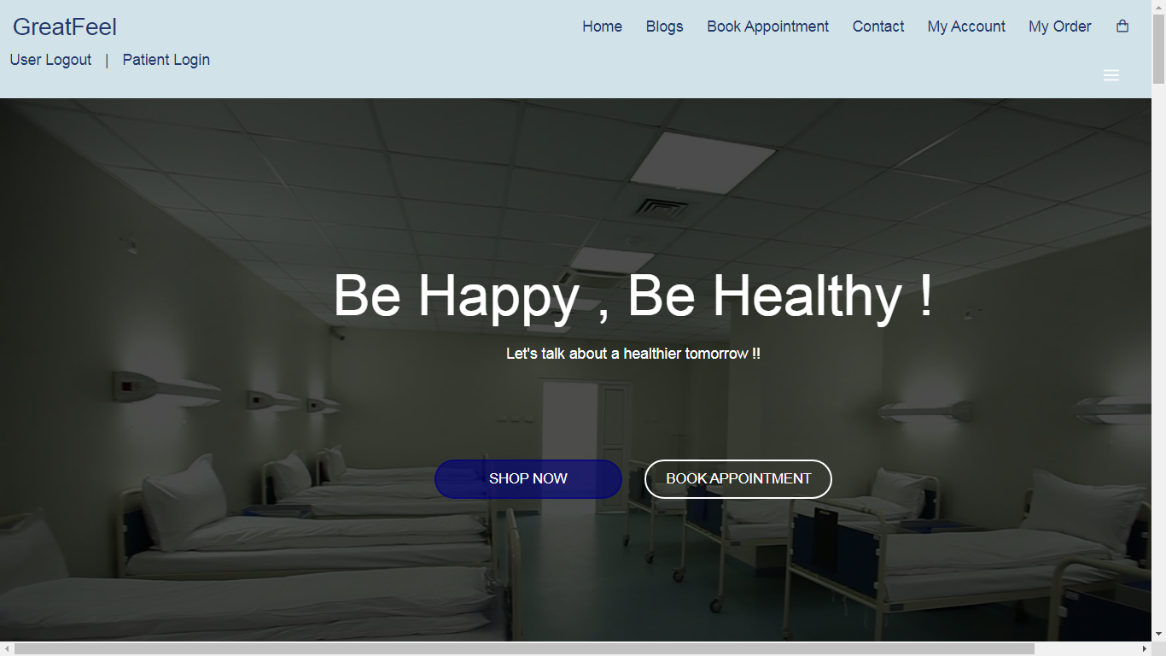

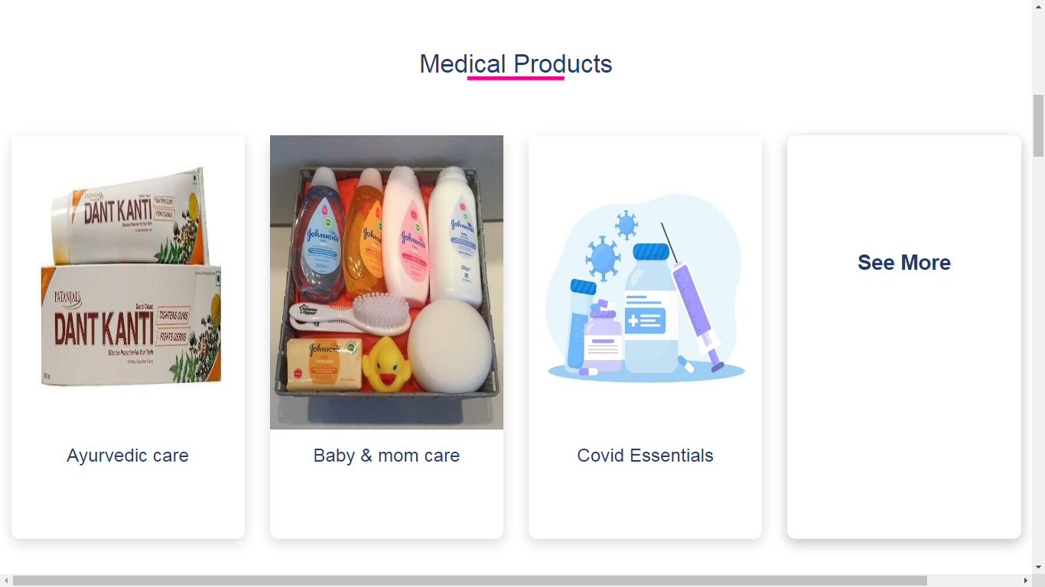



**Product Categories Page**

**Description : This is the product categories page where user can select product Category.**

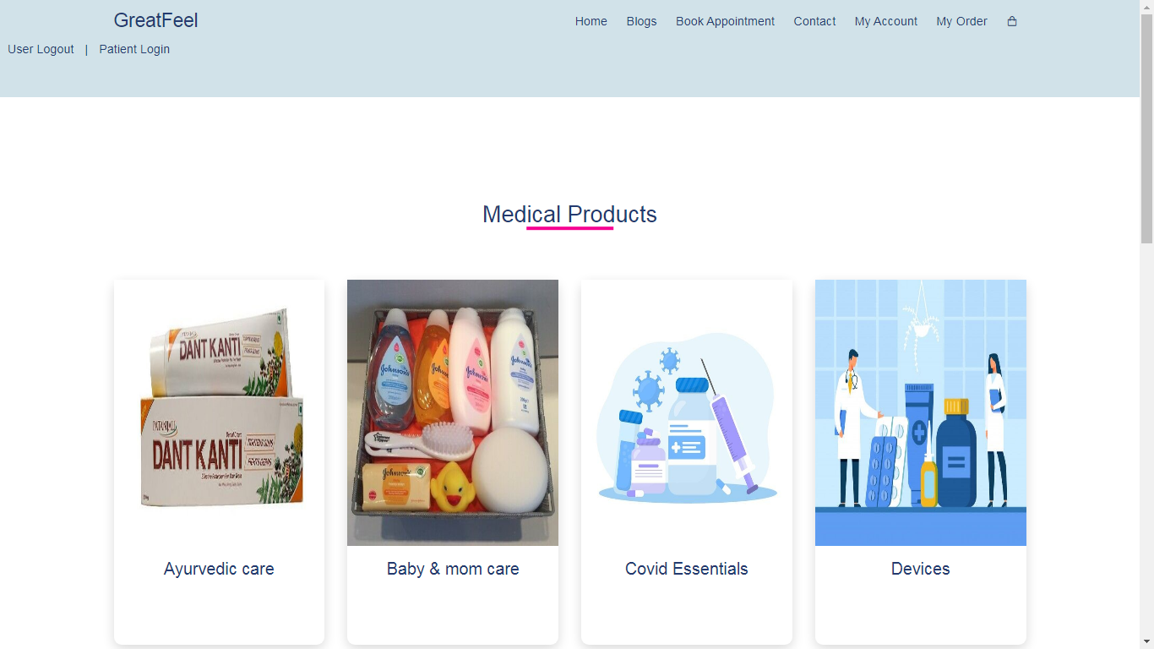

**Products Page**

**Description : This is the product page where user can select any products.**

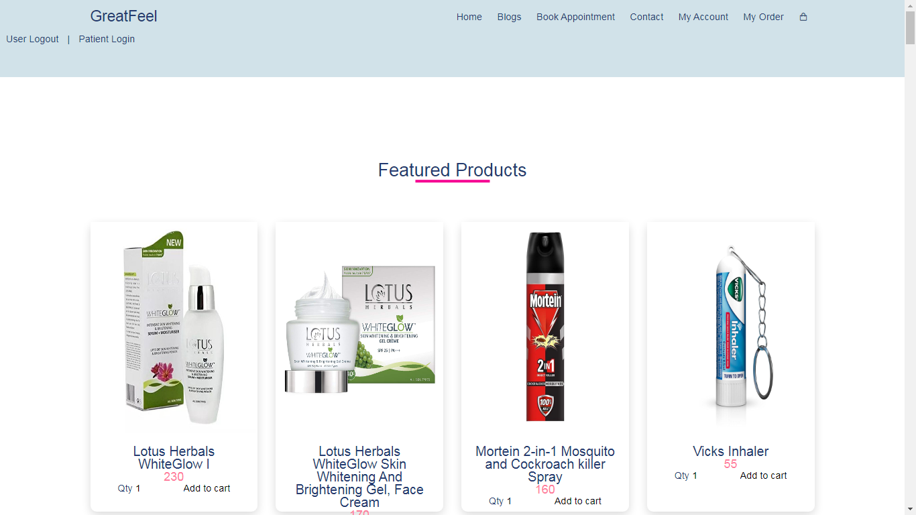

**Doctors Page**

**Description : This is the Doctors page where user can select Doctor to Book appointment.**

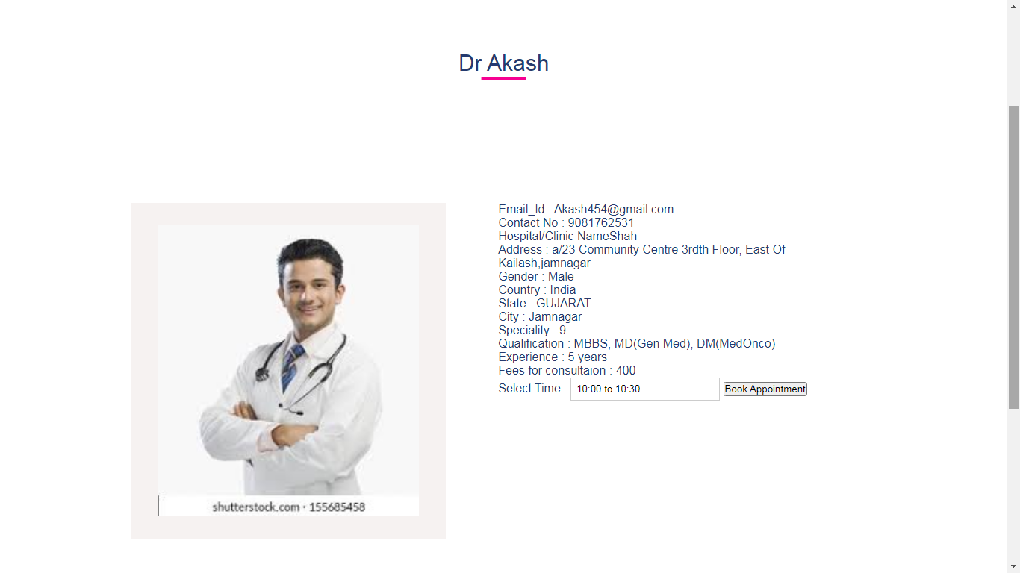

**Patient Login**

**Description : This is the Patients login page where patient can Login/register.**

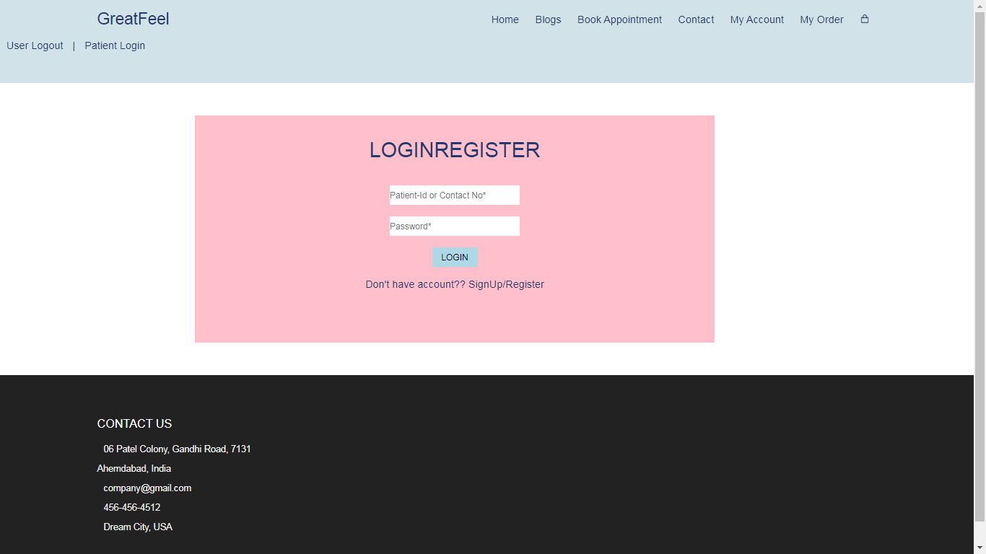

**My Appointment Page**

**Description : This is the Appointment page where user can View Booked Appointments.**

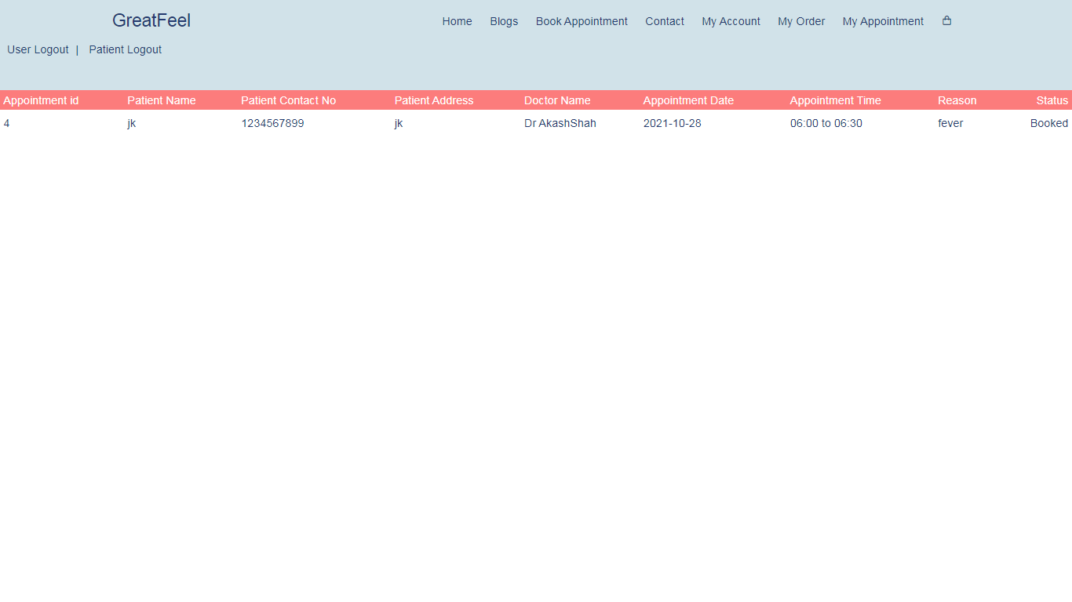

**User Login Page**

**Description : This is the User Login page where user can Login or Register.**

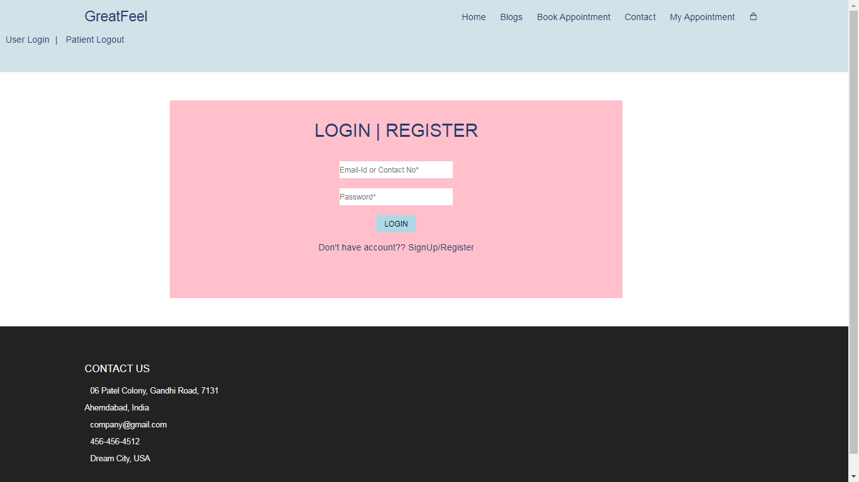

**Cart Page**

**Description : This is the cart page where user can view products added to cart.**

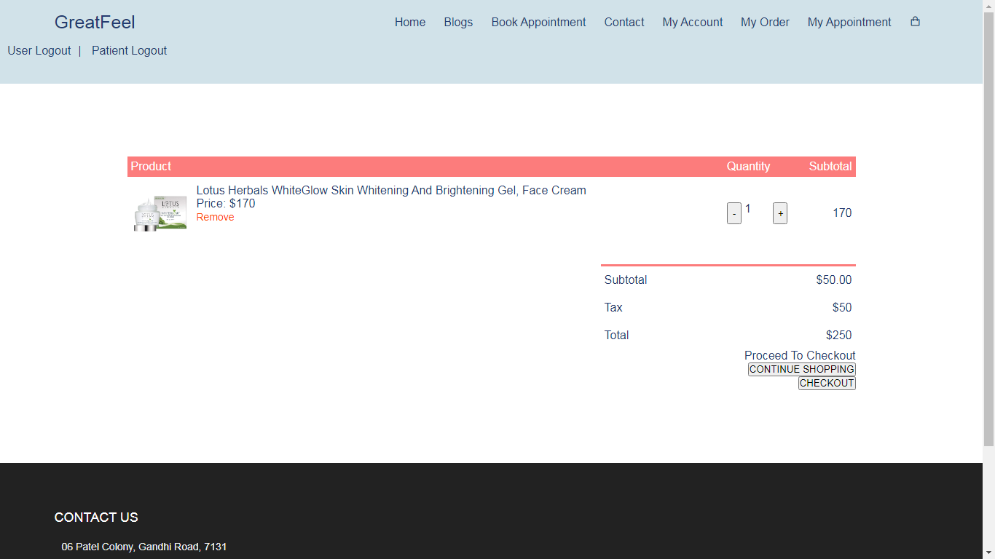

**Checkout Page**

**Description : This is the Checkout Page page where user can perform checkout process.**

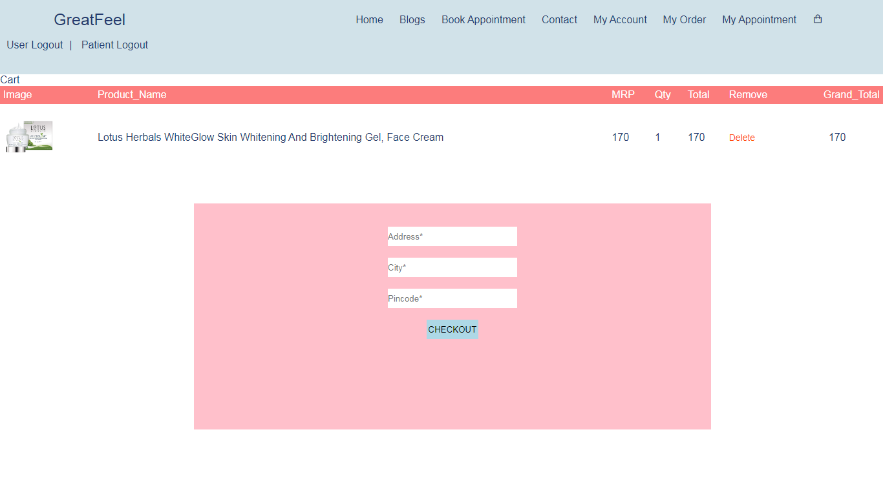

**Admin Side**

**Product Categories-master Page**

**Description : This is the Product Categories-master Page where admin can add, edit or remove product categories.**

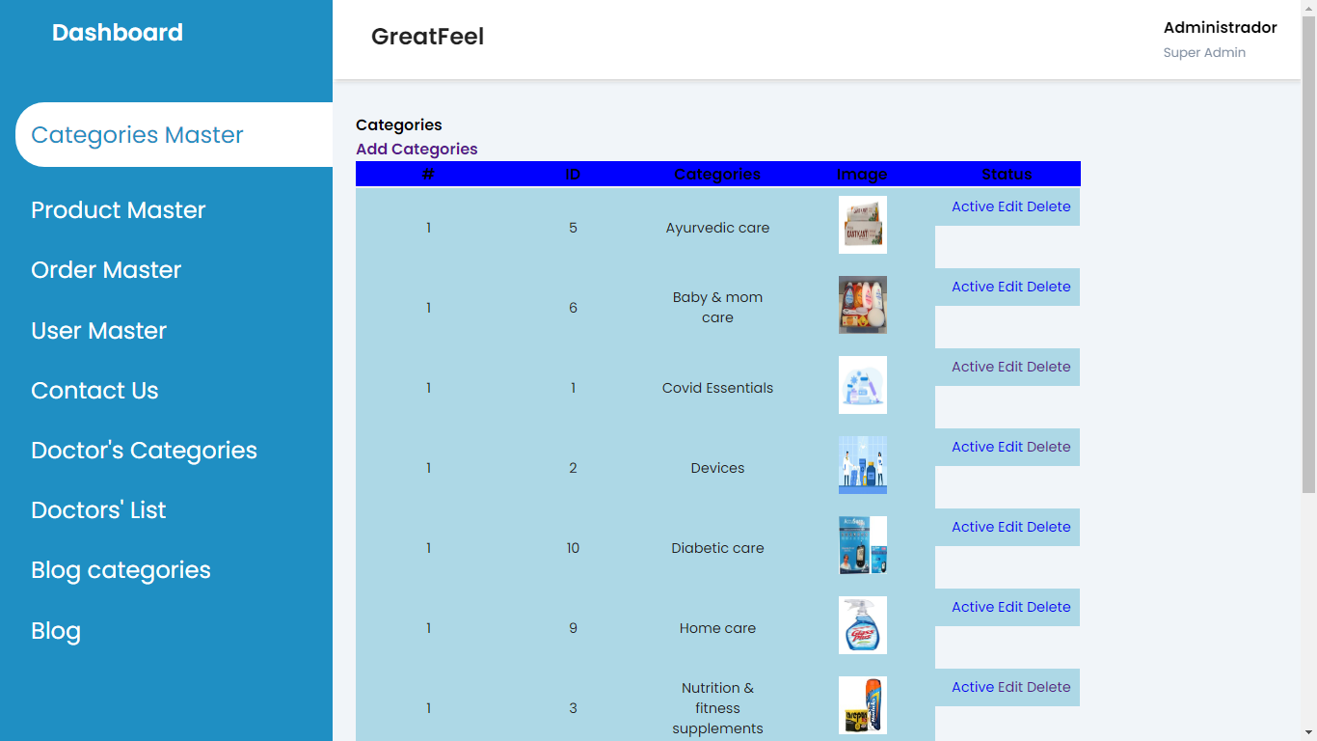

**Product-Master Page**

**Description : This is the Product-master Page where admin can add, edit or remove products.**

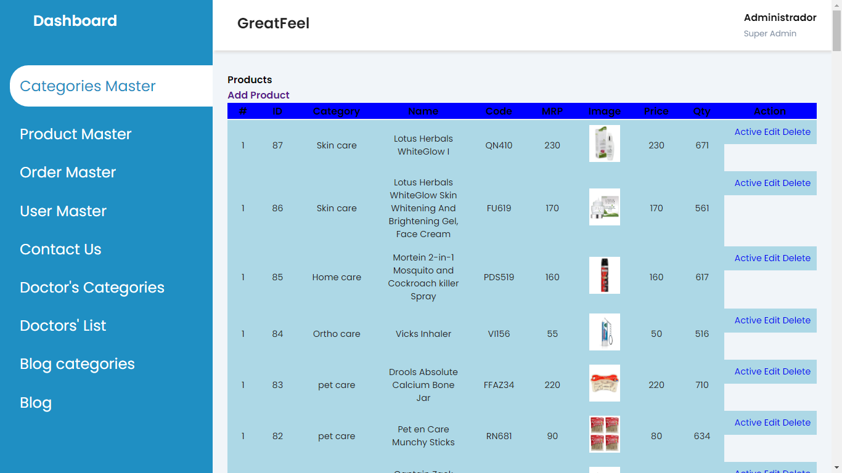

**Order-master**

**Description : This is the Order-master Page where admin can View Orders.**

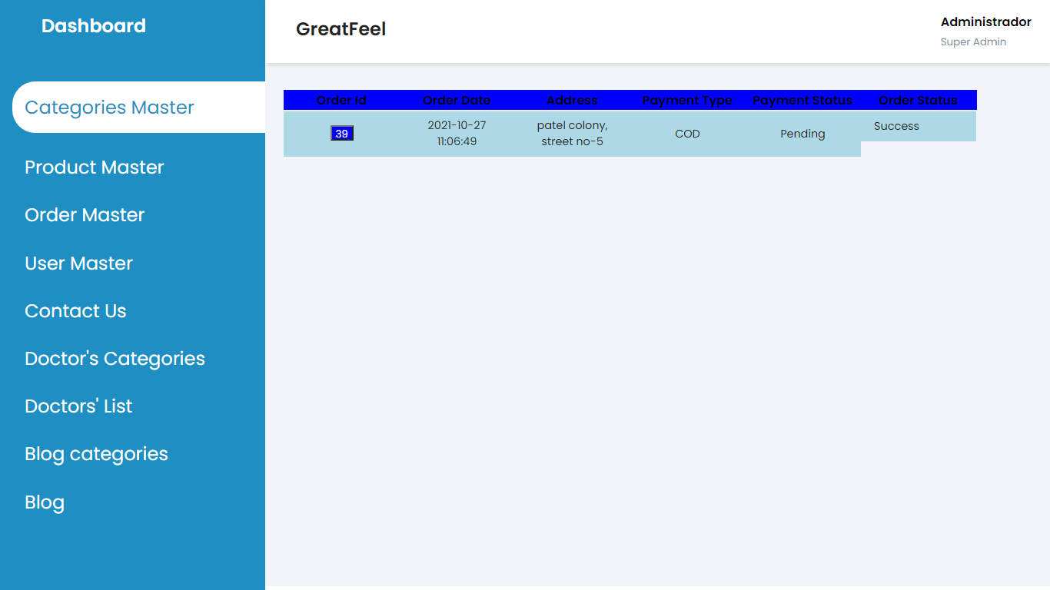

**Doctors Categories**

**Description : This is the doctors categories Page where admin can add, edit or remove doctor categories.**

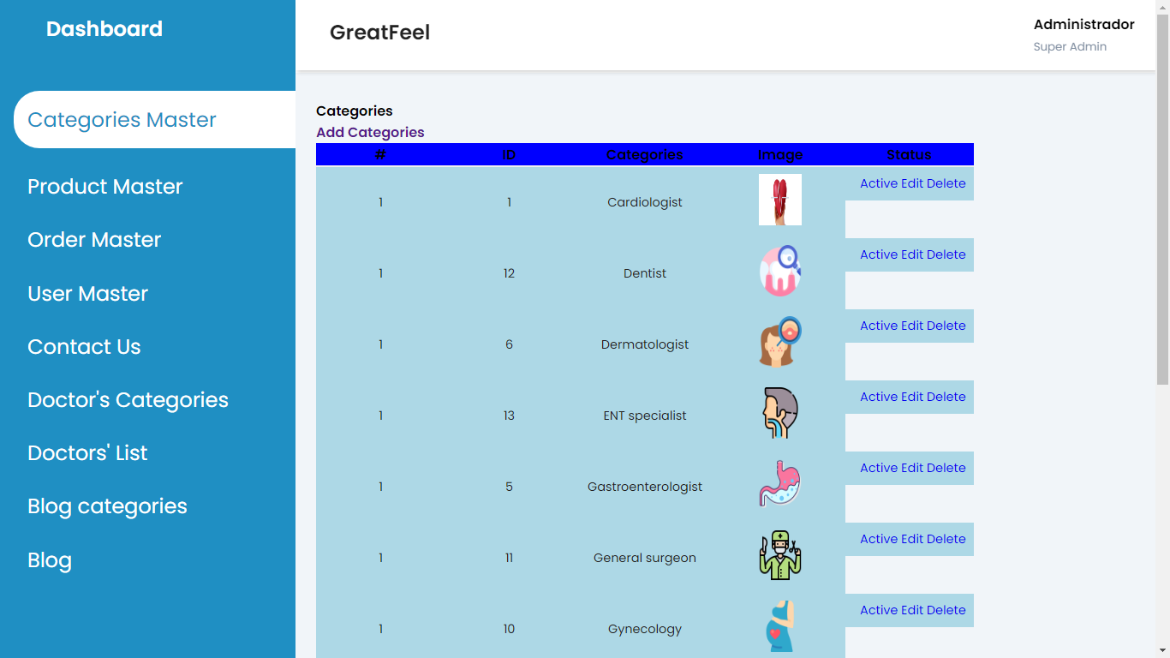

**Doctors-page**

**Description : This is the Doctors Page where admin view or deactive Doctors.**

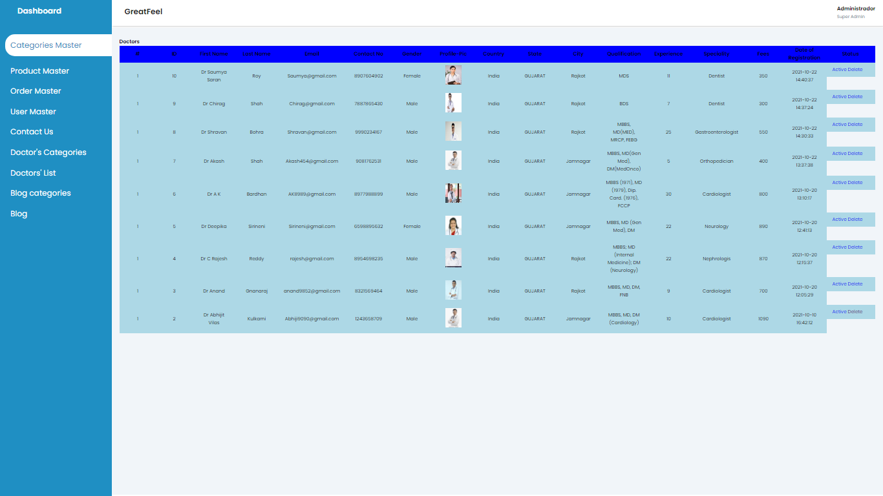

**Blogs-categories**

**Description : This is the Blog Categories Page where admin can add, edit or remove blog categories.**

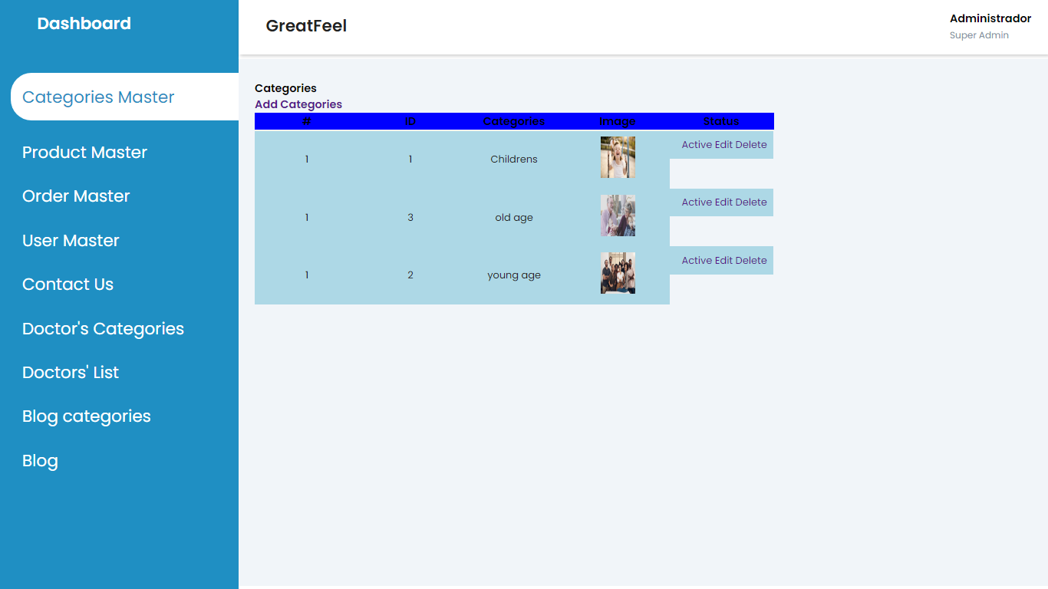

**Blog Page**

**Description : This is the Blogs Page where admin can add, edit or remove Blogs.**

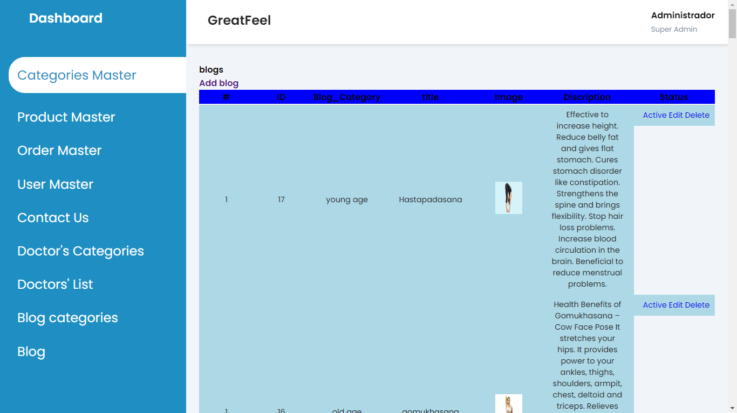

**Limitation & Future Enhancement**

* **Limitation:**
* Smart card technology is not supported.
* Document scanning services are not provided.
* Product delivery tracking can not be done.
* **Future Enhancement :**
* E-wallet system can also be applied.
* Options of debit and credit payment can be added.
* Product delivery tracking facility can be included.
* Document scan can be added.

**Bibliography**

[**www.w3hschools.com**](http://www.w3hschools.com)

[**www.php.net**](http://www.php.net)

[**www.tutorialspoint.com**](http://www.tutorialspoint.com)