|  |
| --- |
|  |
|  |
|  |
|  |
| **Some, Dyuti** |
|  |

Version control

**Version History**

|  |  |  |  |
| --- | --- | --- | --- |
| Date | Version | Author | Description |
| 27th May.2024 | 1 | Dyuti Some | Incorporated changes after internal review |

**Table of Contents**

[1 Executive Summary 4](https://myoffice.accenture.com/personal/dyuti_some_accenture_com/Documents/Desktop/GSI_REPORT_SRS.docx#_Toc167443662)

[1.1 Objective 4](https://myoffice.accenture.com/personal/dyuti_some_accenture_com/Documents/Desktop/GSI_REPORT_SRS.docx#_Toc167443663)

[1.2 Overview 4](https://myoffice.accenture.com/personal/dyuti_some_accenture_com/Documents/Desktop/GSI_REPORT_SRS.docx#_Toc167443664)

[2 Overall Description 5](https://myoffice.accenture.com/personal/dyuti_some_accenture_com/Documents/Desktop/GSI_REPORT_SRS.docx#_Toc167443665)

[2.1 Functional Scope 5](https://myoffice.accenture.com/personal/dyuti_some_accenture_com/Documents/Desktop/GSI_REPORT_SRS.docx#_Toc167443666)

[2.2 Impacted Systems 5](https://myoffice.accenture.com/personal/dyuti_some_accenture_com/Documents/Desktop/GSI_REPORT_SRS.docx#_Toc167443667)

[2.3 Definition & Acronyms 5](https://myoffice.accenture.com/personal/dyuti_some_accenture_com/Documents/Desktop/GSI_REPORT_SRS.docx#_Toc167443668)

[3 Business Module –Utilities 6](https://myoffice.accenture.com/personal/dyuti_some_accenture_com/Documents/Desktop/GSI_REPORT_SRS.docx#_Toc167443669)

[3.1 Use Case Scenario – Document Management 6](https://myoffice.accenture.com/personal/dyuti_some_accenture_com/Documents/Desktop/GSI_REPORT_SRS.docx#_Toc167443670)

[3.1.1 User Case Diagram 6](https://myoffice.accenture.com/personal/dyuti_some_accenture_com/Documents/Desktop/GSI_REPORT_SRS.docx#_Toc167443671)

[3.1.2 Actors & Actions 6](https://myoffice.accenture.com/personal/dyuti_some_accenture_com/Documents/Desktop/GSI_REPORT_SRS.docx#_Toc167443672)

[3.1.3 Process Flow 6](https://myoffice.accenture.com/personal/dyuti_some_accenture_com/Documents/Desktop/GSI_REPORT_SRS.docx#_Toc167443673)

[3.1.4 Business Requirement 6](https://myoffice.accenture.com/personal/dyuti_some_accenture_com/Documents/Desktop/GSI_REPORT_SRS.docx#_Toc167443674)

[3.1.5 Triggering Event 6](https://myoffice.accenture.com/personal/dyuti_some_accenture_com/Documents/Desktop/GSI_REPORT_SRS.docx#_Toc167443675)

[3.1.6 User Interaction 7](https://myoffice.accenture.com/personal/dyuti_some_accenture_com/Documents/Desktop/GSI_REPORT_SRS.docx#_Toc167443676)

[3.1.6.1 UI Type - Web/Mobile 7](https://myoffice.accenture.com/personal/dyuti_some_accenture_com/Documents/Desktop/GSI_REPORT_SRS.docx#_Toc167443677)

[3.1.6.2 Sample Form 8](https://myoffice.accenture.com/personal/dyuti_some_accenture_com/Documents/Desktop/GSI_REPORT_SRS.docx#_Toc167443678)

[3.1.6.3 Property Sheet 11](https://myoffice.accenture.com/personal/dyuti_some_accenture_com/Documents/Desktop/GSI_REPORT_SRS.docx#_Toc167443679)

[3.1.6.4 Business Rules 15](https://myoffice.accenture.com/personal/dyuti_some_accenture_com/Documents/Desktop/GSI_REPORT_SRS.docx#_Toc167443680)

[3.1.6.5 Master Data Interaction 15](https://myoffice.accenture.com/personal/dyuti_some_accenture_com/Documents/Desktop/GSI_REPORT_SRS.docx#_Toc167443681)

[3.1.6.6 Error & Validation Messages 15](https://myoffice.accenture.com/personal/dyuti_some_accenture_com/Documents/Desktop/GSI_REPORT_SRS.docx#_Toc167443682)

[3.1.6.7 Post Conditions 15](https://myoffice.accenture.com/personal/dyuti_some_accenture_com/Documents/Desktop/GSI_REPORT_SRS.docx#_Toc167443683)

[3.1.6.8 Localization 15](https://myoffice.accenture.com/personal/dyuti_some_accenture_com/Documents/Desktop/GSI_REPORT_SRS.docx#_Toc167443684)

[3.1.7 Process Flow – Alternate flow 15](https://myoffice.accenture.com/personal/dyuti_some_accenture_com/Documents/Desktop/GSI_REPORT_SRS.docx#_Toc167443685)

[3.1.8 Non-Functional Requirements 16](https://myoffice.accenture.com/personal/dyuti_some_accenture_com/Documents/Desktop/GSI_REPORT_SRS.docx#_Toc167443686)

[4 Enterprise Diagram 16](https://myoffice.accenture.com/personal/dyuti_some_accenture_com/Documents/Desktop/GSI_REPORT_SRS.docx#_Toc167443687)

[5 Sign Off 16](https://myoffice.accenture.com/personal/dyuti_some_accenture_com/Documents/Desktop/GSI_REPORT_SRS.docx#_Toc167443696)

[5.1 Acceptance Criteria of SRS 16](https://myoffice.accenture.com/personal/dyuti_some_accenture_com/Documents/Desktop/GSI_REPORT_SRS.docx#_Toc167443697)

[5.2 Document Sign Off 16](https://myoffice.accenture.com/personal/dyuti_some_accenture_com/Documents/Desktop/GSI_REPORT_SRS.docx#_Toc167443698)

[6 Glossary 16](https://myoffice.accenture.com/personal/dyuti_some_accenture_com/Documents/Desktop/GSI_REPORT_SRS.docx#_Toc167443699)

# 1 Executive Summary

## 1.1 Objective

The purpose of the document is to detail the requirements related to Manage Recent Docs. This has been done through.

* Study of the requirements given in the Annexure document
* Walkthroughs

SRS document includes

* Detailed overview of the proposed application
* Process flow
* User interface
* Business requirement
* Attribute Identification

This document will now become the basis for the detailed design, development of application and the deployment thereof.

Any changes to this document once signed off will be controlled through change request process defined for the OCBIS program.

## 1.2 Overview

**Manage Recent Docs:**

Manage Recent Docs include the following use cases:

Here we can upload the Recent Docs and search the uploaded files.

**Manage IGC:**

Manage IGC include the following use cases:

* + Here we can add/edit/delete IGC contacts.
  + Here we can upload/edit/delete and search IGC documents.
  + Here we can upload /edit/delete and search IGC photographs.

**Manage Contact Us:**

Manage Contact Us include the following use cases:

* Here we can add the contacts.
* Here we can update the contacts as well.
* Here we can delete the contacts.

**Manage Core Faculty:**

Manage Core Faculty include the following use cases:

* Here we can add the name and the designation of the faculty to their respective divisions.
* Here we can update the faculty name and designation as well.
* Here we can delete the faculty.

# 2 Overall Description

## 2.1 Functional Scope

**Manage Recent Docs:**

|  |  |
| --- | --- |
| ID | Description |
| S1.C1.1 | Manage Recent Docs |

**Manage IGC:**

|  |  |
| --- | --- |
| ID | Description |
| S1.C1.2 | Manage IGC |

**Manage Contact Us:**

|  |  |
| --- | --- |
| ID | Description |
| S1.C1.3 | Manage Contact Us |

**Manage Core Faculty:**

|  |  |
| --- | --- |
| ID | Description |
| S1.C1.4 | Manage Core Faculty |

## 2.2 Impacted Systems

|  |  |  |
| --- | --- | --- |
| System | Inbound Relation | Outbound Relation |
| Enterprise Content Managment System | yes | yes |

## 2.3 Definition & Acronyms

|  |  |
| --- | --- |
| Acronym | Description |
| GSI | Geological Survey of India |
| OCBIS | Online Core Business Integrated System |
| SRS | Software Requirement Specification |

# 3 Business Module – Utilities

Utilities menu basically take care of all the files uploaded, adding faculties, adding contacts and the metadata.

|  |  |
| --- | --- |
| As Per Annex Document | Status |
| Document Management | In Scope |
| Search documents or photographs | In Scope |

All enhanced/new/dropped use cases will be handled through a change request.

## 3.1 Use Case Scenario – Document Management

**Manage Recent Docs:**

* The system will have provision for uploading and viewing of the uploaded files of Manage Recent Docs etc.

**Manage IGC:**

* The system will have provision to add/edit/delete IGC contacts, metadata of IGC documents and IGC photographs and search IGC documents and IGC photographs.

**Manage Contact Us:**

* The system will have provision to add, update and delete the contacts.

**Manage Core Faculty:**

* The system will have provision to add, update and delete the faculty to their respective division.

### 3.1.1 User Case Diagram

NA

### 3.1.2 Actors & Actions

NA

### 3.1.3 Process Flow

NA

### 3.1.4 Business Requirement

**Manage Recent Docs:**

* Here we can upload the Recent Docs and search the uploaded files.

**Manage IGC:**

* Here we can add/edit/delete IGC contacts.
* Here we can upload/edit/delete and search IGC documents.
* Here we can upload /edit/delete and search IGC photographs.

**Manage Contact Us:**

* Here we can add, update, and delete the contacts.

**Manage Core Faculty:**

* Here we can add, update, and delete the faculties in their respective divisions.

### 3.1.5 Triggering Event

NA

### 3.1.6 User Interaction

User will click on Manage Recent Docs to see the uploaded documents.

**Manage Recent Docs:**

This is not a public page. It is only accessible to some particular users.

Here user can add/edit/delete the documents present.

**Manage IGC:**

This is not a public page. It is only accessible to some particular users.

Here user can add/edit/delete the documents/photographs present and can add/edit/delete the IGC contact details also.

**Manage Contact Us:**

This is not a public page. It is only accessible to some persons.

User can add/edit/delete the contact information.

**Manage Core Faculty:**

This is not a public page. It is only accessible to some persons.

User can add/edit/delete the faculties in their respective divisions.

#### 3.1.6.1 UI Type - Web/Mobile

Web

#### 3.1.6.2 Sample Form

**Manage Recent Docs:**

This is not a public page. It is only accessible to some particular users.

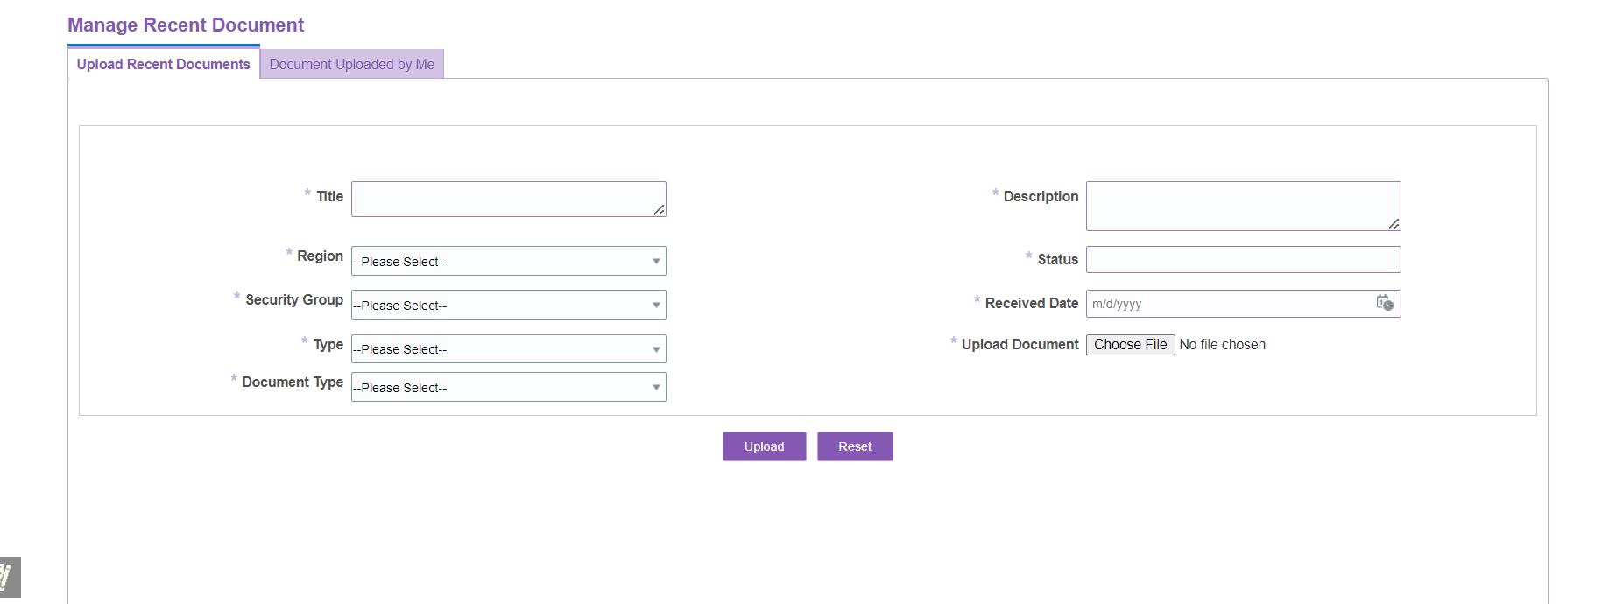

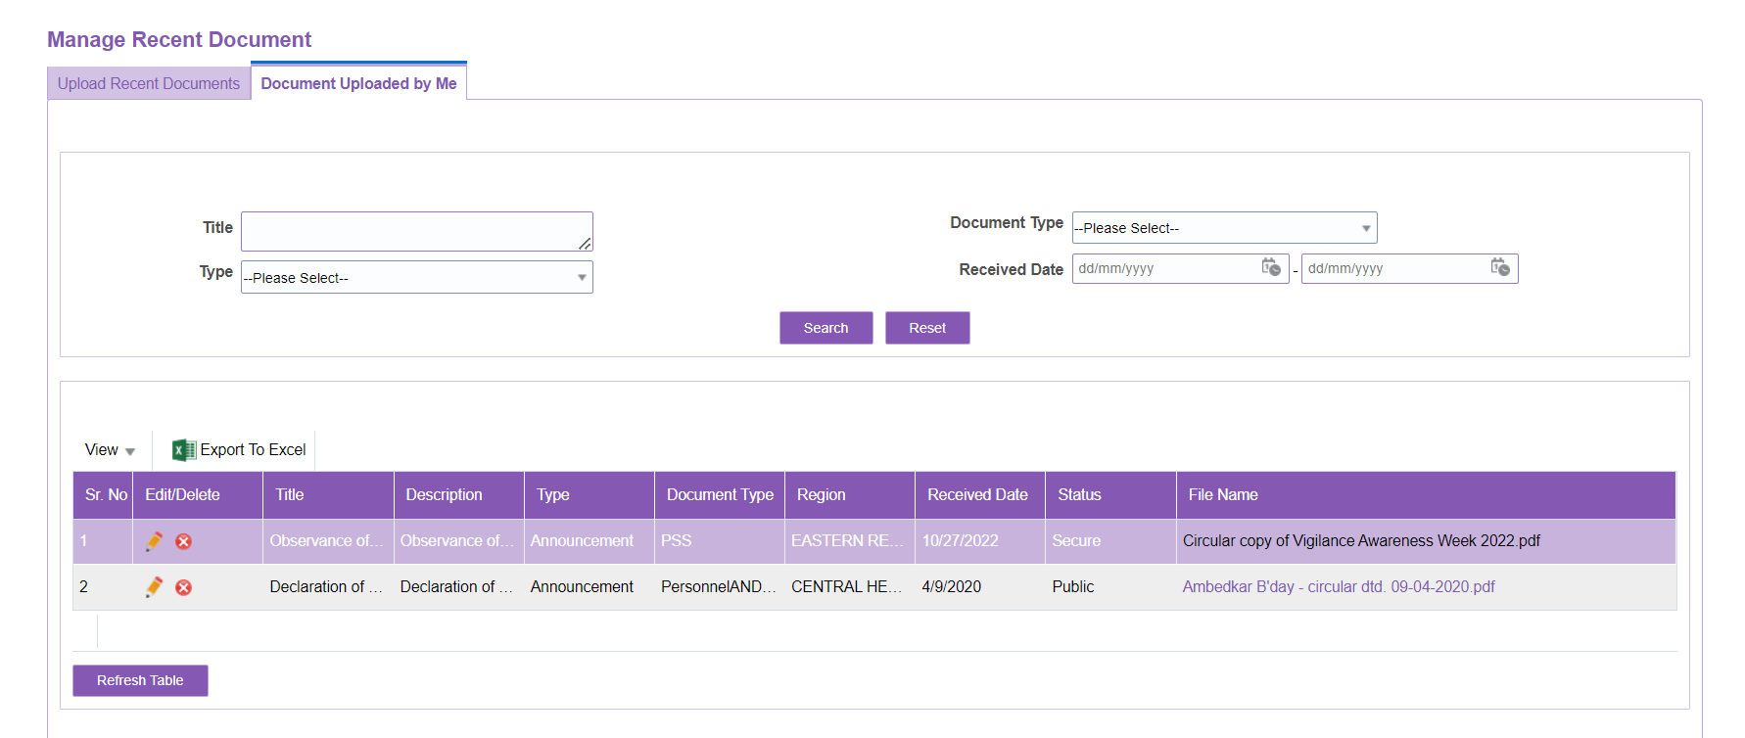

**Manage IGC:**

**[Manage IGC Contact Us](https://employee.gsi.gov.in/webcenter/portal/OCBIS/pages_myworkspace/pageUtilities/pageManageIGC)**:

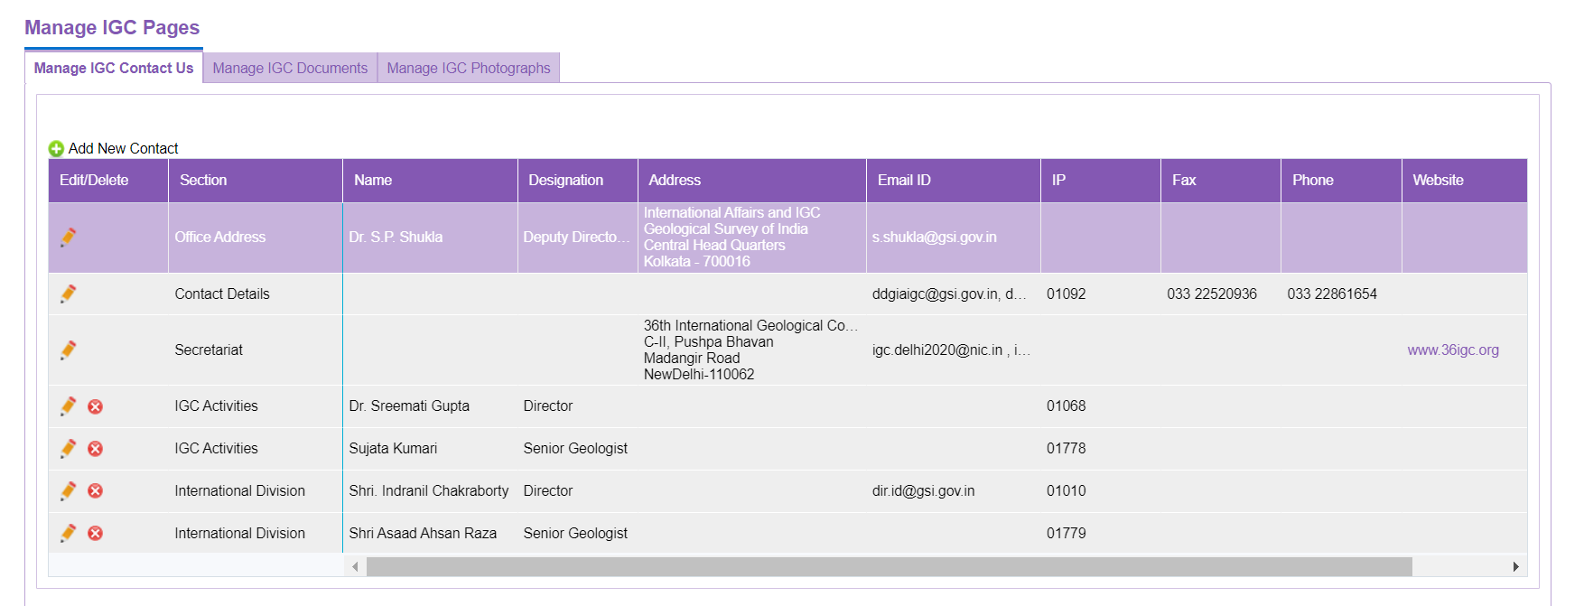

**[Manage IGC Documents](https://employee.gsi.gov.in/webcenter/portal/OCBIS/pages_myworkspace/pageUtilities/pageManageIGC)**:

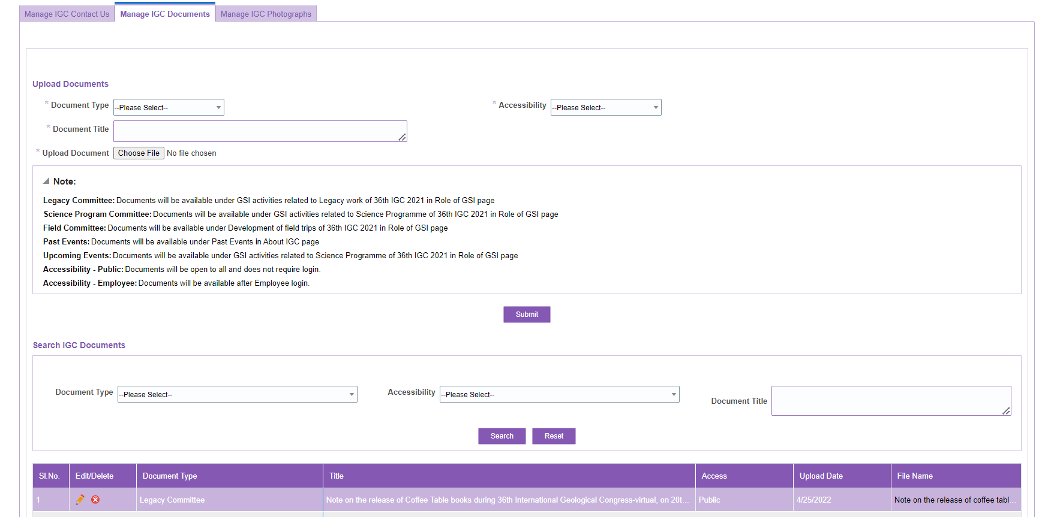

[**Manage IGC** **Photographs**](https://employee.gsi.gov.in/webcenter/portal/OCBIS/pages_myworkspace/pageUtilities/pageManageIGC):

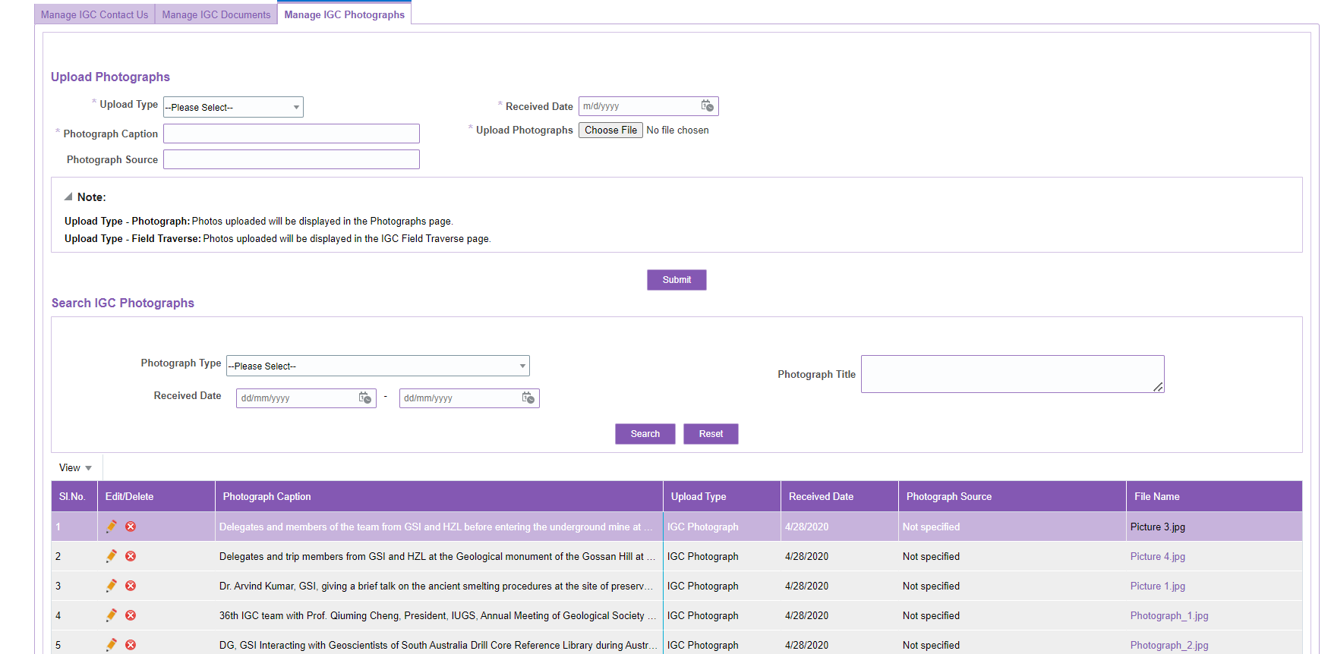

**Manage Contact Us:**

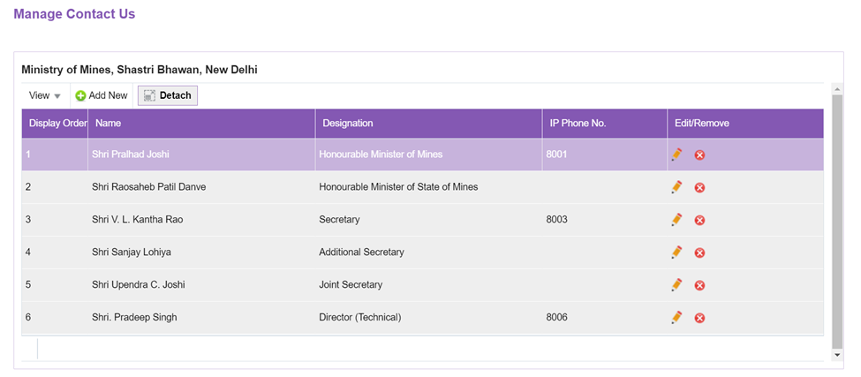

**Manage Core Faculty:**

#### 3.1.6.3 Property Sheet

**Manage Recent Docs:**

|  |  |  |  |  |  |  |  |  |
| --- | --- | --- | --- | --- | --- | --- | --- | --- |
| Field ID | Field Name | Required | Field Type | Data Type | Master Data | Min. Length | Max. Length | Remarks |
| 1 | Title | Yes | TextBox | String | NA | NA | NA | Manual |
| 2 | Region | Yes | DropDown | String | Master Table | NA | NA | Manual |
| 3 | Security Group | Yes | DropDown | String | NA | NA | NA | Manual |
| 4 | Type | Yes | DropDown | String | NA | NA | NA | Manual |
| 5 | Document Type | Yes | DropDown | String | NA | NA | NA | Manual |
| 6 | Description | Yes | TextBox | String | NA | NA | NA | Manual |
| 7 | Status | Yes | TextBox | String | NA | NA | NA | Manual |
| 8 | Received Date | Yes | Date | String | NA | NA | NA | Manual |
| 9 | Upload Document | Yes | InputFile | NA | NA | NA | NA | Manual |
| 10 | Upload | NA | Command Button | NA | NA | NA | NA | Manual |
| 11 | Reset | NA | Command Button | NA | NA | NA | NA | Manual |

**Document uploaded by Me:**

|  |  |  |  |  |  |  |  |  |
| --- | --- | --- | --- | --- | --- | --- | --- | --- |
| Field ID | Field Name | Required | Field Type | Data Type | Master Data | Min. Length | Max. Length | Remarks |
| 1 | Title | NA | TextBox | String | NA | NA | NA | Manual |
| 2 | Region | NA | TextBox | String | Master Table | NA | NA | Manual |
| 3 | File Name | NA | TextBox | String | NA | NA | NA | Manual |
| 4 | Type | NA | DropDown | String | NA | NA | NA | Manual |
| 5 | Document Type | NA | DropDown | String | NA | NA | NA | Manual |
| 6 | Description | NA | TextBox | String | NA | NA | NA | Manual |
| 7 | Status | NA | TextBox | String | NA | NA | NA | Manual |
| 8 | Received Date | NA | Date | String | NA | NA | NA | Manual |
| 9 | Edit/Delete | NA | NA | NA | NA | NA | NA | Manual |
| 10 | Search | NA | Command Button | NA | NA | NA | NA | Manual |
| 11 | Reset | NA | Command Button | NA | NA | NA | NA | Manual |
| 12 | Refresh Table | NA | Command Button | NA | NA | NA | NA | Manual |

**Manage IGC:**

[**Manage IGC Contact Us**](https://employee.gsi.gov.in/webcenter/portal/OCBIS/pages_myworkspace/pageUtilities/pageManageIGC):

|  |  |  |  |  |  |  |  |  |
| --- | --- | --- | --- | --- | --- | --- | --- | --- |
| Field ID | Field Name | Required | Field Type | Data Type | Master Data | Min. Length | Max. Length | Remarks |
| 1 | Section | NA | TextBox | String | NA | NA | NA | Manual |
| 2 | Name | NA | TextBox | String | Master Table | NA | NA | Manual |
| 3 | Designation | NA | TextBox | String | NA | NA | NA | Manual |
| 4 | Address | NA | TextBox | String | NA | NA | NA | Manual |
| 5 | Email ID | NA | TextBox | String | NA | NA | NA | Manual |
| 6 | IP | NA | TextBox | String | NA | NA | NA | Manual |
| 7 | Fax | NA | TextBox | String | NA | NA | NA | Manual |
| 8 | Phone | NA | TextBox | String | NA | NA | NA | Manual |
| 9 | Website | NA | InputFile | NA | NA | NA | NA | Manual |
| 10 | Add New Contact | NA | Command Link | NA | NA | NA | NA | Manual |
| 11 | Edit/Delete | NA | Command Link | NA | NA | NA | NA | Manual |

**[Manage IGC Documents](https://employee.gsi.gov.in/webcenter/portal/OCBIS/pages_myworkspace/pageUtilities/pageManageIGC)**:

|  |  |  |  |  |  |  |  |  |
| --- | --- | --- | --- | --- | --- | --- | --- | --- |
| Field ID | Field Name | Required | Field Type | Data Type | Master Data | Min. Length | Max. Length | Remarks |
| 1 | Document Title | Yes | TextBox | String | Master Table | NA | NA | Manual |
| 2 | Upload Document | Yes | InputFile | NA | NA | NA | NA | Manual |
| 3 | Accessibility | Yes | DropDown | String | Master Table | NA | NA | Manual |
| 4 | File Name | NA | NA | NA | NA | NA | NA | Manual |
| 5 | Document Type | Yes | DropDown | String | NA | NA | NA | Manual |
| 6 | Title | NA | TextBox | String | NA | NA | NA | Manual |
| 7 | Access | NA | TextBox | String | NA | NA | NA | Manual |
| 8 | Upload Date | NA | Date | String | NA | NA | NA | Manual |
| 9 | Edit/Delete | NA | NA | NA | NA | NA | NA | Manual |
| 10 | Search | NA | Command Button | NA | NA | NA | NA | Manual |
| 11 | Reset | NA | Command Button | NA | NA | NA | NA | Manual |
| 12 | Submit | NA | Command Button | NA | NA | NA | NA | Manual |

[**Manage IGC Photographs**](https://employee.gsi.gov.in/webcenter/portal/OCBIS/pages_myworkspace/pageUtilities/pageManageIGC) :

|  |  |  |  |  |  |  |  |  |
| --- | --- | --- | --- | --- | --- | --- | --- | --- |
| Field ID | Field Name | Required | Field Type | Data Type | Master Data | Min. Length | Max. Length | Remarks |
| 1 | Upload Type | Yes | DropDown | String | NA | NA | NA | Manual |
| 2 | Photograph Caption | Yes | TextBox | String | Master Table | NA | NA | Manual |
| 3 | Photograph Source | NA | TextBox | String | NA | NA | NA | Manual |
| 4 | Upload Photographs | Yes | InputFile | String | NA | NA | NA | Manual |
| 5 | File Name | NA | NA | String | NA | NA | NA | Manual |
| 6 | Received Date | NA | Date | String | NA | NA | NA | Manual |
| 7 | Edit/Delete | NA | NA | NA | NA | NA | NA | Manual |
| 8 | Search | NA | Command Button | NA | NA | NA | NA | Manual |
| 9 | Reset | NA | Command Button | NA | NA | NA | NA | Manual |
| 10 | Submit | NA | Command Button | NA | NA | NA | NA | Manual |

**Manage Contact Us:**

|  |  |  |  |  |  |  |  |  |
| --- | --- | --- | --- | --- | --- | --- | --- | --- |
| Field ID | Field Name | Required | Field Type | Data Type | Master Data | Min. Length | Max. Length | Remarks |
| 1 | Add New | NA | Command link | String | NA | NA | NA | Manual |
| 2 | Display Order | NA | Textbox | String | NA | NA | NA | Manual |
| 3 | Name | NA | textbox | String | NA | NA | NA | Manual |
| 4 | Designation | NA | textbox | String | NA | NA | NA | Manual |
| 5 | IP Phone | NA | Textbox | String | NA | NA | NA | Manual |
| 6 | Edit/Delete | NA | NA | NA | NA | NA | NA | Manual |

**Manage Core Faculty:**

|  |  |  |  |  |  |  |  |  |
| --- | --- | --- | --- | --- | --- | --- | --- | --- |
| Field ID | Field Name | Required | Field Type | Data Type | Master Data | Min. Length | Max. Length | Remarks |
| 1 | Add New | NA | Command link | String | NA | NA | NA | Manual |
| 2 | Display Order | NA | Textbox | String | NA | NA | NA | Manual |
| 3 | Name & Designation | NA | Textbox | String | NA | NA | NA | Manual |
| 4 | Edit/Delete | NA | NA | NA | NA | NA | NA | Manual |

#### 3.1.6.4 Business Rules

NA

#### 3.1.6.5 Master Data Interaction

NA

#### 3.1.6.6 Error & Validation Messages

NA

#### 3.1.6.7 Post Conditions

* The uploaded documents should be stored in the Content Management system.

#### 3.1.6.8 Localization

NA

### 3.1.7 Process Flow – Alternate flow

NA

### 3.1.8 Non-Functional Requirements

Please refer to OCBIS System Non-Functional Requirements Specification v1.0

# 4 Enterprise Diagram

NA

# 5 Sign Off

## 5.1 Acceptance Criteria of SRS

The sign off & Acceptance process for the project deliverables illustrated in the table above is as follows:

1. First submission of deliverables will be provided to the GSI Project Director or PMU by the submission date for review & approval.
2. The GSI Project Director or PMU will review the deliverables and provide written comments & observations within 10 working days.
3. The IA project team will update the deliverables post receipt of written comments & observations and do final submission of deliverables to the GSI Project Director or PMU within 3 working days from the receipt of written comments & observations.
4. Sign-off & Deemed Acceptance will be assumed in case of occurrence of either of the events detailed below:
   1. Within 5 working days from date of final submission of the deliverables, to the GSI Project Director or PMU unless any response to observations identified in step 2 need further modification. In the event of disagreement, matters will be settled under Section 2 of the Program Management Plan; or
   2. GSI decides to move to a new phase or puts the deliverable to commercial use.

Any changes/ modifications suggested post Sign-off/ Deemed Acceptance thereon will be subject to change control process per Schedule I of Section II of the RFP, detailed also in Section 15 of the Program Management Plan.

## 5.2 Document Sign Off

|  |  |  |  |
| --- | --- | --- | --- |
| Sl No | Signed Off By | Version | Date |
|  |  |  | MMM DD, YYYY format |
|  |  |  | MMM DD, YYYY format |

# 6 Glossary

NA