16418530

**Table of Contents**

|  |  |
| --- | --- |
| Contents | Page.no |
| Getting started | 1 |
| Designs  Wireframe  My Home page  My Bio page  My Resume page  My Contact page | 2  2  2  3  4 |
| Sketches  Homepage  Bio  Resume  Contact |  |
| Images |  |
| Evidence |  |
| Load Speed |  |
| Progression |  |

16418530

Getting Started

Before I truly started on making my portfolio, I went around and looked individuals' portfolios and got a couple of contemplations on how I could style and convey mine. I saw an extensive measure of them were making using a front end like Bootstrap or HTML5BoilerPlate, JavaScript. I started creating my site using HTML and CSS only which took about 12 weeks to complete it. I made one Repo with name CSY1018 on GitHub. I clone it into my local computer and created the folder for different file. For images I created Images folder and CSS folder for CSS file on my local computer. Then I push it into GitHub.

After that I started to code using Atom and regularly I push the changes into GitHub.

Design

Wireframe

Wireframe of Homepage

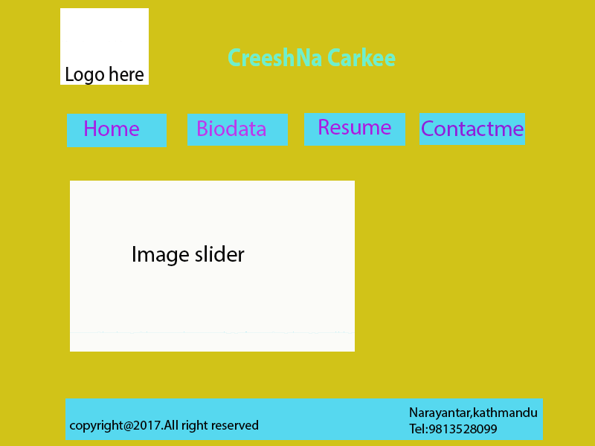

**Wireframe of Resume**

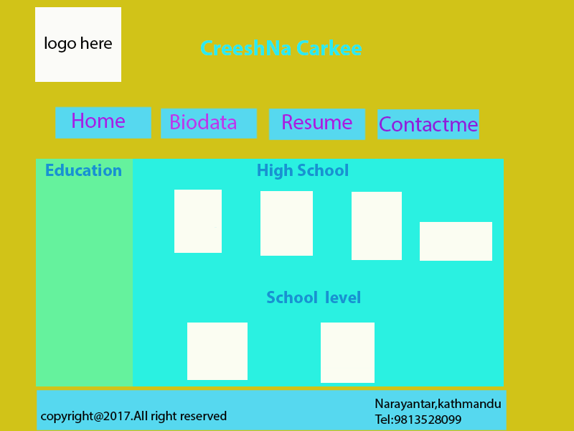

**Wireframe of My Biodata**

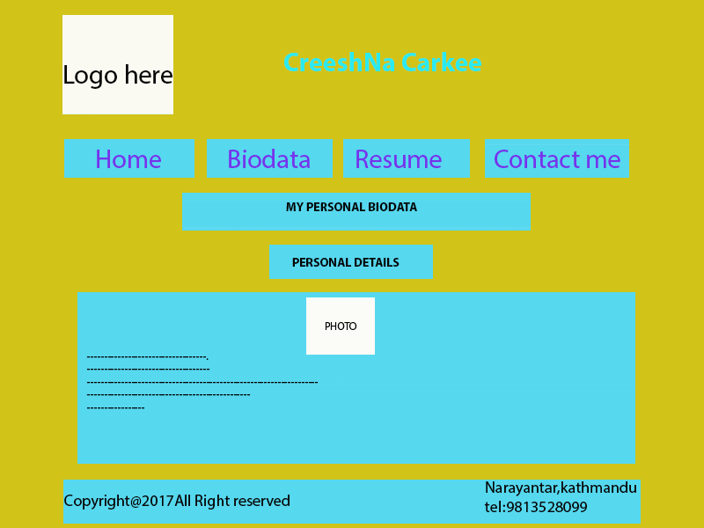

**Wireframe of Contact page**

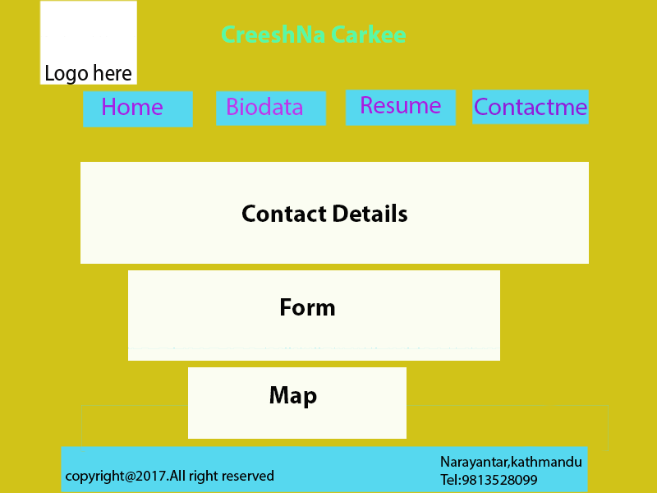

**Sketch**

**Homepage:** I made my homepage to be extremely straightforward and simple to help the client explore over the entire site. I had added footer at the base of each page .The menu bar will be a light blue colour in background and when on hover it will change to purple. Also my header will be zoom in when on hover. There is my Personal logo on top left corner of each page.

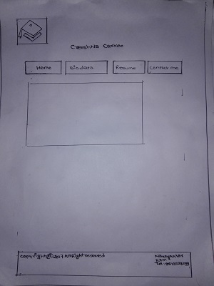

**Bio page:** In this page I had included my personal Photo in a circular shapes so that visitor can easily see my picture.

I had also included my own biodata. These bio data is inside a div of colour light green.

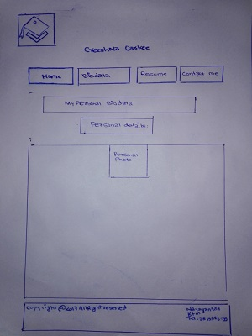

**Resume:** In this page I created sidebar and main bar. Sidebar contained description about my education career and main bar contained Images of my certificates which zoom in when on hover.

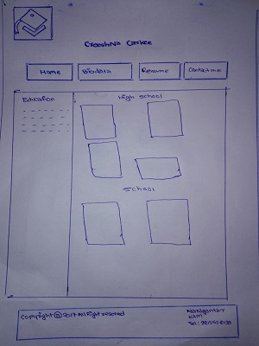

**Contact:** In this page I added about my contact detail, support form and map. Altogether there are 3 different box. I used gradient colour in contact detail box. I used background image for Form.

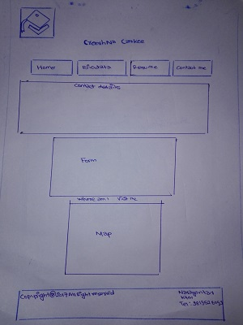

**Images**

 C:\Users\Acer\Desktop\CSY1018\csy1018a1\images\favicon.jpg

These are the Image created by me using Photoshop. Both the Image are same but different in size as they are used as logo and favicon icon. It can be clearly displayed on tab, pc and mobile. I had used simple logo as well as favicon icon so that everyone understand the meaning of this image. It’s very simple, here is square box and Academic cap which represent the Resume and other stuff.

**Good Practice**

**Evidence**

I passed my document to the w3school validator where I checked for my CSS and html. I passed every CSS into W3schhol validator and I corrected my error and conclude with no error.

I also passed my html file into it and fixes the bug in it. I checked my error in the following website.

<https://jigsaw.w3.org/css-validator/validator>

<https://validator.w3.org>

**Load speed**

Each users who knows the web will realize that the most imperative things is speed. Ensuring that a site can stack as quick as it can is one of the best models of good practice that can be executed into website architecture. I have tried my site on Pingdom.com and the outcomes are beneath. As should be obvious my site stacked in 385ms, which is quicker than 98% of different sites tried utilizing this administration. In spite of the fact that with more decrease in the size of pictures and so forth this figure could rebelliously be enhanced and my site could be made faster.

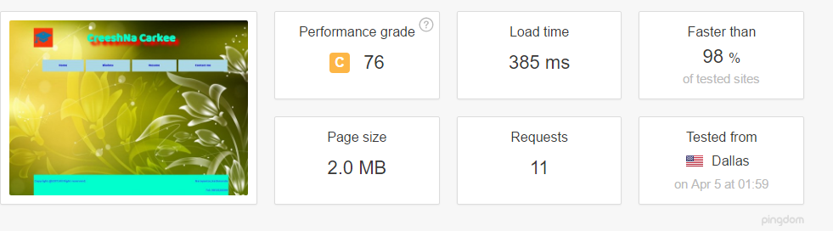

**Visual:**