**SEO Optimization Report(Infosys):** **https://www.infosys.com/**

The following parameters consist of the analysis of Infosys website from the SEO point of view. The SEO tool used was (SEOptimer.com and Moz.com). Here are some analysis and recommendations that are to be done so that the website does well from the SEO point of view.

**1)Exceutive Summary:** The most important findings of the SEO analysis which have been found are as follows:

A)The website does well from the SEO point of view, both on page and off page SEO but not 100% efficient and cannot be! There is room for improvement and it always will be.

**2)Technical SEO:**

A)*Site speed*: The site speed denotes the time taken by a website to load fully or display its content. Talking about Infosys website, its not doing well from the mobile point of view or desktop. It surely needs improvement.

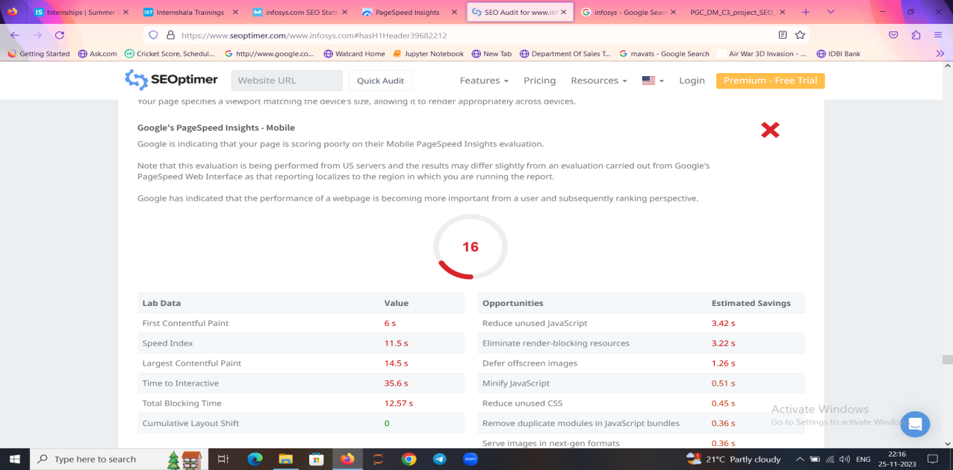

From Desktop point of view:

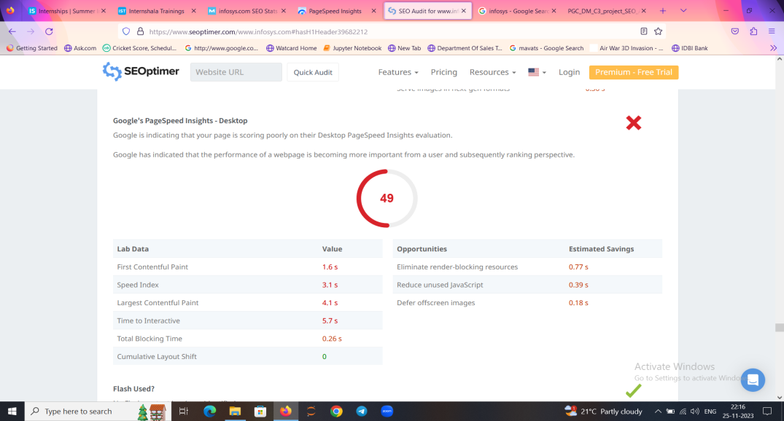

The score is 77 which needs improvement, more than 90 means good while less than 30 means the website is poor. To improve ,they need to reduce the loading speed by using less javascript ,using relevant keywords to increase rank in SERP(Search Engine Ranking Page).

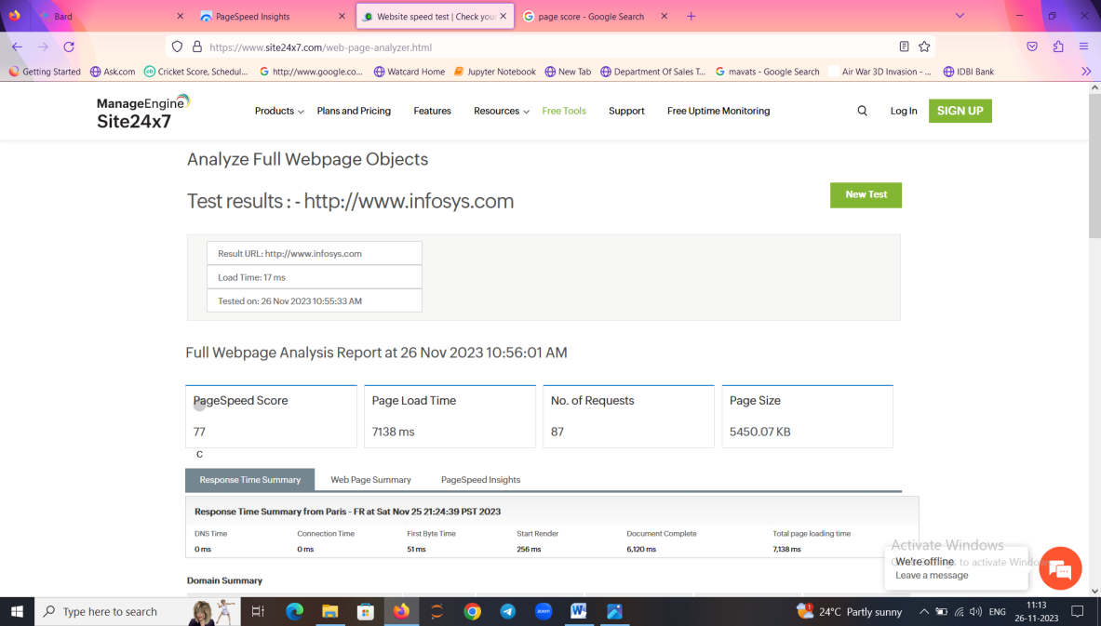

**B)Key word Research:**

Keyword research is the process of identifying and analyzing the search terms that people use to find information online. It is an important part of on page SEO.

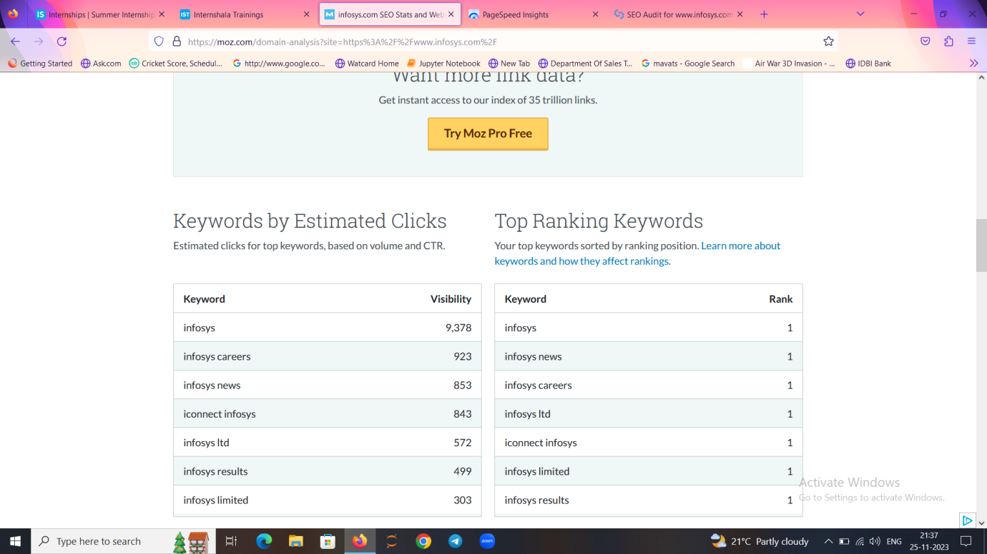

**Room for Improvement**: Overall, as the SEOptimer website analyses the results, the keywords are scattered . To rank higher in the google search page the keywords should be focused and also revolve around title, meta tag and header tag. H1 tag should only be used once as it has been recommended to rank the page higher.

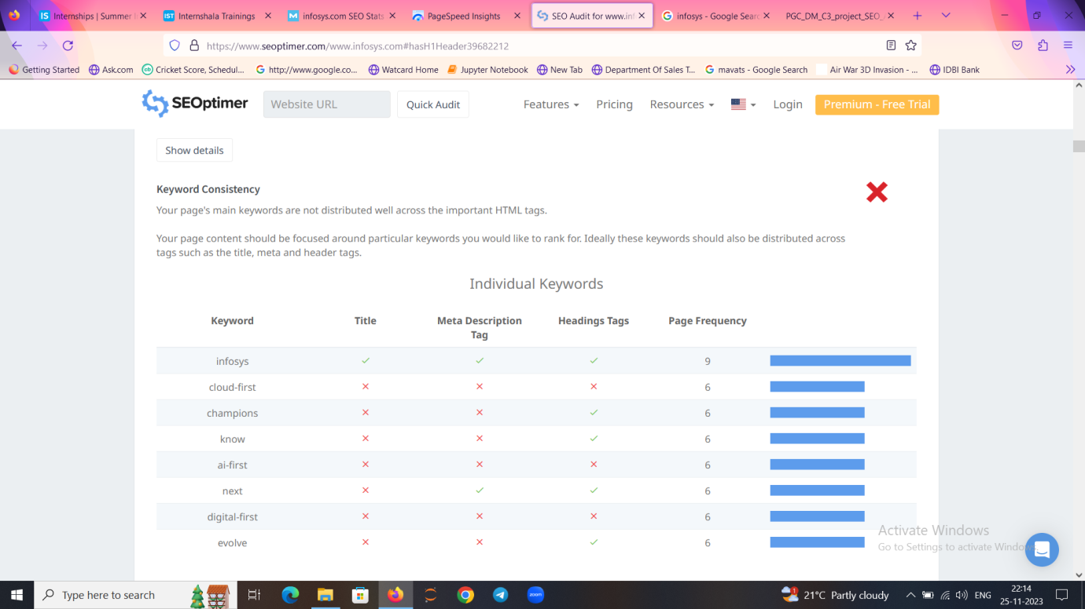

**C)Title tag and Meta description:**

They both play a crucial role in the On-page SEO, while it is recommended that title tag should be 55-60 characters in length and meta description should be 155-160 characters in length.

Considering Infosys website, it follows both criteria. Following is the analysis of the same.

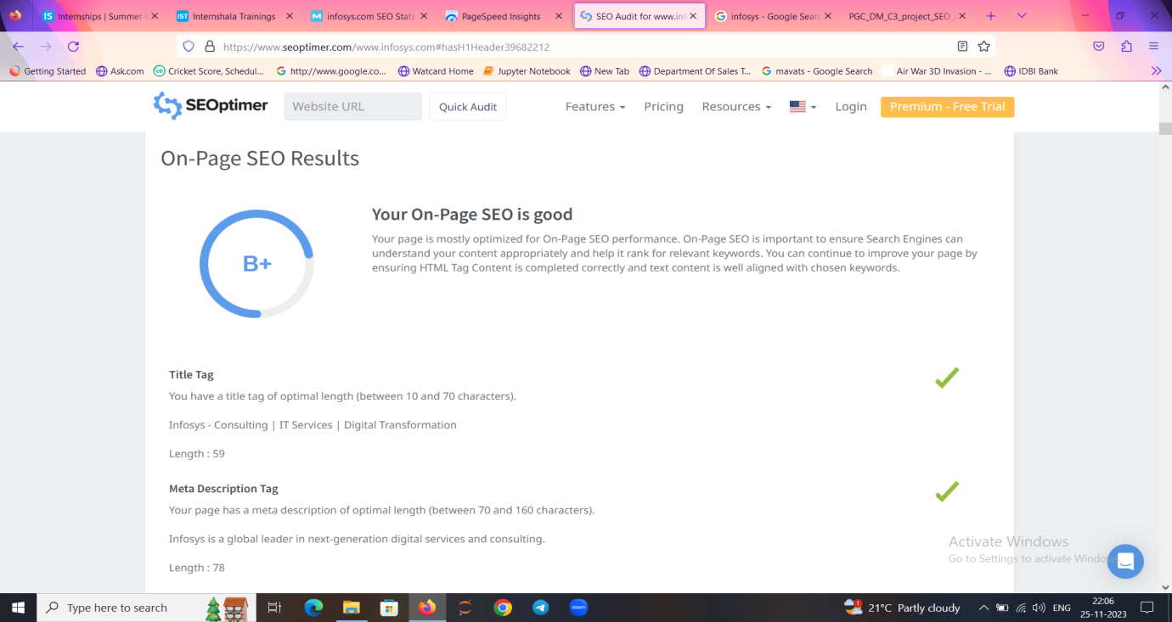

**Image Optimization AND Amount of Content:**

Image optimization is the process of compressing and resizing images to reduce their file size without sacrificing their quality. This is also an important practice in on-page SEO practice.

The amount of content should be at least 500 words but here it is missing which needs to be resolved. According to a good SEO practice, the content should be more than 500 words.

Considering the case of the Infosys website, the analysis is that out of 69 images, 9 of them are missing alt tags. To improve upon, they should always try to include alt tags in the images they want to post which is recommended.

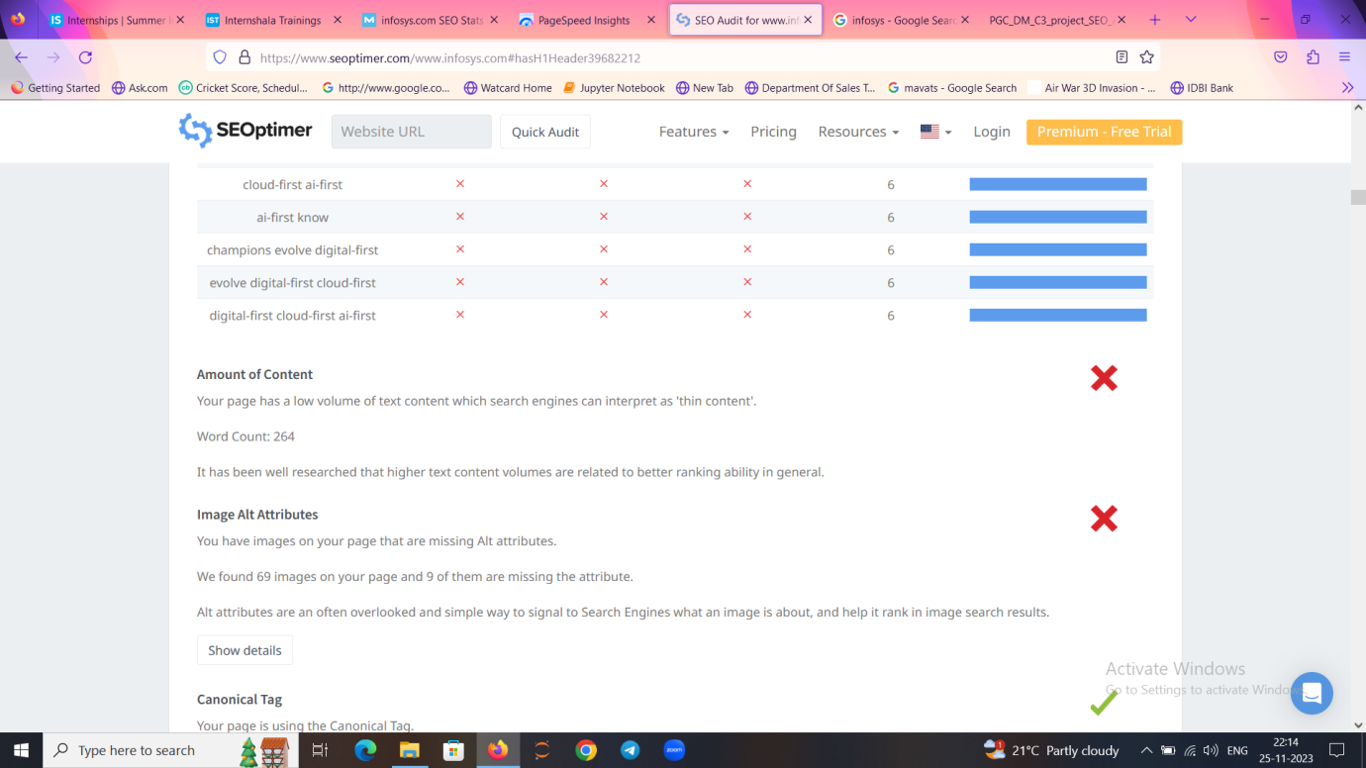

**OFF PAGE SEO:**

The off page SEO is defined as the type of SEO which is applied outside of the parent website. It includes no of backlinks, PA score(Page Authority), DA score(Domain Authority), Social media engagements,etc.

**1)No of Backlinks and Spam score:**

Backlinks are the links from other websites which are generally considered as good to increase their rank and authoritativeness.

Spam score is a measure of how likely your website is going to be considered as spam.

Moz analysis states that the infosys website has good DA score and less spam score.

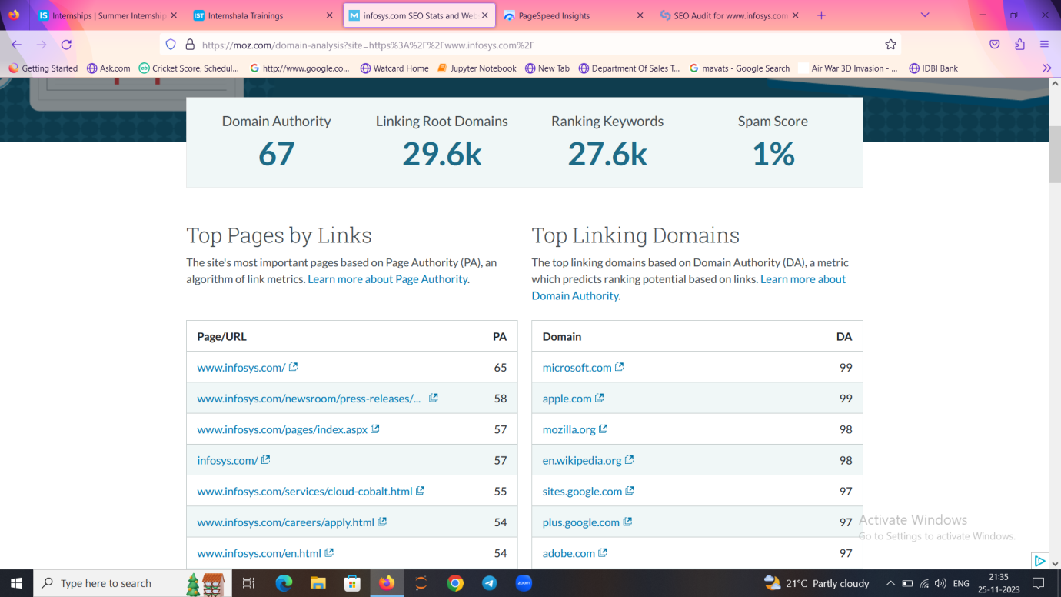

According to SEOptimer website:

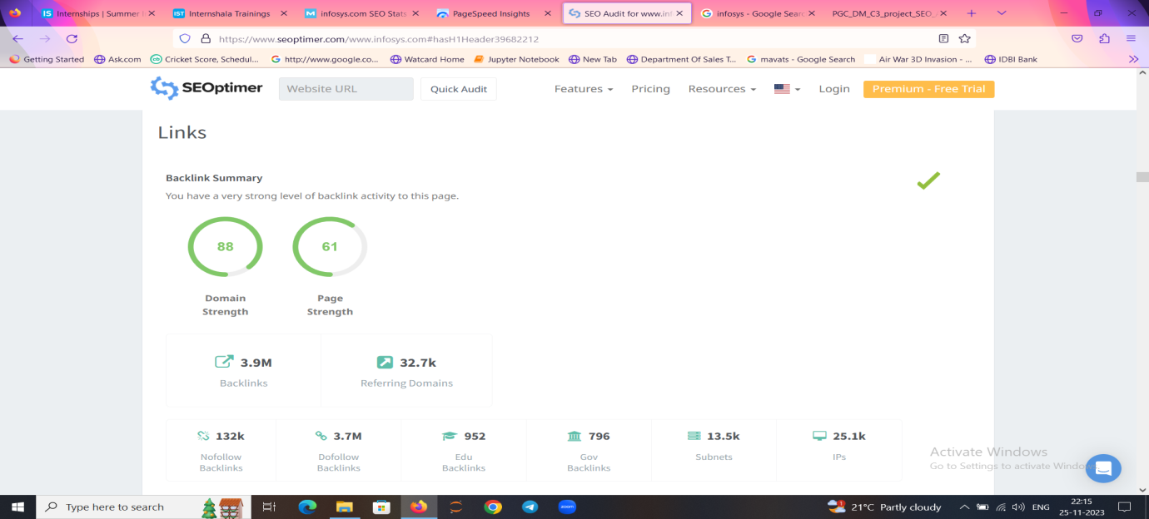

**Recommendations:**

1)Infosys needs to work on its page rank, it takes time to load both on mobile and desktop.

2)It needs to use alt tags for images for smooth functioning.

3)It should avoid using H1 tag multiple times as H1 tag is recommended to be used only once.

**Conclusion**:

The website should focus on using only H1 tag once to be in a better position compared to its competitors, while if we compare the page speed insights the website is not performing well both on mobile and desktop wise. Too many java script codes have been used which causes it to take more time for loading.