Show tech analyzer tool is a script written in Python language to extract information from the “show tech” file we receive from the customer. This only purpose of this tool is to make data collection easier from the logs that we receive from the customer.

Disclaimer: This is totally an amateur project. Please don’t rely ONLY on this tool to make any judgement/decision.

This user guide is brief description of the functions that are included with this tool.

File name – Analyze.py

At the time of writing this document, these are the functions that are added into the tool:

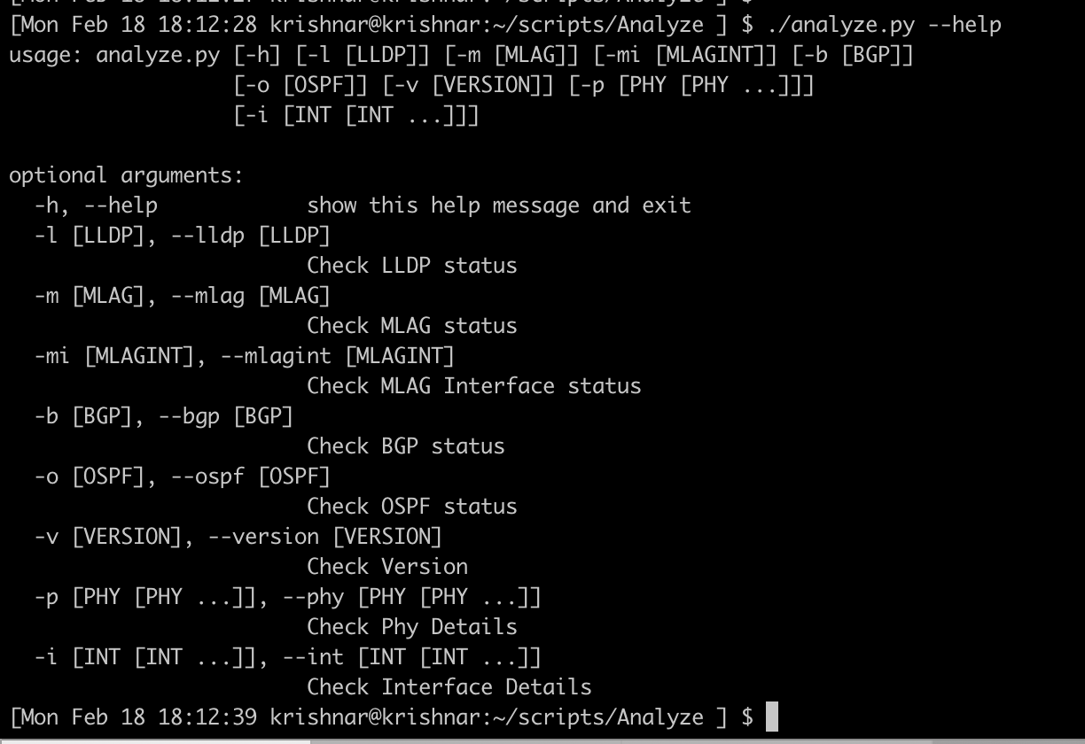

I am planning to add more modules into the program over the time.

To make using this tool easier, I have an alias variable set like this:

[Mon Feb 18 18:14:23 krishnar@krishnar:~/scripts/Analyze ] $ alias a

alias a='/Users/krishnar/scripts/Analyze/analyze.py'

**Python Packages needed for this tool:** This tool mostly works using the built-in Python packages, however we use ArgParse and Tabulate packages for managing user input and output respectively. Please install these two packages using a package manager such as PIP. If you have any conflicting version of these packages in your system already, we go ahead install the new packages in a VirtualEnv.

Syntaxt of this tool: codefilename.py <operation> <optional position argument> <inputfilename>

**Example:**

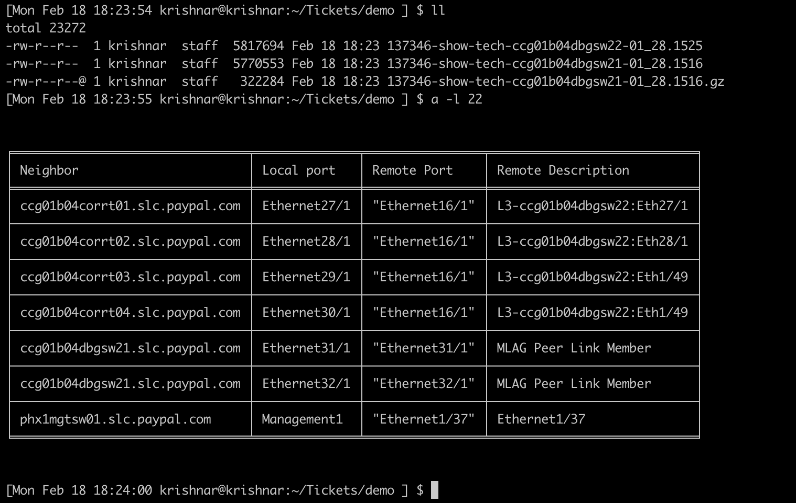

In the above diagram, I have done a LLDP check against a file name ‘22’. As you can see there is no file called 22 in the folder. However, the script is written in a such a way to find the best match using the keyword that you specify. The script will ignore any .gz files. This save sometime for engineers, as they don’t have to type the file name.

What if there are more than one match? The script will stop and will give you list of multiple matching files.

Question: Can I directly give the file name, instead of all these tricks? Will it work?

Answer: Yes, you can.

A few more examples:

**BGP**

This function will give BGP neighbor details classified per VRF.

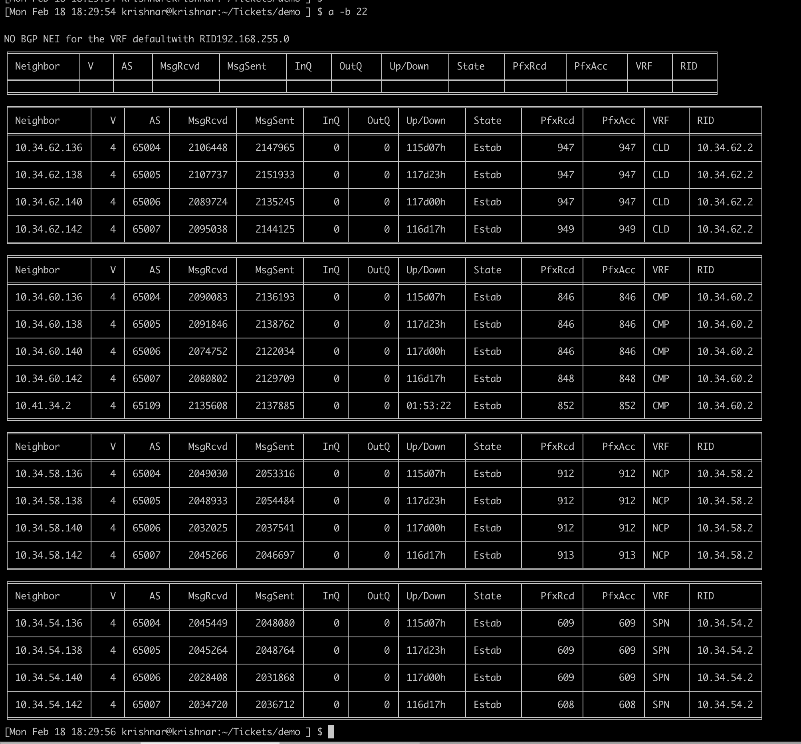

**MLAG:**

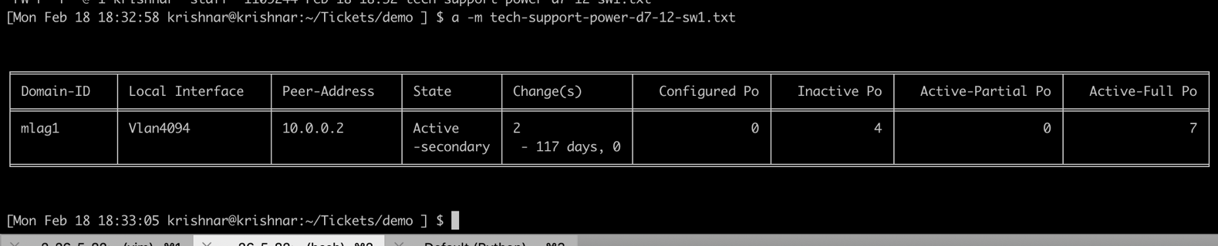

**MLAG Interfaces:**

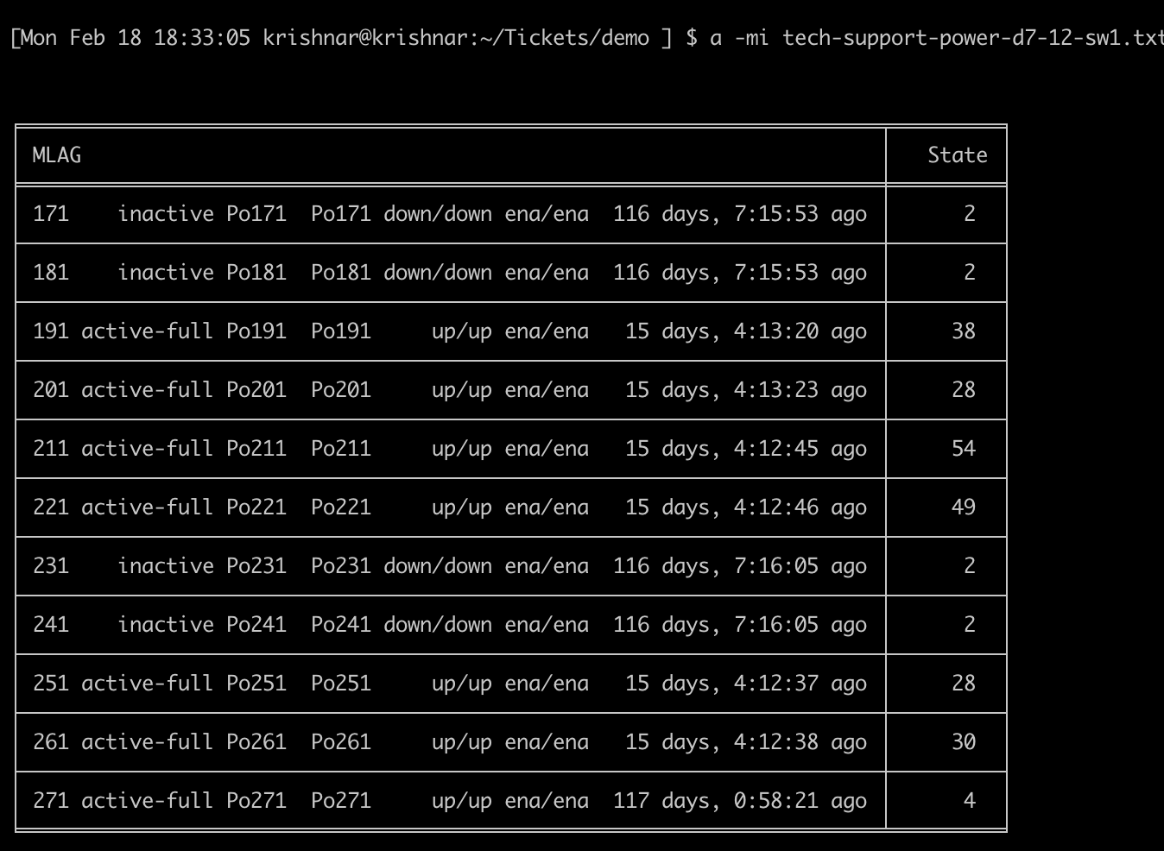

**OSPF:**

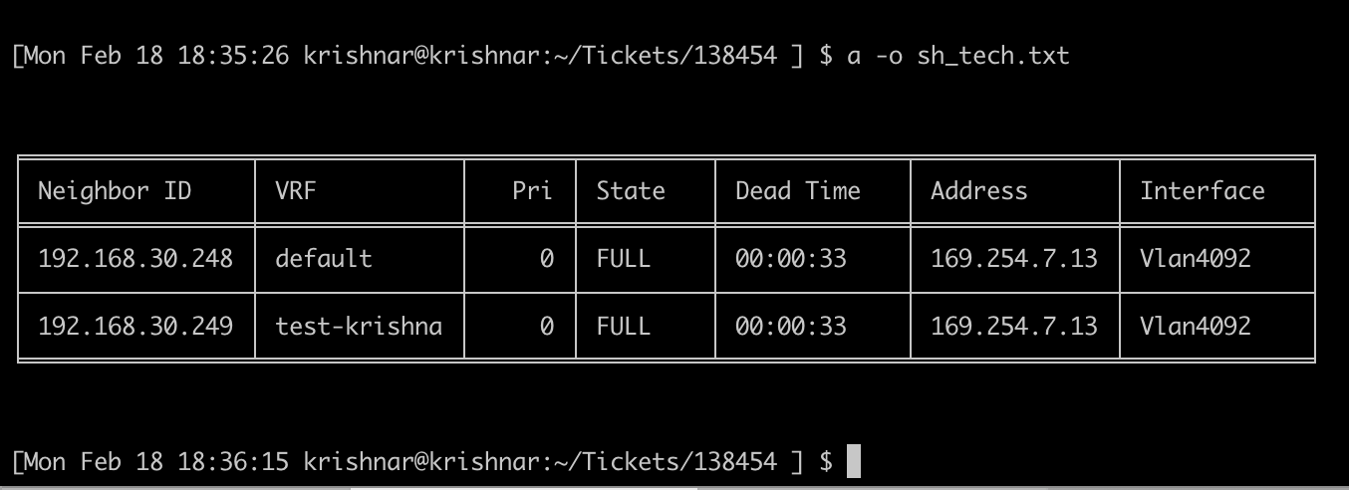

**Show Version:**

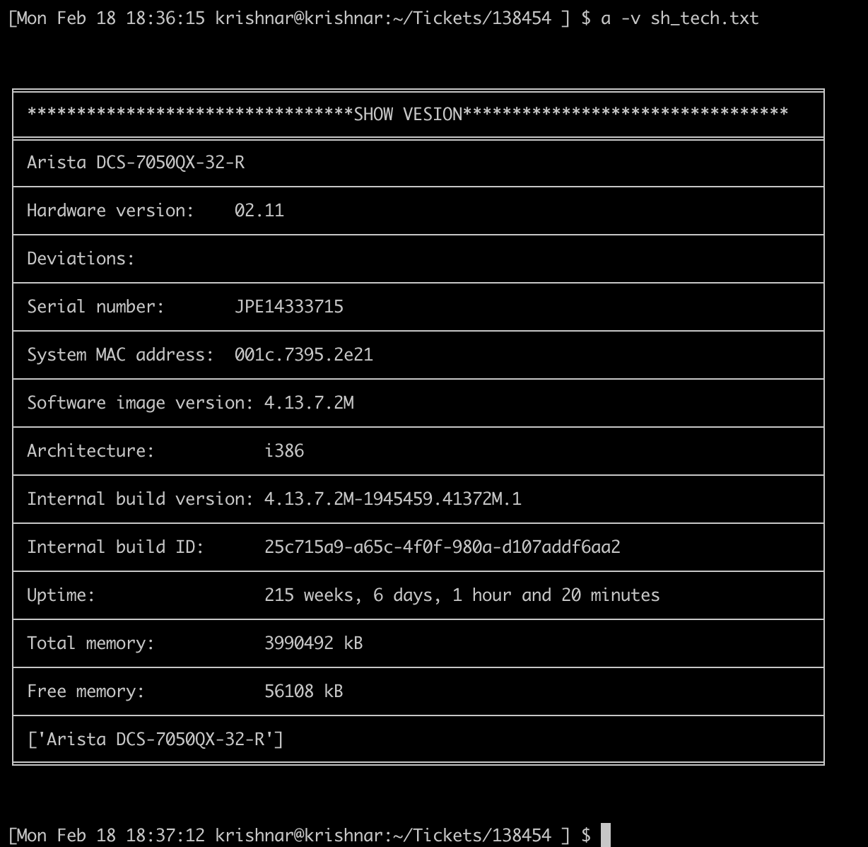

**Interface PHY details:**

Please specify an interface name when running this command. The script will autocomplete eth1 to Ethernet1 / eth2/1 to Ethernet2/1.

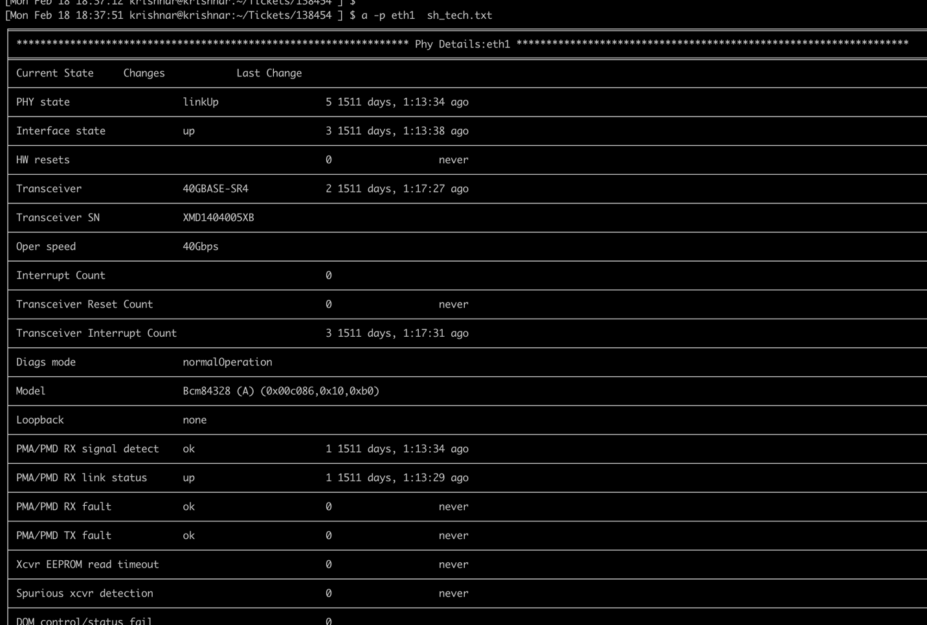

**Interface Details:**

Please specify an interface name when running this command. The script will autocomplete eth1 to Ethernet1 / eth2/1 to Ethernet2/1.

