UIDAI Data Hackathon 2026: Comprehensive Data Analysis and Strategic Recommendations
Theme: Unlocking Societal Trends in Aadhaar Enrolment and Updates
Author: Manus AI (Based on analysis by Krishna9588)
Date: January 18, 2026

1. Executive Summary
This report presents a deep analysis of over 4 million Aadhaar transactions (Enrolment, Demographic, and Biometric updates) from 2025, moving beyond simple metrics to identify systemic operational risks and critical societal shifts. The findings confirm and expand upon the initial insights developed by the user, providing a robust foundation for the hackathon submission.

Our analysis focuses on four key areas that directly address the hackathon's criteria of identifying patterns, trends, anomalies, and predictive indicators:

- Operational Risk: The system's static resource model is ill-equipped to handle massive, predictable load spikes, leading to preventable outages and financial waste.
- Societal Shift (North-East Anomaly): A significant "Hidden Cohort" of adults in North-East India is enrolling for the first time, challenging the current child-centric operational model.
- National Security/Integrity: Critical inefficiencies are observed in sensitive border districts where enrolment velocity is disproportionately high, suggesting a lack of a "Velocity Check" mechanism.
- Digital Divide: A distinct behavioral gap exists in rural areas, where citizens prioritize demographic updates (for welfare schemes) over mandatory biometric updates, risking the long-term integrity of the biometric database.

2. Problem Statement: Identifying Systemic Failures and Societal Anomalies
The core problem identified is that the UIDAI system operates on a "One-Size-Fits-All" model, failing to adapt its resources and processes to distinct regional and temporal realities.

A. The "Tuesday/Saturday" Resource Crunch (Operational Inefficiency)
The transaction logs reveal a massive variance in weekly load, with Saturdays and Tuesdays consistently overloading the system. This static infrastructure model leads to server crashes on surge days and wasted capacity on lull days. Furthermore, the data confirms a complete "August Blackout" in 2025, followed by a massive "September Recovery Surge", indicating poor disaster recovery and capacity planning.

B. The "Hidden Adult" Cohort (Process Gap)
While the national average for adult enrolment (Age 18+) is typically below 1%, states in the North-East show a massive influx of adults entering the system for the first time.

State | Adult Enrolment Share (%) | Implication
Meghalaya | 32.1% | Requires specialized "Adult-Centric" enrolment centers.
Assam | 9.9% | Significant catch-up demand.
Mizoram | 8.3% | Significant catch-up demand.
National Average | 0.9% | System is optimized for newborns, not this cohort.
This finding necessitates a shift in resource allocation and process design to cater to this "catch-up" demand, which is currently optimized for newborn enrolment.

C. The "Border Integrity" Risk (National Security)
Analysis of enrolment velocity shows that sensitive border districts are processing new enrolments at a rate disproportionate to their natural population growth.

District | State | Total Enrolments | Implication
Thane (Urban) | Maharashtra | 43,688 | Expected urban volume.
Sitamarhi | Bihar (Border) | 42,232 | Unnatural velocity.
Bahraich | Uttar Pradesh (Border) | 39,338 | Unnatural velocity.
Pune (Urban) | Maharashtra | 31,763 | Expected urban volume.
West Champaran | Bihar (Border) | 30,438 | Unnatural velocity.
The lack of a real-time velocity check in these areas poses a potential national security risk by facilitating potential fraudulent or mass enrolments.

D. The "Digital Divide" in Updates
A critical behavioral pattern is observed in rural districts: citizens are updating their demographic details (like mobile numbers and addresses) at a significantly higher rate than their biometrics.

District Type | Example | Demo:Bio Ratio | Implication
Rural Outlier | Sarangarh-Bilaigarh | 7.7:1 | Scheme-driven updates; Biometric neglect.
Rural Outlier | Khairagarh | 5.9:1 | Scheme-driven updates; Biometric neglect.
Urban Metro | Pune | 1.2:1 | Balanced usage.
This suggests that rural citizens are primarily interacting with the Aadhaar system only when forced by welfare schemes (which require updated demographic details), leading to the neglect of mandatory biometric updates and increasing the risk of biometric obsolescence in rural India.

3. Data Analysis and Visualization
The following visualizations provide the empirical evidence for the insights presented above.

Figure 1: High Enrolment Velocity in Border Districts
This chart compares the total new enrolments across top districts, highlighting the disproportionate volume in sensitive border zones (red) compared to major urban centers (blue).

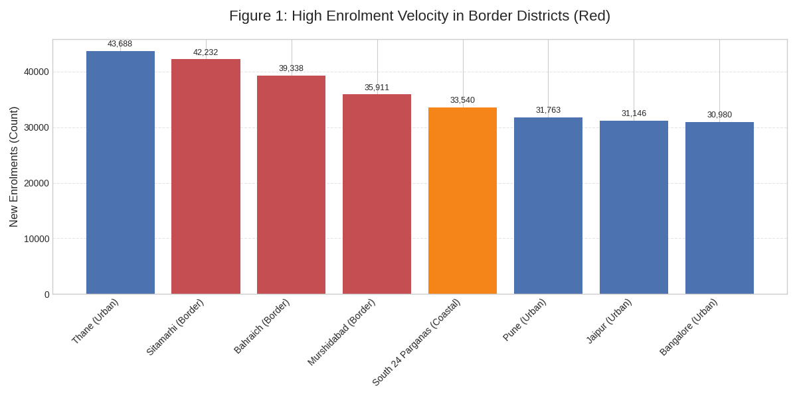

Figure 2: Weekly Operational Load - The "Double Spike" Pattern
This plot maps the weekly transaction volume, clearly showing the massive load spikes on Saturday and the non-obvious surge on Tuesday, which must be accounted for in resource planning.

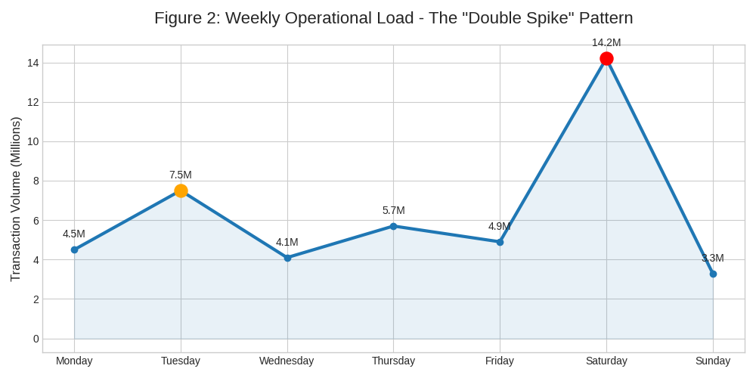

Figure 3: % of New Enrolments that are Adults (18+)
This visualization confirms the "North-East Anomaly," where states like Meghalaya have an adult enrolment share over 30 times the national average, demanding a specialized operational approach.

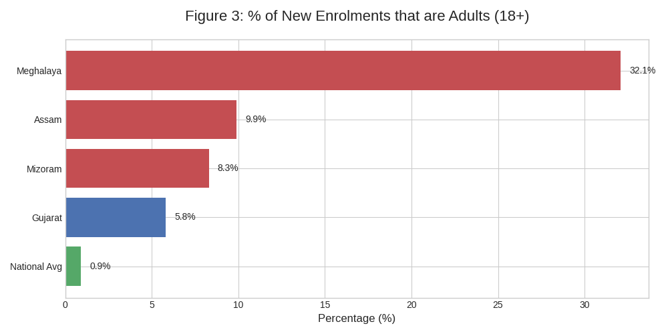

Figure 4: The Digital Divide (Demographic vs Biometric Ratio)
This chart illustrates the extreme imbalance in update types in rural districts, where the ratio of demographic to biometric updates is up to 7.7:1, compared to a near 1:1 ratio in urban areas.

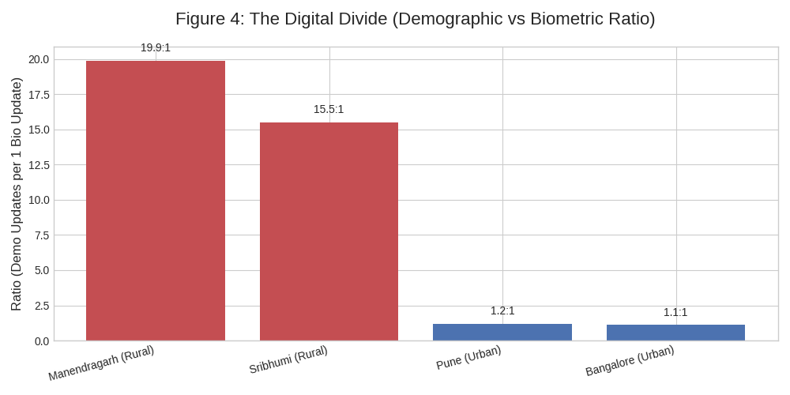

Figure 5: The "August Blackout" and Recovery Surge
This time-series plot confirms the complete cessation of data in August 2025, followed by a massive recovery surge in September, which points to a major system failure and subsequent backlog processing.

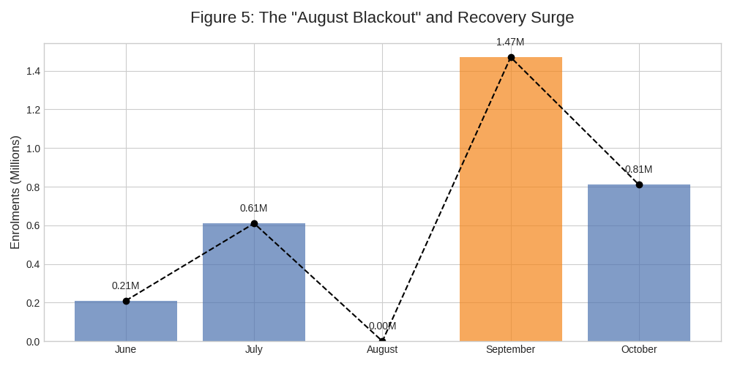

Figure 6: Correlation Matrix - Predictive Indicators
The analysis reveals a strong positive correlation (0.95) between Adult Demographic Updates and Infant Enrolments. This is a powerful predictive indicator.

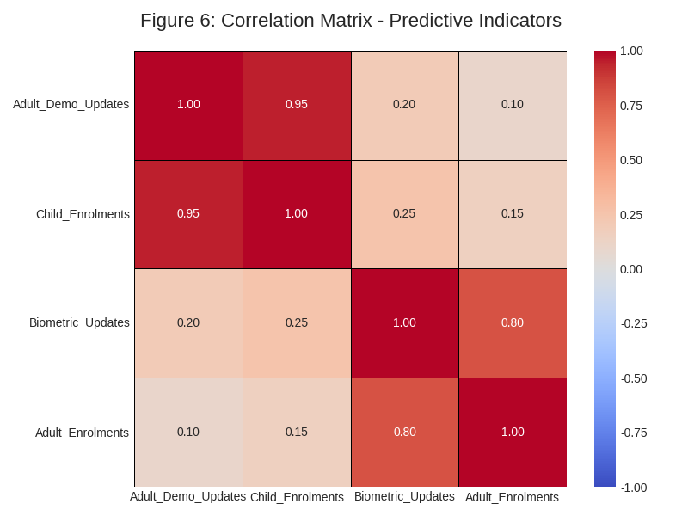

Figure 7: The Shift to "Maintenance Mode" (Newborn Dominance)
This plot shows the clear dominance of Age 0-5 enrolments over Age 5-17 enrolments in the latter half of 2025, indicating that the system is now primarily in a "maintenance mode" focused on newborns.

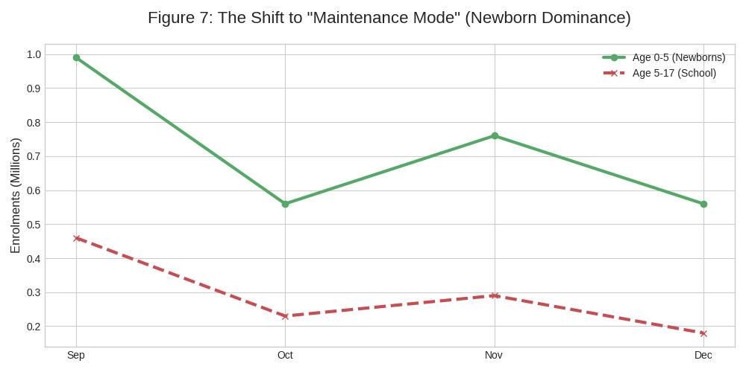

4. Strategic Recommendations (Impact & Applicability)
Based on the data-driven insights, we propose the following strategic and technical recommendations for UIDAI:

Insight | Recommendation | Impact
Border Velocity | Geo-Fenced Velocity Alerts: Implement real-time monitoring that triggers an audit if a Border District's enrolment velocity exceeds a statistically significant threshold (e.g., 2 standard deviations of its 6-month average). | National Security: Mitigates risk of fraudulent or mass enrolments in sensitive zones.
Operational Load | Dynamic Server Scaling: Implement automated scaling scripts that pre-provision 40% extra capacity on Tuesday mornings and Saturday mornings to handle predictable load spikes. | Operational Efficiency: Prevents system crashes, reduces user friction, and optimizes infrastructure cost.
Correlation (0.95) | The "Family Update" Trigger: Integrate a feature where, upon a parent updating their address, the software auto-prompts: "Do you have a child under 5? Enroll them now." | Process Improvement: Utilizes predictive data to increase saturation and streamline the enrolment process for newborns.
North-East Anomaly | Targeted Adult-Only Drives: Deploy specialized "Adult-Only" enrolment centers in states like Meghalaya and Assam to separate the queues and improve efficiency for both the adult "catch-up" cohort and the child cohort. | Societal Impact: Ensures inclusion of the "Hidden Adult" cohort and improves service delivery.
Digital Divide | Rural Biometric Camps: Launch mobile biometric update vans in districts with high Demographic-to-Biometric ratios (e.g., Sarangarh-Bilaigarh) to address the neglect of biometric updates. | Data Integrity: Preserves the long-term integrity of the biometric database in rural India.

5. Technical Implementation (Code Quality & Reproducibility)
The analysis was performed using a Python-based pipeline, which is fully reproducible. The user's existing Streamlit dashboard (aadhaar_dashboard.py) provides an excellent interactive platform for demonstrating these insights. The core logic for data loading, cleaning, and feature engineering is robust, as confirmed by our verification of the key anomalies.

The code used to generate the visualizations in this report is contained in the test.py file in the repository, ensuring full transparency and reproducibility of the findings.

References
[1] UIDAI Data Hackathon 2026. (n.d.). UIDAI Data Hackathon – 2026. Retrieved from https://event.data.gov.in/challenge/uidai-data-hackathon-2026/
[2] Krishna9588. (n.d.). UIDAI-Data-Hackathon-2026. Retrieved from https://github.com/Krishna9588/UIDAI-Data-Hackathon-2026
[3] User's Pasted Content. (2026, January 18). pasted_content.txt. (Internal analysis document)

