MARS
Migration and Remediation System
Unified migration and security remediation harness
Project overview, architecture, end-to-end flow and verified results
Item | Detail
Repository | github.com/KrishnaAnnavaram/MARS
Version | Harness 1.0.0 · policy 2026.09.1
Date | 25 September 2026
Evidence run | RUN-01M3CR9RP2HEW5A7P5MEJCWVGG
Platform tested | JDK 21.0.11 · Maven 3.8.7 · Windows 11

Contents
1. Executive summary 3
Results at a glance 3
2. Why MARS exists 4
The five non-negotiable rules 4
3. What was unified 5
4. Architecture 6
5. End-to-end flow 7
6. Human decision gates 8
Choosing a strategy 8
7. The migration capability 9
Migration Advisor — should we migrate? 9
Reference-Pack Engine — how we migrate 9
8. The security capability 11
Intake and discovery 11
Routing 11
Verification of every applied fix 11
9. Identity, mutation, validation and evidence 12
Persistent identity 12
The single Mutation Gateway 12
Validation and verdict 12
Evidence and audit 12
10. Results — complete run on the real toolchain 13
10.1 Assessment 13
10.2 Human decisions recorded 13
10.3 Migration rounds 13
10.4 Security plans 14
10.5 Verification of applied fixes 14
10.6 Validation dimensions 14
10.7 Verdict 15
11. Results — real migration of the employee service 16
12. Test evidence 17
Defects found by the tests and fixed 17
13. Limitations 19
14. How to run MARS 20
Where results are stored 20

1. Executive summary
MARS is a developer harness that upgrades Java/Spring applications and fixes their security vulnerabilities in one audited run. It merges three existing systems into one engine:
- Bootshift: a migration engine
- the Vulnerability Remediation Harness (VRH)
- a Spring Boot 3 → 4 migration workflow
Together they get one identity model, one change ledger, one approval process and one final verdict.
Core rule: nothing changes the code unless a human approved it, and every claim the harness makes is backed by recorded evidence.

Results at a glance
Question | Answer
Does the whole system build? | Yes. mvn install: BUILD SUCCESS
Is existing behaviour preserved? | Bootshift's own suite: 190 run, 0 failures, 3 skipped (environmental), identical to the pre-change baseline. All 1,076 legacy files are byte-identical to the originals.
Do the harness test suites pass? | Yes. 175 run, 0 failures, 0 errors (unit, architecture, contract, schema, parity, integration, end-to-end)
Does it work on the real toolchain? | Yes. Real Maven and real running applications: 2 acceptance runs, 0 failures.
Real migration result | Employee service Spring Boot 3.5.0 → 4.1.1: GREEN in 8 compiler rounds. Behaviour matches the recorded reference run (9 probes, 5 explained differences).
Complete demo run (this document) | RUN-01M3CR9RP2HEW5A7P5MEJCWVGG: migration GREEN; 2 security fixes Cleared; all ledgers and decisions verified intact; verdict NEEDS_HUMAN.

2. Why MARS exists
Teams modernizing Java services face two jobs that are usually done separately, and that interfere with each other:
Problem | What goes wrong when the jobs are separate
Platform migration (e.g. Spring Boot 3.5 → 4.1) | Security fixes written against the old platform break or get lost during the upgrade.
Vulnerability remediation | Some fixes are impossible on the old platform: the fixed library version requires the new one. Those fixes silently stall.
Audit and trust | Tools change code without a traceable reason. Approvals live in editable documents. "Tests passed" hides that some checks never ran.

MARS answers three questions in one run, with evidence:
- Should we migrate, and how urgently? A grounded GREEN / YELLOW / RED / UNKNOWN recommendation.
- Which vulnerabilities can be fixed now, and which need the migration first? Explicit sequencing, including BLOCKED_BY_PLATFORM.
- What exactly changed, why, who approved it, and did it really work? A verifiable evidence package and verdict.

The five non-negotiable rules
# | Rule | How it is enforced
1 | No agent directly mutates tracked source. | Every change is a ChangeProposal applied by one Mutation Gateway. Architecture tests fail the build otherwise, and a runtime detector flags direct writes.
2 | No AI or tool self-authorizes a change. | Approvals are human decisions bound to the exact proposal hash. Machine identities (llm, agent, copilot, harness…) are refused.
3 | A RED recommendation never starts a migration by itself. | The run stops at Human Gate A until a person chooses a strategy.
4 | Unknown evidence stays unknown. | Missing data is recorded as UNKNOWN / NOT_RUN / INSUFFICIENT_EVIDENCE and never counted as a pass.
5 | Protected business logic is not rewritten for elegance. | The three source systems are kept byte-for-byte. Bootshift runs unchanged, and ported rules are checked by parity tests.

3. What was unified
Source system | Contribution | How MARS uses it
Bootshift (Java) | Persistent file identity, immutable snapshot, isolated workspace, hash-chained change ledger, file mutation gateway, inventory, build model, application graph, lifecycle facts | Called unchanged. Built in the same Maven reactor as the kernel base; its 190 tests still run on every build.
Vulnerability Remediation Harness | Excel issue register; CWE routing catalog → knowledge base → research; fix strategies; re-scan, red-team and QA gates; merge-arbiter scoring | Ported to Java rule-for-rule. Knowledge files read in place, unchanged. Parity tests compare with the original JavaScript.
Spring migration reference | Spring Boot 3 → 4 reference pack, a round-based compiler-driven workflow, behaviour probes, a recorded real migration | Ported as a deterministic engine. Rules pinned to the pack's SHA-256; the recorded run is the parity baseline.

4. Architecture
MARS follows a Shared Kernel + Capability Packs architecture:
- The kernel owns the infrastructure: identity, graph, evidence, decisions, mutation, validation and run state.
- Capability packs own domain knowledge (migration, security) and see only the kernel's contracts.
- The kernel never depends on a capability.
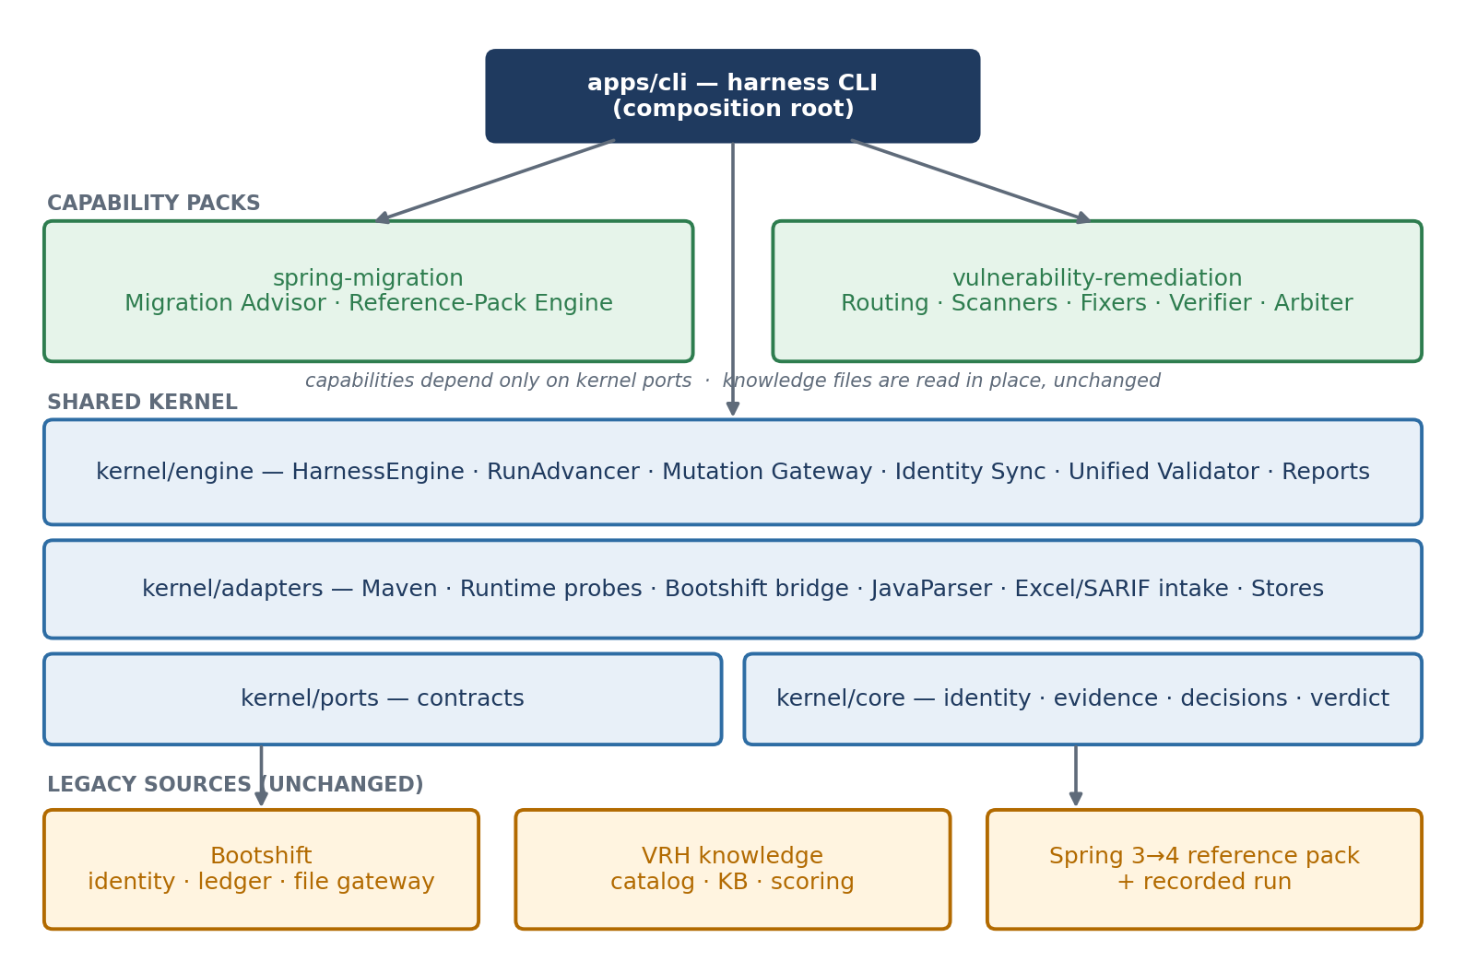
Figure 1 — Module architecture
Module | Responsibility
legacy-sources/bootshift | File identity, ledger, file writer, inventory, graph, lifecycle facts (unchanged)
kernel/core | Domain model: identities, evidence, findings, decisions, proposals, validation, verdict, run state
kernel/ports | Interfaces every tool and capability must satisfy
kernel/adapters | Maven, Java runtime probing, JavaParser, Excel/SARIF intake, stores, Bootshift bridge
kernel/engine | Orchestration: phases, gates, resumable state loop, Mutation Gateway, validation, reporting
capabilities/spring-migration | Migration Advisor and reference-pack round engine
capabilities/vulnerability-remediation | Routing, scanners, fixers, verification, arbiter
apps/cli | The harness command-line tool and wiring
tests | Unit, architecture, contract, schema, parity, integration, end-to-end, real-toolchain acceptance

5. End-to-end flow
A run moves through six stages: analysis → human decision → authorized execution → re-assessment → validation → verdict.
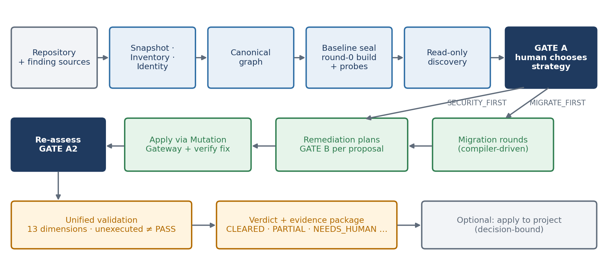
Figure 2 — End-to-end flow with human gates
Phase | What happens | Guarantee
0 Ingest | Bootshift snapshots the repository and creates an isolated workspace and checkpoint repository. | The repository is only read.
1 Inventory and identity | Every file gets a FILE_ID. Every module, type, member and statement gets a persistent ID. | Identity survives renames and edits.
2 Canonical graph | Bootshift's application graph plus an identity overlay. | One graph for both capabilities.
3 Baseline seal | Round 0: build, test, start the app and probe it, before any change. Everything is sealed with a hash. | No mutation before the seal.
4 Read-only discovery | Security findings, root cause and blast radius; migration assessment; sequencing recommendation. | Workspace hash checked unchanged.
Gate A | The developer chooses an execution strategy. | Nothing executes without it.
Execution | Migration rounds and/or remediation, each change a proposal through the gateway. | Single writer, authorized, reversible.
Gate A2 | Migration re-assessed after security work; the developer is asked again if still relevant. | Decisions made on current facts.
Validation and verdict | 13 validation dimensions, then a verdict with strict precedence. | An unexecuted check is never a pass.

6. Human decision gates
Every decision is a write-once JSON record. It is protected by an HMAC integrity hash and bound by hash to exactly what it decides about. It is refused if the actor is a machine identity.
Gate | When | Choices | Bound to
A — Execution strategy | After discovery | MIGRATE_FIRST, SECURITY_FIRST, MIGRATION_ONLY, SECURITY_ONLY, ANALYZE_ONLY, STOP | Combined-assessment hash + baseline seal
B — Remediation | Per proposal | APPROVED, REJECTED, DEFERRED | That proposal's SHA-256 + baseline seal
A2 — Post-security migration | After security work, if migration is not GREEN | PROCEED, SKIP, STOP | Refreshed assessment hash
Apply to project | After the verdict | APPROVED, REJECTED, DEFERRED | Current ledger head

- A missing decision is never approval: undecided proposals stay PENDING_APPROVAL, and the verdict says so.
- A proposal edited after approval loses the approval ("stale approval").
- A tampered decision file authorizes nothing.
- LLM-authored patches must carry model, prompt and response hashes, and always need a human approval.

Choosing a strategy
Strategy | Use when | What runs
MIGRATE_FIRST | Some fixes need the new platform (RED) | Migration, then remediation against the migrated code
SECURITY_FIRST | A critical vulnerability cannot wait | Independent fixes, then migration, then platform-blocked fixes re-planned once
MIGRATION_ONLY | Upgrade now, security later | Migration only; findings reported as deferred
SECURITY_ONLY | No upgrade this cycle | Remediation only; platform-blocked fixes reported; Gate A2 offered
ANALYZE_ONLY / STOP | Assessment only / abandon | No change at all

7. The migration capability

Migration Advisor — should we migrate?
The advisor gives separate answers rather than one blended score:
- traffic light (GREEN / YELLOW / RED / UNKNOWN)
- need
- priority
- complexity
- effort score (0–100)
- evidence confidence
RED comes from the developer's objectives, not from the calendar. Example: a vulnerable library whose only fixed version needs Spring Boot 4 turns the light RED even while Boot 3.5 is supported.
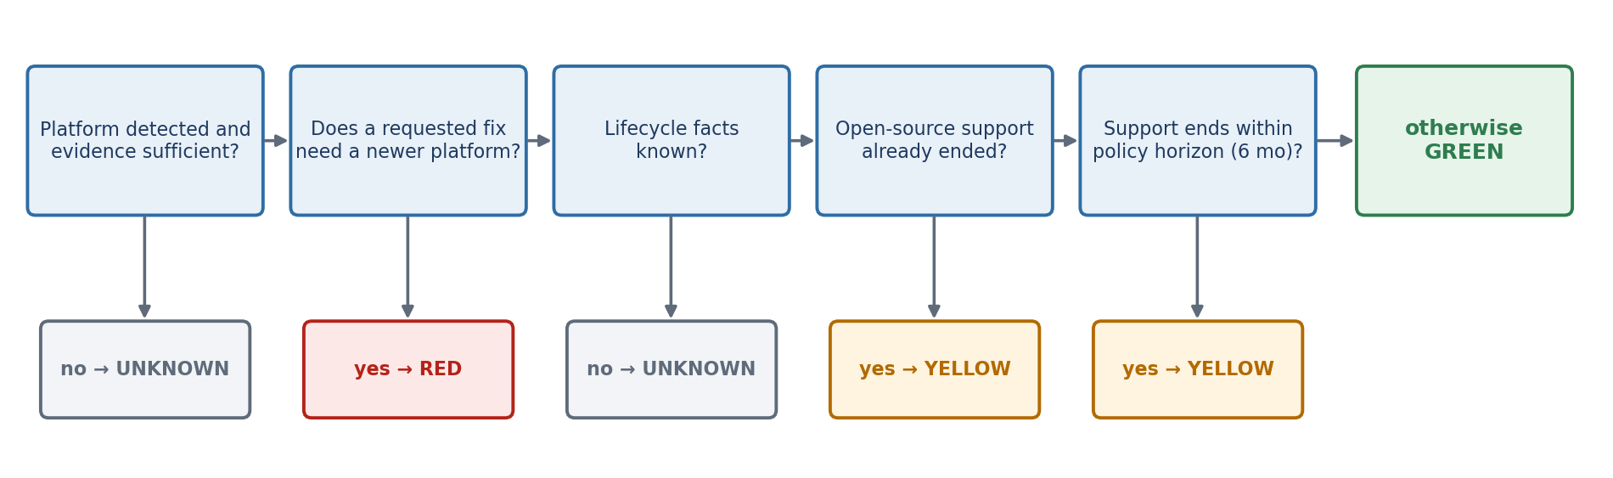
Figure 3 — Traffic-light rules, evaluated left to right
The effort score is an auditable, policy-weighted sum of ten factors (weights total 100). Every known factor cites evidence; an unknown factor is reported as unknown.
Factor | Weight
Mandatory migration issue count | 20
Removed / relocated API count | 14
Platform version distance | 12
Dependency incompatibility count | 12
Java version jump | 8
Configuration breakage count | 8
Module / service breadth | 8
Runtime test coverage gap | 8
Unknown internal components | 5
Ecosystem constraints | 5

Reference-Pack Engine — how we migrate
- Round 0 is the sealed baseline. Pre-existing failures are recorded, never fixed.
- The pack's build-file rules are applied up front: parent 4.1.1, Java 21, webmvc starter, springdoc 3.x, Docker JRE.
- Each round builds in a disposable copy. A source rule is applied only when a round fails with that rule's quoted symptom, and only to the files the errors name.
- An error no rule covers stops the run for a human ("never guess an import path"). An approved human patch lets the rounds resume.
- After a green package, the app is started and the same HTTP probes are replayed. Every difference must be one the pack documents.

8. The security capability

Intake and discovery
Source | Anchoring
VRH Excel issue register | Affected files, symbols and File.java:line references → statement identity
SARIF (any scanner) | Physical location → statement
Dependency advisories | Build file + coordinate; may carry a platform requirement
Built-in rule scanner (CWE-89, 943, 22, 502, 798, 532, 770) | Statement identity; corroborates imported findings

Routing
Route | When | Output
CATALOG | The CWE is in the VRH catalog | Canonical pattern; deterministic fix where available
KB | Catalog gap, KB entry exists | Hybrid-ranked strategy (e.g. HF-PATH-001) with provenance
RESEARCH | Catalog and KB gap, analysis supplied | Low confidence, ≥2 candidates, strategy only, no fabricated citations
EVIDENCE_GAP | No or insufficient research | Evidence-gap plan, never a confident fix
BLOCKED_BY_PLATFORM | The fixed version needs a newer platform and migration was not done | No proposal; reported truthfully
ALREADY_REMEDIATED | An earlier change (e.g. migration) already fixed it | Confirmed by re-scan

Verification of every applied fix
Gate | Checks
Build / QA | One VERIFY build in a disposable copy; new test failures vs baseline fail it
Re-scan | The finding's rule no longer fires at the same statement identity
Red team | Attack vectors replayed against the patched code
Behaviour guard | No symbol outside the proposal's declared scope changed
Merge arbiter | Score vs severity threshold plus hard gates → Cleared or Blocked (VRH scoring.json, unchanged)

9. Identity, mutation, validation and evidence

Persistent identity
Every file, module, class, method, field and statement gets an allocated ID. After each change the harness re-observes the code and reattaches each ID, trying these in order:
- provider mapping
- exact fingerprint
- structural similarity with an ambiguity margin
- context
- a new ID
Uncertain matches are marked; ambiguous ones are never guessed. When SecurityConfig.java was renamed to ApiKeyConfig.java in testing, every file, class, method and statement ID survived, and the finding stayed linked.

The single Mutation Gateway
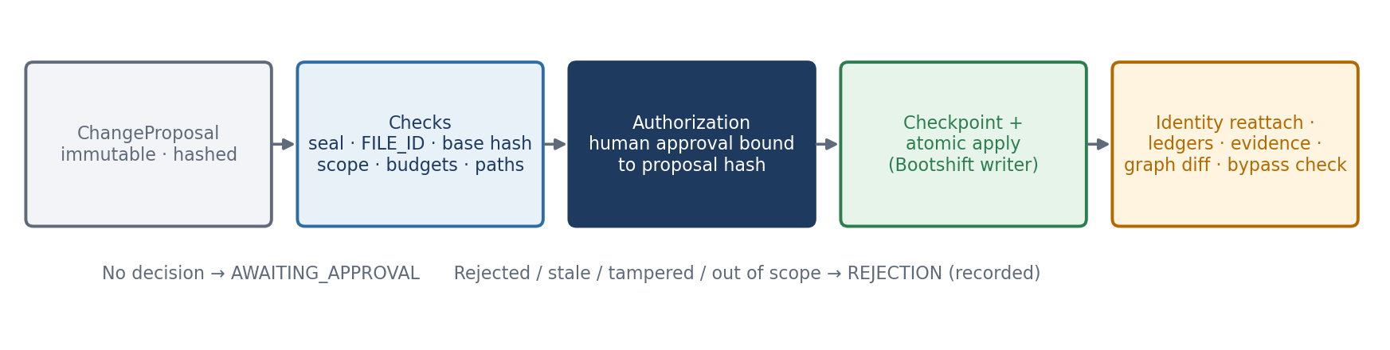
Figure 4 — The only path that writes source

Validation and verdict
Thirteen dimensions are validated. NOT_RUN, NOT_COMPARED, TOOL_UNAVAILABLE and INSUFFICIENT_EVIDENCE are never counted as a pass. The verdict follows a strict precedence:
Order | Outcome | When
1 | BLOCKED | Any hard failure: failed gate, still vulnerable, mutation bypass
2 | NEEDS_HUMAN | Any decision outstanding (a missing decision is not approval)
3 | INSUFFICIENT_EVIDENCE | A mandatory dimension has no evidence
4 | PARTIAL | Something unresolved: blocked by platform, deferred, rejected
5 | CLEARED | Everything resolved and every mandatory dimension passed

Evidence and audit
The evidence log, the change ledger and the lineage ledger are hash chains. Decisions carry HMAC integrity hashes. Proposals are immutable. The command harness verify recomputes all of them from disk. Every artifact follows the versioned JSON Schemas in schemas/v1.

10. Results — complete run on the real toolchain
What was run. The bundled composite fixture (fixtures/composite/inventory-service), end to end, with real Maven and a real running application. Run RUN-01M3CR9RP2HEW5A7P5MEJCWVGG, stored under runs/RUN-01M3CR9RP2HEW5A7P5MEJCWVGG/.
The fixture is a Spring Boot 3.5 service with these problems planted:
- a SQL injection (CWE-89)
- a path traversal (CWE-22)
- unsafe deserialization (CWE-502)
- a hard-coded key (CWE-798)
- a vulnerable springdoc 2.x dependency whose fix exists only on the Spring Boot 4 line (a synthetic advisory, clearly marked)

10.1 Assessment
Dimension | Result
Traffic light | RED — PREREQUISITE, priority HIGH
Why | Migration is a prerequisite for 1 requested objective(s): [Remediating FIXTURE-ADV-SPRINGDOC-0001 CWE-1104 (springdoc-openapi 2.x (fixture advisory): fixed only on the 3.x line) needs org.springdoc:springdoc-openapi-starter-webmvc-ui >= 3.1.0, which requires Spring Boot 4.0+ (reference pack spring-boot-3-to-4 §1.4: springdoc-openapi 3.x is the Spring Boot 4 line; 2.x is the Boot 3 line); the project is on 3.5.0]
Complexity / effort / confidence | LOW / 20 of 100 / MEDIUM
Recommended | Spring Boot 4.1.1 on Java 21; strategy MIGRATE_FIRST
Baseline (round 0) | build passed; 1 test(s) run, 0 failure(s); application started: yes

10.2 Human decisions recorded
Decision | Choice | Subject | Actor
execution strategy | MIGRATE_FIRST | run | krishna.annavaram
proposal approval | APPROVED | INV-101 | krishna.annavaram
proposal approval | APPROVED | INV-102 | krishna.annavaram
proposal approval | DEFERRED | INV-104 | krishna.annavaram

10.3 Migration rounds
Round | Intent | Outcome | Rules applied
0 | package | passed | —
1 | test-compile | passed | SB4-PARENT, SB4-JAVA, SB4-STARTER-WEBMVC, SB4-SPRINGDOC
2 | package | passed | —
Behaviour: 🟡 same status on all 3, body differs on 1
Probe | Verdict | Explanation
health is public | body-differs | Boot 4 health document: keys reordered, larger payload, same information (reference pack §13)
search widget | identical | —
product 2 | identical | —

10.4 Security plans
Finding | CWE | Route | Confidence
INV-101 | CWE-89 | CATALOG | High
INV-102 | CWE-22 | KB | Low
INV-103 | CWE-502 | RESEARCH | Low
INV-104 | CWE-798 | CATALOG | Medium
FIXTURE-ADV-SPRINGDOC-0001 | CWE-1104 | ALREADY_REMEDIATED | High

10.5 Verification of applied fixes
Finding | Re-scan | Red team | QA / Build | Score | Decision
INV-101 CWE-89 | FIXED | NO_BYPASS_FOUND | Passed / Passed | 100/85 | Cleared
INV-102 CWE-22 | FIXED | NO_BYPASS_FOUND | Passed / Passed | 100/85 | Cleared

10.6 Validation dimensions
Dimension | Status
COMPILE | PASS
BUILD_PACKAGE | PASS
TESTS | PASS
RUNTIME_STARTUP | PASS
BEHAVIOR_PROBES | PASS_WITH_EXPLAINED_DIFFERENCES
SECURITY_RESCAN | PASS
RED_TEAM | PASS
IDENTITY_INTEGRITY | PASS
MUTATION_BYPASS | PASS
EVIDENCE_COVERAGE | PASS
GRAPH_DIFF | PASS
OLD_NEW_DIFFERENTIAL | PASS_WITH_EXPLAINED_DIFFERENCES
DEPENDENCY_SCAN | NOT_RUN

10.7 Verdict
Verdict: NEEDS_HUMAN. 1 decision(s) outstanding; a missing decision is not an approval
Item | Status | Reason
Migration | MIGRATED | Green after 3 round(s), last passed
INV-101 CWE-89 | FIXED | Cleared (100/85; rescan FIXED, redteam NO_BYPASS_FOUND, behavior BEHAVIOR_PRESERVED, qa Passed, build Passed)
INV-102 CWE-22 | FIXED | Cleared (100/85; rescan FIXED, redteam NO_BYPASS_FOUND, behavior BEHAVIOR_PRESERVED, qa Passed, build Passed)
INV-103 CWE-502 | PENDING_APPROVAL | RESEARCH strategy awaits human approval
INV-104 CWE-798 | DEFERRED_BY_DEVELOPER | deferred by krishna.annavaram
FIXTURE-ADV-SPRINGDOC-0001 CWE-1104 | FIXED | remediated by an earlier authorized change (re-scan confirms the resolved version is fixed)

Integrity check (harness verify): change ledger INTACT (21 events), lineage ledger INTACT, evidence log INTACT, decisions INTACT.
The verdict is NEEDS_HUMAN on purpose. The research-route finding (CWE-502) was deliberately left undecided, to show that a missing decision is never treated as approval.

11. Results — real migration of the employee service
The acceptance suite migrated the employee service from the Spring migration reference, from Spring Boot 3.5.0 to 4.1.1. It ran on real Maven, and the application ran for real. The results were compared with the recorded reference run.
Round | Intent | Outcome | Rules applied (evidence-driven)
0 | package | passed (19 tests, 5 skipped) | — (sealed baseline + probes)
1 | test-compile | compile-failed | SB4-PARENT, SB4-JAVA, SB4-STARTER-WEBMVC, SB4-DOCKER-JRE
2 | test-compile | compile-failed | SB4-JACKSON3, SB4-HEALTH
3 | test-compile | compile-failed → stop for a human | SB4-WEBMVC-TEST, SB4-JACKSON3, SB4-MOCKITOBEAN, SB4-DATAJPA-TEST
— | human patch | approved and applied | AutoConfigureTestDatabase import (resolved from the 4.1.1 jar)
4 | test-compile | passed | —
5 | package | tests-failed (401) | —
6 | test-compile | passed | SB4-SECURITY-TEST
7 | package | passed → GREEN | —

Behaviour: the same status on all 9 probes. The 5 body-only differences are each explained by the reference pack (health document format, error timestamp format). That is the same result as the recorded reference run.
Human step: Boot 4 moved AutoConfigureTestDatabase, which the reference pack does not cover. The harness stopped instead of guessing. The new location was resolved from the actual 4.1.1 jar (spring-boot-jdbc-test), submitted as a patch and approved, and the rounds resumed.

12. Test evidence
Suite | What it proves | Result
Bootshift's own suite | The kernel base is unchanged | 190 run, 0 fail, 3 skip
Unit | IDs, decisions, state machine, verdict, policy, advisor and traffic light, normalization, routing, fixers, arbiter, gateway authorization | pass
Identity golden | Rename, edit, move, split, merge, uncertain and ambiguous mapping | pass
Architecture | Single writer, layering, no capability global state, only humans record decisions, reports never write state, legacy sources unchanged | pass
Contract and schema | Assessments carry evidence, proposals carry base identity, unexecuted ≠ pass; every artifact validates against schemas/v1 | pass
Parity (96 tests) | Java ports vs the original JavaScript run through Node: register, routing, KB ranking, research, arbiter (1,152 combinations), build errors, probes, diffs | pass
Integration | Crash and resume without duplicate changes, bypass detection, full CLI flow, apply-to-project safety | pass
End to end | Acceptance scenarios 1–10 and every sequencing scenario | pass
Total harness |  | 175 run, 0 failures
Real toolchain | Real Maven and real running apps: employee service 3.5.0 → 4.1.1 GREEN; composite migrated and fix Cleared | 2 run, 0 failures

The end-to-end suites use the production wiring with one substitution: a clearly labelled test stand-in for Maven and the running application. It reproduces the real compiler's failure modes, and the production parser reads its output. The real-toolchain suite uses no stand-ins.

Defects found by the tests and fixed
Found by | Defect | Fix
E2E | Fix verifier crashed on symbols that existed at baseline | Null-safe comparison
E2E | Build model not refreshed after the migration changed pom.xml | Re-read the build model after build-file changes
E2E | Platform-blocked fixes never re-planned when migration ran after security | Re-plan them once after the migration
E2E | A refused approved proposal left the run stuck | The phase always moves on through validation
Integration | A crash between applying and verifying a fix left it unverified on resume | Recovery verifies it, never re-applies it
Gateway matrix | Rename targets not checked; migration Java edits without declared scope | Path, scope and budget checks added
Schema test | A zero effort count cited no evidence | The scan itself is recorded and cited
Parity | Unicode spaces and empty root-cause handling differed from the original JavaScript | Aligned with the original behaviour
Real toolchain | Baseline and final runtimes used different fresh copies, so seeded data differed | One shared runtime working folder per run
Demo run | A deferred strategy-only proposal was reported as rejected | A human decision is now the reason of record

13. Limitations
- Statement-level identity is Java-only; other files keep a file-level ID.
- There is one migration reference pack (Spring Boot 3 → 4). It does not cover every real-world move (e.g. AutoConfigureTestDatabase), and the harness stops for a human instead of guessing.
- Research judgement is an input. Without an analysis file, a double-gap finding gets an evidence-gap plan.
- Automatic fixers cover common shapes only (SQL concatenation, path containment, dependency bumps). Other plans are approved strategies that need a concrete patch.
- Approver identity is locally asserted. The HMAC integrity hash provides tamper evidence, not non-repudiation.
- No pull-request automation. The outputs are the evidence package, the patch, and a decision-bound apply.
- Tests that need Docker (Testcontainers) were skipped on both sides of every comparison, so PostgreSQL behaviour is unverified.
- The DEPENDENCY_SCAN dimension is reported as NOT_RUN when no dependency scanner ran. It is never counted as a pass.

14. How to run MARS
Prerequisites: JDK 21 and Maven 3.8+. Node.js 22 is optional (only for parity tests), and so is Docker (only for target projects that use Testcontainers).
Step | Command
Build and test | mvn install
Analyze (read-only) | java -jar apps/cli/target/harness.jar analyze <repo> --findings issues.xlsx --probes probes.json
Inspect | harness status | migration-assessment | findings --run RUN-…
Decide (Gate A) | harness decide execution --run RUN-… --strategy MIGRATE_FIRST --actor <name> --role owner --rationale "…"
Advance | harness resume --run RUN-…
Approve a fix (Gate B) | harness approve remediation --run RUN-… --proposal PROP-… --verdict APPROVED --actor <name> --role owner --rationale "…"
Report and verify | harness report --run RUN-… · harness verify --run RUN-…
Apply to the project | harness approve apply --run RUN-… then harness apply --run RUN-… --decision DEC-…

Where results are stored
Location | Contents
runs/RUN-…/reports/ | final-report.md, verdict.json, cumulative.patch, migration report, VRH-format fix plans
runs/RUN-…/discovery/ | Security discovery, migration assessment, combined assessment
runs/RUN-…/plans/ | Migration plan and rounds, remediation plans
runs/RUN-…/decisions/ proposals/ | Human decisions and immutable change proposals
runs/RUN-…/ledger/ provenance/ | Change ledger, lineage ledger, evidence log
runs/RUN-…/validation/ | Per-fix verification reports and final validation
docs/ | Implementation report, protection map, architecture decisions (ADR-U001…U007)

