**METHODOLOGY**

Now a days in the world of comparison every one compares and then selects the best deal. They spend their lots of time in just searching for the deals by comparing them on different sites for hotels, flights, trains etc. This is the problem faced by the people in the world of modernization.

So what if this problem gets solved so here we have built a software which will be there in the users system and will try to reduce the workload of the user. We are building a robot which will help the user as it creates a User interface to catch information and control applications simply like people do. They interpret, trigger responses and communicate with different systems so as to perform a vast variety of repetitive task. This robot is better as it never takes rest and gets activated as the user becomes active or gets connected with the system. Lets understand it through an example:

Suppose a person is planning to visit Rajasthan the heritage state of India. So when he will access the net to search for Rajasthan the robot also gets activated and through user interface as mentioned above it will catch the information and will keep a watch over the trigger of the user and the different task performed by the user, as it will get to know that user is planning to visit Rajasthan it will automatically search for famous cities , places , forts , behind stories of many places and many more interesting and attractive places and display it to the user, second thing will be to look for hotels and finding the best by comparing with others, third thing will be about mode of travel flight, train etc.. all different modes will be displayed to the user so that he can select the one required by him.

These all activities will make the users trip more cost-effective, safe, user will get to know about that place beforehand.

For the development of this software we are using **scrum development**. It is most commonly used sub domain of agile methodology which is used to handle big and complicated projects. It is used by mobile application development services companies. Through this it makes the agile mobile app development more efficient.

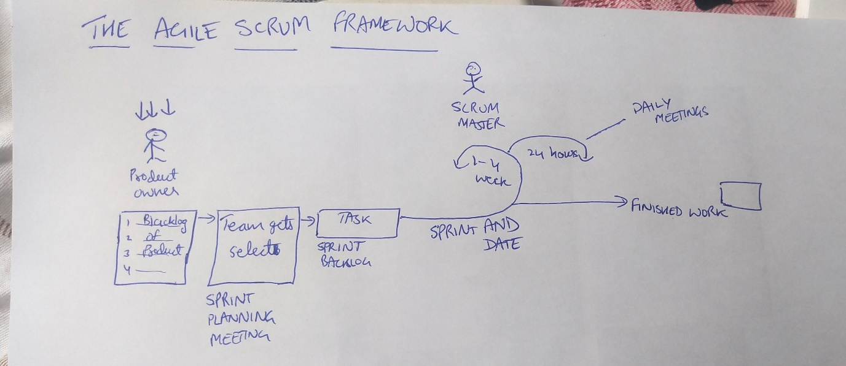

Scrum development works as it first generates the product backlog then the team sits and starts planning then the work comes into process for the time period in which it has to be completed during that daily meetings are scheduled and work process is being checked after the completion of the work a response is generated.

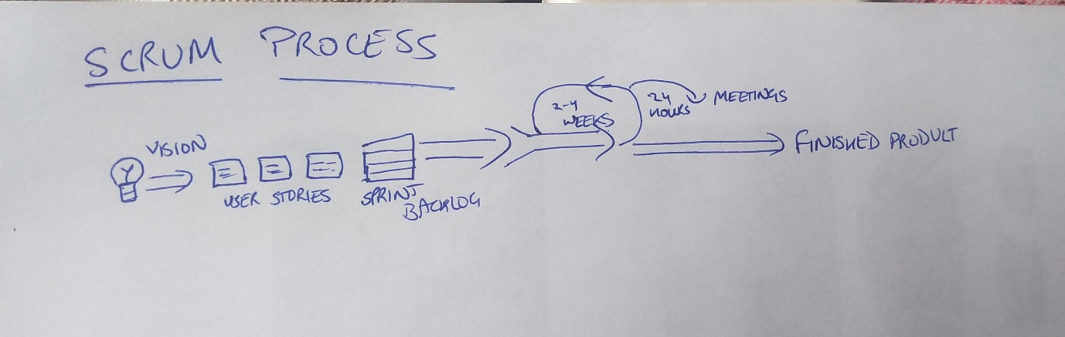

Advantages of Scrum methodology are:

1. This method helps in controlling the cost of the users project.
2. Helps the user to generate a valuable product by providing the requirements of the user at a fast rate.
3. Quality, Maintaining quality is a key principle of development with Scrum which will create vale of the users project.
4. High quality of the project will be made by the user.
5. He will also get ability to incorporate changes
6. Better platform to complete complex projects

The end result of scrum is increment. To deliver an increment that is complete on its own it should contain all the standards set by the user and the team members.

Requirements for my project are ::

First I require a team which consist of a project manager for looking at what the team is working on.

And assist with a guidance. A scrum master to look that the agile scrum is followed accurately or not by the team and also checks the team performance.

Scrum team which is responsible for development, coding, testing and solving the errors and working in an efficient and effective way.

My robot will work on the data gathered by it and will generate a data base for itself and will work on the information collected. And help the user to plan his trip in a cost effective way.

This will be our main motive to help the user in his work.

Services which our robot will provide to the user will be:

* A chat box so that my robot can give a precise and accurate results.
* A voice mode for the user so that he can talk with the robot if he doesn’t want to type
* A robot which will generate an accurate results within less time and at a very fast rate

I will test my project in the following ways:

1)firstly my development team will test it

2)the students of university will test it