week05-day-2-assignments-answers

Exercise: *Assignment for Langflow*
Build a test case reviewer using Langflow. Your system should take a test case , create your own prompt template, review the test case for quality (completeness, clarity, and best practices), and produce:
List of issues
Suggestions for improvement
An improved version of the test case

Langflow_TestcaseReviewer 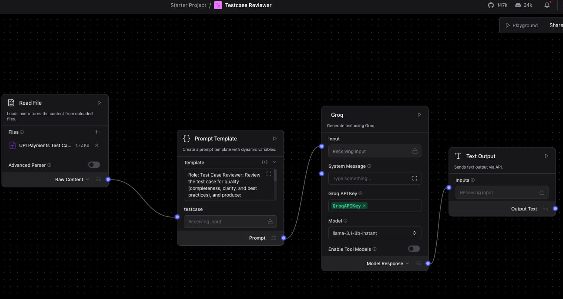

Langflow_TestcaseReviewer_Output: