MODULE: 4 (List and Hooks)

* *Explain Life cycle in Class Component and functional component with Hooks?*

A ***lifecycle*** that encompasses their birth, growth, and eventual removal. Let’s explore the lifecycle in both class components and functional components with Hooks.

*Class Components:*

*Mounting Phase:*

Constructor: The constructor is called when an instance of the component is created. It initializes the component’s state and binds event handlers.

***render()***: The render() method generates the component’s UI based on its current state and props.

***componentDidMount ():*** This method is invoked after the component is added to the DOM. It’s a good place to set up timers, network requests, or subscriptions.

***Updating Phase:***

*componentDidUpdate(prevProps, prevState):* Called after the component updates (when new props or state are received). Useful for handling side effects or re-rendering based on changes.

*shouldComponentUpdate(nextProps, nextState):* Determines whether the component should re-render. Optimize performance by preventing unnecessary updates.

***Unmounting Phase:***

***componentWillUnmount():*** Invoked just before the component is removed from the DOM. Clean up any resources (e.g., cancel timers, unsubscribe from subscriptions).

* ***Functional Components with Hooks:***

***useState Hook:***

Allows functional components to manage local state.

Example:

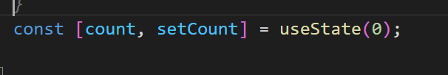

***useEffect Hook:***

Replaces lifecycle methods like componentDidMount, componentDidUpdate, and componentWillUnmount.

Handles side effects (e.g., data fetching, subscriptions).

Example:

Other Hooks:

***useContext***: Access context values.

***useReducer***: Manage complex state logic.

***useMemo***: Optimize expensive computations.

***useCallback***: Memoize functions to prevent unnecessary re-renders.

Remember that Hooks allow functional components to handle state and side effects more elegantly, making them a powerful alternative to class components. 🚀

Summary: React components g*o through a lifecycle of mounting, updating, and unmounting. Class components use lifecycle*